**Grants**

**Personnel &Index**

**Sciences &**

**Health**

**Professions**

**Course**

**Descriptions**

**Graduate**

**School**

**Education**

**Business**

**Arts & Humanities**

**Albany State**

CORE CURRICULUM

**CONTENTS**

Area A Essential Skills . . . . . . . . . . . . . . . . . . . . . . . . . . . . . . . . . .65

Area B Institutional Options . . . . . . . . . . . . . . . . . . . . . . . . . . . . . .65

Area C Humanities/Fine Arts . . . . . . . . . . . . . . . . . . . . . . . . . . . . .65

Area D Science, Mathematics and Technology . . . . . . . . . . . . . . .65

Area E Social Science . . . . . . . . . . . . . . . . . . . . . . . . . . . . . . . . . . .66

Above the Core . . . . . . . . . . . . . . . . . . . . . . . . . . . . . . . . . . . . . . . .66

**Albany State**

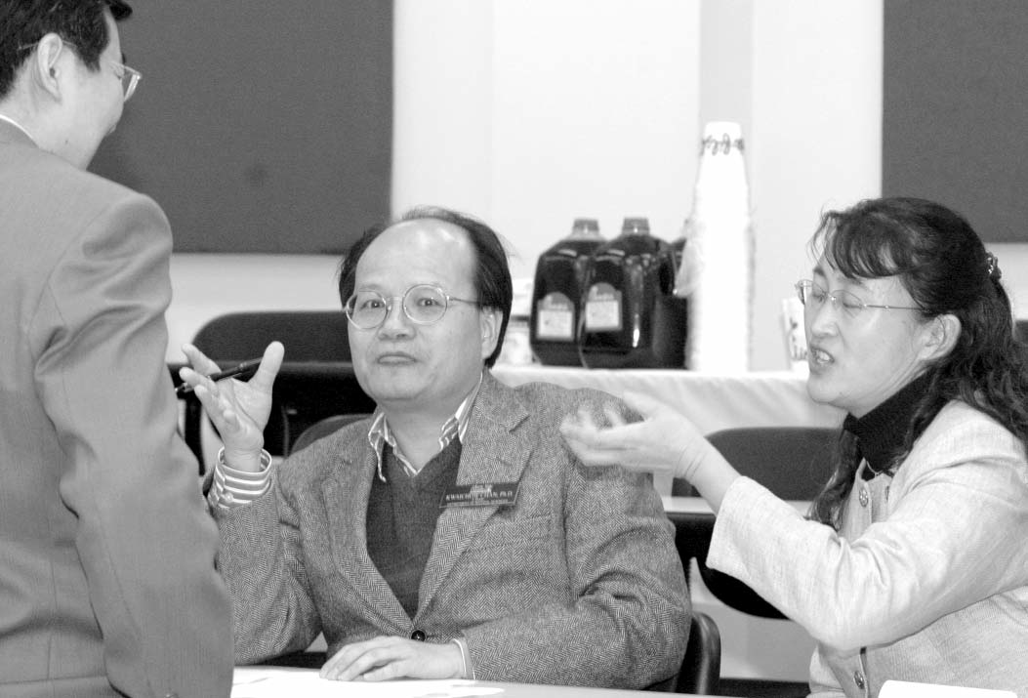

2008-2012 Undergraduate Catalog

CORE CURRICULUM

**Core Curriculum**

**Sciences &**

**Health**

**Professions**

**Graduate**

**School**

**Course**

**Descriptions**

**Personnel &Index**

**Albany State**

**Business**

**Education**

**Arts & Humanities**

**Albany State**

The Core Curriculum of the University System of Georgia is the general education foundation upon which all degree programs are built. It is de- signed to aid the student in further developing basic knowledge needed for success in degree programs. The following Core Curriculum areas are common to all degree programs of Albany State University: Area A (Essential Skills), Area B (Institutional Options), Area C (Humanities/Fine Arts), Area D (Science, Mathematics, and Technology), Area E (Social Sciences) and Above the Core. Core Curriculum Area F (courses related to the program of study) is uniquely specific for each program. The courses which are common to all programs are shown below:

**10 Hours**

|  |  |  |
| --- | --- | --- |
| **Course Numbers**  ENGL 1101 | **Area A – Essential**  English Composition I (required) or | **Skills 9-**  3 |
| HONOR 1111  ENGL 1102 | Honors Humanities 1 (Honors Students only)  English Composition II (required) or | 3 |
| HONOR 1112 | Honors Humanities II (Honors Students only) |  |
| MATH 1101 | *Select one, as required:*  Math Modeling | 3 |
| MATH 1111 | College Algebra | 3 |
| MATH 1113  MATH 1211 | Pre-Calculus (required for the following majors:  Mathematics, Computer Science, Chemistry, Biology) Calculus I (required for Pre-Engineering majors) | 3  4 |
| COMM 1100 | **Area B - Institutional Options**  Analytic Discussion of Global Issues (required) | **5 Hours**  3 |
| HIST 1002 | Introduction to African Diaspora | 2 |
| ENGL 2111 | **Area C - Humanities/Fine Arts**  World Literature I (required) or | **6 Hours**  3 |
| HONOR | 2111 Honors Humanities III (Honors Students only) | 3 |
| ARAP 1100 | *Select one:*  Art Appreciation | 3 |
| ENGL 2112 | World Literature II | 3 |
| MUSC 1100 | Music Appreciation | 3 |
| FREN 2201 | Intermediate French | 3 |
| GRMN 2221 | Intermediate German | 3 |
| SPAN 2231 | Intermediate Spanish | 3 |
| FIAR 1100 | Introduction to Fine Arts | 3 |
| HONR 2112 | Honors Humanities IV (Honors Students only) | 3 |
| BIOL 1111K | **Area D - Science, Mathematics and Technology** *Option I-Non Science Majors-Select any two courses* Introduction to Biological Sciences | **10- 11 Hours**  4 |
| BIOL 1112K | Introduction to Biological Sciences | 4 |
| BIOL 1114K | Survey of Biotechnology | 3 |
| BIOL 1115K | Introduction to Environmental Biology | 3 |
| CHEM 1151K | Survey of Chemistry I | 4 |
| CHEM 1152K | Survey of Chemistry II | 4 |
| PHYS 1001K | Physical Science I | 4 |
| PHYS 1002K | Physical Science II | 4 |
| PHYS 1020 | Survey of Modern Science & Technology | 3 |
| CSCI 1003 | **Area D - Science, Mathematics and Technology**  *Select any one course from this list:*  Introduction to Technology | 2 |
| SSCI 2402 | Microcomputers in Social Science | 3 |
| MATH 2411 | Basic Statistics | 3 |
| MATH 1201 | Survey of Calculus | 3 |
| CSCI 1101 | Introduction to Computers | 3 |
| PHYS 2100 | Computer Applications | 3 |
| MATH 1113 | Pre-Calculus | 3 |

2008-2012 Undergraduate Catalog

**Core Curriculum**

**Personnel &Index**

**Sciences &**

**Health**

**Professions**

**Course**

**Descriptions**

**Graduate**

**School**

**Education**

**Business**

**Arts & Humanities**

**Albany State**

**Option II-Science Majors-Select any two course sequence**

CHEM 1211K General Chemistry I 4

CHEM 1212K General Chemistry II 4

PHYS 1111K Introduction to Physics I 4

PHYS 1112K Introduction to Physics II 4

PHYS 2221K Principles of Physics I 4

PHYS 2222K Principles of Physics II 4

*Select any one course from the list below:*

MATH 1113 Pre-Calculus 3

MATH 1211 Calculus I 4

MATH 2212 Calculus II 4

PHYS 2100 Computer Applications 3

**Area E - Social Science 12 Hours**

POLS 1101 U.S. & Georgia Government (required) or 3

HONR 1161 Honors American Government (optional for Honors Students only) 3

*Electives–Select at least one History course and two other courses:*

ECON 2105 Macroeconomics 3

ECON 2106 Microeconomics 3

ECON 2201 Survey of Economics 3

GEOG 1101 Introduction to Human Geography 3

HIST 1111 Survey of World History I 3

HIST 1112 Survey of World History II 3

HIST 2111 Survey of American History I 3

HIST 2112 Survey of American History II 3

HIST 2113 Minorities in America 3

HONR 1151 Honors World History I (Honors Students only) 3

HONR 1152 Honors World History II (Honors Students only) 3

PHIL 2101 Introduction to Philosophy 3

POLS 2101 Introduction to Political Science 3

POLS 2102 Introduction to Law 3

PSYC 1101 General Psychology 3

SOCI 2011 Principles of Sociology 3

SOCI 2031 Introduction to Anthropology 3

**Above the Core 6 Hours**

ASU 1200 Freshman Seminar & Service to Leadership (Required) 3

*Select any three courses from the list below:*

HEDP 1001 Introduction to Wellness 1

PEDH 1001 Team Sports I 1

PEDH 1002 Fitness 1

PEDH 1003 Recreational Skills I 1

PEDH 1004 Recreational Skills II 1

PEDH 1005 Lifetime Skills I 1

PEDH 1006 Lifetime Skills II 1

PEDH 1007 Aquatics 1

**Area F - Courses Related to the Major**

(Area F courses are determined by the specific major and relate only to that major)

18 Hours

**Arts & Humanities**

**Core Curriculum Total 63-64**

2008-2012 Undergraduate Catalog

**Sciences &**

**Health**

**Professions**

**Graduate**

**School**

**Course**

**Descriptions**

**Personnel &Index**

**Albany State**

**Business**

**Education**

**Arts & Humanities**

**Personnel &Index**

**Sciences &**

**Health**

**Professions**

**Course**

**Descriptions**

**Graduate**

**School**

**Education**

**Business**

**Arts & Humanities**

**Albany State**