TABLE OF CONTENTS

**Table of Contents**

**MISSION, HISTORY & PROFILE**

Mission Statement .....................................................................9

History .....................................................................................10

Profile ......................................................................................11

Accreditation ...........................................................................11

Undergraduate and Graduate Studies ......................................11

The James Pendergrast

Memorial Library ....................................................................11

The Albany State University

Alumni Association .................................................................11

Academic Calendar .................................................................12

Orientation Schedule ...............................................................19

**ADMISSIONS**

General Requirements .............................................................21

Freshman Admissions..............................................................21

SAT Requirements...................................................................21

ACT Requirements ..................................................................21

College Preparatory Curriculum .............................................21

Area of Deficiency Alternatives ..............................................22

Transfer Students .....................................................................22

Transient Student .....................................................................23

International Students ..............................................................23

Advanced Placement for Freshmen.........................................23

Joint Enrollment Program

(Post Secondary Option) .........................................................23

Senior Citizens ........................................................................24

Special Students ......................................................................24

Applicants from Non-accredited

Colleges ...................................................................................24

Readmits ..................................................................................24

Auditors ...................................................................................24

**FINANCIAL INFORMATION**

Financial Aid Application Procedures .....................................27

Sources of Financial Aid

Scholarships.............................................................................29

Grants ......................................................................................31

Employment ............................................................................32

Loan Programs ........................................................................32

Veterans Assistance .................................................................33

Refund Policy for Financial Aid..............................................33

Withdrawal Policy for Financial Aid.......................................34

Financial Information

Student Fee Schedule ..............................................................35

Definition of Full-Time Student ..............................................35

Other Fees and Charges ...........................................................35

Citizens of Georgia 62 and Older ............................................36

Audit (Noncredit) Fee .............................................................36

Payment of Fees and Charges..................................................36

General Refunds ......................................................................36

Room and Board Refunds .......................................................36

Boarding Student Fees.............................................................36

**ENROLLMENT MANAGEMENT AND STUDENT AFFAIRS**

Orientation ...............................................................................39

Housing ...................................................................................39

Health Services ........................................................................39

Counseling, Testing and

Disabled Student Services .......................................................39

Regents’ Center for Learning Disorders

at Georgia Southern .................................................................40

Provisions for Learning Disabilities and

Physically Handicapped Students ...........................................40

Religious Life ..........................................................................41

Student Activities Office .........................................................41

Student Identification Card .....................................................41

Parking.....................................................................................41

Student Organizations .............................................................42

Who’s Who ..............................................................................42

Athletics...................................................................................42

The James C. Reese Student Union.........................................42

Required Attendance Regulations:

Class Attendance .....................................................................43

Statement of Disruptive and

Obstructive Behavior...............................................................43

Career Services ........................................................................43

The Right to Share in

Policy Making .........................................................................44

Academic Information.............................................................44

Degree Requirements. .............................................................44

Commencement .......................................................................44

Regents’ Test............................................................................44

Foreign and Disabled Student Services ...................................47

Matriculation Time for Degree ................................................47

Credit Load. .............................................................................47

**ACADEMIC INFORMATION**

Academic Advisement...................................................................49

Grading System .......................................................................49

Graduation/Degree Audit ........................................................50

Honors and Awards..................................................................50

Academic Standing..................................................................50

Academic Probation/Suspension .............................................51

Residence Classification..........................................................51

Legal Residency Requirements ...............................................51

Registration and Schedule Changes ........................................52

Auditing Courses for Non-Credit ............................................52

Withdrawal from University....................................................52

Transcripts ...............................................................................52

Academic Classification ..........................................................53

Academic Renewal Policies

and Procedures ........................................................................53

Academic Repeat Policy .........................................................53

Transient Status .......................................................................53

Veterans Assistance Program...................................................54

Buckley Amendment ...............................................................54

**Education**

**Business**

**Arts & Humanities**

**Albany State**

**Personnel &**

**Index**

**Course**

**Descriptions**

**Graduate**

**School**

**Sciences &**

**Health**

**Professions**

**2008-2012 UNDERGRADUATE CATALOG 5**

**Table of Contents**

Grade Point Average ................................................................54

Visitors in University Classrooms ...........................................54

State of Georgia Legislative

Requirements ...........................................................................54

Second Degrees .......................................................................54

Procedure for Applying to Take College

Level Examination Program (CLEP) ......................................54

**SPECIAL PROGRAMS**

The Honors Program ...............................................................57

Outreach Programs ..................................................................57

SDU Credits ............................................................................57

Non-Credit Courses .................................................................57

Cooperative Education ............................................................58

Off-Campus Programs.............................................................58

Department of Military Science ..............................................58

Army ROTC (Reserve Officer’s

Training Corps) Program ...................................................58

Center for Excellence in Teaching and

Learning/Learning Support Services .......................................60

The Weekend University .........................................................62

**CORE CURRICULUM**

Area A Essential Skills ............................................................65

Area B Institutional Options....................................................65

Area C Humanities/Fine Arts ..................................................65

Area D Science, Mathematics and Technology.......................65

Area E Social Science .............................................................66

Above the Core........................................................................66

**COLLEGE OF ARTS & HUMANITIES**

Department of English and

Modern Languages ..................................................................68

English Curriculum .................................................................69

Spanish Curriculum .................................................................71

Mass Communication ..............................................................72

Department of Fine Arts ..........................................................75

Art Curriculum ........................................................................76

Music Curriculum....................................................................77

Speech & Theatre Curriculum ................................................81

Department of History, Political Science

and Public Administration .......................................................84

Minor Programs.......................................................................84

History Curriculum..................................................................85

Political Science Curriculum ...................................................87

Pre-Law ...................................................................................89

Department of Psychology, Sociology

and Social Work.......................................................................90

Psychology Curriculum ...........................................................92

Sociology Curriculum .............................................................94

Social Work Curriculum ..........................................................95

**COLLEGE OF BUSINESS**

Internship .................................................................................99

Weekend College .....................................................................99

Two-Plus-Two Program...........................................................99

Department of Business Administration................................100

Business Management Curriculum .......................................101

Health Care Management Curriculum ..................................102

Technology Management ......................................................105

Department of Accounting, Information

Systems and Marketing .........................................................107

Accounting Curriculum .........................................................109

Business Information Systems Curriculum ...........................110

Marketing Curriculum ...........................................................112

Minor in International Business ............................................114

**COLLEGE OF EDUCATION**

Department of Teacher Education ...............................................117

Early Childhood Education Curriculum ................................118

Middle Grades Education Curriculum ..................................120

Special Education Curriculum...............................................123

Admission to Teacher Education Unit...................................128

Requirements for Admission to Teach Education Unit .........128

Advisement Academy............................................................129

Education Minor ....................................................................131

Department of Health, Physical Education and Recreation ..132

Health & Physical Education Curriculum .............................132

Health, Physical Education & Recreation Curriculum..........135

**COLLEGE OF SCIENCES & HEALTH PROFESSIONS**

Department of Nursing ..........................................................139

Criteria for Admission ...........................................................139

Appeal for Readmission ........................................................140

RN Student Admission ..........................................................140

Bachelor of Science in Nursing .............................................140

Program of Study...................................................................141

Pre-Medicine .........................................................................142

Pre-Medical Technology .......................................................142

Pre-Pharmacy ........................................................................142

Department of Criminal Justice.............................................142

Curriculum.............................................................................142

Program of Study...................................................................145

Forensic Science ....................................................................146

Department of Natural Sciences ............................................149

Biology Curriculum...............................................................150

Science Education Curriculum ..............................................153

Chemistry Curriculum ...........................................................155

Pre-Engineering Curriculum .................................................156

Department of Mathematics and

Computer Science..................................................................157

Computer Science Curriculum ..............................................158

Department of Natural Sciences ............................................149

Computer Information

Systems Curriculum ..............................................................160

Applied Science Curriculum .................................................160

Mathematics Curriculum .......................................................162

**GRADUATE SCHOOL**

Degrees Offered.....................................................................165

Admission..............................................................................166

Degree Requirements ...........................................................167

**Albany State**

**Arts & Humanities**

**Business**

**Education**

**Graduate**

**School**

**Course**

**Descriptions**

**Sciences &**

**Health**

**Professions**

**Personnel &**

**Index**

**6 2008-2012 UNDERGRADUATE CATALOG**

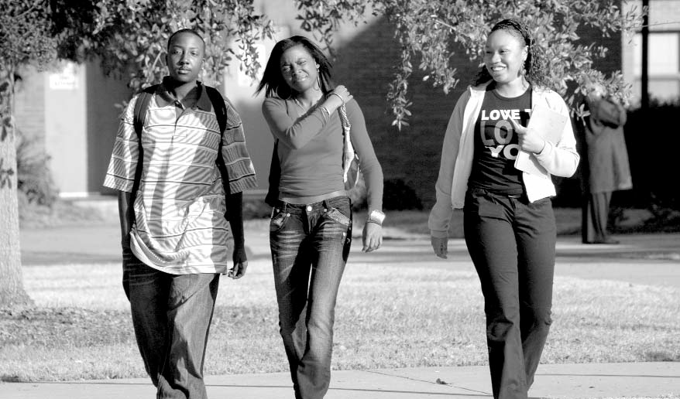**COURSE DESCRIPTIONS**

Accounting ...........................................................................169

Albany State University .......................................................170

Art ......................................................................................170

Biology..................................................................................172

Business Administration .......................................................176

Business Information Systems and Education .....................176

Chemistry .............................................................................178

Computer cience..................................................................180

Cooperative Education .........................................................181

Criminal Justice ....................................................................182

Learning Support...................................................................184

Driver Education ..................................................................185

Early Childhood Development .............................................185

Economics ............................................................................186

Education ..............................................................................187

Engineering...........................................................................187

English ..................................................................................188

Entrepreneurship ..................................................................190

Finance .................................................................................191

Fine Arts................................................................................191

Forensic Science ...................................................................191

French ...................................................................................193

Geography ............................................................................194

German .................................................................................194

Health Education ..................................................................194

History ..................................................................................195

Honors ..................................................................................197

Interdisciplinary Natural ciences.........................................198

Journalism ............................................................................198

Management..........................................................................199

Management-Healthcare Administration .............................200

Marketing .............................................................................200

Mass Communication ............................................................201

Mathematics ..........................................................................203

Media Education....................................................................205

Middle Grades Education ......................................................205

Military Science ....................................................................205

Modern Languages ................................................................206

Music .....................................................................................206

Nursing ..................................................................................228

Philosophy .............................................................................229

Physical Education ................................................................229

Physics ...................................................................................231

Political Science ....................................................................232

Psychology ............................................................................235

Recreation..............................................................................238

Social Science........................................................................239

Social Work ...........................................................................239

Sociology ...............................................................................241

Spanish ..................................................................................245

Special Education ..................................................................247

Speech & Theatre ..................................................................248

Theatre ...................................................................................249

**PERSONNEL & INDEX**

General Administrative Officers............................................251

Academic Officers .................................................................251

Academic Department Chairs ...............................................251

Administrative Support Staff.................................................252

Faculty ...................................................................................252

Personnel Emeriti ..................................................................260

University System of Georgia Profile ...................................263

Members of the Board of Regents......................................263

Institutions ..........................................................................264

Index ......................................................................................265

Telephone Directory ..............................................................267