**Biology**

**Business**

**BIOL 1111K - Intro to Biological Sciences.00 OR 4.00 Credits**

A course designed for non-science majors that emphasizes fun- damental concepts of the cell (i.e., cell structure and function, mi- tosis and metabolism), and plant anatomy and physiology through the use of lectures, audio visual aids, selected laboratory experi- ments, and demonstrations.

**BIOL 1112K - Intro to Biological Sciences.00 OR 4.00 Credits**

**Education**

A course designed for non-science majors that emphasizes human anatomy and physiology, classical and molecular genetics, evolution, ecology, and surveys the plant and animal kingdoms through lec- tures, audio-visual aids, selected laboratory experiments, and demon- strations.

**BIOL 1114K - Survey of Biotechnology . ..00 OR 4.00 Credits** This course studies the basic concepts, applications and impact of manipulative DNA technology on plants, animals and man.

**Sciences &**

**Health**

**Professions**

**BIOL 1115K - Intro to**

**Environmental Biology . . . . . . . . . . . . . . ..00 OR 3.00 Credits** This course studies the basic concepts and impact of the inte related complexities of the environment on man, plants, animals and society. *Co-requisite(s): BIOL 1115.*

**BIOL 1801 - Science Career Exploration . . . . . .1.00 Credits** This course is designed to introduce students (majors and non ma- jors) to the diverse career opportunities in the biological, biomed- ical, chemical and related sciences.

**Graduate**

**School**

**BIOL 2111K - Biology I . . . . . . . . . . . . . . ..00 OR 4.00 Credits**

A study of the animal kingdom will be introduced with discussions on the continuity and diversity of life; emphasis will be placed on basic chemistry, the cell, and classification, biological contri- butions, characteristics, life cycles, and economic importance of se- lected phyla.

**Course**

**Descriptions**

*Prerequisite: none for majors; permission of instructor for non-ma- jors.*

**BIOL 2112K - Biology II . . . . . . . . . . . . . ..00 OR 4.00 Credits** Continuity, evolution and activity of life, and the animal and its environment will be discussed in this course; special emphasis will be placed on the following topics: reproduction, development, clas- sical and molecular genetics, organic evolution, human anatomy and physiology, ecology and the environment.

*Prerequisite: BIOL 2111K.*

**BIOL 2113K - Invertebrate Zoology . . . ..00 OR 3.00 Credits** This course will emphasize classification, biological contribu- tions, characteristics, morphology, phylogeny, and adaptive radiation among the invertebrate animal phyla.

*Prerequisite: BIOL 2111K or permission of instructor.*

**BIOL 2211K - Introduction to Microbiology.00 OR 4.00 Credits** General course in microbiology consisting of fundamental prin- ciples gained from a study of representative types of microbial organisms (morphology and physiology strongly emphsized). *Prerequisites: BIOL 2111K and BIOL 2112K or permission of in- structor.*

**BIOL 2311 - General Botany I . . . . . . . . ..00 OR 4.00 Credits**

*Co-requisite(s): BIOL 2311K.*

**BIOL 2311K - General Botany I . . . . . . ..00 OR 4.00 Cr edits** An introduction to the study of the plant kingdom with emphasis on plant structure and function, reproduction and heredity.

*Prequisites: BIOL 2111K and 2112K or permission of instructor.*

**BIOL 2312K - General Botany II . . . . . . ..00 OR 4.00 Credits**

A study of the evolutionary relationships of representative nonvas- cular and vascular plants.

*Prerequisite: BIOL 2311K..*

**BIOL 2320K - Laboratory**

**Research Techniques . . . . . . . . . . . . . . . . ..00 OR 3.00 Credits** This course is designed to provide students with common labo- ratory procedures that are utilized in experimental methodologies. *Prerequisite(s): (BIOL 2112K US D or BIOL 2112 US D ) and (CHEM 2112 KUSD or CHEM 2112 US D). Co-requisite(s): BIOL*

*2320.*

**BIOL 2411K - Human**

**Anatomy/Physiology I . . . . . . . . . . . . . . . ..00 OR 4.00 Credits** Introduction to the gross and microscopic structure and functional relationships of the integument, bones, muscles, nerves and en- docrine organs.

**BIOL 2412K - Human**

**Anatomy/Physiology II . . . . . . . . . . . . . . ..00 OR 4.00 Credits** This course emphasizes the gross and microscopic structure/function of the following systems: cardiovascular, lymphatic, respiratory, uri- nary, digestive and reproductive.

**BIOL 2415 - Scientific Writing . . . . . . . ..00 OR 3.00 Credits** This course is designed to acquaint learners with discovery in- quiry processes and to provide competencies for writing scientific papers. *Prerequisite: permission of instructor.*

**BIOL 2801 - Test Taking Skills in Science . . . . . .2.00 Credits** This course is designed to enhance the student's science know edge and reasoning skills needed to extract and deduce information, thereby increasing the probability of scoring favorably on examina- tions required for admission to graduate and professional schools. (MCAT,DAT,GRE, VET and others).

**BIOL 3101K - Environmental Biology . . ..00 OR 4.00 Credits** Introduction to fundamental ecological concepts, with emphasis on the study of ecosystems, energy, biogeochemical cycles, resources, pollution and human ecology.

*Prerequisite: BIOL 2111K.*

**172**

**Personnel &**

**Index**

2008-2012 Undergraduate Catalog

**Course Descriptions**

**BIOL 3109 - Advanced concepts in**

**Biological Sciences .......................................00 OR 3.00 Credits** This course will address concepts and methodologies in biology. The interactions and relationships of protistan, monerans, fungi, plants and animals will also be stressed. Special emphasis will be morphological and physiological aspects of living organisms.

**BIOL 3201K - Entomology . . . . . . . . . . . ..00 OR 4.00 Credits** Introduction to the study of insect life histories, habitats and their relationships with emphasis on the economic importance and con- trol of these organisms.

*Prerequisite: BIOL 2111K.*

**BIOL 3250K - Biochemistry . . . . . . . . . . ..00 OR 4.00 Credits** The student examines the structure, function, and metabolism of carbohydrates, amino acids and proteins, lipids, and nucleic acids, (topics include bioenergetics, enzyme kinetics, photosynthesis, and the interdependence of the various metabolic pathways of inter- mediate metabolism) in this course.

*Prerequisite: CHEM 2302K.*

**BIOL 3309K - Plant Anatomy . . . . . . . . ..00 OR 4.00 Credits** The study of structure and development of vegetative and repro- ductive organs of vascular plants with emphasis on angiosperms. *Prerequisite: BIOL 2311K.*

**BIOL 3311K - Intro to satural Resources.00 OR 3.00 Credits** An introduction to the study of population issues, resource avail- ability, environmental water quality, and energy and food resource depletion.

*Prerequisite: BIOL 2111K and CHEM 2112K or permission of in-*

*structor.*

**BIOL 3312K - Planning/Managing**

**sat Resource ................................................00 OR 3.00 Credits** The study of renewable and nonrenewable resources will be consid- ered as it relates to evaluating and making objective decisions regarding strategic planning for future survival.

*Prerequisite(s): BIOL 3101K and BIOL 3311K.*

**BIOL 3313K - sat Resource/**

**Environ Policy . . . . . . . . . . . . . . . . . . . . . ..00 OR 5.00 Credits** This course explores potential means of achieving control over environmental concerns and examines the interaction and effect of local, state and federal governments on environ- mental policy. *Prerequisites: BIOL 3101K, 3311K and 3312K.*

**Albany State**

**BIOL 3314K - Conservation of Energy . ..00 OR 3.00 Credits**

**Arts & Humanities**

A course designed to acquaint students with the growing depend- ency of modern society on fossil fuel supplies, the possible exhaus- tion of these fuels and the social, economic and technical problems involved in stabilizing our energy needs for future gen- erations. *Prerequisite: Junior or senior standing or permission of in- structor.*

**BIOL 3315K - Conservation of**

**Energy Resource ..........................................00 OR 3.00 Credits** A course that introduces the student to energy technologies that im- pact on transportation, buildings and industry as it relates to low- ering energy costs. The course explores major successful economic and conservative strategies, including curtailment, improved effi- ciency and readjustments that have been successful in these areas. *Prerequisite: BIOL 3314K.*

**Business**

**BIOL 3316K - Sources/Use of Plant/Wildlife.00 OR 3.00 Credits** A course that introduces the student to the ways plant and wildlife resources have been used throughout history and studies their im- portance in food production and non-edible product utilization. *Prerequisite: BIOL 3101K or 3311K.*

**Education**

**BIOL 3317K - satural Resources/Food**

**Product..........................................................00 OR 3.00 Credits**

A course that introduces the student to the food requirements of organisms in specific geographical habitats and examines methods that may be used to increase food quantities in our natural re- sources.

**Sciences &**

**Health**

**Professions**

*Prerequisite: Junior or senior standing or permission of instructor.*

**Graduate**

**School**

**Personnel &**

**Index**

**Course**

**Descriptions**

2008-2012 Undergraduate Catalog

**173**

**Course Descriptions**

**Education**

**Business**

**Arts & Humanities**

**Albany State**

**174**

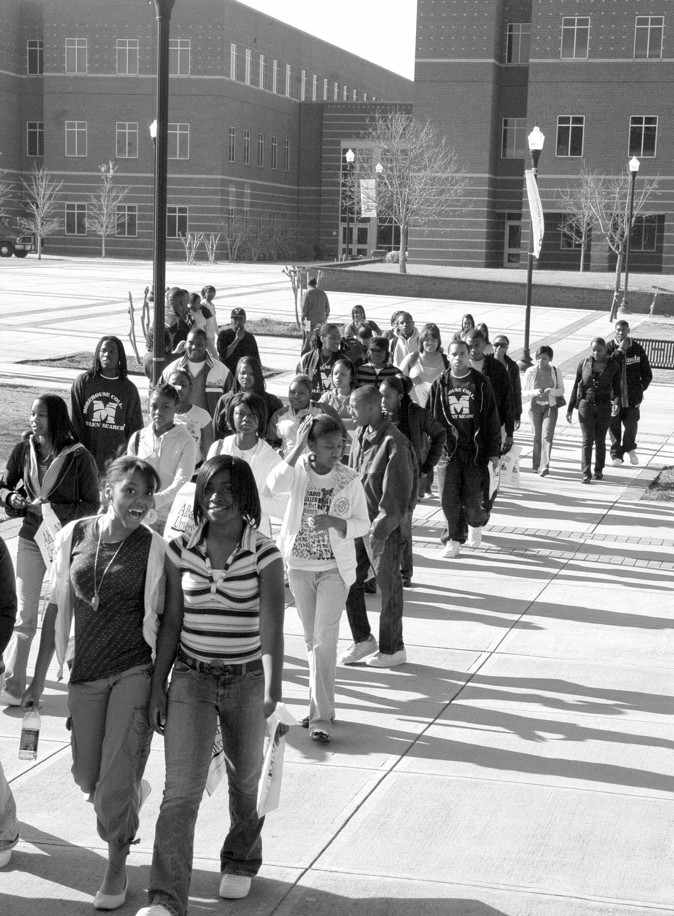

**Personnel &**

**Index**

**Sciences &**

**Health**

**Professions**

**Course**

**Descriptions**

**Graduate**

**School**

2008-2012 Undergraduate Catalog

**Course Descriptions**

**BIOL 3318K - Marine Life Resources** . . . ..00 OR 3.00 Credits A course that introduces the student to the marine ecosystem which includes plants, animals, invertebrates and vertebrates in their unique environment.

*Prerequisite(s): (BIOL 3311K US D or BIOL 3311 US D or*

*BIO 306 UG D).*

**BIOL 3319K - Conservation of Marine Life.00 OR 3.00 Credits** A course that introduces the student to the oceans of the world and examines conservation techniques that are applicable to various marine environments.

*Prerequisite(s): (BIOL 3318K US D or BIO 330 UG D or BIOL*

*3318 US D).*

**BIOL 3320K - Principles/Tech in**

**Water Resources Service .............................00 OR 4.00 Credits**

A course that introduces the student to the procedures needed to examine water over a wide quality range, including water suitable for domestic or industrial supplies, surface water, and treated and untreated municipal or industrial wastewater.

*Prerequisite(s): (BIOL 3311K US D or BIO 306 UG D or*

*BIOL 3311 US D).*

**BIOL 3321K - Conservation/Plant/**

**Wildlife Resources .......................................00 OR 3.00 Credits**

A course that introduces the student to the impact of expansion by urban populations on plant and wildlife resources and focuses on specific conservation strategies that help reverse negative trends that have been established through years of misuse and abuse. *Prerequisite: Junior or Senior or Permission of instructor.*

**BIOL 3401K - Introduction to Histology ..00 OR 4.00 Credits** Introduction to the study of tissues with emphasis placed on light microscopic preparations.

*Prerequisite(s): (BIOL 2111K US D or BIOL 2111 US D or*

*BIO 205 UG D). Co-requisite(s): BIOL 3401.*

**BIOL 3501K - Principles of Genetics . . . ..00 OR 4.00 Credits** Introduction to the study of the modern concepts of heredity in plants and animal systems.

*Prerequisite(s): (BIOL 2111K US D or BIOL 2111 US D or BIO 205*

*UG D) and (BIOL 2112K US D or BIOL 2112 US D) and (BIOL*

*2311K US C or BIOL 2311 US D or BIO 208 UG D).*

**BIOL 3611 - Medical Mycology . . . . . . . ..00 OR 4.00 Credits** Design to acquaint students with select fungal groups that cause human disease.

*Prerequisite(s): (BIOL 2111K US D or BIOL 2111 US D).*

*Co-requisite(s): BIOL 3611K.*

**BIOL 3801K - Electron Microscopy . . . . .00 OR 3.00 Credits**

A mini-course that introduces techniques needed to examine specimens utilizing the transmission electron microscope. *Prerequisite: Junior or Senior status or permission of instructor.*

**BIOL 3901 - Pathophysiology . . . . . . . . . . . . . . . .3.00 Credits** Survey of the fundamentals of human diseases, with emphasis on anatomical, physiological and clinical processes

*Prerequisite(s): (BIOL 2112K US D or BIOL 2112 US D) or (BIOL*

*2111K US D or BIOL 2111 US D or BIO 205 UG D).*

**BIOL 4001 - Research/Independent Study I . . . .1.00 Credits** The student will be introduced to research and independent methods of scientific research, will make oral presentations on scientific topics

of interest and plan a research project with assistance from a faculty advisor. (Required of all majors.)

*Prerequisite: senior classification or permission of instructor.*

**BIOL 4002 - Research/Independent Study II . . .1.00 Credits** The student will make oral presentations and present research findings (written and oral) derived from independent study. *Prerequisite(s): ( BIOL 4001 US D or BIO 401 UG D).*

**Albany State**

**Arts & Humanities**

**BIOL 4101K - General Physiology . . . . . ..00 OR 4.00 Credits**

In this course, the experimental approach to physiology is emphasized including the nerve impulse, enzymes and their properties, along with other selected topics. Prerequisites: BIOL

2112K and senior status.

*Prerequisite(s): (BIOL 2112K US D or BIOL 2112 US D).*

**BIOL 4201K - Introduction to Parasitology.00 OR 4.00 Credits** Fundamentals of parasitism is investigated in this course with emphasis on life histories and economic importance of protozoan, helminth, and arthropod parasites.

**Business**

*Prerequisite(s): (BIOL 2112K US D or BIOL 2112 US D)*

**BIOL 4222 - Biology Senior Research . . ..00 OR 3.00 Credits** The student will be introduced to research and independent methods of scientific research, conduct supervised research project, collect and analyze data, write a research paper on the topic of research and finally will make oral presentations on sc entific topics of interest. *Prerequisite(s): BIOL 4001.*

**Education**

**BIOL 4301K - Developmental Biology . . ..00 OR 4.00 Credits** Classical methods of analysis and the series of embryonic stages from gametogenesis to histogenesis will be emphasized. Also, basic conceptual topics such as nuclear totipotency, cell determination, cytoplasmic localization, induction, and morphogenesis are interspersed.

**Sciences &**

**Health**

**Professions**

*Prerequisite(s): (BIOL 2112K US D or BIOL 2112 US D).*

**BIOL 4401K - Comparative**

**Vertebrate Anatomy . . . . . . . . . . . . . . . . . ..00 OR 4.00 Credits** Course lectures will include comparative structure and evolu- tionary relationships among a series of chordates from amphioxus to mammals, with thorough laboratory dissections of at least one repre- sentative from each of the vertebrate classes.

**Graduate**

**School**

*Prerequisite(s): (BIOL 2112K US D or BIOL 2112 US D). Co-requisite(s): BIOL 4401.*

**BIOL 4501K - Immunology . . . . . . . . . . ..00 OR 4.00 Credits** Structural and physiological properties of microbes, including im- munology, infectious diseases and regular immune- type responses are covered in this course.

**Course**

**Descriptions**

*Prerequisite(s): (BIOL 2211K US D or BIOL 2211 US D).*

*Co-requisite(s): BIOL 4501.*

**BIOL 4601K - Plant Physiology . . . . . . . ..00 OR 4.00 Credits**

A study of vascular plant functions, including absorption and translocation of water and solutes, transpiration, photosynthesis, respiration, growth and development and hormonal regulation is done in this course.

**Personnel &**

**Index**

*Prerequisite(s): ( BIOL 2311K US D or BIO 209 UG D or BIOL 2311*

*US D )and ( BIOL 2312K US D or BIOL 2312 US D). Co-requisite(s): BIOL 4601.*

2008-2012 Undergraduate Catalog

**175**

**Course Descriptions**

**BIOL 4701K - Cell/Molecular Biology . . ..00 OR 4.00 Credits** This course is designed to acquaint students with the organization and function of the cell utilizing cytological techniques to investigate structure and function.

**Albany State**

*Prerequisite(s): (BIOL 2311K US D or BIOL 2311 US D or*

*BIO 209 UG D).*

*Co-requisite(s): BIOL 4701.*

**BIOL 4702K - Biotechnology . . . . . . . . . ..00 OR 4.00 Credits** The course is designed to illustrate the current rise in biotechnology and explore its application in plant, animal, biomedical, human society, and global environment. This course will also provide "hands-on" experience with modern biotechnology and molecular biology research techniques in the laboratory.

**Arts & Humanities**

*Prerequisite(s): (BIOL 2211K US D or BIOL 2211 US D) and (BIOL 3250K US D or BIOL 3250) or (CHEM 3250K US D or CHEM 3250 US D).*

*Co-requisite(s): BIOL 4702.*

**Business**

**BIOL 4805 - Seminar . . . . . . . . . . . . . . . . . . . . . .1.00 Credits** This course is designed to give the education major appropriate methodologies needed to plan and conduct a research project. *Prerequisite(s): Education major with junior or senior status.*

**BIOL 4901 - MARC Honors Seminar . . . . . . . . .1.00 Credits** This course is designed to introduce students (MARC Honors participants) to research methodologies and will provide appropriate competencies needed to present research investigations on scientific topics of interest.

**Education**

*Prerequisite: permission of instructor.*

**BIOL 4902 - MARC Honors Seminar . . . . . . . . .1.00 Credits** This course will provide participants with the background needed to plan, conduct and present research findings under the guidance of a faculty advisor.

**Sciences &**

**Health**

**Professions**

*Prerequisite: permission of instructor.*