**Financial Information**

**Personnel &Index**

**Sciences &**

**Health**

**Professions**

**Course**

**Descriptions**

**Graduate**

**School**

**Education**

**Business**

**Arts & Humanities**

**Albany State**

FINANCIAL

INFORMATION

**CONTENTS**

Financial Aid Application Procedures . . . . . . . . . . . . . . . . . . . . . . .27

Sources of Financial Aid

Scholarships . . . . . . . . . . . . . . . . . . . . . . . . . . . . . . . . . . . . . . . . . .29

Grants . . . . . . . . . . . . . . . . . . . . . . . . . . . . . . . . . . . . . . . . . . . . . . .31

Employment . . . . . . . . . . . . . . . . . . . . . . . . . . . . . . . . . . . . . . . . . .32

Loan Programs . . . . . . . . . . . . . . . . . . . . . . . . . . . . . . . . . . . . . . . .32

Veterans Assistance . . . . . . . . . . . . . . . . . . . . . . . . . . . . . . . . . . . . .33

Refund Policy for Financial Aid . . . . . . . . . . . . . . . . . . . . . . . . . . .33

Withdrawal Policy for Financial Aid . . . . . . . . . . . . . . . . . . . . . . .34

Financial Information

Student Fee Schedule . . . . . . . . . . . . . . . . . . . . . . . . . . . . . . . . . . .35

Definition of Full-Time Student . . . . . . . . . . . . . . . . . . . . . . . . . . .35

Other Fees and Charges . . . . . . . . . . . . . . . . . . . . . . . . . . . . . . . . .35

Citizens of Georgia 62 and Older . . . . . . . . . . . . . . . . . . . . . . . . . .36

Audit (Noncredit) Fee . . . . . . . . . . . . . . . . . . . . . . . . . . . . . . . . . . .36

Payment of Fees and Charges . . . . . . . . . . . . . . . . . . . . . . . . . . . . .36

General Refunds . . . . . . . . . . . . . . . . . . . . . . . . . . . . . . . . . . . . . . .36

Room and Board Refunds . . . . . . . . . . . . . . . . . . . . . . . . . . . . . . . .36

Boarding Student Fees . . . . . . . . . . . . . . . . . . . . . . . . . . . . . . . . . .36

**Albany State**

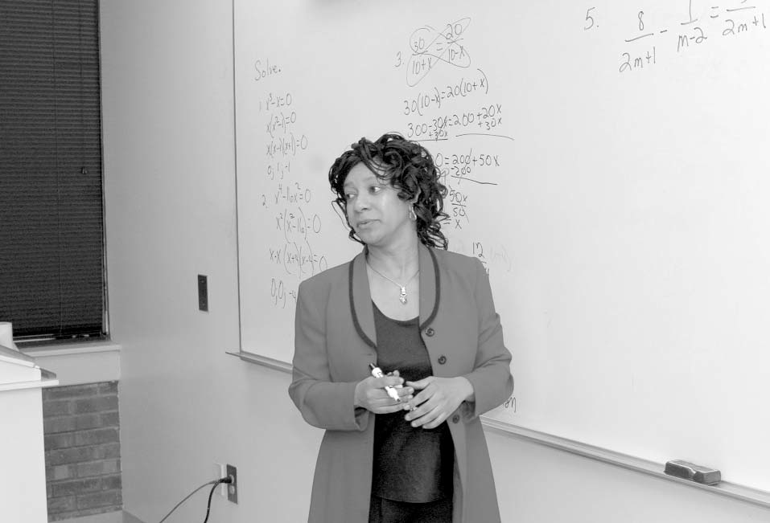

**26** 2008-2012 Undergraduate Catalog

Financial Aid Information

**Financial Information**

**Sciences &**

**Health**

**Professions**

**Graduate**

**School**

**Course**

**Descriptions**

**Personnel &Index**

**Albany State**

**Business**

**Education**

**Arts & Humanities**

**Albany State**

It is the Mission of the Albany State University Office of Financial aid to provide financial assistance to students and parents for the purpose of financing their education. The Office of Financial Aid Office will serve its customers (actual and potential) by providing proper customer service, adequate consumer information and also by providing adequate financial aid packages to meet their financial needs, based on their individual eligibility, to meet there cost of attendance (direct and indirect). Albany State University provides financial assistance for promising students who, without such help, would be unable to attend. The University, however, believes that the principal responsibility for financing an education lies with students and their families. Most financial aid programs are based on the financial needs of students. Need is the difference between the cost of education at Albany State University and the amount applicants and their families are expected to contribute toward the cost of education.

**FINANCIAL AID APPLICATION PROCEDURES**

Students desiring financial aid should complete the Free Application for Federal Student Aid (FAFSA) as soon as possible after January 1. Students are urged to complete the FAFSA [online](http://fafsa.ed.gov) at http://fafsa.ed.go[v](http://fafsa.ed.gov). The Albany State University School Code is 001544.

# Annual Appliction Deadline Dates

|  |  |
| --- | --- |
| **April 15, 2011** | Priority FAFSA Processing Deadline |
| **June 1, 2011** | FAFSA Processing Deadline for the Fall Semester |
| **June 30, 2011** | Verification Document Deadline Date |

The Office of Financial Aid will be processing completed applications for the academic year as soon as Federal regulations are received and the Board of Regents determines tuition rates for the academic year. A student must be accepted for enrollment (new students and readmits) before he/she can be awarded.

Application processing can take six weeks or longer during peak processing periods. Although the priority deadline is April 15 of each year, application that are not competed by the following deadlines may be processed by the beginning of that semester Fall semester, June 15; spring semester, November 15; summer semester, April 15. If you have not completed the application process (this included providing addi- tional documentations as requested by the Office of Financial Aid) by the dates given above, you should be prepared to pay all educational costs assessed on your fee statement.

**Satisfactory Academic Progress (SAP)**

Federal regulations require that all students receiving any form of financial assistance make and maintain satisfactory academic progress (SAP) toward the completion of their degrees, within a reasonable period of time, in order to remain eligible to receive assistance. Students are evaluated on the basis of GPA (Grade Point Average), credit hour completion, and maximum time frame. Students are considered to be making satisfactory academic progress if they meet the two standards of measurement (Qualitative and Quantitative). Failure to maintain SAP will result in the loss of all federal and state aid, including:

* Federal Pell Grant
* Federal Supplemental Education Opportunity Grant (FSEOG)
* Federal Work Study
* Federal Stafford Loans (Subsidized and Unsubsidized)
* Federal Plus Loans
* Federal Perkins Loans
* Federal Teach Grant
* State of Georgia Financial Aid Programs including the Georgia HOPE Scholarship Programs
* Other Grant and/or Scholarship programs which require Satisfactory Academic Progress verification.

Satisfactory Academic Progress will be reviewed based on cumulative academic history. Qualitative and Quantitative measurement will be evaluated at the end of Spring Semester to determine eligibility for the next academic year.

In order to be eligible for federal financial aid funding or the Georgia HOPE Scholarship, a student must be making “Good” Satisfactory Academic Progress (SAP). Four (4) standards are used to measure Satisfactory Academic Progress:

**QUALITATIVE MEASUREMENT**

Evaluation of Grade Point Average (GPA rule)

1. Undergraduate students must maintain a 2.0 or above cumulative grade point average. Graduate students must maintain a 3.0 or above cumulative grade point average. Renewal and Repeat classes are included in the GPA calculation for financial aid purposes.

**QUANTITATIVE MEASUREMENT**

Completion Percentage (67% rule)

1. Students must, as a minimum, complete at least 67% (or 2/3) of the courses they attempt toward a program of study. Please NOTE: Satisfactory grades are A, B, C, D, or S. All remedial courses (Learning Support and Regents) past the first 30 hours and Academic Renewal classes are included in this calculation.

Maximum Timeframe (150% rule)

1. Students must complete their program of study within the allowable timeframe. The maximum number of hours allowed is 150% of the number of semester hours required to earn a degree. For example at Albany State University, the average degree requires 120 hours for completion and the average graduate degree requires 60 hours for completion; therefore students may not receive financial aid after they have attempted 190 semester hours (undergraduate), 90 hours for Second Undergraduate, and 90 semester hours (graduate). The first 30 semester hours of Learning Support and Regents courses combined are not counted in the maximum number of hours. Academic Renewal and Transfer credits are counted in the maximum number of hours.

**Students who change majors or degree programs may reach their eligibility limits for receiving financial aid before obtaining a degree. Students who elect to change majors or degree programs should do so early to avoid jeopardizing eligibility for financial aid.**

Maximum Learning Support (Max Remediation rule)

1. Students cannot receive financial aid for more than 30 semester hours of remedial coursework (Learning Support and Regents courses). If these courses must be taken beyond 30 semester hours, students must enroll at their own expense. If an appeal is granted through the appeal process, then the student may receive financial aid to cover the cost of the remedial classes

**Definition of Hours Attempted and Completed**

Hours counted as attempted include:

* All ASU courses for which the student receives any of the following grades: A, B, C, D, S, F, I and U
* All ASU courses marked as W, WF, and IP
* All ASU hours forgiven under the Academic Renewal Policy and Grade Replacement Policy as approved by the Office of Academic Services and Registrar.

Hours not counted as attempted include:

* All ASU courses designated as Audit

Hours successfully completed include:

* All ASU courses for which the student receives a passing grade: A, B, C, D and S

Hours unsuccessfully completed include:

* All ASU courses for which the student receives any of the following grades: F, I or U
* All ASU courses marked as W, WF or IP

**Maximum Time Frame: Definition of Hours Attempted**

Hours counted as attempted include:

* All ASU courses for which the student receives any of the following grades: A, B, C, D, S, F, I and U
* All ASU courses marked as W, WF, and IP
* All ASU hours forgiven under the Academic Renewal Policy and Grade Replacement Policy as approved by the Office of Academic Services and Registrar.
* All credits accepted for transfer from another institution

**Transient Courses**

Approved Transient courses are considered to be courses attempted at Albany State University and are monitored for Satisfactory Academic Progress accordingly.

**Second Degrees, Double Majors, and Minors**

There are no adjustments to Qualitative or Quantitative measurements for students seeking second degrees double majors and or minors.

**Completed Program of Study but no Degree Earned**

**A student who completes the academic requirements for a program, but does not have a degree is not eligible for further Federal Title IV aid for that program.**

The Office of Academic Services and Registrar, after approving the audit, will determine if the student has completed all course requirements for degree. This includes courses for double major or minor. After your audit for degree has been completed, you will be identified as a potential graduate. If you fail to meet graduation requirements, you may no longer be eligible to receive financial aid funds.

* Students who did not have the required GPA to earn their degree will not be eligible to receive financial aid funding, through the Office of Financial Aid, for the next semester of enrollment
* Students who did not pass any required exam (comprehensive exam, Praxis, etc.) will not be eligible to receive financial aid funding, through the Office of Financial Aid, for the next semester of enrollment.

Students who are not eligible to receive financial aid funding through the Office of Financial Aid, for the next semester enrollment will have to pay out of pocket.

**Unofficial Withdrawal (Grades of “F” in all courses)**

Students who earn a grade of “F” in all courses at the end of a semester are defined as Unofficially Withdrawn from the university by the Federal Department of Education.

**Reinstatement of Financial Aid**

Students may apply for reinstatement of financial aid by achieving one of the following:

* Accomplishing a successful appeal through the process described below
* Enrolling at your own expense until you are making “Good” Satisfactory Academic Progress towards a degree.

**Appeals Process**

An appeals process is available for students who have extenuating circumstances that account for their lack of academic progress. Appeals must be made in writing to the Financial Aid Appeals Committee. Students must submit the Financial Aid Appeals Petition form along with supporting documents to indicate the specific reason(s) for failure to make satisfactory progress. The committee will review the petition and supporting documents, as well as past performance and past academic record. Students will be notified in writing of the committee’s decision. Students that are academically eligible for enrollment and are approved for financial aid through an appeal remain eligible until the next evaluation period. Please make sure that you include all documentation you think will be necessary with your appeal petition as both approvals and denials are final.

* Students whose appeal has been approved by the Financial Aid Appeals Committee will be evaluated for Satisfactory Academic Progress at the end of semester of enrollment until the minimum standards for Qualitative and Quantitative measurement are met.
* **Beginning with the Fall 2011 semester, students are allowed to submit a maximum of five (5) Financial Aid Appeal Petitions.**
* Students whose appeal has been approved are not meeting minimum Qualitative and or Quantitative measurements, and thus may not be eligible for certain grant or scholarship programs, such as those offered by the State of Georgia.
* Your appeal cannot be granted if mathematically, you cannot meet the minimum graduation requirements for your degree within the maximum timeframe allowed. Students in this situation will not qualify for Federal financial aid funds and thus will have to pay tuition cost at their own expense.
* If you are readmitting (completed Readmission Application) back into the university, your Appeal Petition cannot be acted upon until you have been approved for readmission back into the university by your Academic Department

The Financial Aid Appeals Committee will review all students whose Satisfactory Academic Progress did not improve after the 1 term of enrollment and determine if the student will be approved for financial aid eligibility for the subsequent term, denied financial aid eligibility for the subsequent term, or have to provide additional documentation by appealing for the subsequent semester.

A student may be required to provide an academic success plan as developed Albany State University Academic Advising Office or your departmental academic advisor.

Depending on information provided in your appeal, the Office of Financial Aid may forward your information to the Albany State University Office of Counseling and Testing for evaluation.

2008-2012 Undergraduate Catalog **27**

**28** 2008-2012 Undergraduate Catalog

**Scholarships**

**Sciences &**

**Health**

**Professions**

**Graduate**

**School**

**Course**

**Descriptions**

**Personnel &Index**

**Albany State**

**Business**

**Education**

**Arts & Humanities**

**Albany State**

SOURCES OF FINANCIAL AID

SCHOLARSHIPS

**THE PRESIDENTIAL SCHOLARSHIP**

The Albany State University Foundation recognizes Presidential Scholars each academic year, granting an award which may be up to the student’s cost of attendance. A Presidential Scholar must rank in the upper five percent of his/her graduating high school class and must have a competitive SAT/ACT score. In addition to SAT/ACT requirements, valedictorians and salutatorians will be considered. Additionally, applicants will need three letters of recommendation and a 500 word essay. The Application deadline is April 20th of each year. The student who wishes to apply for the Presidential Scholarship should contact the Velma Fudge Grant Honors Progrm, Office of the President or the Office of Financial Aid. Please visit the Financial Aid Website at [www.asurams.ed](http://www.asurams.edu)u for application procedures.

**THE ALBANY STATE UNIVERSITY FOUNDATION SCHOLARSHIP**

The Albany State University Foundation will recognize Foundation Scholars each academic year, granting an award which may be up to $2000 per year. An Albany State University Foundation Scholar must have a competitive SAT/ACT score which should be no less than 1000 SAT or

22 Composite ACT and a 3.5 grade point average. The student who wishes to apply for the Albany State University Foundation Scholarship should contact the Velma Fudge Grant Honors Program, Office of the President or the Office of Financial Aid. Please visit the Financial Aid Website at [www.asurams.ed](http://www.asurams.edu)u for application procedures.

**JAMES H. PORTER ACADEMIC SCHOLARSHIPS**

Porter Academic Scholarships are made possible through a trust fund created by James H. Porter and authorized by the Board of Regents of the University System of Georgia. The scholarships are provided as an incentive to attract academically talented students to the University. Prior- ity will be given to prior recipients for renewal.

Award Criteria

Minimum eligibility requirements to receive the James H. Porter Academic Scholarship include:

* Must be a Georgia Resident
* Must be a full-time students (graduate or undergraduate)
* Undergraduate students
  + Students with no previous college credit (freshman) must have an SAT (critical reading and mathematics) 1000 or higher and a high school GPA in academic subjects of 3.0 or better
  + Students with prior college experience must have a college GPA of 3.3 or better
* Graduate Students
  + Must have a minimum undergraduate GPA of 3.3 or higher
  + Must have a minimum score:
    - 1,100 (verbal and quantitative) or higher on the GRE or;
    - 500 or higher on the GMAT and;
    - Meet program admission test score requirements
* Awards are limited to four years (undergraduate) and/or two years (graduate)
* Renewal awards
  + Must maintain a 3.0 GPA or higher
  + Renewal is not automatic and is dependent on available funding.
  + Students are expected to re-apply every year.

Determination of Award Amounts

The determination of the Scholarship award amounts are based on available funding.

Scholarship awards for the James H. Porter Academic Scholarship are from $1000 - $5000 annually.

**GEORGIA’S HOPE SCHOLARSHIP (HELPING OUTSTANDING PUPILS EDUCATIONALLY)**

If you are a Georgia resident enrolling in a degree program at a Georgia public college, university, or technical college, you may be eligible for the HOPE Scholarship. The Georgia HOPE Scholarhips awards covers 90% of the prior year matriculation (tuition) cost. The HOPE Scholarship no long provides funding for mandatory fees nor does it provides a book allowance.

The HOPE Scholarship Program is funded through the Georgia Lottery. The program will assist entering freshmen graduating from a Georgia high school, with a "B" average in a college preparatory curriculum. The scholarship provides assistance, which includes tuition, mandatory fees and a book allowance up to $150 per semester.

Students who are not academically eligible for a HOPE Scholarship immediately after high school graduation may be eligible for a HOPE Schol- arship after attempting 30, 60 or 90 hours of study, or students who lost HOPE due to not maintaining a 3.0 grade-point average may be eligible to regain HOPE after attempting 60 or 90 hours of study. Eligibility under both categories can be considered by completing the HOPE Evalua- tion Request Form. The assistance from the scholarship is the same as that of a freshman receiving HOPE. For more information on HOPE Schol- arship go to: [http://www.gacollege411.org.](http://www.gacollege411.org)

2008-2012 Undergraduate Catalog **29**

**Scholarships**

**Personnel &Index**

**Sciences &**

**Health**

**Professions**

**Course**

**Descriptions**

**Graduate**

**School**

**Education**

**Business**

**Arts & Humanities**

**Albany State**

**Albany State**

**THURGOOD MARSHALL SCHOLARSHIPS**

The Thurgood Marshall Scholarship is awarded to entering freshman enrolled in full-time study pursuing a bachelor’s degree. The recipient must have attained a score of 1,100 minimum on the SAT and a score of 24 minimum on the ACT, and a grade point average of 3.0. Additionally, the recipient must be recommended by his/her high school and demonstrate commitment to academic excellence and community service.

**Albany State University National Alumni Association Scholarships**

The Albany State University National Alumni Association awards scholarship annually to undergraduate students. For more information, you can contact the Albany State University National Alumni Association at 229-430-3982. Scholarships include:

* The Marie H. Dixon (see below)
* National Slumni Association Directors Scholarship
* Pre Alumni Associatio Scholarship

**MARIE H. DIXON SCHOLARSHIP**

The Marie H. Dixon Scholarship is presented by the Albany State University Alumni Association to perpetuate the memory of its president emer- itus. This award is made to one eligible student who is either enrolled at Albany State University or intends to enroll at the institution.

The ASU Alumni Association grants one $1,000 scholarship annually. The recipient must meet the following requirements:

• A minimum 2.5 grade-point average.

• Exhibit outstanding leadership abilities through specific activities and events.

• Demonstrate a financial need.

For more information or to apply, contact the office of Alumni Affairs at (229) 430-4658.

**The Gates Millennium Scholars Program**

The Gates Millennium Scholars Program (GMS), funded by a grant from the Bill & Melinda Gates Foundation, was established in 1999 to provide outstanding African America, American Indian/Alaska Native, Asian Pacific Islander American, and Hispanic American students with an opportunity to complete and undergraduate college education

To apply, visit http://www.gmsp.org.

**LAW ENFORCEMENT PERSONNEL DEPENDENTS GRANT**

This grant in the amount of $2,000 per academic year is awarded to eligible Georgia residents who are dependent children of Georgia law en- forcement officers, prison guards or firemen who are permanently disabled or were killed in the line of duty. Students who qualify should con- tact the FAO. For more information go to: [http://www.gacollege411.org.](http://www.gacollege411.org)

**GEORGIA PUBLIC SAFETY MEMORIAL GRANT**

The son or daughter of any Georgia public safety officer who was killed or is permanently disabled in the line of duty is eligible for this grant. The program, which is funded by the Georgia Lottery for Education, covers the Cost of Attendance at a Georgia public post-secondary institu- tion, minus other gift aid received, including the Law Enforcement Personnel Dependents Grant. For more information on Georgia Public Safety Memorial Grant go to: [http://www.gacollege411.org.](http://www.gacollege411.org)

**ROBERT C. BYRD SCHOLARSHIP PROGRAM**

This scholarship program is available to students who demonstrate outstanding academic achievement. The purpose of the program is to pro- mote student excellence and achievement and to recognize exceptionally able student who show promise of continued excellence. The recipi- ent receives a stipend of $1,500 for the academic year. For more information on the Robert C. Byrd Scholarship go to: [http://www.gacollege411.org.](http://www.gacollege411.org)

**TY COBB SCHOLARSHIP**

This scholarship is awarded annually to sophomores, juniors and seniors. Recipients must be a Georgia resident, demonstrate financial need, and possess a 3.0 grade-point average or better. Applications can be obtained by writing: Ty Cobb Foundation, P.O. Box 725, Forest Park, GA

30051.

**ALICE MINOR STUBBS HAWTHORNE SCHOLARSHIP**

This scholarship was established in memory of Mrs. Hawthorne to inspire youths to beat the odds and obtain a college education. The scholar- ship covers tuition and fees at Albany State University. The recipient must meet the following requirements:

• Be enrolled in the ASU College of Business

• Major in marketing or management

• Maintain a grade-point average of 2.5 or better

• Entering junior or senior status

**30** 2008-2012 Undergraduate Catalog

**Sciences &**

**Health**

**Professions**

**Graduate**

**School**

**Course**

**Descriptions**

**Personnel &Index**

**Albany State**

**Business**

**Education**

**Arts & Humanities**

**EXTERNAL SCHOLARSHIPS**

Numerous Scholarships are available through external sources such as local churches, clubs, professional organizations, private foundations and civic groups. High school students should also check with their high school libraries and guidance counselors. The FAO posts on a continuous basis through ASU-INFO (e-mail) scholarship announcements that are received in the FAO. The World Wide Web is a great and helpful resource when searching for scholarships, and many provide free information. Listed below are some reputable scholarship Web sites.

[www.fastweb.com](http://www.fastweb.com) [www.gacollege411.org](http://www.gacollege411.org) [www.studentaid.ed.gov](http://www.studentaid.ed.gov) [www.dl.ed.gov](http://www.dl.ed.gov)

.**GRANTS**

**FEDERAL PELL GRANT**

[www.dlenote.ed.gov](http://www.dlenote.ed.gov) [www.collegeispossible.org](http://www.collegeispossible.org) [www.collegeboard.org](http://www.collegeboard.org)

[www.freschinfo.com](http://www.freschinfo.com) [www.collegenet.com](http://www.collegenet.com) [www.scholarships.com](http://www.scholarships.com)

The fund makes financial assistance available to eligible students attending approved post-high school institutions. Eligibility and actual amount of aid are determined by the Office of Education. This is a need-based program for undergraduates with no repayment required. Completion of the Free Application for Federal Student Aid (FAFSA) is required. For more information on the Federal Pell Grant go to: <http://www.fafsa.ed.gov> and <http://www.pin.ed.gov>

**Albany State**

**FEDERAL SUPPLEMENTAL EDUCATIONAL OPPORTUNITY GRANT (SEOG)**

The Supplemental Educational Opportunity Grant Program is for students with exceptional financial need who, without the grant, would be un- able to continue their education. This is a federally-funded grant program for undergraduate students who have not earned a bachelor's degree. To be eligible, a student must be enrolled at least half-time. The maximum award for an academic year is $4,000; however, because of limited funds, awards generally do not exceed $1,000 per academic year. This award is based on need with no repayment required.

**Federal TEACH Grant**

Through the College Cost Reduction and Access Act of 2007, Congress created the Teacher Education Assistance for College and Higher Education (TEACH) Grant Program that provides grants of up to $4,000 per year to students who intend to teach in a public or private elementary or secondary school that serves students from low-income families. If, after reading all of the information on this fact sheet, you are interested in learning more about the TEACH Grant Program, you should contact the financial aid office at the college where you will be enrolled.

**Iraq and Afghanistan Service Grant**

A student who is not eligible for a Pell Grant but whose parent or guardian was a member of the U.S. Armed Forces and died as a result of service performed in Iraq or Afghanistan after September 11, 2001 may be eligible to receive the Iraq and Afghanistan Service Grant.

### Additional Student Eligibility Requirements

- Be under 24 years old or

- Enrolled in college at least part-time at the time of the parent’s or guardian’s death.

The grant award is equal to the amount of a maximum Pell Grant for the award year – not to exceed the cost of attendance for that award year.

EMPLOYMENT

**FEDERAL WORK-STUDY PROGRAM**

The Federal Work-Study Program provides jobs for students who need financial aid and who must earn a part of their educational expenses. Stu- dents must be enrolled at least half-time. In arranging a job and determining how many hours per week a student may work under this program, the student's financial need, class schedule and academic progress will be taken into account. This program is based on need.

**LOAN PROGRAMS**

**FEDERAL Direct GRAD PLUS LOAN (GRADUATES)**

Graduate and professional degree students can borrow a Direct GRAD PLUS Loan to help cover education expenses. The terms and conditions applicable to the Direct PLU Loan for undergraduate students. These terms and conditions include:

* A determination that you (the applicant) do not have an adverse credit history and
* A fixed interest rate of 7.9% for Direct PLUS Loans.

Unlike parent PLUS applicants, you (the student applicant) are required to complete the Free Application for Federal Student Aid (FAFSA). In addition, before you can receive a PLUS Loan, your school must have determined your minimum eligibility for Direct Subsidized and Unsubsidized Stafford Loans.

**FEDERAL PERKINS LOAN (FORMERLY NDSL)**

Funds are provided to the University for the purpose of making low-interest, long-term loans available to students who demonstrate need. Loans are available to both graduate and undergraduate students. Repayment of a Perkins Loan begins nine months after the student leaves college, graduates or drops below half-time. The interest rate is 5%. Free Application for Federal Student Aid (FAFSA) form is required.

**32** 2008-2012 Undergraduate Catalog

**Loans**

**Sciences &**

**Health**

**Professions**

**Graduate**

**School**

**Course**

**Descriptions**

**Personnel &Index**

**Albany State**

**Business**

**Education**

**Arts & Humanities**

**VETERANS ASSISTANCE PROGRAMS**

Veterans, active duty personnel, and eligible dependents are encouraged to take full advantage of benefits available through the Veterans Ad- ministration. Those students eligible for benefits should apply for Admissions to the University and complete the Admissions process. An ap- plication for VA Education Benefits should be completed prior to entering the institution. The Veteran or other eligible persons are advised to have money available to cover the first semester's tuition and fees at the time of enrollment. Albany State University does not participate in advanced payment with the VA. Interested persons should contact the Veterans Affairs component of the Registrar's Office for information and assistance pertaining to eligibility and application for Veterans Educational Benefits at (229) 430-4638.

**REFUND POLICY FOR FINANCIAL AID RECIPIENTS**

**RETURN OF TITLE IV FUNDS**

As cited in section 484B of the Higher Reauthorization Act of 1998 (1965) and section 668.22 of the Federal Register, students who receive Title IV grant or loan funds and withdraw from a school after beginning attendance, the amount of Title IV grant or loan assistance earned by the student must be determined for the amount of time class was attended, and if necessary, **return the calculated unearned portion**, to the Department of Education. **You may also be subject to Albany State University’s Satisfactory Academic Progress guidelines.**

**Title IV grants and loans include:**

|  |  |
| --- | --- |
| 1. Pell Grant | 6. Subsidized Stafford Loan |
| 2. Academic Competitiveness Grant | 7. Perkins Loan |
| 3. National SMART Grant | 8. Parent Plus (Graduate Student) |
| 4. Supplemental Education Opportunity Grant | 9. Parent Plus Loan (Parent) |
| 5. Unsubsidized Stafford Loan |  |

The Return of Title IV Funds (Return) regulations do not dictate an institutional refund policy. Instead, a school is required to determine the earned and unearned Title IV aid a student has earned as of the date of the student ceased attendance based on the amount of time the student spent in attendance. The calculation of Title IV funds earned by the student has no relations to the student’s incurred institutional charges.

**Withdrawal Dates**

**Official Withdrawals**

For official withdrawals, the date you withdraw from classes is the date of record for Return of Title IV Funds calculations, unless your intent to withdraw on an alternate date is documented. If you are not going to continue to attend school, you will need to complete an official withdrawal through the Registrars Office as soon as you decide to leave.

**Unofficial Withdrawals**

In the case of an unofficial withdrawal where the student did not complete the semester, and took no action to officially withdraw from the university through the Registrar’s Office; the university will determine the withdrawal date.

**Federal Regulations mandate that Albany State University must calculate earned and unearned portions of financial aid if necessary and return those funds to the student or the Department of Education whether the student “Officially” withdrew or “Unofficially” withdrew from the University.**

**Repayment Obligations**

**If you do not attend classes, you will have to repay all financial aid funds received.** If you do not attend classes, you have not established eligibility for the financial aid that you received therefore all financial aid funds MUST be repaid within 30 days.

**If you attend classes, the University will calculate your repayment based on federal regulations.** The repayment calculation is based on the time you attended classes for that semester. This calculation, based on the withdrawal date, determines the type and amount of financial aid you received. The calculation also identifies the financial aid earned for the semester and the amount the University and you must return to the Department of Education.

**Procedures for Return of Title IV Funds (R2T4)**

If the total amount of Title IV grant and/or loan funds that the student earned is less than the amount received by the student, the difference between these amounts must be returned to the Title IV program (Department of Education) in the following order of priority (not to exceed the amount originally disbursed):

|  |  |
| --- | --- |
| 1. Unsubsidized Stafford Loan | 6. Pell Grant |
| 2. Subsidized Stafford Loan | 7. Academic Competitiveness Grant |
| 3. Perkins Loan | 8. National SMART Grant |
| 4. Parent Plus (Graduate Student) | 9. Supplemental Education Opportunity Grant |
| 5. Parent Plus Loan (Parent) |  |

The institution and the student share the responsibility for returning Title IV funds. The institution returns the “unearned” Title IV funds that have been paid to the school to cover the student’s institutional charges received from Title IV grant and/or loan programs. The student is responsible to repay any unpaid institutional charges resulting from the Return of Title IV Funds Calculation.

The school must return Title IV funds due to the Department of Education no later that 30 days after the date the school determines the student withdrew. Due to the time necessary to research the last date of enrollment for students who unofficially withdraw from the university (must investigate by contacting all professors). In cases involving unofficially withdrawn students, they maybe be notified of the unearned portion well after the withdrawal took place.

If the student owes funds back to the Department of Education, the university will advise the student within 30 days of determining that the student withdrew: The student has 45 days from the date of notification from the university to take action on the overpayment. If the student’s portion of unearned Title IV funds includes a federal grant, the student has to pay no more than 50% of the initial Pell award that the student is responsible for returning.

PLEASE NOTE: Students who completely withdraw from the University will be subject to Financial Aid Satisfactory Academic Progress (SAP) Guidelines. Please visit the SAP guidelines that refer to Minimum Percentage of Credit Hours Completion at www.asurams.edu.



2008-2012 Undergraduate Catalog **33**

**Financial Information**

**Personnel &Index**

**Sciences &**

**Health**

**Professions**

**Course**

**Descriptions**

**Graduate**

**School**

**Education**

**Business**

**Arts & Humanities**

**Albany State**



**34**

2008-2012 Undergraduate Catalog

**Financial Information**

**Sciences &**

**Health**

**Professions**

**Graduate**

**School**

**Course**

**Descriptions**

**Personnel &Index**

**Albany State**

**Business**

**Education**

**Arts & Humanities**

**Albany State**

FINANCIAL INFORMATION

Albany State University receives the major portion of its operating funds through appropriations from the State of Georgia. This arrangement en- ables the University to offer high quality educational programs to its students at a minimal cost. The fiscal year for the University consists of three semesters–summer, fall and spring–and student fees are assessed on this basis. Fees are charged in accordance with the regulations and schedules set forth in this section, the basis of which is a 12 semester hour minimum load. Since fees are due and payable as an integral part of registration, students must pay all assessed fees during the process.

**STUDENT FEE SCHEDULE**

The University reserves the right to change, without previous notice, its fees, charges, rules and regulations at the beginning of any semester; how- ever, this right will be exercised cautiously. It is the student’s responsibility to know the fees which are in effect each semester for which he/she enrolls.

**DEFINITION OF FULL-TIME STUDENT**

A student with an academic schedule of 12 or more semester hours is considered a full-time student. A student with less than 12 semester hours is considered a part-time student. With this status, a student pays all semester fees, in full, except the tuition, which is paid on a per-semester hour basis. The fee per semester hour is as follows:

|  |  |  |
| --- | --- | --- |
|  | Undergraduate | Graduate |
| In-state Tuition | $ 106.00 | $ 127.00 |
| Out-of State Tuition | $ 423.00 | $ 508.00 |

|  |  |  |
| --- | --- | --- |
| **Other Fees and Charges** | Undergraduate | Graduate |
| Graduation Fee | $ 96.00 | $ 111.00 |
| Applied Courses | $ 100.00 | $ 100.00 |
| Books and Supplies–estimate per semester | $ 500.00 | $ 500.00 |
| Laboratory Fees (For noted courses) | $ 25.00 | $ 25.00 |
| Penalty Fee | $ 35.00 | $ 35.00 |
| Technology Fee | $ 43.00 | $ 43.00 |

• Graduation fees are only payable during the student’s senior year.

• Books and supply purchases are handled directly through the campus bookstore.

• Penalty fee is charged when one fails to complete the registration process by the date noted on the academic calendar. The fee increases $5.00, per day, starting the second day and continuing each subsequent day to deadline

.

2008-2012 Undergraduate Catalog **35**

**Financial Information**

**Personnel &Index**

**Sciences &**

**Health**

**Professions**

**Course**

**Descriptions**

**Graduate**

**School**

**Education**

**Business**

**Arts & Humanities**

**Albany State**

**00**

**CITIZENS OF GEORGIA 62 AND OLDER**

Georgians 62 years of age and older are eligible to enroll as undergraduate or graduate students on a “space available” basis without paying most of the normal fees or tuition. For complete eligibility requirements and application information, contact the Admissions Office.

**AUDIT (NON-CREDIT) FEE**

**Albany State**

Fees for attending class on an audit or non-credit basis are calculated on the same schedule as regular academic fees.

**PAYMENT OF FEES AND CHARGES**

ALL FEES AND CHARGES ARE PAYABLE AT THE TIME OF REGISTRATION. Fees to the University are to be paid by Cash, Money Order, Certified Check, Cashier’s Check, Traveler’s Check, Visa or MasterCard–ONLY. Remittance should be made payable to Albany State Univer- sity and addressed to the Office of Fiscal Affairs. Remittance should be for the EXACT AMOUNT of the fees due per semester. When fees are sent by mail, the full name and the social security number of the student for whom payment is intended should be provided. Personal checks (sub- ject to approval). COUNTER CHECKS ARE NOT ACCEPTED.

**GENERAL REFUNDS**

In accordance with the refund policy of the Board of Regents, refunds will be made on institutional charges and other mandatory fees upon a stu- dent’s total withdrawal from the institution. The refund amount for a student withdrawing from the institution shall be based on a pro rate per- centage, determined by dividing the number of calendar days in the semester that the student completed by the total calendar days in the semester. The total calendar days in a semester will include the weekends, but will exclude scheduled breaks of five or more days in which a student was on an approved leave of absence.

A student is only eligible to retain the percentage of Title IV aid disbursed that is equal to the percentage of the enrollment period completed by the student. The unearned Title IV aid must be returned to the appropriate federal aid program(s). Students who withdraw from the institution when the calculated percentage of completion is greater than 60% are not entitled to a refund of any proportion of institutional charges and no Title IV aid needs to be returned. When one withdraws prior to the first day of class, he/she is entitled to a 100% refund. A refund of all tuition and other mandatory fees shall be made in the event of death of a student at any time during the academic year.

The student is responsible for returning the unearned Title IV Program assistance for which the school is not required to return. The amount to be returned is the net amount disbursed from each source in the same order required by the school (Unsubsidized FFEL/Direct Stafford Loan, Subsidized FFEL/Direct Stafford Loan, Perkins Loan, FFEL/Direct PLUS, Pell Grant, FSEOG and other Title IV programs) less the portion re- turned to the respective source(s) by the school. Loan proceeds are returned in accordance with the terms of the promissory note, while only 50 percent of the grant assistance (Pell Grant and/or FSEOG) is the responsibility of the student to pay. The grant overpayment must be paid or pay- ment arrangements should be made up to 45 days after being sent notification from the school or following the date the school was required to notify the student. Failure to act will result in the reporting of the overpayment to the Department of Education, where it will be referred for collection and loss of eligibility for Title IV funds until overpayment is paid in full.

Any student who wishes to withdraw from the University must secure a withdrawal form from the Registrar’s Office, complete it and have it ap- proved by the Registrar, Director of Financial Operations, Vice President for Student Affairs and Director of Financial Aid. The student must file a copy in each office and will then be eligible for a refund of fees in accordance with the above policy.

**ROOM AND BOARD REFUNDS**

Refunds for room and board will be made on a pro-rata basis. The student will be charged for each day of the semester for which he/she remains in the dormitory and uses the dining hall and laundry services. Any student who wishes to withdraw from the dormitory must secure a Housing Release Contract Form from their respective resident hall director. The completed form and key to the dormitory room must be submitted to the resident hall director and the identification card must be returned to the RamCard Office prior to the issuance of a refund.

**BOARDING STUDENT FEES**

Students from outside of the Albany area are expected to live on the campus. The following rates include room rental, meals, tuition, technology, health, activity, athletics and laundry fees for in-state undergraduate students enrolled for 12 or more hours.

**Double Occupancy Triple Occupancy Quad Occupancy Apartment Occupancy**

Andrews, Wiley and Gibson Halls $3,755.00

North, South and East Halls $3,922.00

Andrews Hall(Limited number of rooms) $3,057.00

4 Bedroom Suite $4,342.00

4 Bedroom Apartment $3,925.00

Students who do not have accommodations in the residence halls may secure their meals in the University dining hall by purchasing the board plan or making deposits to a pre-paid RamBucks Account. The board plan costs $950.00 per semester. The deposits made to the RamBucks Ac- count may vary, yet the credited funds can be used at the various campus dining locations.

**36** 2008-2012 Undergraduate Catalog

**Financial Information**

**Sciences &**

**Health**

**Professions**

**Graduate**

**School**

**Course**

**Descriptions**

**Personnel &Index**

**Albany State**

**Business**

**Education**

**Arts & Humanities**

**Albany State**

**00**

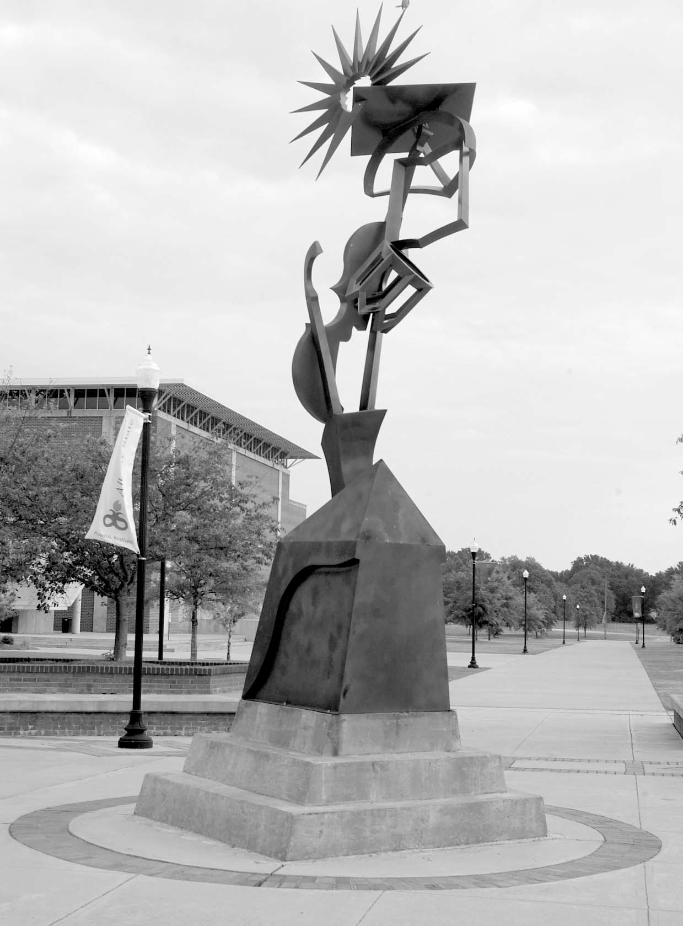

2008-2012 Undergraduate Catalog **3**

**Personnel &Index**

**Sciences &**

**Health**

**Professions**

**Course**

**Descriptions**

**Graduate**

**School**

**Education**

**Business**

**Arts & Humanities**

**Albany State**

**Sciences &**

**Health**

**Professions**

**Graduate**

**School**

**Course**

**Descriptions**

**Personnel &Index**

**Albany State**

**Business**

**Education**

**Arts & Humanities**