**Sciences &**

**Health**

**Professions**

**Graduate**

**School**

**Course**

**Descriptions**

**Personnel &Index**

**Albany State**

**Education**

**Business**

**Arts & Humanities**

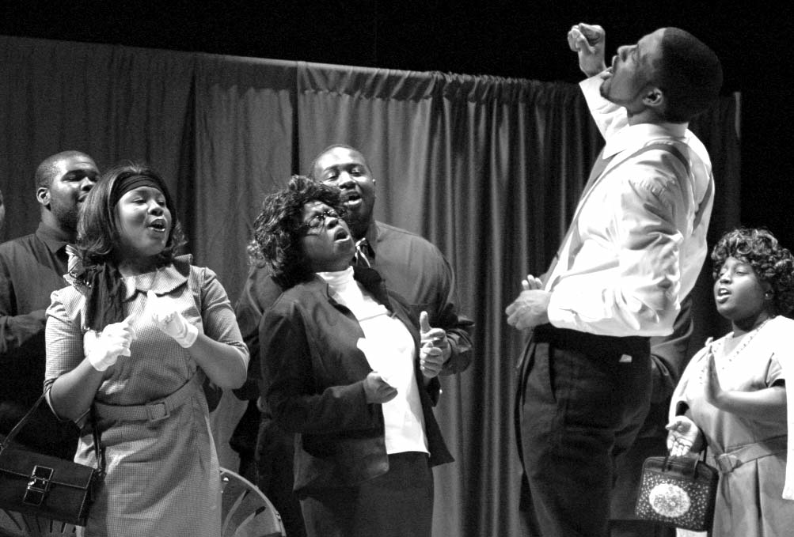

COLLEGE OF ARTS & HUMANITIES

**CONTENTS**

Deoartent of Behavioral Sciences

Department of English and

Modern Languages . . . . . . . . . . . . . . . . . . . . . . . . . . . . . . . . . . . . .68

English Curriculum . . . . . . . . . . . . . . . . . . . . . . . . . . . . . . . . . . . . .69

Spanish Curriculum . . . . . . . . . . . . . . . . . . . . . . . . . . . . . . . . . . . . .71

Mass Communication . . . . . . . . . . . . . . . . . . . . . . . . . . . . . . . . . . .72

Department of Fine Arts . . . . . . . . . . . . . . . . . . . . . . . . . . . . . . . . .75

Arts Curriculum . . . . . . . . . . . . . . . . . . . . . . . . . . . . . . . . . . . . . . .76

Music Curriculum . . . . . . . . . . . . . . . . . . . . . . . . . . . . . . . . . . . . . .77

Speech & Theatre Curriculum . . . . . . . . . . . . . . . . . . . . . . . . . . . .81

Department of History, Political Science

and Public Administration . . . . . . . . . . . . . . . . . . . . . . . . . . . . . . . .84

Minor Programs . . . . . . . . . . . . . . . . . . . . . . . . . . . . . . . . . . . . . . .84

History Curriculum . . . . . . . . . . . . . . . . . . . . . . . . . . . . . . . . . . . . .85

Political Science Curriculum . . . . . . . . . . . . . . . . . . . . . . . . . . . . .87

Social Work

. . . . . . . . . . . . . . . . . . . . . . . . . . . . . . . . . . . . . . .90

Psychology Curriculum . . . . . . . . . . . . . . . . . . . . . . . . . . . . . . . . . .92

Sociology Curriculum . . . . . . . . . . . . . . . . . . . . . . . . . . . . . . . . . . .94

Social Work Curriculum . . . . . . . . . . . . . . . . . . . . . . . . . . . . . . . . .95

**Arts & Humanities**

2008-2012 Undergraduate Catalog **67**

**Personnel &Index**

**Sciences &**

**Health**

**Professions**

**Course**

**Descriptions**

**Graduate**

**School**

**Education**

**Albany State**

**Business**

**Arts & Humanities**

**English & Modern Languages**

COLLEGE OF ARTS & HUMANITIES

**Arts & Humanities**

The College of Arts and Humanities includes the Departments of Behavioral Sciences, English, Modern Languages, Mass Communications, Fine Arts, History and

Political Science, MPA Program and Social Work.

Through the cooperation of several departments, the College of Arts and Humanities also offers training in the area of pre-law.

008-2012 Undergraduate Catalo