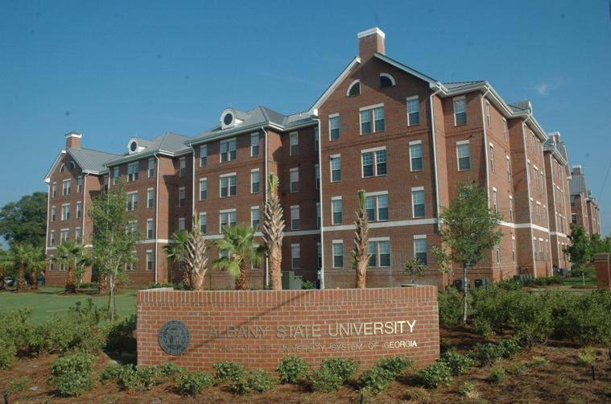



**ALBAALBANY STATE**

**UNIVERSITY**

2011-2012 UNDERGRADUATE CATALOG

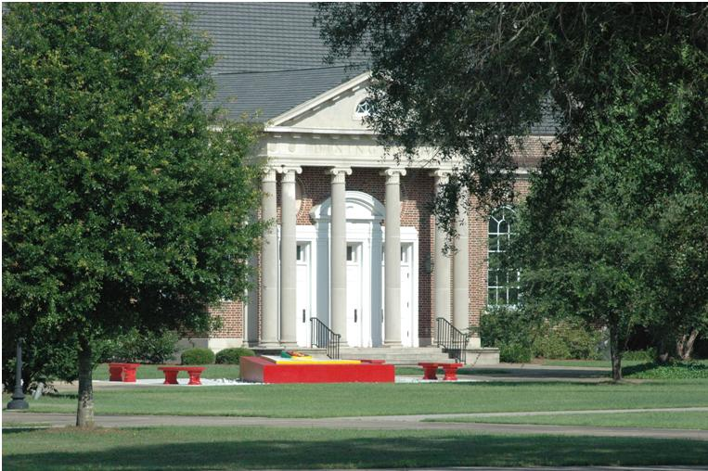

ALBANY STATE UNIVERSITY

Albany State University is an integral part of the University System of GA (USG) governed by the USG Board OF Regents as mandated by the State of Georgia. Albany State University recruits, admits and provides services, financial aid and instruction to all students with- out regard to race, religion, sex, disability or national origin. The University is an affirmative action, equal opportunity employer in all applicants for faculty, staff and student employment positions are considered without regard to race, religion, sex, disability or national origin. The statements set forth in this catalog are for informational purposes only and should not be construed as the basis of a contract between a student and this institution. While provisions of this catalog will ordinarily be applied as stated, Albany State University reserves the right to change any provision listed in this catalog, including but not limited to academic requirements for graduation, without actual notice to individual students. It is especially important that each student note that it is his/her responsibility to keep him/her apprised of current graduation requirements for his/her particular degree program.

Albany State University is an affirmative action, equal opportunity educational institution.

Albany State University Catalog and Announcements (2011) (Official Series)

VOL. XLVII July 2011 No. 1

For Information on Admissions call

(229)430-4646; 1-800-822-RAMS(Georgia only) or

visit the web site at [www.asurams.edu.](http://www.asurams.edu)

*Catalog updates can be viewed @ [www.asurams.edu.](http://www.asurams.edu)

TABLE OF CONTENTS

Mission, History & PROFILE 4

History 6

Profile 7

Accreditation 7

Undergraduate And Graduate Studies 7

The James Pendergrast Memorial Library 7

The Albany State University Alumni Association 7

Fall 2011 Academic Calendar 8

Spring 2012 Academic Calendar 9

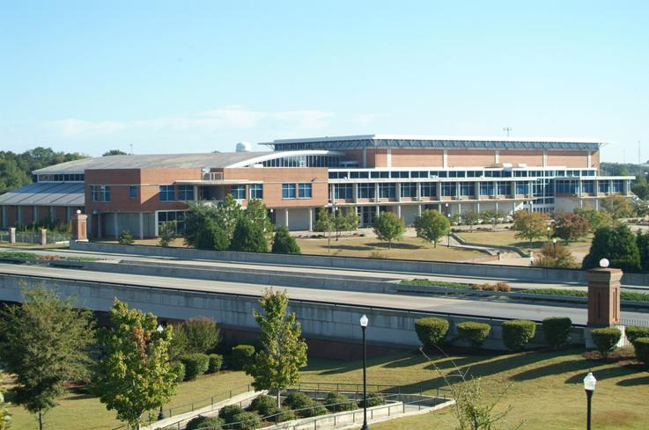

# MISSION, HISTORY

# & PROFILE

**CONTENTS**

Mission, History & PROFILE 4

History 6

Profile 7

Accreditation 7

Undergraduate And Graduate Studies 7

The James Pendergrast Memorial Library 7

The Albany State University Alumni Association 7

Fall 2011 Academic Calendar 8

Spring 2012 Academic Calendar 9

MISSION STATEMENT

Albany State University, an historically black institution in Southwest Georgia, has been a catalyst for change in the region from its inception as the Albany Bible and Manual Training Institute to its designation as a university. Founded in 1903 to educate African American youths, the University proudly continues to fulfill its historic mission while also serving the educational needs of an increasingly diverse student population.

A progressive institution, Albany State University seeks to foster the growth and development of the region, state and nation through teaching, research, creative expression and public service. Through its collaborative efforts, the University responds to the needs of all its constituents and offers educational programs and service to improve the quality of life in Southwest Georgia.

The primary mission of Albany State University is to educate students to become outstanding contributors to society. Offering Bachelor’s, Master’s and Education Specialist degrees and a variety of non-degree educational programs, the University emphasizes the liberal arts as the foundation for all learning by exposing students to the humanities, fine arts, social sciences and the sciences. Global learning is fostered through a broad-based curriculum, diverse University activities and the expanding use of technology.

A leader in teacher education, nursing, criminal justice, business, public administration and the sciences, Albany State provides a comprehensive educational experience with quality instruction as the hallmark of all its academic programs. The University embraces the concept of “students first” as a core institutional value and is committed to “education on a personal level.” The University advocates the total development of students, especially the underserved, and provides a wholesome academic environment in which students can study, learn and develop through their interaction with fellow students, faculty, staff, administrators, visiting scholars and community leaders. Consistent with the core mission of the University System of Georgia, Albany State University exhibits the following characteristics:

* A supportive campus climate, necessary services, and leadership and development opportunities, all to educate the whole person and meet the needs of students, faculty and staff;
* Cultural, ethnic, racial, and gender diversity in the faculty, staff and student body, supported by practices and programs that embody the ideals of an open, democratic and global society;
* Technology to advance educational purposes, including instructional technology, student support services and distance education;
* Collaborative relationships with other system Institutions, state agencies, local schools and technical institutes, and business and industry, sharing physical, human, information, and other resources to expand and enhance programs and services to the citizens of Georgia.
* With other state universities in the University System of Georgia, Albany State University shares:
* A commitment to excellence and responsiveness within a scope of influence defined by the needs of an area of the state, and by particularly outstanding programs or distinctive characteristics that have a magnet effect throughout the region or state;
* A commitment to a teaching/learning environment, both inside and outside the classroom, that sustains instructional excellence, serves a diverse and college-prepared student body, promotes high levels of student achievement, offers academic assistance, and provides developmental studies programs for a limited student cohort;
* A high quality general education program supporting a variety of disciplinary, interdisciplinary, and professional academic programming at the baccalaureate level, with selected Master’s and Education Specialist degrees, and selected Associate degree programs based on area need and/or inter-institutional collaborations;
* Improving the quality of life of African-American males via the educational, research, intervention and service programs coordinated through the Center for the African-American Male.
* A commitment to public service, continuing education, technical assistance, and economic development activities that address the needs, improve the quality of life, and raise the educational level within the University’s scope of influence;
* A commitment to scholarly and creative work to enhance instructional effectiveness and to encourage faculty scholarly pursuits, and a commitment to applied research in selected areas of institutional strength and area need. While Albany State University shares much in common with other state universities, it is dedicated to preparing leaders for underserved populations and is committed to the following distinctive purposes:
* Providing quality educational experiences for underserved populations in the region, state and nation;
* Promoting and preserving the historical and culturally distinctive traditions which define African American culture;
* Offering of a comprehensive array of programs in health care services, community development, human disabilities, cultural enhancement, business and economic development, international trade and entrepreneurship;
* Graduating marketable students not only through technologically advanced academic programs but also through undergraduate research, studies abroad, internships, service learning and developmental pre-professional experiences;
* Improving the quality of life of African-American males via the educational, research, intervention and service programs coordinated through the Center for the African-American Male.

## HISTORY

Albany State University, established originally as the Albany Bible and Manual Training Institute and supported by private and religious organizations, was founded in 1903 by Joseph Winthrop Holley. The Institute provided religious and manual training for African American youths of Southwest Georgia. The mission was to train teachers to teach basic academic skills and to train in the trades and industries, with special emphasis on domestic science and art. The Institute remained a privately supported Institution until 1917.

In 1917, the Institute became a state-supported, two-year college with a Board of Trustees, and its name was changed to Georgia Normal and Agricultural College. Offering only a limited program in agriculture, the College viewed as its primary purpose the training of elementary teachers. In 1932, the Board of Regents was established, and the college became a part of the newly established University System of Georgia.

In order to meet the changing needs of society, the mission of the College was expanded in 1943, and the College was granted four-year status and authorized to confer the bachelor’s degree in elementary education and home economics. At this time, the College assumed the name Albany State College. Six years later, the program of the College was again expanded to include offerings in the arts and sciences, with majors in the humanities and social studies.

Beginning in 1954, secondary-level programs were developed for teacher preparation in science, health and physical education, business, music, mathematics and natural sciences. The College continued to experience growth and development and was authorized in 1961 to offer a four-year degree program in nursing.

Always striving to address the educational needs of the time, the graduate program, a cooperative effort with Georgia State University, was added to the curriculum during the fall of 1972. Under this program, master’s degrees were offered in business education, mathematics education, elementary education, English education, health and physical education, music education and science education (biology, chemistry and physics). In the spring of 1975, a master’s degree in business administration, through Valdosta State College, was added to the graduate program.

During the decade of the ’70s, the number of faculty earning the doctorate degree increased by more than fifty percent, and in September 1981, the College began offering a graduate program designed and delivered solely by faculty and staff of Albany State College. Master’s degrees in business administration and education were offered. Since then criminal justice, nursing and public administration have been added.

Albany State College was granted university status in July 1996, and the name of the Institution was changed to Albany State University. Dur- ing this impressive growth and development, the University has been guided by the following presidents:

|  |  |
| --- | --- |
| **Joseph Winthrop Holley, D.D., LL.D.** (1903-1943)  **Aaron Brown, Ph.D., LL.D., Ed.D.** (1943-1953)  **William H. Dennis, LL.D.** (1953-1965)  **Thomas Miller Jenkins, J.D., LL.D.** (1965-1969) | **Charles L. Hayes, Ed.D.** (1969-1980)  **Billy C. Black, Ph.D.** (1980-1996)  **Portia Holmes Shields, Ph.D.** (1996-2005)  **Everette J. Freeman, Ed.D., M.A., B.A.,** (2005 – Present) |

## PROFILE

## ACCREDITATION

Albany State University is accredited by the Commission on Colleges of the Southern Association of Colleges and Schools (1866 Southern Lane, Decatur, Georgia 30033-4097: Telephone number 404-679-4501) to award Bachelor’s, Master’s and Education Specialist degrees. Albany State University is also accredited by the National Council for Accreditation of Teacher Education, the Georgia Professional Standards Commission, the Association of Collegiate Business Schools and Programs, the National League for Nursing, the Georgia Board of Nursing, and Council on Social Work Education. Individual colleges and departments also hold memberships in the regional and national professional organizations associated with the respective discipline.

## UNDERGRADUATE AND GRADUATE STUDIES

The ASU Undergraduate Curriculum includes studies in various disciplines through the college of Arts and Humanities, the College of Business, the College of Education and the College of Science & Health Professions. The University offers graduate studies leading to the Master of Education degree (M.Ed.), Master of Business Administration degree (M.B.A.), the Masters of Science in Criminal Justice degree (M.S.), the Master of Public Administration degree (M.P.A.), the Master of Science degree in Nursing (M.S.N.) and the Specialist degree in Educational Administration (Ed.S.).

## THE JAMES PENDERGRAST MEMORIAL LIBRARY

The James Pendergrast Memorial Library is a modern, 73,000 square foot facility, which opened in 1994, and seats more than 900. It features Galileo Labs, study areas, a large lecture room, the Office of OIIT, NASA/SEMMA Lab and the Curriculum Resource Center are all housed in the Library. The six million dollar building houses more than 199,196 volumes and subscriptions to 268 periodicals. The library collection includes print and electronic journals, monographs, microfiche collection, including the ERIC DOCUMENT collection on microfiche. The library has an automated library system called ExLibris/Voyager which includes cataloging, circulation, serials, acquisitions and a public catalog module. Special collections include books by and about African Americans, Black Literature and books written by Dr. Joseph Winthrop Holley, founder of the University.

The library maintains an extensive microfiche collection, including the Full ERIC DOCUMENT collection on microfiche. The library has an automated library system called Voyager which includes cataloging, circulation, serials, acquisitions and a public catalog. Special collections include Black Literature, and books written by Dr. Joseph Winthrop Holley, founder of the University.

The James Pendergrast Memorial Library supports Albany State University’s academic programs. It supports the achievement of the goals as stated in the mission of the University through providing information resources, instructional materials, and access to research. It aids Albany State University in serving a regional role in Southwest Georgia in the area of library resources. The Library’s on-line public catalog GIL (Galileo Interconnected Libraries) also referred to as the RAMCAT is available from any remote site to all who have internet connection. The location is <http://gil.asurams.edu>. GIL also offers remote access to other libraries in the University System of Georgia.

The library has a strong virtual collection that includes Galileo which is a collection of many databases indexing thousands of periodicals and scholarly journals. Over 2,000 journals titles are full-text. Other resources include EBSCO Host, Interlibrary Loan and GIL Express which provides online borrowing of books for universal borrowing between other institutions in the University System of Georgia.

THE ALBANY STATE UNIVERSITY ALUMNI ASSOCIATION

The Alumni Association of Albany State University is a composite group of graduates and former students as well as friends of the University who are associate members. The organization exists to support and promote the interests of the University. The Alumni Association is organized on a local, state, regional and national basis. It has a resident office and a full-time Director of Alumni Affairs/Executive Secretary who

|  |  |
| --- | --- |
| June 1 | Deadline to apply for Admission and Readmission for Fall Semester |
| August 3-5 | Faculty and Staff Institute |
| August 6 | Residence Halls open for new students (First-time Freshmen/Transfer) 7:00 a.m. - 5:00 p.m. |
| August 8 | Compass Testing, 8:00 a.m. - 5:00 p.m. |
| August 9 | New Student Orientation for students and parents begins at 8:00 a.m.—Noon.  Academic advisement & registration for new students & transfers (August new student orientation participants only) 1:00 p.m. –5:00 p.m.  Freshman induction begins at 7:00 p.m. |
| August 9-14 | Welcome Week for New Residential Students |
| August 10 | New Student Registration (8:00 a.m. - 5:00 p.m.) |
| August 11-12 | Registration continues for all students (on campus and on web) |
| August 12-13 | Residence Halls check-in 10:00 a.m. -10:00 p.m. for returning students. (Students that have failed to reserve late check-in and have not checked in by August 13 will be deemed no-shows and are subject to losing their room assignment). |
| August 15 | Classes begin for Full Term and A Term Online; Faculty begin ongoing Attendance Verification Process |
| August 15-17 | Drop/add for Full Term and A Term Online classes. Classes cannot be added after August 17. No refund will be made for classes voluntarily dropped after August 17. (This does not apply to withdrawals from school). |
| August 18 | Fee payment deadline (by 4:00 p.m.) for registered classes |
|  | Faculty Attendance Verification Deadline for Full session and A Term classes |
| September 5 | Labor Day Holiday |
| September 6 | Traditional Classes resume |
| September 14-15 | Graduation Fair - 10:00 a.m.- 4:00 p.m. Reese Student Union |
| September 15 | Deadline to apply for graduation and pay graduation fee |
|  | Last Day to drop A Term Online Classes with a grade of "W" |
| October 3 | Classes end for A Term Online |
| October 4 | Grades due in Banner for A Term Online Classes by 3:00 p.m. Classes Begin for B Term Online |
| October 4-5 | Mid-term examinations Full Session |
| October 7 | Faculty Attendance Verification Deadline for B Term classes |
|  | Mid-term grades for all students due in Banner by 3:00 p.m. |
| October 12 | Last day to drop a course and withdraw from school with a grade of "W" by 5:00 p.m. for Full Term Classes |
| TBA | Regents' Test Dates |
| October 23-29 | Homecoming Week --  **(Homecoming - October 29)** |
| October 26 | Last day to Drop B Term Online Classes with a grade of "W" |
| November 7-11 | Advisement for Spring Semester |
| November 14-18 | Registration for Spring Semester |
| November 1 | Deadline to apply for Admission and Readmission for Spring Semester |
| November 15 | Deadline to apply for Degree Audit |
|  | Deadline to remove "I" and "IP" grades before automatic "F" |
| November 23-27 | Thanksgiving Holidays |
| November 28 | Traditional Classes resume |
| December 2 | Classes end |
| December 3,5, 6, & 7 | **FINAL EXAMINATIONS FOR END OF TERM FOR ALL STUDENTS** |
| December 8 | Residence hall check-out (late check-out begins at 3:00 p.m.); prior approval required for late check out or improper check out fee charged (fines begin after 3:00 p.m. without prior approval). |
| December 9 | **END OF TERM GRADES DUE IN BANNER BY 3:00 P.M. FOR ALL STUDENTS** |
| December 10 | Commencement 9:45 a.m. Albany James H. Gray Civic Center |
| December 16 | Deadline to file Repeat Policy Application for courses repeated Fall Semester. Any forms submitted after the deadline will not be processed. |
| **See page** **49** **of the undergraduate catalogue (on web) for "WF" policy after the 16 credit hour limit.** | |
| Albany State University reserves the right to make changes to the Academic Calendar when necessary. | |

**Office of Academic Services and Registrar**

## Fall 2011 Academic Calendar

**Office of Academic Services and Registrar**

## Spring 2012 Academic Calendar