**Statistics: The Science of Decisions Project**

**Wenke Huang**

Question 1:

Based on the background information, we can read that our independent variable is congruence while our dependent variable is the time that it takes to name the color.

Question 2:

**Null Hypothesis**: The population mean time that we need to read words under congruent and incongruent conditions are the same. (mu_C = mu_I)

**Alternative Hypothesis**: The population mean time that we need to read words under congruent condition is less than the population mean time that we need under incongruent condition. (mu_C < mu_I)

Here, mu_C and mu_I stand for the population mean time that we need to read words under congruent and incongruent conditions, respectively. They do not stand for sample mean values directly, but the sample means are unbiased estimations of population means.

I would like to choose t-test here since we have no access to the population standard deviation in this case. This will be the two-sampled one-tailed paired t-test with sample size being 24. Because the alternative hypothesis that we focus on is being “less than” instead of being “not equal to”. The distributions of these samples basically follow normal distribution, and details will be discussed in the following two parts.

Question 3:

We calculate the mean, median, standard deviation (std) and total count (n) here. The results are listed below.

|  |  |  |
| --- | --- | --- |
|  | Congruent | Incongruent |
| mean | 14.051125 | 22.01591667 |
| median | 14.3565 | 21.0175 |
| std | 3.559357958 | 4.797057122 |
| n | 24 | 24 |

Where the mean and median measure the central tendency while standard deviation measures the variability. These three statistics will also be useful when we calculate our t-statistic.

Question 4:

We would like to perform the histograms with density instead of count here. Additionally, since we would like to check if these may follow the normal distributions, we also add the normal distribution curve. The mean and standard deviation of these curve are the mean and standard deviation that we have calculated in the previous part.

Package “ggplot2” from R will help us obtain the plots that we want.

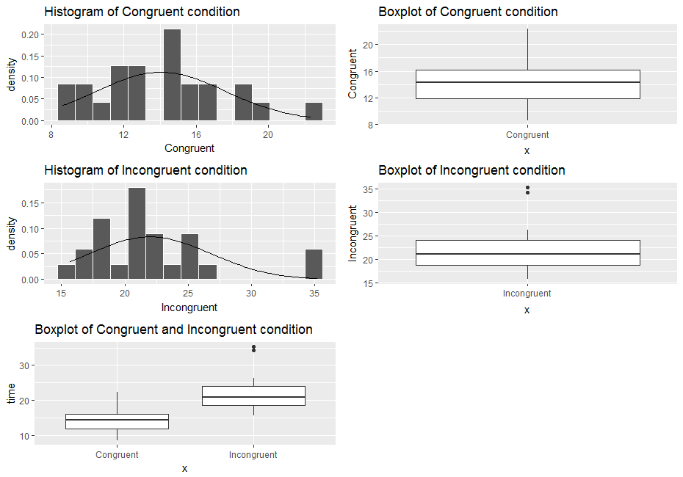

The plots are listed above. We can see that only around 4% of the points of “Congruent” are greater than 20 while approximately 7% of the points of “Incongruent” are greater than 33. I think that both can be considered following the normal distribution. Because we can see the trend of that the frequency tends to be higher in the middle and lower at two tails. With more possible points, I believe that the normal trend will be more obvious.

From the individual boxplots, we notice that there are several outliers under the incongruent condition with extremely long time. The comparison between these two conditions shows obvious difference between groups. Because the maximum value of congruent condition is almost equal to the median of incongruent condition.

Question 5:

Firstly, we calculated the difference values of congruent and incongruent conditions. Based on these, we can find the mean and standard deviation which are -7.965 and 4.865, respectively.

Secondly, we would like to find the standard error here. After calculation, we got it to be 0.993. Based on it, we can get our t-statistic -8.021.

We would like to set our significance level alpha to be 0.05 here. With the degree of freedom being 23, we have our one-tailed critical value being -1.714. Since our t value -8.021 is much less than -1.714, we would like to reject the null hypothesis. If we would like to calculate the p value, we will get 0.0001 which is also much less than 0.05. The conclusion of rejecting our null hypothesis will remain the same.

Hence, we will think that the it does take much longer to read under incongruent condition than under congruent condition.

Question 6:

I think this may result from whether our brains are more sensitive to textual information or the information of less direct features. Maybe there exist the hierarchy of processing different types of information in our brain.

We may think another experiment. We will tell the participants several numbers, like 1, 2, and 3. At the same time, we also show the participants some numbers which may not be the same one that they are hearing, like 2, 3, and 4. Under congruent condition, what they see and hear will match each other. Under incongruent condition, what they see and hear may not match each other exactly.

Reference:

1. Stroop effect, Wikipedia, <https://en.wikipedia.org/wiki/Stroop_effect>