Willy Husted

9/25/14

CMSI 370

Usability Metrics and Heuristic Evaluation

iOS 7 Usability Statistics

|  |  |  |  |  |  |  |  |  |  |
| --- | --- | --- | --- | --- | --- | --- | --- | --- | --- |
| Name | Task | Efficiency | Errors | Satisfaction |  |  |  | | |
|  |  |  |  |  |  |  | iOS 7 (iPhone 5s)  ————————————  Efficiency Errors Satisfaction  ———————————— Turn Wi-Fi off and on  Create contact  Add new clock for Port-au-Prince | |  |
| Willy | Wi-Fi | 6.4 | 0 | 10 |  |  |  |
|  | Clock | 10.9 | 0 | 9 |  |  |  |
|  | Contact | 16.3 | 0 | 8 |  |  |  |
|  |  |  |  |  |  |  |  |
| Pete | Wi-Fi | 6.6 | 0 | 9 |  |  |  |
|  | Clock | 13.4 | 1 | 7 |  |  |  |
|  | Contact | 22.2 | 1 | 7 |  |  |  |
|  |  |  |  |  |  |  |  |  |  |
| Maurice | Wi-Fi | 5.1 | 0 | 7 |  |  |  |  |  |
|  | Clock | 18.8 | 1 | 5 |  |  |  |  |  |
|  | Contact | 32.3 | 4 | 8 |  |  |  |  |  |
|  |  |  |  |  |  |  |  |  |  |
| Zane | Wi-Fi | 6.2 | 1 | 10 |  |  |  |  |  |
|  | Clock | 9.6 | 1 | 10 |  |  |  |  |  |
|  | Contact | 25.9 | 1 | 8 |  |  |  |  |  |
|  |  |  |  |  |  |  |  |  |  |
| Jackson | Wi-Fi | 5.1 | 0 | 10 |  |  |  |  |  |
|  | Clock | 9.5 | 1 | 10 |  |  |  |  |  |
|  | Contact | 29.5 | 3 | 5 |  |  |  |  |  |
|  |  |  |  |  |  |  |  |  |  |
| Josh | Wi-Fi | 2.6 | 0 | 10 |  |  |  |  |  |
|  | Clock | 9.31 | 0 | 8 |  |  |  |  |  |
|  | Contact | 15.76 | 0 | 9 |  |  |  |  |  |
|  |  |  |  |  |  |  |  |  |  |
| Greg | Wi-Fi | 2.7 | 0 | 10 |  |  |  |  |  |
|  | Clock | 12.54 | 0 | 6 |  |  |  |  |  |
|  | Contact | 25.38 | 2 | 6 |  |  |  |  |  |
|  |  |  |  |  |  |  |  |  |  |
| Ed | Wi-Fi | 4.8 | 0 | 10 |  |  |  |  |  |
|  | Clock | 11 | 0 | 8 |  |  |  |  |  |
|  | Contact | 16.5 | 0 | 9 |  |  |  |  |  |
|  |  |  |  |  |  |  |  |  |  |

|  |  |  |  |  |  |  |  |  |  |
| --- | --- | --- | --- | --- | --- | --- | --- | --- | --- |
| John | Wi-Fi | 5.2 | 0 | 9 |  |  |  |  |  |
|  | Clock | 12.2 | 0 | 7 |  |  |  |  |  |
|  | Contact | 19.7 | 1 | 7 |  |  |  |  |  |
|  |  |  |  |  |  |  |  |  |  |
| Katie | Wi-Fi | 7.1 | 1 | 10 |  |  |  |  |  |
|  | Clock | 14.2 | 1 | 10 |  |  |  |  |  |
|  | Contact | 18.4 | 0 | 9 |  |  |  |  |  |

Android Usability Statistics

|  |  |  |  |  |  |  |  |  |  |
| --- | --- | --- | --- | --- | --- | --- | --- | --- | --- |
| Name | Task | Efficiency | Errors | Satisfaction |  |  |  | | |
|  |  |  |  |  |  |  | Android (Nexus 4)  ————————————  Efficiency Errors Satisfaction  ————————————  Turn Wi-Fi off and on  Create contact  Add new clock for Port-au-Prince | |  |
| Akers | Wi-Fi | 6 | 0 | 6 |  |  | 4) |
|  | Clock | 9.7 | 0 | 9 |  |  |  |
|  | Contact | 22.4 | 1 | 9 |  |  |  |
|  |  |  |  |  |  |  |  |
| Joaquin | Wi-Fi | 7.3 | 0 | 7 |  |  |  |
|  | Clock | 31.4 | 13 | 4 |  |  |  |
|  | Contact | 27.6 | 1 | 5 |  |  | e, Haiti |
|  |  |  |  |  |  |  |  |  |  |
| Gaston | Wi-Fi | 10.9 | 1 | 5 |  |  |  |  |  |
|  | Clock | 23.4 | 1 | 7 |  |  |  |  |  |
|  | Contact | 30.6 | 5 | 3 |  |  |  |  |  |
|  |  |  |  |  |  |  |  |  |  |
| Jordan | Wi-Fi | 6.8 | 1 | 8 |  |  |  |  |  |
|  | Clock | 22.8 | 5 | 5 |  |  |  |  |  |
|  | Contact | 15.1 | 1 | 7 |  |  |  |  |  |
|  |  |  |  |  |  |  |  |  |  |
| Armand | Wi-Fi | 7.6 | 1 | 8 |  |  |  |  |  |
|  | Clock | 16.6 | 3 | 8 |  |  |  |  |  |
|  | Contact | 25.9 | 1 | 6 |  |  |  |  |  |
|  |  |  |  |  |  |  |  |  |  |
| Jake | Wi-Fi | 6.5 | 0 | 8 |  |  |  |  |  |
|  | Clock | 36.6 | 4 | 3 |  |  |  |  |  |
|  | Contact | 25.9 | 1 | 7 |  |  |  |  |  |
|  |  |  |  |  |  |  |  |  |  |
| Hannah | Wi-Fi | 38.1 | 3 | 7 |  |  |  |  |  |
|  | Clock | 20 | 2 | 7 |  |  |  |  |  |
|  | Contact | 21.7 | 2 | 7 |  |  |  |  |  |
|  |  |  |  |  |  |  |  |  |  |
| Matt | Wi-Fi | 6.5 | 0 | 10 |  |  |  |  |  |
|  | Clock | 20.5 | 1 | 10 |  |  |  |  |  |
|  | Contact | 21 | 0 | 10 |  |  |  |  |  |
|  |  |  |  |  |  |  |  |  |  |
| Sierra | Wi-Fi | 4.7 | 0 | 10 |  |  |  |  |  |
|  | Clock | 13.5 | 0 | 9 |  |  |  |  |  |
|  | Contact | 22.2 | 0 | 10 |  |  |  |  |  |
|  |  |  |  |  |  |  |  |  |  |
| Ed | Wi-Fi | 5.3 | 0 | 10 |  |  |  |  |  |
|  | Clock | 19.8 | 0 | 9 |  |  |  |  |  |
|  | Contact | 18 | 0 | 10 |  |  |  |  |  |

I. Usability Metrics

In order to test the usability of the two most popular mobile platforms—iOS and Android—we had to first decide which metrics to test. The standard ones for interaction design include: learnability, efficiency, errors, memorability, and satisfaction. The popularity of frequent use of mobile phones prevented us from being able to assess either learnability (everyone we tested was a proficient user) or memorability (people use their phones too often to ever forget how!). Therefore, we decided as a team to test the metrics of efficiency, errors, and satisfaction.

After our study, I determine that iOS performed better than Android, particularly due to the overall better efficiency iOS had. On average, the tasks took less time on iOS than Android. As an aspiring engineer, I value efficiency of a device very highly; I see it as the best indicator of usability. Errors are the second most highly valued, but at times human errors can be confused as device-usability errors, giving this metric slightly less emphasis. This makes errors not quite as reliable of a metric for determining usability. The metric with the lowest priority is satisfaction because it is so subjective; however, I did notice a correlation between efficiency and satisfaction.

II. Heuristic Evaluation

I will use Bruce Tognazzini’s first principles of interaction design to explain why iOS outperformed Android. While I will not be referencing all of them, a full list of his principles can be found here: http://asktog.com/atc/principles-of-interaction-design/

One of Tognazzini’s first principles is consistency. He defines his principle of in-house consistency, suggesting that one ought to “maintain a general look & feel across your products/services.” I argue that iOS aligned with this principle more closely than Android. Android primarily uses the upper left corner of the screen to navigate backwards. In other words, whatever view you previously saw can often be returned to by tapping the upper left corner. It is generally accompanied by a < symbol, a good indicator that you will be going back. For example, see the phone and clock apps:

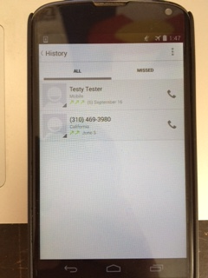 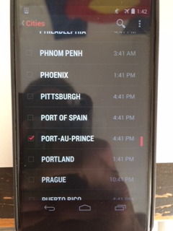

Phone app Clock app

One view that goes against this consistency is when creating a new contact. Instead of a < symbol to indicate a return to the previous screen, it is replaced by the word “DONE” and a checkmark. Observing the participants in the study, I noticed many of them were confused by this change in lexicon and were not certain where to confirm the new contact created. They became familiar with the upper left corner as a “navigate backward” button, so many participants did not look at that button as a “confirm” button.

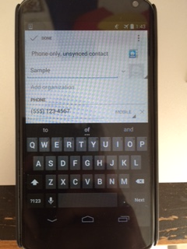

Creating a new contact

iOS more closely follows Tognazzini’s principle of consistency by using the upper right of the screen and a + symbol to indicate an addition to the current app. For example, the clock and phone app—both of which were used in this study—utilize this format.

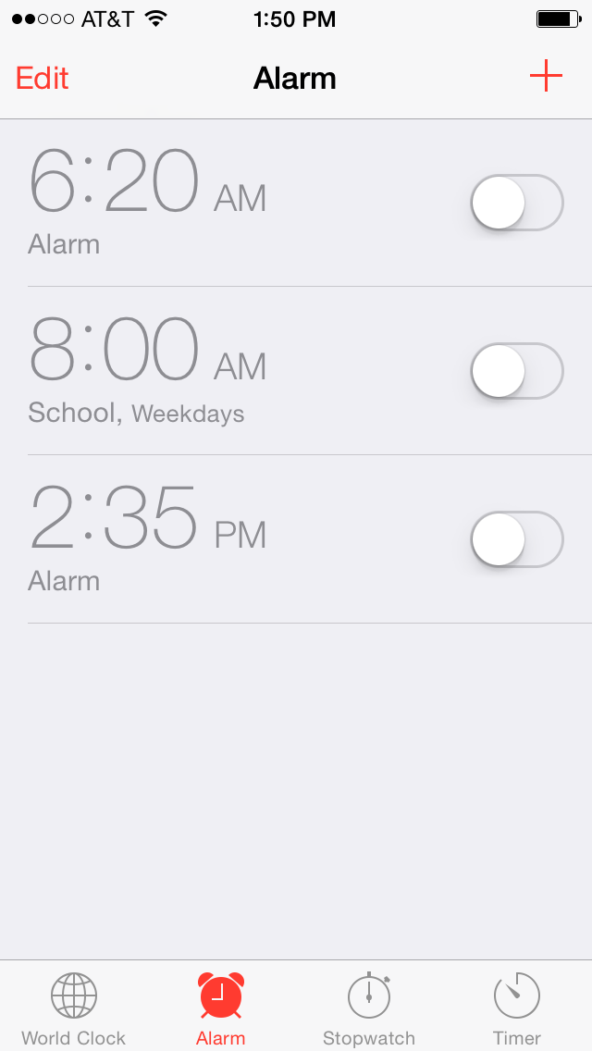 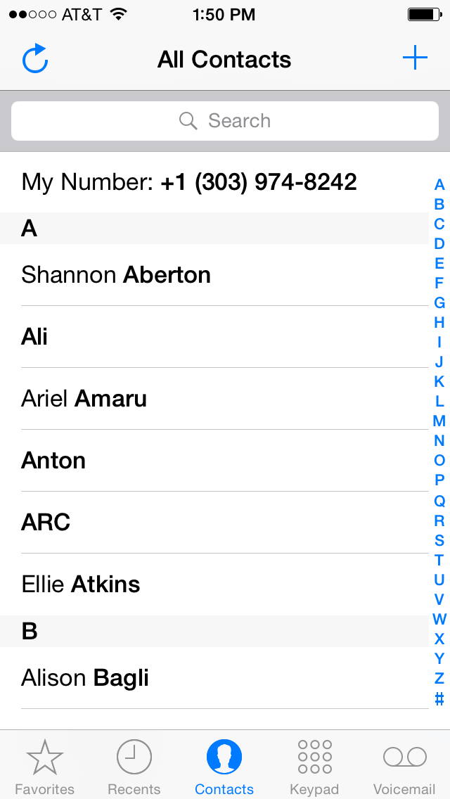

Clock app Phone app

After giving users the task of adding Port-au-Prince to the clock app, they were instantly familiar with the + symbol in the upper right indicating an addition to the current app (if they had not been familiar already). Therefore, when asked to create a new contact, users could trust the + symbol in the phone app to perform a similar task as in the clock app. Though not a perfect comparison to the navigation design in Android, this shows that iOS follows Tognazzini’s principle of consistency more closely than Android, providing one reason why iOS performed better.

Another one of Tognazzini’s principles is use of metaphors, which iOS again utilizes better than Android. Tognazzini defines his principle: “Choose metaphors that will enable users to instantly grasp the finest details of the conceptual model.” This is a fairly broad concept, so I will highlight a more specific part of his principle, in which he says: “Good metaphors generate in the users’ minds a strong series of connections to past experiences from the real world…” In the case of dropdown and pull-up menus, iOS more closely emulates “experiences from the real world” than Android.

Both Android and iOS have shortcuts for performing the task of turning Wi-Fi off and on. On Android, a user may pull down from the top of the screen to get a drop-down menu, and then the Wi-Fi toggle is just a few clicks away. iOS has a similar schema, except the Wi-Fi toggle can instead be found in a pull-up menu, accessed by swiping up from the bottom of the screen. On Android, the dropdown menu fully covers the screen. One can just barely see the faint outline of the screen that was just covered, giving the subtle clue that there is something (the previous screen) “behind” the current dropdown menu. With iOS’s pull-up menu, this notion is much clearer, as seen in the figures below:

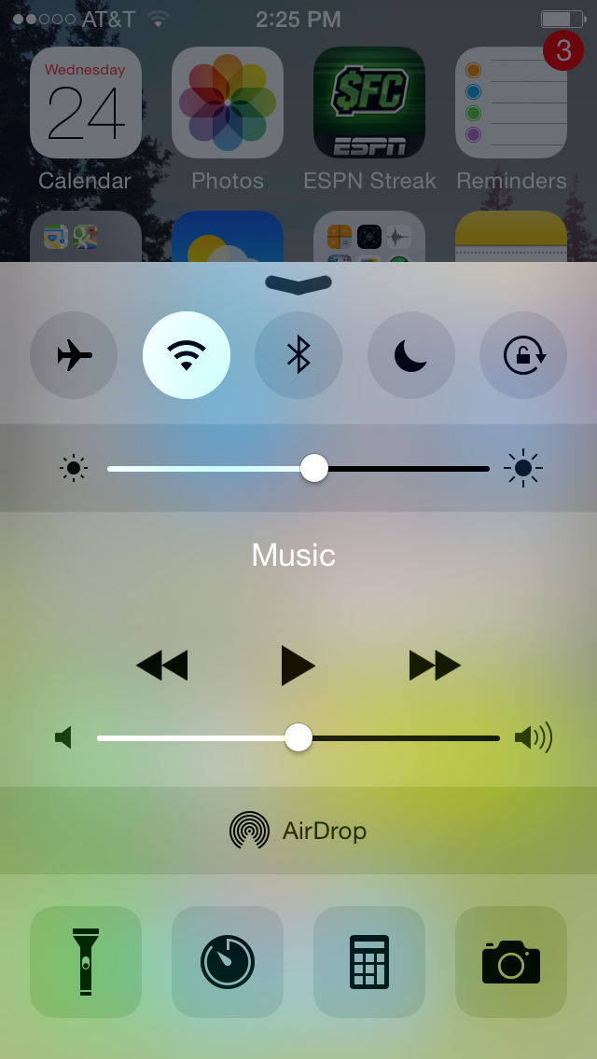

iOS

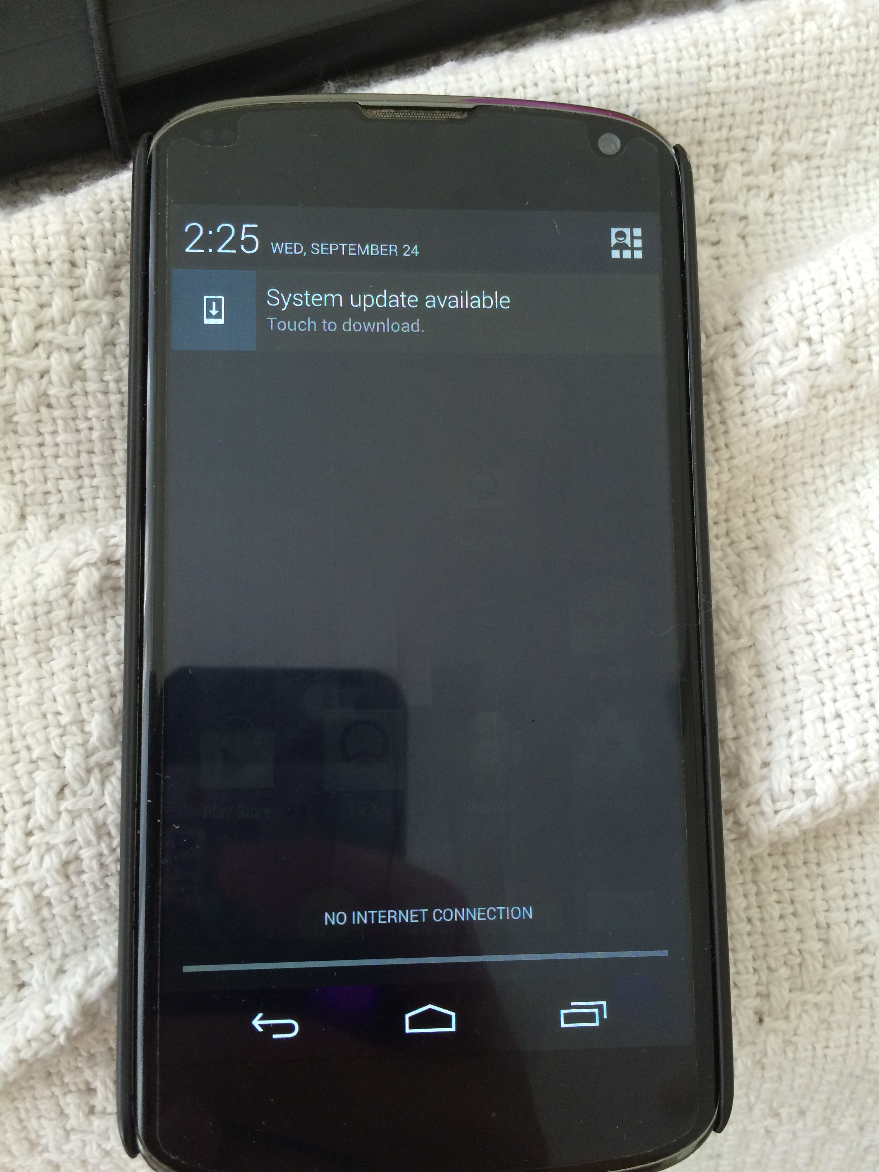

Android

iOS does two important things to provide the real-life feeling of something behind the menu. One, the menu does not fully cover the screen, so the top part of the previous screen can be seen (although it is dimmed to show that it is not currently the main focus). The second iOS design that separates it from Android’s dropdowns is the use of translucency. iOS designers chose to blur the background of the pull-up menu. This design reflects Tognazinni’s metaphor guideline, as it reminds the user of the real-life experience of a tinted window. It makes it clear that, while the things in the background—apps, in the case of the screenshot above—are not the main focus, they are still there and can be accessed if the current menu is dismissed.

Bruce Tognazzini has nineteen first principles, but consistency and use of metaphors are the two that most accurately explain why iOS outperformed Android in our study. The differences were subtle: for example, Android’s dropdown menu used the idea of translucency in alignment with Tognazzini’s metaphors principle, but iOS simply did it better. It is no surprise that the two leading platforms of the smart phone market align with most—if not all—of Tognazzini’s principles. But the little details matter greatly, and may offer insight as to why iOS was the clear winner in our study.