Willy Husted

I/O and File “Gymnastics”

1. ssh -L 8008:10.22.210.221:8000 whusted@my.cs.lmu.edu

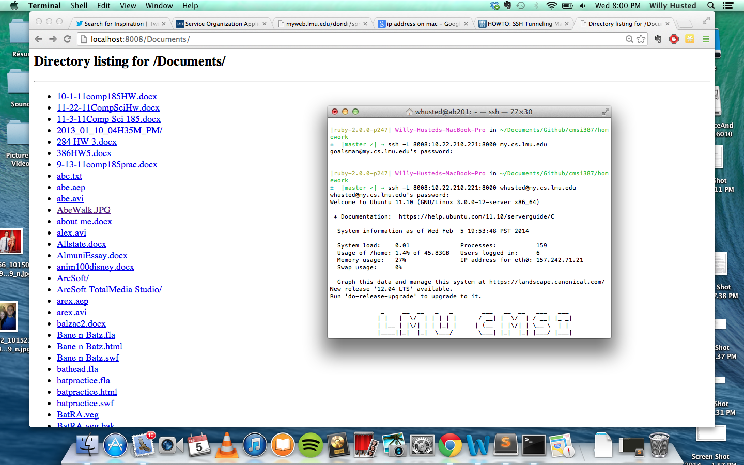

2. commands used, in order:

ssh whusted@my.cs.lmu.edu

screen

ping facebook.com

ctrl –ad (used to detach screen)

(logout of my.cs.lmu.edu)

(log back in)

screen –r

Screen shots:

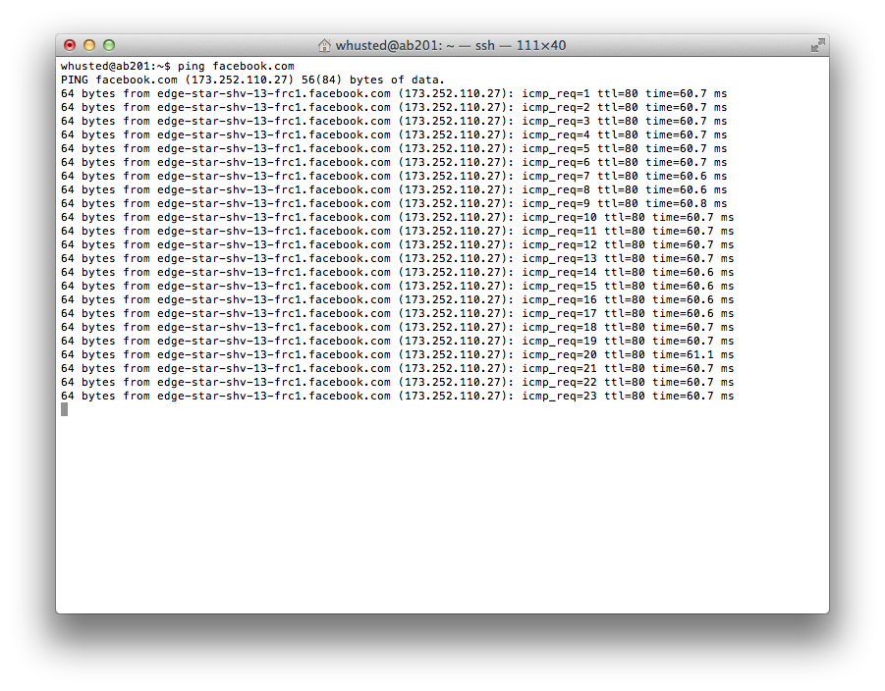

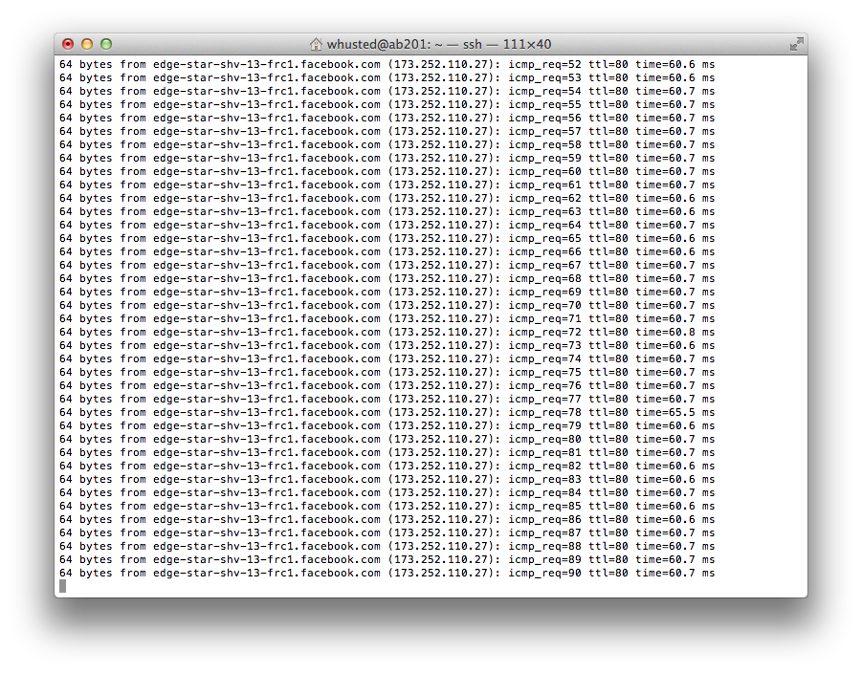

3.

a.) du –d 1 –h | sort -r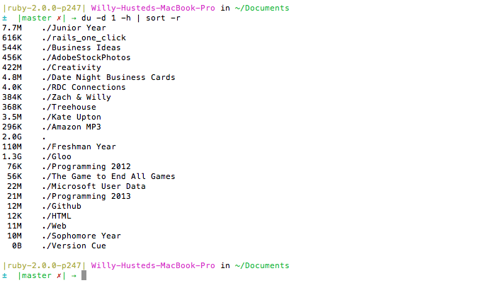

b.) du | grep –e o[a-z]\*o