**Question 1**

The C program *paretodnes.c* is attached in the Appendix. We use the following code to compile it.

gcc paretodens.c -o paretodens -lm -Wall -pedantic

In this way we have generated an executable file called *paretodens.* Run this program, the following window will pop up. Users will enter the values of x, alpha and beta for pareto distribution one by one.

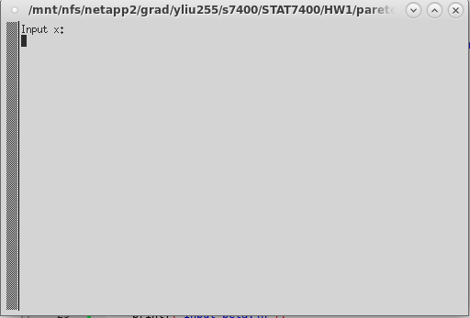

Three sets of values are used to test it.

1. x = 4, alpha = 2, beta = 3

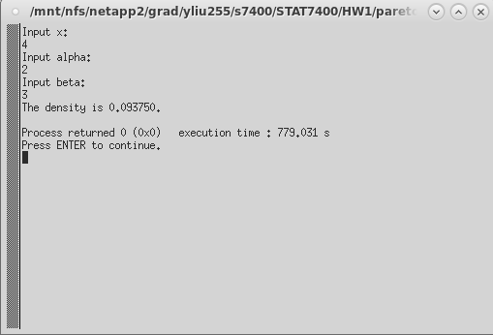

1. x = 4, alpha = 5, beta = 3

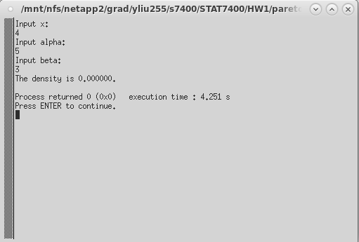

1. x = 4, alpha = 2, beta = -3

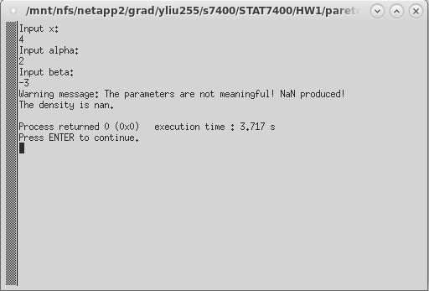

**Question 2**

The R program *dpareto.r* is as follows.

dpareto <- function(x,alpha,beta){

#Calculate the maximum length of inputs

L <- max(length(x), length(alpha), length(beta))

#Align all the inputs

x <- rep(x,length.out = L)

alpha <- rep(alpha,length.out = L)

beta <- rep(beta,length.out = L)

#Initialize the densities with NaN

dens <- rep(NaN, length.out = L)

for (i in 1:L){

if (alpha[i] <= 0 || beta[i] <= 0){

warning("NaNs produced")

next

} else if (x[i] < alpha[i]){

dens[i] <- 0

} else{

dens[i] <- beta[i]*alpha[i]^beta[i]/x[i]^(beta[i]+1)

}

}

return(dens)

}

I use the following set of values to test it.

* x = c(4,4,4)
* alpha = c(2,5,2)
* beta = c(3,3,-3)

The results are as follows.

> dpareto(c(4,4,4),c(2,5,2),c(3,3,-3))

[1] 0.09375 0.00000 NaN

Warning message:

In dpareto(c(4, 4, 4), c(2, 5, 2), c(3, 3, -3)) : NaNs produced

Then I use this function to plot the density in R. Two sets of parameters are used.

1. alpha = 1, beta = 1

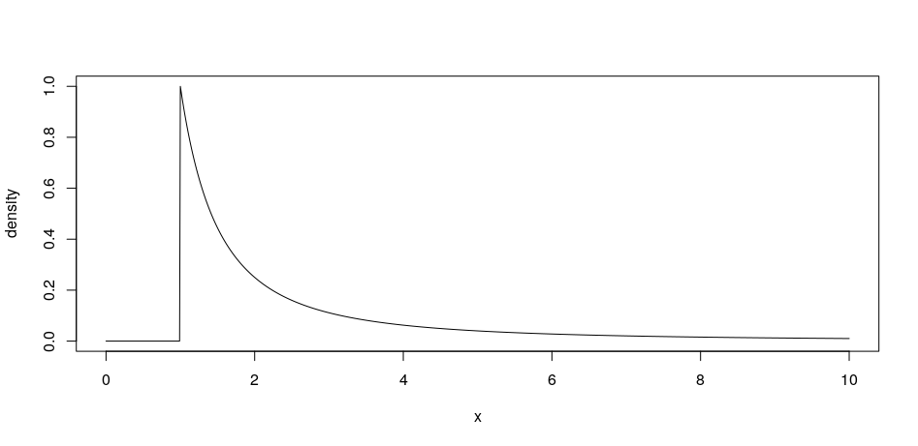

1. alpha = 2, beta = 3

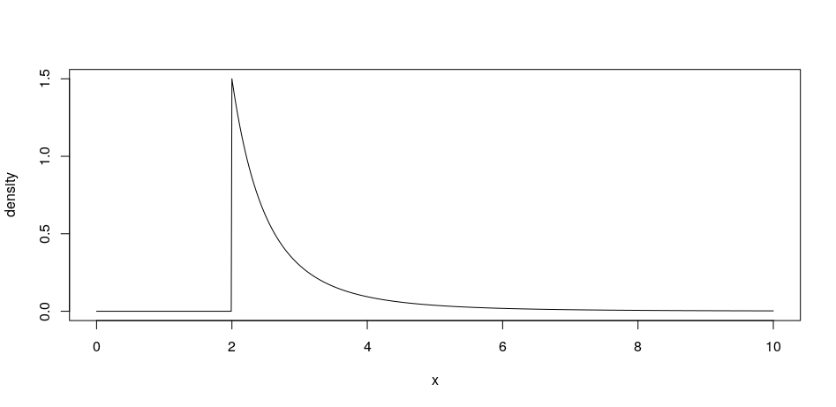

**Appendix**

paretodens.c

#include <stdio.h>

#include <math.h>

/*Define parto density function*/

double paretodens(double x, double alpha, double beta) {

/*Check whether alpha and beta are positve*/

if (alpha <=0 || beta <= 0){

printf("Warning message: The parameters are not meaningful! NaN produced!\n");

return NAN;

}

/*Check whether x is greater than alpha*/

else if (x < alpha){

return 0;

}

else {

return beta*pow(alpha,beta)/pow(x,beta+1);

}

}

int main() {

double x,alpha,beta;

printf("Input x:\n");

scanf("%lf",&x);

printf("Input alpha:\n");

scanf("%lf",&alpha);

printf("Input beta:\n");

scanf("%lf",&beta);

printf("The density is %lf.\n", paretodens(x,alpha,beta));

return 0;

}