**Problem 1**

Four graphs of approximation errors against $−\log_{2}\left(h\right)$ are plotted in R respectively.

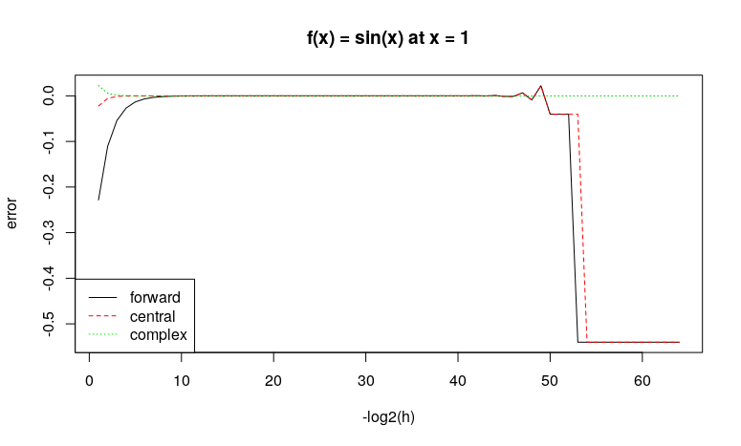

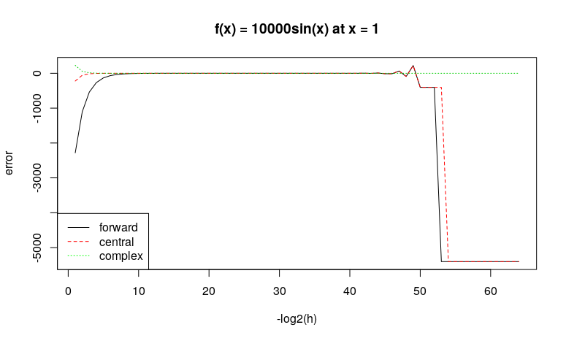

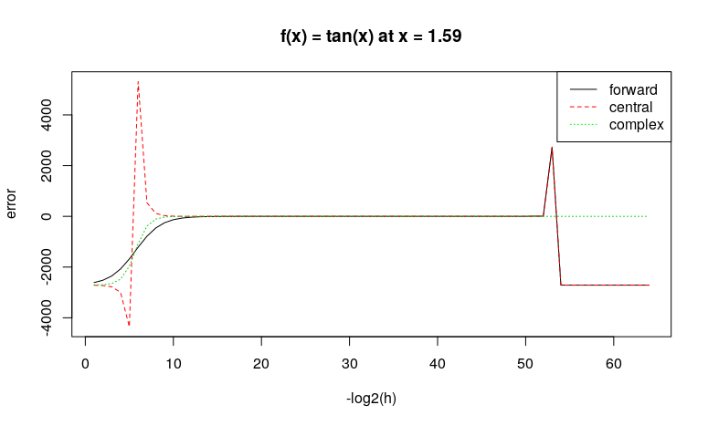

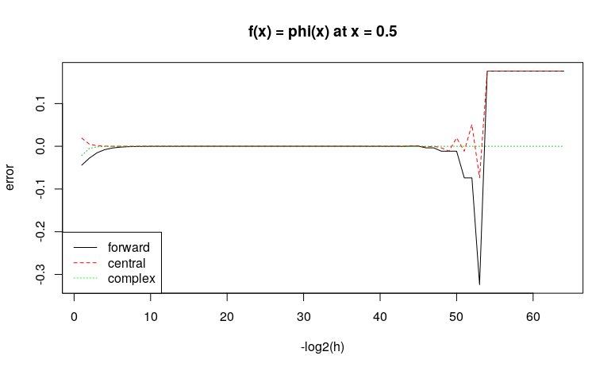

As we can see from the graphs, if the step size is too large, the approximation is not accurate. Similarly, the approximation errors will also build up due to round-off errors if the step size if too small. Among the three methods, complex differences are more stable with different step sizes. In general, central method performs better than forward method. To conclude, a step size in the smooth area (around $2^{−20}$ to $2^{−40}$) of the graphs should be more appropriate for approximation.

**Problem 2**

With function *package.skeleton*, a general structure for package *pareto* is created. After putting different files in appropriate places, I used the following code to build the source package file and check it.

R CMD build pareto

R CMD check pareto_1.0-1.tar.gz

Then I installed this package in R and an simple example is given as follows.

> install.packages("~/s7400/STAT7400/pareto_1.0-1.tar.gz", repos = NULL, type = "source")

> library(pareto)

> dpareto(1:5, 2, 1)

[1] 0.0000000 0.0000000 0.2222222 0.1250000 0.0800000

> dpareto(1:5, 2, 1, log = TRUE)

[1] -Inf -Inf -1.504077 -2.079442 -2.525729