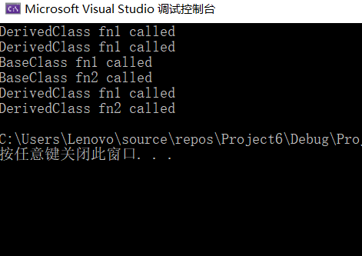
#include<iostream>
#include <string>
using namespace std;

class BaseClass {
public:
void fn1() { cout << "BaseClass fn1 called" << endl; }
void fn2() { cout << "BaseClass fn2 called" << endl; }
};
class DerivedClass : public BaseClass {
public:
void fn1() { cout << "DerivedClass fn1 called" << endl; }
void fn2() { cout << "DerivedClass fn2 called" << endl; }
};

int main() {
DerivedClass derivedClass;
DerivedClass* ptrDerived = &derivedClass;
BaseClass* ptrBase = &derivedClass;

derivedClass.fn1();
derivedClass.fn1();
ptrBase->fn1();
ptrBase->fn2();
ptrDerived->fn1();
ptrDerived->fn2();

return 0;
}

