作者：爱前端不爱恋爱  
链接：https://zhuanlan.zhihu.com/p/194064783  
来源：知乎  
著作权归作者所有。商业转载请联系作者获得授权，非商业转载请注明出处。

### **一.发送效果**

### **HTML**

<div id="send-btn">

<button>

// 这里是一个svg的占位 Send

</button></div>

**CSS**

#send-btn{

display: flex;

align-items: center;

justify-content: center;

height: 100vh;}

button {

background: #5f55af;

border: 0;

border-radius: 5px;

padding: 10px 30px 10px 20px;

color: white;

text-transform: uppercase;

font-weight: bold;}

button svg {

display: inline-block;

vertical-align: middle;

padding-right: 5px;}

button:hover svg {

animation: fly 2s ease 1;}

@keyframes fly {

0% {

transform: translateX(0%);

}

50% {

transform: translateX(300%);

}

100% {

transform: translateX(0);

}}

### **GIF图**

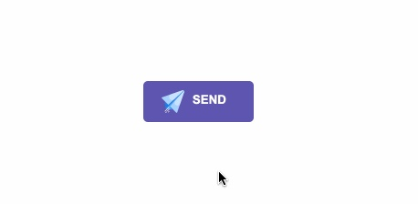

作者：爱前端不爱恋爱  
链接：https://zhuanlan.zhihu.com/p/194064783  
来源：知乎  
著作权归作者所有。商业转载请联系作者获得授权，非商业转载请注明出处。

### **二.霓虹效果**

### **HTML**

<div id="neon-btn">

<button class="btn one">Hover me</button>

<button class="btn two">Hover me</button>

<button class="btn three">Hover me</button></div>

**CSS**

#neon-btn {

display: flex;

align-items: center;

justify-content: space-around;

height: 100vh;

background: #031628;}

.btn {

border: 1px solid;

background-color: transparent;

text-transform: uppercase;

font-size: 14px;

padding: 10px 20px;

font-weight: 300;}

.one {

color: #4cc9f0;}

.two {

color: #f038ff;}

.three {

color: #b9e769;}

.btn:hover {

color: white;

border: 0;}

.one:hover {

background-color: #4cc9f0;

-webkit-box-shadow: 10px 10px 99px 6px rgba(76,201,240,1);

-moz-box-shadow: 10px 10px 99px 6px rgba(76,201,240,1);

box-shadow: 10px 10px 99px 6px rgba(76,201,240,1);}

.two:hover {

background-color: #f038ff;

-webkit-box-shadow: 10px 10px 99px 6px rgba(240, 56, 255, 1);

-moz-box-shadow: 10px 10px 99px 6px rgba(240, 56, 255, 1);

box-shadow: 10px 10px 99px 6px rgba(240, 56, 255, 1);}

.three:hover {

background-color: #b9e769;

-webkit-box-shadow: 10px 10px 99px 6px rgba(185, 231, 105, 1);

-moz-box-shadow: 10px 10px 99px 6px rgba(185, 231, 105, 1);

box-shadow: 10px 10px 99px 6px rgba(185, 231, 105, 1);}

### **GIF图**

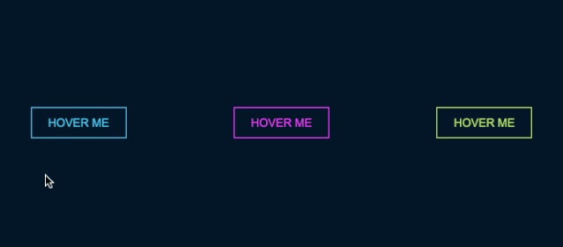

### **三.边框效果**

### **HTML**

<div id="draw-border">

<button>Hover me</button></div>

**CSS**

#draw-border {

display: flex;

align-items: center;

justify-content: center;

height: 100vh;}

button {

border: 0;

background: none;

text-transform: uppercase;

color: #4361ee;

font-weight: bold;

position: relative;

outline: none;

padding: 10px 20px;

box-sizing: border-box;}

button::before, button::after {

box-sizing: inherit;

position: absolute;

content: '';

border: 2px solid transparent;

width: 0;

height: 0;}

button::after {

bottom: 0;

right: 0;}

button::before {

top: 0;

left: 0;}

button:hover::before, button:hover::after {

width: 100%;

height: 100%;}

button:hover::before {

border-top-color: #4361ee;

border-right-color: #4361ee;

transition: width 0.3s ease-out, height 0.3s ease-out 0.3s;}

button:hover::after {

border-bottom-color: #4361ee;

border-left-color: #4361ee;

transition: border-color 0s ease-out 0.6s, width 0.3s ease-out 0.6s, height 0.3s ease-out 1s;}

### **GIF效果**

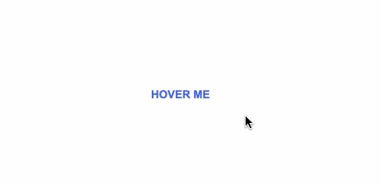

### **四.圆形效果**

### **HTML**

<div id="circle-btn">

<div class="btn-container">

// 这里有一个svg元素 <button>Hover me</button>

</div></div>

**CSS**

#circle-btn {

display: flex;

align-items: center;

justify-content: center;

height: 100vh;}

.btn-container {

position: relative;}

button {

border: 0;

border-radius: 50px;

color: white;

background: #5f55af;

padding: 15px 20px 16px 60px;

text-transform: uppercase;

background: linear-gradient(to right, #f72585 50%, #5f55af 50%);

background-size: 200% 100%;

background-position: right bottom;

transition:all 2s ease;}

svg {

background: #f72585;

padding: 8px;

border-radius: 50%;

position: absolute;

left: 0;

top: 0%;}

button:hover {

background-position: left bottom;}

### **GIF图**

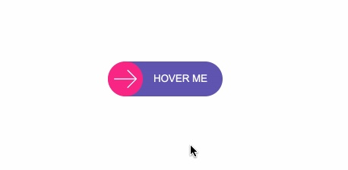

### **五.圆角效果**

### **HTML**

<div id="border-btn">

<button>Hover me</button></div>

**CSS**

#border-btn {

display: flex;

align-items: center;

justify-content: center;

height: 100vh;}

button {

border: 0;

border-radius: 10px;

background: #2ec4b6;

text-transform: uppercase;

color: white;

font-size: 16px;

font-weight: bold;

padding: 15px 30px;

outline: none;

position: relative;

transition: border-radius 3s;

-webkit-transition: border-radius 3s;}

button:hover {

border-bottom-right-radius: 50px;

border-top-left-radius: 50px;

border-bottom-left-radius: 10px;

border-top-right-radius: 10px;}

### **GIF图**



### **六.冰冻效果**

### **HTML**

<div id="frozen-btn">

<button class="green">Hover me</button>

<button class="purple">Hover me</button></div>

**CSS**

#frozen-btn {

display: flex;

align-items: center;

justify-content: center;

height: 100vh;}

button {

border: 0;

margin: 20px;

text-transform: uppercase;

font-size: 20px;

font-weight: bold;

padding: 15px 50px;

border-radius: 50px;

color: white;

outline: none;

position: relative;}

button:before{

content: '';

display: block;

background: linear-gradient(to left, rgba(255, 255, 255, 0) 50%, rgba(255, 255, 255, 0.4) 50%);

background-size: 210% 100%;

background-position: right bottom;

height: 100%;

width: 100%;

position: absolute;

top: 0;

bottom:0;

right:0;

left: 0;

border-radius: 50px;

transition: all 1s;

-webkit-transition: all 1s;}

.green {

background-image: linear-gradient(to right, #25aae1, #40e495);

box-shadow: 0 4px 15px 0 rgba(49, 196, 190, 0.75);}

.purple {

background-image: linear-gradient(to right, #6253e1, #852D91);

box-shadow: 0 4px 15px 0 rgba(236, 116, 149, 0.75);}

.purple:hover:before {

background-position: left bottom;}

.green:hover:before {

background-position: left bottom;}

### **GIF图**

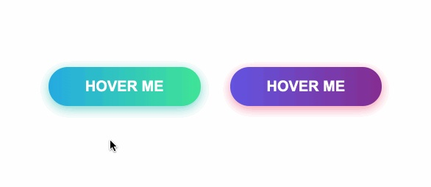

### **七.闪亮效果**

### **HTML**

<div id="shiny-shadow">

<button><span>Hover me</span></button></div>

**CSS**

#shiny-shadow {

display: flex;

align-items: center;

justify-content: center;

height: 100vh;

background: #1c2541;}

button {

border: 2px solid white;

background: transparent;

text-transform: uppercase;

color: white;

padding: 15px 50px;

outline: none;

overflow: hidden;

position: relative;}

span {

z-index: 20;}

button:after {

content: '';

display: block;

position: absolute;

top: -36px;

left: -100px;

background: white;

width: 50px;

height: 125px;

opacity: 20%;

transform: rotate(-45deg);}

button:hover:after {

left: 120%;

transition: all 600ms cubic-bezier(0.3, 1, 0.2, 1);

-webkit-transition: all 600ms cubic-bezier(0.3, 1, 0.2, 1);}

### **GIF图**

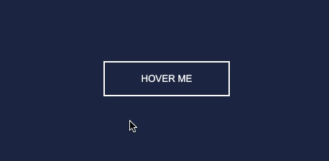

### **八.加载效果**

### **HTML**

<div id="loading-btn">

<button><span>Hover me</span></button></div>

**CSS**

#loading-btn {

display: flex;

align-items: center;

justify-content: center;

height: 100vh;}

button {

background: transparent;

border: 0;

border-radius: 0;

text-transform: uppercase;

font-weight: bold;

font-size: 20px;

padding: 15px 50px;

position: relative;}

button:before {

transition: all 0.8s cubic-bezier(0.7, -0.5, 0.2, 2);

content: '';

width: 1%;

height: 100%;

background: #ff5964;

position: absolute;

top: 0;

left: 0;}

button span {

mix-blend-mode: darken;}

button:hover:before {

background: #ff5964;

width: 100%;}

### **GIF图**

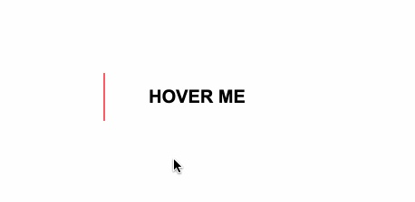

### **总结**

巧用伪元素:before、:after等，让你的页面按钮眼前一亮。