# -*- coding: utf-8 -*-

from __future__ import print_function

import tensorflow as tf

from tensorflow.examples.tutorials.mnist import input_data

# number 1 to 10 data

mnist = input_data.read_data_sets('MNIST_data', one_hot=True)

def compute_accuracy(v_xs, v_ys):

global prediction

y_pre = sess.run(prediction, feed_dict={xs: v_xs, keep_prob: 1})

correct_prediction = tf.equal(tf.argmax(y_pre,1), tf.argmax(v_ys,1))

accuracy = tf.reduce_mean(tf.cast(correct_prediction, tf.float32))

result = sess.run(accuracy, feed_dict={xs: v_xs, ys: v_ys, keep_prob: 1})

return result

def weight_variable(shape):

initial = tf.truncated_normal(shape, stddev=0.1)

return tf.Variable(initial)

def bias_variable(shape):

initial = tf.constant(0.1, shape=shape)

return tf.Variable(initial)

def conv2d(x, W):

# stride [1, x_movement, y_movement, 1]

# Must have strides[0] = strides[3] = 1

return tf.nn.conv2d(x, W, strides=[1, 1, 1, 1], padding='SAME')

def max_pool_2x2(x):

# stride [1, x_movement, y_movement, 1]

return tf.nn.max_pool(x, ksize=[1,2,2,1], strides=[1,2,2,1], padding='SAME')

# define placeholder for inputs to network

xs = tf.placeholder(tf.float32, [None, 784])/255. # 28x28

ys = tf.placeholder(tf.float32, [None, 10])

keep_prob = tf.placeholder(tf.float32)

x_image = tf.reshape(xs, [-1, 28, 28, 1])

# print(x_image.shape) # [n_samples, 28,28,1]

## conv1 layer ##

W_conv1 = weight_variable([5,5, 1,32]) # patch 5x5, in size 1, out size 32

b_conv1 = bias_variable([32])

h_conv1 = tf.nn.relu(conv2d(x_image, W_conv1) + b_conv1) # output size 28x28x32

h_pool1 = max_pool_2x2(h_conv1) # output size 14x14x32

## conv2 layer ##

W_conv2 = weight_variable([5,5, 32, 64]) # patch 5x5, in size 32, out size 64

b_conv2 = bias_variable([64])

h_conv2 = tf.nn.relu(conv2d(h_pool1, W_conv2) + b_conv2) # output size 14x14x64

h_pool2 = max_pool_2x2(h_conv2) # output size 7x7x64

## fc1 layer ##

W_fc1 = weight_variable([7*7*64, 1024])

b_fc1 = bias_variable([1024])

# [n_samples, 7, 7, 64] ->> [n_samples, 7*7*64]

h_pool2_flat = tf.reshape(h_pool2, [-1, 7*7*64])

h_fc1 = tf.nn.relu(tf.matmul(h_pool2_flat, W_fc1) + b_fc1)

h_fc1_drop = tf.nn.dropout(h_fc1, keep_prob)

## fc2 layer ##

W_fc2 = weight_variable([1024, 10])

b_fc2 = bias_variable([10])

prediction = tf.nn.softmax(tf.matmul(h_fc1_drop, W_fc2) + b_fc2)

# the error between prediction and real data

cross_entropy = tf.reduce_mean(-tf.reduce_sum(ys * tf.log(prediction),

reduction_indices=[1])) # loss

train_step = tf.train.AdamOptimizer(1e-4).minimize(cross_entropy)

sess = tf.Session()

# important step

# tf.initialize_all_variables() no long valid from

# 2017-03-02 if using tensorflow >= 0.12

if int((tf.__version__).split('.')[1]) < 12 and int((tf.__version__).split('.')[0]) < 1:

init = tf.initialize_all_variables()

else:

init = tf.global_variables_initializer()

sess.run(init)

for i in range(1000):

batch_xs, batch_ys = mnist.train.next_batch(100)

sess.run(train_step, feed_dict={xs: batch_xs, ys: batch_ys, keep_prob: 0.5})

if i % 50 == 0:

print(compute_accuracy(

mnist.test.images, mnist.test.labels))

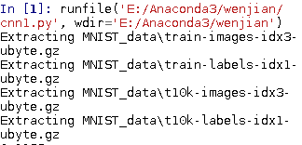

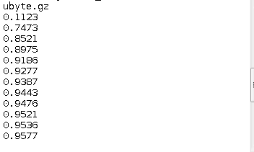

随便训练了下，训练时间比较久，

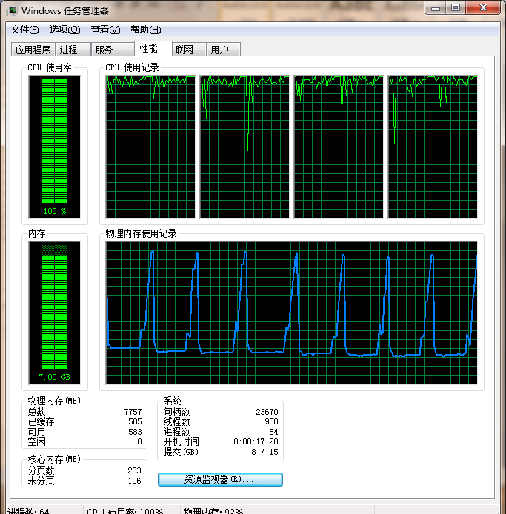

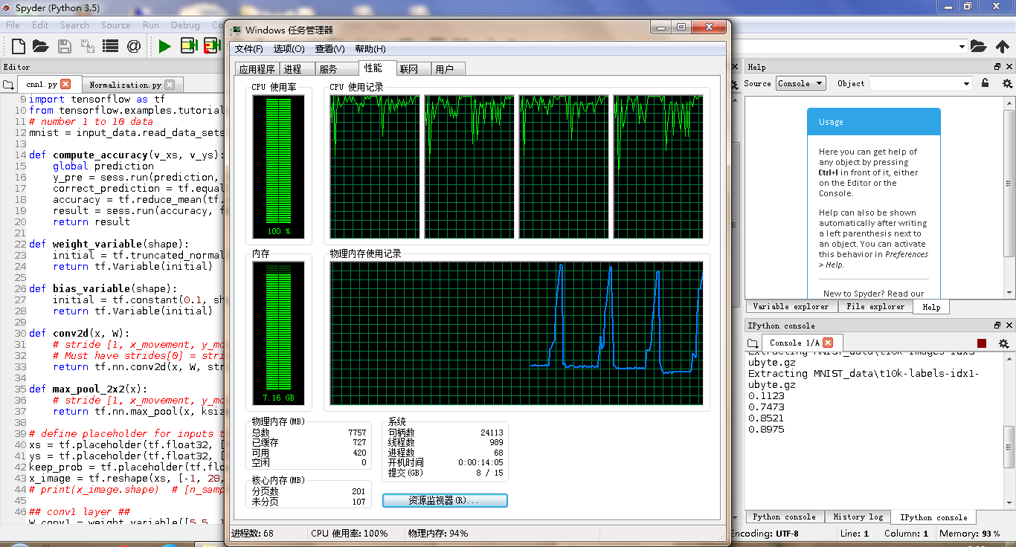

1.程序讲解

该程序采用CNN卷积神经网络识别训练1到10的数字。

##获取训练数据

from tensorflow.examples.tutorials.mnist import input_data

# number 1 to 10 data

mnist = input_data.read_data_sets('MNIST_data', one_hot=True)

##定义需要用到的函数，分别是验证正确率的compute_accuracy、获取神经网络边上的权重weight_variable，bias_variable（偏置函数）、CNN卷积层函数conv2d、CNN池化层函数max_pool_2x2

**def compute_accuracy(v_xs, v_ys):**

**global prediction**

#得到用测试数据算出来的预测值

**y_pre = sess.run(prediction, feed_dict={xs: v_xs, keep_prob: 1})**

#与标准值比较得偏差

# tf.argmax()返回行或列的最大值下标向量，1为行。

# tf.equal()两传入参数相等返回1，不等返回0.

**correct_prediction = tf.equal(tf.argmax(y_pre,1), tf.argmax(v_ys,1))**

# tf.cast()转换参数值的类型

# tf.reduce_mean()求平均值，没指定第二参数则所有值，指定1

#按行

**accuracy = tf.reduce_mean(tf.cast(correct_prediction, tf.float32))**

#运行得到正确概率。

**result = sess.run(accuracy, feed_dict={xs: v_xs, ys: v_ys, keep_prob: 1})**

**return result**

**def weight_variable(shape):**

**initial = tf.truncated_normal(shape, stddev=0.1)**

# truncated_normal()正态分布，均值为0，标准差0.1。如果随机

#出来的值偏离平均值超过两个标准差，这个数将被重新随机

**return tf.Variable(initial)**

**def bias_variable(shape):**

**initial = tf.constant(0.1, shape=shape)**

# constant()产生一个给定定值的常量

**return tf.Variable(initial)**

**def conv2d(x, W):**

# stride [1, x_movement, y_movement, 1]

# Must have strides[0] = strides[3] = 1

#x 为四维矩阵，参数一传入batch的数量，后三位对应节点矩阵#W为过滤器规格 ，如[5,5,3,16]，过滤器5x5，当前层深度3，

#输出层深度16。步长1，填充0。

**return tf.nn.conv2d(x, W, strides=[1, 1, 1, 1], padding='SAME')**

**def max_pool_2x2(x):**

# stride [1, x_movement, y_movement, 1]

#ksize过滤器尺寸2x2，步长2

**return tf.nn.max_pool(x, ksize=[1,2,2,1], strides=[1,2,2,1], padding='SAME')**

#tf.placeholder()程序运行时才指定参数值，用于训练参数的传入。

**xs = tf.placeholder(tf.float32, [None, 784])/255. # 28x28**

**ys = tf.placeholder(tf.float32, [None, 10])**

**keep_prob = tf.placeholder(tf.float32)**

# tf.reshape()改变矩阵维度，-1表示该维度的值随意。

**x_image = tf.reshape(xs, [-1, 28, 28, 1])**

#接下来是建立训练神经网络，该神经网络的结构是卷积层池化层，#卷积层池化层，全连接层，全连接层，分别对应**conv1 layer，conv2** #**layer，#fc1 layer，fc2 layer**

#传入的batch（训练数据）的形式变化：[100,784]->[100,28,28,1]->

#[100,28,28,32]->[100,14,14,32]->[100,14,14,64]->[100,7,7,64]->

#[100,7*7*64]->[100,1024]->[100,10]

**## conv1 layer ##**

**W_conv1 = weight_variable([5,5, 1,32]) # patch 5x5, in size 1, out size 32**

**b_conv1 = bias_variable([32])**

#conv2d()矩阵乘，tf.nn.relu()激励函数去线性化。

**h_conv1 = tf.nn.relu(conv2d(x_image, W_conv1) + b_conv1) # output size 28x28x32**

**h_pool1 = max_pool_2x2(h_conv1) # output size 14x14x32**

**## conv2 layer ##**

**W_conv2 = weight_variable([5,5, 32, 64]) # patch 5x5, in size 32, out size 64**

**b_conv2 = bias_variable([64])**

**h_conv2 = tf.nn.relu(conv2d(h_pool1, W_conv2) + b_conv2) # output size 14x14x64**

**h_pool2 = max_pool_2x2(h_conv2) # output size 7x7x64**

**## fc1 layer ##**

**W_fc1 = weight_variable([7*7*64, 1024])**

**b_fc1 = bias_variable([1024])**

**# [n_samples, 7, 7, 64] ->> [n_samples, 7*7*64]**

**h_pool2_flat = tf.reshape(h_pool2, [-1, 7*7*64])**

**h_fc1 = tf.nn.relu(tf.matmul(h_pool2_flat, W_fc1) + b_fc1)**

#tf.nn.dropout()一定概率将输出值保留，避免过拟合。

**h_fc1_drop = tf.nn.dropout(h_fc1, keep_prob)**

**## fc2 layer ##**

**W_fc2 = weight_variable([1024, 10])**

**b_fc2 = bias_variable([10])**

#tf.nn.softmax()将传入矩阵转化为概率值，按行，就是矩阵每行相#加值为1

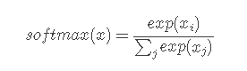

**prediction = tf.nn.softmax(tf.matmul(h_fc1_drop, W_fc2) + b_fc2)**

$H\left(p,q\right)=-\sum_{x}{p\left(x\right)logq(x)}$

**cross_entropy = tf.reduce_mean(-tf.reduce_sum(ys * tf.log(prediction),**

**reduction_indices=[1])) # loss**

# tf.train.AdamOptimizer（）优化器，学习效率0.0001，让损失值往

#减小趋势发展来改变参数值

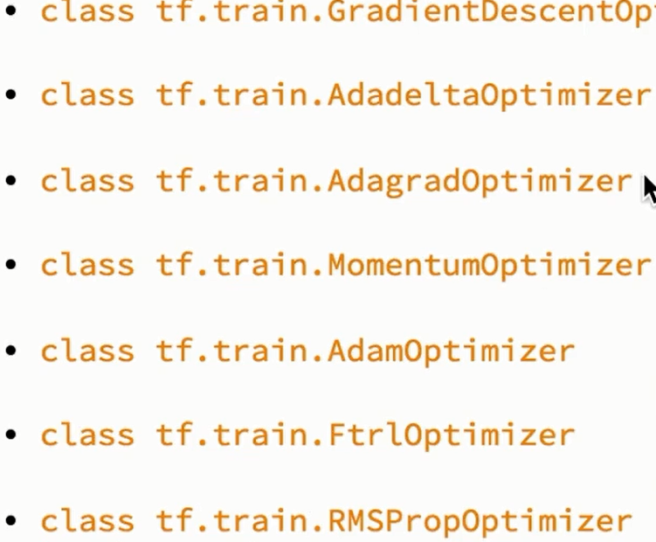

**train_step = tf.train.AdamOptimizer(1e-4).minimize(cross_entropy)**

**sess = tf.Session()**

#根据tensorflow版本来选择初始化变量的方式

**if int((tf.__version__).split('.')[1]) < 12 and int((tf.__version__).split('.')[0]) < 1:**

**init = tf.initialize_all_variables()**

**else:**

**init = tf.global_variables_initializer()**

**sess.run(init)**

#训练1000次，把训练数据分成每份100个样值，50%的概率筛

#选训练值，这样循环输入的训练参数每次都会不一样。

**for i in range(1000):**

**batch_xs, batch_ys = mnist.train.next_batch(100)**

**sess.run(train_step, feed_dict={xs: batch_xs, ys: batch_ys, keep_prob: 0.5})**

# 每50次测试一下准确度，测试准确度的样本与训练的样本不是#同一个来源

**if i % 50 == 0:**

**print(compute_accuracy(**

**mnist.test.images, mnist.test.labels))**