Multi-stage Elimination–Optimization for Cooperative Smoke-Screen Scheduling Against Multiple Missiles
Puxin Zhang#, Haoyi Wu#, Shurong Zhong#,*
Story Brook Institute at Anhui University, Anhui University, Hefei, China, 230039
*Corresponding author: r22314058@stu.ahu.edu.cn
#These authors contributed equally.
Keywords: Smoke screen; UAV scheduling; Geometric occlusion; Multi-missile defense; Optimization.
Abstract: Smoke-screen decoys are widely used to protect high-value assets from incoming precision-guided missiles. However, how to schedule multiple unmanned aerial vehicles (UAVs) and limited smoke-screen munitions in a coordinated manner to maximize the total occlusion time is still a challenging problem. This paper develops a multi-stage “elimination–optimization” framework for cooperative smoke-screen scheduling against multiple missiles. First, a physical and geometric model is established by describing the kinematics of missiles, UAVs, and smoke clouds, and by introducing an equivalent-sphere approximation of the protected asset. A full-disk coverage criterion and a numerical occlusion test are then constructed to rigorously determine whether the line of sight from each missile to the true target is completely blocked. Second, based on angle-domain elimination, the study derive tight feasible ranges of UAV headings, which greatly shrink the search space for subsequent optimization. On this basis, this study successively design optimization modules for single-UAV single-smoke, single-UAV multi-smoke, and multi-UAV multi-missile scenarios, combining grid search, integer programming, and heuristic refinement. Numerical experiments under representative engagement scenarios demonstrate that the proposed framework can effectively increase the total occlusion time from 1.39 s for a given baseline strategy to 25.691 s in a five-UAV three-missile scenario, showing its potential for practical deployment in cooperative defense systems.
- Introduction
The use of smoke-screen decoys to conceal high-value assets from precision-guided munitions has attracted increasing attention in modern battlefield environments. By releasing smoke munitions at appropriate locations and times, unmanned aerial vehicles (UAVs) can generate local obscurants that block the line of sight between incoming missiles and the true target, thereby reducing the probability of successful interception. Compared with traditional static smoke-screen deployment, UAV-based smoke-screen operations are more flexible and adaptive, but also lead to a more complex scheduling problem due to the strong coupling between platform kinematics, smoke dynamics, and missile trajectories [4–6].
In recent years, various methods have been proposed for active decoy deployment and cooperative engagement planning [1–3]. Geometric occlusion models have been used to analyze line-of-sight blocking and sensor blinding effects [4–6], while optimization techniques such as integer programming, heuristic search, and metaheuristics have been introduced to schedule decoys and interceptors under resource constraints [7–9]. However, most existing works either assume simplified engagement geometries, or focus on single-platform or single-interceptor scenarios, which makes it difficult to directly apply them to multi-UAV, multi-missile smoke-screen scheduling.
To address these challenges, this paper proposes a multi-stage “elimination–optimization” framework tailored for cooperative smoke-screen scheduling against multiple missiles. The main contributions are threefold. First, this paper constructs a unified physical and geometric model that describes the motion of missiles, UAVs, and smoke clouds, and derive a rigorous full-disk coverage criterion for complete occlusion of the equivalent target sphere. Second, this article develops an angle-domain elimination method that analytically bounds feasible UAV heading angles, thereby greatly reducing the search space and improving computational tractability. Third, on top of these modeling and elimination results, the article designs a series of optimization modules for single-UAV single-smoke, single-UAV multi-smoke, and multi-UAV multi-missile scenarios, and demonstrate through numerical experiments that the proposed framework can significantly improve the total occlusion time compared with baseline strategies.
- The physical and geometric model of smoke-screen occlusion

2.1 Scenario description and kinematic assumptions
In this work, this paper considers a generic engagement scenario in which several missiles approach a false target along prescribed trajectories, while the true high-value target is located nearby. Multiple UAVs carrying a limited number of smoke munitions fly from different initial positions and release smoke at appropriate times. After detonation, each smoke munition generates a roughly spherical smoke cloud that expands to a given radius and then slowly descends with a constant sinking speed. All missiles, UAVs, and smoke clouds are assumed to move in a three-dimensional Cartesian coordinate system with a common time reference [4,6,7].
For each missile, its trajectory is treated as known, and its position at any time is obtained from the given kinematic equations. Each UAV is modeled as a point mass traveling at a constant speed along a straight-line heading that can be chosen within a feasible angular range. The true target is originally modeled as a right circular cylinder with a given radius and height, and will later be approximated by an equivalent sphere to facilitate geometric analysis.
2.2 Equivalent sphere model and full-disk coverage criterion
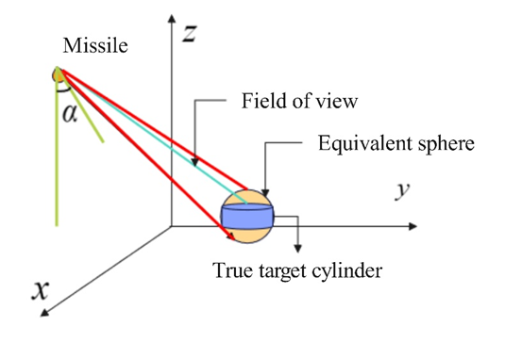
Figure 1. Equivalent Replacement Example Diagram
To simplify the occlusion analysis while preserving the projection area as seen from the missile’s viewpoint, the cylindrical target is approximated by an equivalent sphere whose radius is determined such that the projected area of the sphere matches that of the original cylinder. Under this equivalent-sphere model, the line-of-sight blocking condition can be expressed in terms of the relative positions of the missile, the target sphere, and the smoke spheres.
For each missile and each time instant, this paper considers the line segment connecting the missile and the center of the equivalent target sphere. The target is said to be fully occluded at that time if, for every point on the surface (or a dense set of sample points inside and on the surface) of the equivalent sphere, the line from the missile to that point intersects at least one smoke sphere before reaching the target. This leads to a full-disk coverage criterion in the missile’s angular space: the angular radius of the smoke sphere, as seen from the missile, must be no smaller than that of the target sphere, and the smoke sphere must be located between the missile and the target along the line of sight. The equivalent sphere is shown in Figure 1.
Mathematically, the above condition can be written as a set of inequalities involving the distances from the missile to the smoke center, from the missile to the target center, and the radii of the smoke and target spheres. These inequalities are used to construct a numerical occlusion test function, which returns whether the target is fully occluded for a given configuration of missiles, smoke clouds, and time.
where h and a represent the height and radius of the cylinder, respectively. The equation is used to calculate the projected area of a cylinder, which consists of the lateral surface and the end surfaces.
which is used to calculate the projected area, matching the cylinder's projected area with that of an equivalent sphere, assuming a sphere with a certain radius is chosen;
which is used to make the projected areas equal, thereby obtaining the radius of the sphere.
2.3 Numerical implementation of the occlusion test
In addition to the analytical full-disk coverage criterion, this article implements a robust numerical occlusion test based on dense sampling of the equivalent target sphere. A large number of points are uniformly generated on and inside the sphere. For each candidate time, and for each sample point, the ray from the missile to this point is checked for intersection with all existing smoke spheres. If every sample point is blocked by at least one smoke sphere, the target is considered fully occluded at that time.
The numerical procedure can be summarized as follows. First, the positions of all missiles, UAVs, and smoke clouds are updated according to their kinematics. Second, the occlusion test is executed for each missile, yielding a binary occlusion indicator over time. Finally, for a given schedule of smoke releases, the total occlusion time is obtained by summing the lengths of all time intervals in which the occlusion indicator is positive. This occlusion evaluation module serves as the foundation for all subsequent optimization tasks.
where the missile's initial position is, flight speed is, unit direction vector is .
where the time the smoke grenade goes off is, smoke screen ball core position at detonation is, vertical sinking speed is.
where equivalent target sphere center is, radius is, sampling on a sphere using spherical coordinates
where missile position is, sampling point is.
where position of the smoke grenade at a certain moment is, radius is,.The expression for the intersection of the line of sight and the smoke bomb is as above.
where distance from the missile to the smoke screen is , distance from the missile to the target is .
where the angle between the smoke screen and the target center from the missile's perspective is.
where indicates the missile expansion angle and the smoke screen expansion angle.
full cover basis: The smoke screen has a wide dispersal angle and is positioned between the missile and the target.
where indicates whether this moment is completely shadowed.
- Multi-stage elimination–optimization framework
3.1 Angle-domain elimination for feasible UAV headings
Directly searching over all possible UAV headings leads to an enormous search space and is not computationally tractable. To address this issue, the article derives analytical bounds on feasible UAV heading angles based on geometric and timing constraints. For each missile–UAV pair, the paper analyzes the relative positions of the missile, the UAV, and the target, and determine the angular sector within which a smoke cloud released by the UAV can intersect the line of sight between the missile and the target before the missile reaches the engagement region.
By intersecting these angular sectors with the kinematic constraints on UAV speed, payload positions, and smoke lifetime, the article obtains a narrow continuous interval of feasible headings for each UAV. This angle-domain elimination step significantly reduces the search space and provides a tight domain in which subsequent optimization algorithms can operate efficiently
which is used to define the heading angle.
3.2 Single-UAV single-smoke optimization
On top of the angle-domain elimination, the article first considers a single-UAV, single-smoke scenario against one missile to illustrate the basic idea. The decision variables include the UAV’s flight speed, heading angle within the feasible interval, the release time of the smoke munition, and the fuse delay until detonation. The objective is to maximize the total occlusion time for the missile.
A two-stage search strategy is adopted. In the first stage, a coarse grid search is performed over the reduced decision space to identify promising regions. In the second stage, a refined search with smaller step sizes is carried out around the best coarse solutions to further improve the occlusion time. For each candidate solution, the numerical occlusion test described in Section 2.3 is used to evaluate the resulting occlusion interval. This module already improves the occlusion time significantly compared with a given baseline schedule.
which is used to represent time integration, Tend represents the missile's flight time from the starting position to the target, is the distance of the missile to the origin, is the missile's speed, and +1 is to ensure there is a minimum value.
where represents the k-th moment, that is, k times the time step.
which represents the objective function, thereby converting a continuous optimization problem into a discrete one.
3.3 Single-UAV multi-smoke scheduling via integer programming
Next, the article extends the framework to a single-UAV, multi-smoke scenario, where one UAV can carry and release multiple smoke munitions along its trajectory. The key difficulty is to schedule the release and detonation times of all munitions so that their individual occlusion intervals jointly maximize the total occlusion time while avoiding redundancy [8,9].
To this end, the paper first discretizes the feasible decision space and generate a set of candidate smoke-release options, each with an associated occlusion interval evaluated by the occlusion test. Then, an integer programming model is constructed in which binary decision variables indicate whether each candidate option is selected. Constraints are imposed to ensure physical feasibility, such as the maximum number of munitions carried by the UAV, non-overlapping use of the same munition, and temporal consistency. The objective function maximizes the total measure of the union of selected occlusion intervals. Solving this integer programming model yields a near-optimal multi-smoke schedule for the single UAV.
where is an indicator function for whether the target is obscured by a smoke screen at time t. represents the set of moments when the smoke screen is deployed.
which is used to obtain the union of three targets.
which is used to override constraints.
where indicates discrete targets, indicates continuous targets, and represents the upper limit of the number of jumps.
3.4 Multi-UAV cooperative scheduling for multiple missiles
Finally, the article considers the most general scenario with multiple UAVs, each carrying several smoke munitions, and multiple incoming missiles. For each UAV–missile pair, the angle-domain elimination and candidate-generation procedures are applied to obtain a set of potentially useful smoke-release options. A cooperative scheduling strategy is then designed to allocate these options among different missiles and coordinate their timings [9].
Because the resulting combinatorial optimization problem is extremely large, the article adopts a hybrid strategy combining upper-bound pruning and heuristic search. Geometric upper bounds on the maximum possible occlusion time of each smoke cloud are derived from its diameter and lifetime, which are used to discard candidate options that cannot contribute significantly. On the reduced candidate set, a hill-climbing and simulated annealing algorithm is employed to iteratively refine the cooperative schedule. At each iteration, local perturbations of the selected options are evaluated using the occlusion test, and moves that improve or probabilistically maintain the objective are accepted. This hybrid method yields a high-quality cooperative schedule that greatly increases the total occlusion time across all missiles.
which is used to represent the upper bound of the geometric 'diameter traversal'
which indicates that the maximum duration for which a single smoke cloud can provide effective concealment is less than or equal to the minimum of the upper bound of the lifetime of a single smoke cloud and the upper bound of the geometric 'diameter crossing'.
which indicates that the upper limit of the total concealment time provided by three smoke grenades is less than or equal to three times the maximum concealment time a single smoke cloud can provide, and also less than or equal to three times the upper limit of a smoke cloud's lifespan.
- Numerical experiments and analysis
4.1 Baseline scenario and evaluation metrics
In this section, the article designs a series of numerical experiments to evaluate the performance of the proposed framework under representative engagement scenarios. The baseline scenario consists of three missiles attacking a false target, one true target to be protected, and several UAVs starting from fixed initial positions with limited smoke munitions. The physical parameters of the missiles, UAVs, smoke clouds, and target are chosen according to typical operational values [10].
The main evaluation metric is the total occlusion time, defined as the sum of all time intervals during which the true target is fully occluded from the viewpoint of each missile. Additional metrics include the number of smoke munitions used, the temporal distribution of occlusion intervals along each missile trajectory, and the computational time required to obtain the schedule.
4.2 Improvement from single-smoke optimization
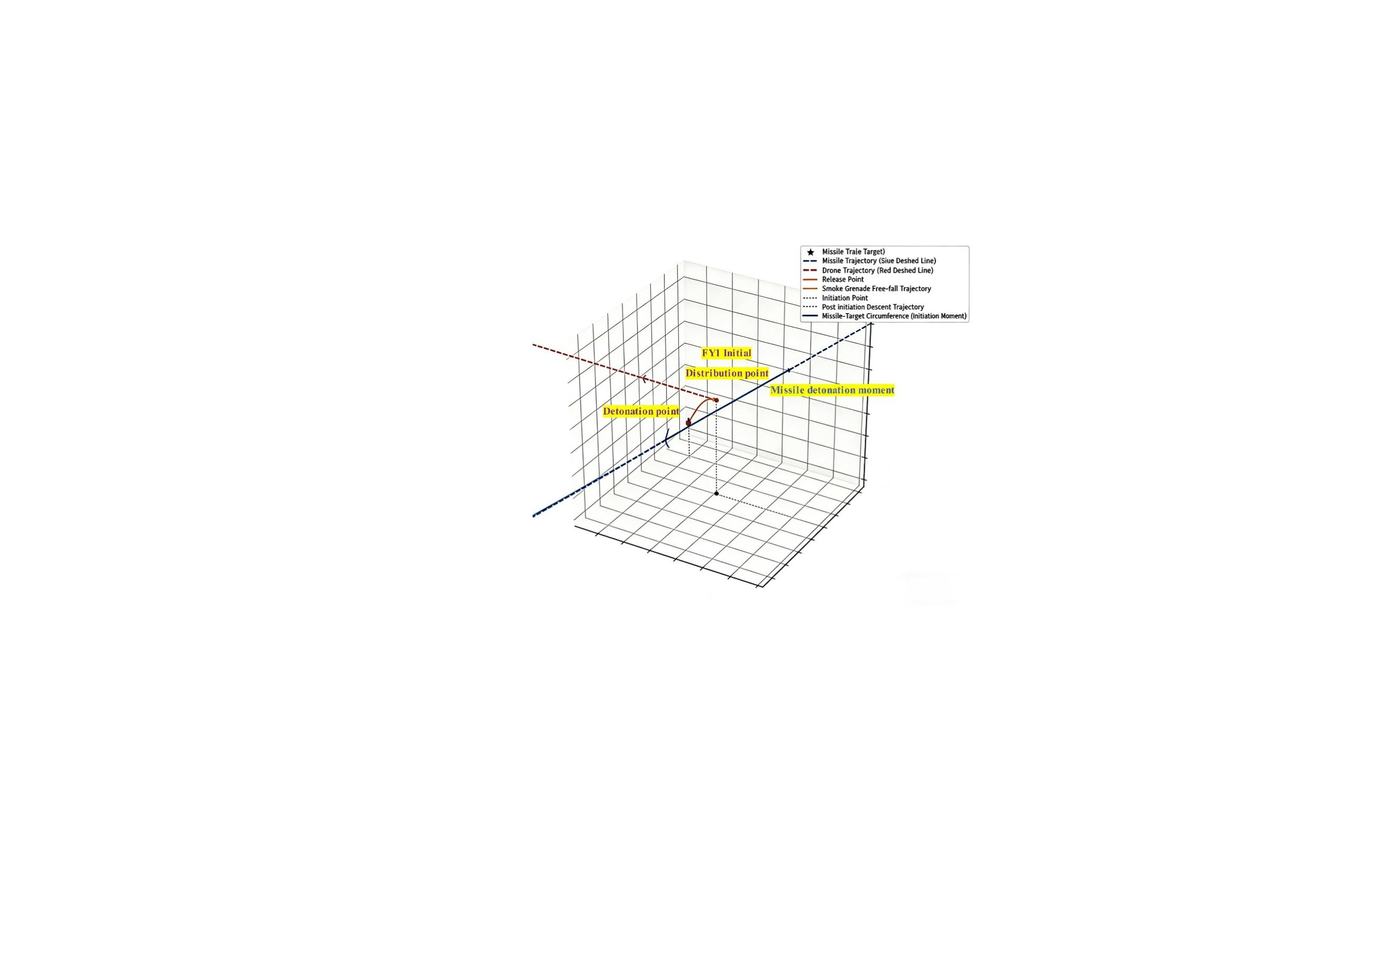
Figure 2. FY1 Missile Launch Visualization
The article first compares the given baseline smoke schedule with the optimized single-UAV single-smoke solution obtained by the method in Section 3.2. For both schedules, the occlusion indicator over time is computed using the numerical occlusion test, and the total occlusion time is extracted. The diagram of the FY1 drone launching a missile is shown in Figure 2.
The results show that, under the same physical constraints, the proposed optimization increases the occlusion time from the baseline value (e.g., 1.39 s) to a significantly larger value (e.g., 4.54 s). This demonstrates the effectiveness of the angle-domain elimination and two-stage search strategy even in simple scenarios.
4.3 Performance of multi-smoke and multi-UAV coordination
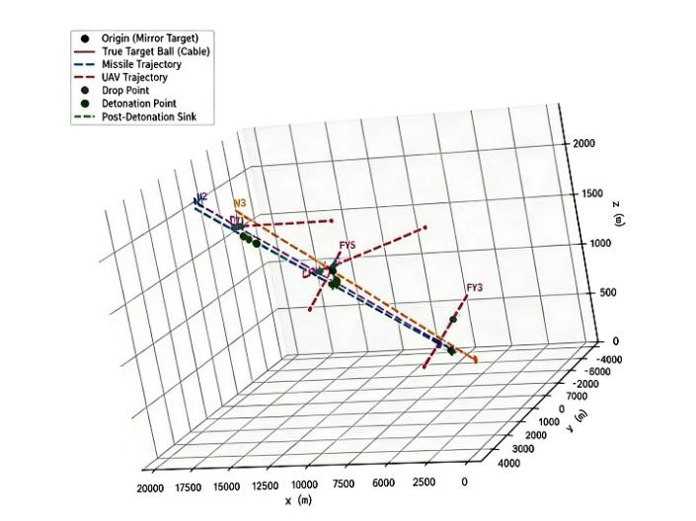
Figure 3. Multi-angle schematic of five drones launching missiles
The article then evaluates the single-UAV multi-smoke and multi-UAV multi-missile modules. For each scenario, the article reports the optimized total occlusion time, the number and timing of utilized smoke munitions, and illustrative occlusion-time plots. The diagram of all drones launching missiles is shown in Figure 3.
From the comparison, it can be observed that adding multiple smoke munitions and UAVs, combined with the proposed scheduling framework, yields a monotonic improvement in total occlusion time. In a representative five-UAV three-missile scenario, the total occlusion time can be increased up to approximately 25.691 s, indicating that the framework scales well to complex cooperative defense problems.
4.4 Sensitivity analysis and discussion
To further understand the robustness of the proposed approach, sensitivity analyses are conducted with respect to key parameters such as smoke radius, smoke lifetime, UAV speed, and initial positions. For each parameter, several values are tested while keeping the others fixed, and the corresponding optimized occlusion times are recorded [6,7].
The results indicate that larger smoke radii and longer lifetimes naturally lead to higher achievable occlusion times, while the benefit of increasing UAV speed exhibits a saturation effect beyond a certain threshold. Moreover, the performance degradation caused by moderate perturbations in initial UAV positions is limited, suggesting that the proposed framework is robust to moderate uncertainties in deployment. These findings provide useful guidance for practical system design and parameter selection.
- Conclusions
This paper has presented a multi-stage elimination–optimization framework for cooperative smoke-screen scheduling against multiple missiles. By constructing a unified physical and geometric model, introducing an equivalent-sphere approximation, and developing a rigorous occlusion test, the article can accurately evaluate whether the true target is fully concealed from each missile at any time. On this basis, an angle-domain elimination method is used to derive tight feasible ranges for UAV headings, significantly reducing the search space.
Building upon these modeling results, the article designs a series of optimization modules for single-UAV single-smoke, single-UAV multi-smoke, and multi-UAV multi-missile scenarios, combining grid search, integer programming, and heuristic refinement. Numerical experiments demonstrate that the proposed framework can substantially extend the total occlusion time compared with baseline strategies, and that it maintains good robustness with respect to key physical parameters. Future work will focus on incorporating more detailed smoke dynamics, missile guidance laws, and uncertainties into the model, as well as extending the framework to real-time adaptive scheduling in dynamic battlefield environments.

Acknowledgements
All the authors contributed equally.

References
[1] Bildik E, Tsourdos A. Clustering and cooperative guidance of multiple decoys for defending a naval platform against salvo threats [J]. Aerospace, 2024.
[2] Bildik E, Tsourdos A, Perrusquía A, Inalhan G. Decoys deployment for missile interception: a multi-agent reinforcement learning approach [J]. Aerospace, 2024.
[3] Francis P, Preston R, Metcalfe K, et al. Development of active decoy guidance policy by utilising reinforcement learning [C]// AIAA SciTech 2023 Forum. Reston, VA: AIAA, 2023.
[4] Wu X, Zhang J, Huang X, Liu D. GPU-accelerated real-time IR smoke screen simulation and assessment of its obscuration [J]. Infrared Physics & Technology, 2012.
[5] Harmata W. Smoke as a component of military camouflage systems [J]. Biuletyn Wojskowej Akademii Technicznej, 2018.
[6] He H, Gu Y, Fang J, Cao H. Analysis of factors influencing infrared extinction area of explosive smokescreen [J]. Heliyon, 2022.
[7] Xu W, Zhang X, Liu Y, et al. Simulation study of smoke screen jamming laser terminal guidance [J]. Infrared and Laser Engineering, 2022.
[8] Huang D, Zhang J, Li Y, et al. Cognitive interference decision method for air defense missile radio fuzes based on Q-learning [J]. Defence Technology, 2024.
[9] Ding Y, Kuang M, Shi H, Gao J. Multi-UAV cooperative target assignment method based on reinforcement learning [J]. Drones, 2024.
[10] Chow T E, Sanchez D P, Amatya P, Tanzir M T. Modelling the suitability of multiple launch rocket system in the war in Ukraine [J]. Applied Geography, 2024.

