第七章 课后习题参考答案
7.7 试分析图7.44所示的脉冲型异步时序逻辑电路。
答：1、求输出函数和控制函数：
J₁=K₁=1, CP₁=CP=1;
J₂=K₂=1, CP₂=CP₁·Q₁=Q₁;
J₃=K₃=1, CP₃=CP₂·Q₂= Q₁·Q₂;
J₄=K₄=1, CP₄=CP₃·Q₃= Q₁·Q₂·Q₃;
2、列次态方程
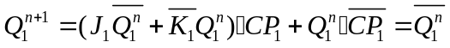
3、列出状态转移真值表，画出状态图
输入 |  |  |  |  | 输出
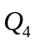 | 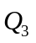 | 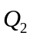 | 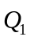 | 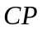 | 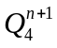 | 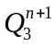 | 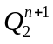 | 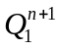
0 | 0 | 0 | 0 | 1 | 0 | 0 | 0 | 1
0 | 0 | 0 | 1 | 1 | 0 | 0 | 1 | 0
0 | 0 | 1 | 0 | 1 | 0 | 0 | 1 | 1
0 | 0 | 1 | 1 | 1 | 0 | 1 | 0 | 0
0 | 1 | 0 | 0 | 1 | 0 | 1 | 0 | 1
0 | 1 | 0 | 1 | 1 | 0 | 1 | 1 | 0
0 | 1 | 1 | 0 | 1 | 0 | 1 | 1 | 1
0 | 1 | 1 | 1 | 1 | 1 | 0 | 0 | 0
1 | 0 | 0 | 0 | 1 | 1 | 0 | 0 | 1
1 | 0 | 0 | 1 | 1 | 1 | 0 | 1 | 0
1 | 0 | 1 | 0 | 1 | 1 | 0 | 1 | 1
1 | 0 | 1 | 1 | 1 | 1 | 1 | 0 | 0
1 | 1 | 0 | 0 | 1 | 1 | 1 | 0 | 1
1 | 1 | 0 | 1 | 1 | 1 | 1 | 1 | 0
1 | 1 | 1 | 0 | 1 | 1 | 1 | 1 | 1
1 | 1 | 1 | 1 | 1 | 0 | 0 | 0 | 0
状态图：
1
2
3
4
5
6
7
8
9
10
11
12
13
14
15
0

4、功能描述：16进制加1计数器。

7.8试分析图7.45所示的脉冲型异步时序逻辑电路。
答：1、求输出函数和控制函数：
J₁=K₁=1, CP₁=CP=1;
J₂=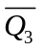, K₂=1, CP₂=CP₁·Q₁=Q₁;
J₃=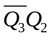, K₃=1, CP₃= CP₁·Q₁=Q₁;
2、列次态方程
3、列出状态转移真值表，画出状态图
0 | 0 | 0 | 1 | 0 | 0 | 1
0 | 0 | 1 | 1 | 0 | 1 | 0
0 | 1 | 0 | 1 | 0 | 1 | 1
0 | 1 | 1 | 1 | 1 | 0 | 0
1 | 0 | 0 | 1 | 1 | 0 | 1
1 | 0 | 1 | 1 | 0 | 0 | 0
1 | 1 | 0 | 1 | 1 | 1 | 1
1 | 1 | 1 | 1 | 0 | 0 | 0
状态图：
1
2
3
4
5
6
7
0

4、功能描述：模5加1计数器。当电路处于无效状态6、7时经过2个或一个脉冲后即可进入正常工作状态。

7.9 试用J-K触发器设计一个七进制异步加法计数器。
答：1、作七进制加法计数器的原始状态表
用3位二进制数000~110表示七进制的数码0~6。所以，原始状态表如下所示：
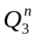 | 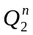 | 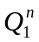 | 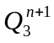 | 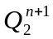 | 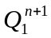
0 | 0 | 0 | 0 | 0 | 1
0 | 0 | 1 | 0 | 1 | 0
0 | 1 | 0 | 0 | 1 | 1
0 | 1 | 1 | 1 | 0 | 0
1 | 0 | 0 | 1 | 0 | 1
1 | 0 | 1 | 1 | 1 | 0
1 | 1 | 0 | 0 | 0 | 0
1 | 1 | 1 | d | d | d

2、确定控制函数（激励函数）
由于有7个有效状态，因此需要3个J-K触发器。其输出、激励状态表如下所示：
 |  |  |  |  |  | 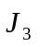 | 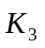 | 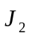 | 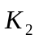 | 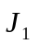 | 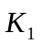 | 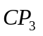 | 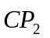 | 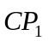
0 | 0 | 0 | 0 | 0 | 1 | d | d | d | d | 1 | d | 0 | 0 | 1
0 | 0 | 1 | 0 | 1 | 0 | 0 | d | 1 | d | d | 1 | d | 1 | 1
0 | 1 | 0 | 0 | 1 | 1 | d | d | d | d | 1 | d | 0 | 0 | 1
0 | 1 | 1 | 1 | 0 | 0 | 1 | d | d | 1 | d | 1 | 1 | 1 | 1
1 | 0 | 0 | 1 | 0 | 1 | d | d | d | d | 1 | d | 0 | 0 | 1
1 | 0 | 1 | 1 | 1 | 0 | d | d | 1 | d | d | 1 | 0 | d | 1
1 | 1 | 0 | 0 | 0 | 0 | d | 1 | d | 1 | d | d | 1 | 1 | 0
1 | 1 | 1 | d | d | d | d | d | d | d | d | d | d | d | d
激励卡诺图为：

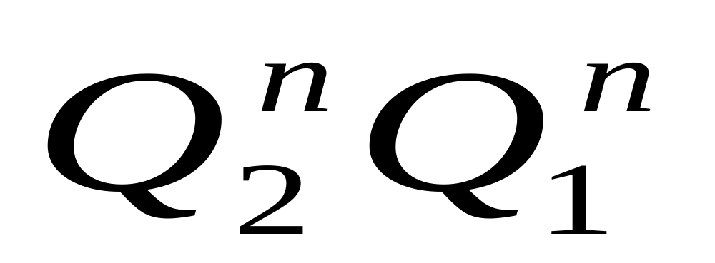
0
1
00
01
10
11
CP₃
0
1
00
01
10
11
J₃
0
1
00
01
10
11
K₃
0
d
0
1
0
0
1
d
d
0
d
1
d
d
d
d
CP₃=
J₃=
d
d
d
d
d
d
d
1
K₃=1

0
1
00
01
10
11
CP₂
0
1
00
01
10
11
J₂
0
1
00
01
10
11
K₂
0
1
1
0
d
d
0
1
d
1
d
d
1
d
d
d
de
d
1
d
d
d
d
1
CP₂=
+
J₂=1
K₂=1

0
1
00
01
10
11
CP₁
0
1
00
01
10
11
J₁
0
1
00
01
10
11
K₁
1
1
1
1
1
d
1
0
1
d
d
1
d
d
1
d
de
1
1
d
1
d
d
d
CP₁=
+
J₁=1
K₁=1

3、自启动检查

1 | 1 | 1 | 1 | 1 | 1 | 1 | 1 | 1 | 1 | 1 | 0 | 0 | 0 | 1
所以电路能自启动。

4、逻辑电路图略。

7.11 设计一个脉冲型异步时序电路，该电路有三个输入端，，，一个输出端Z。当且仅当输入序列--出现时，输出Z由0变为1，仅当又出现一个脉冲时，输出Z才由1变为0。
答：1、由题意分析可得原始状态图和原始状态表：
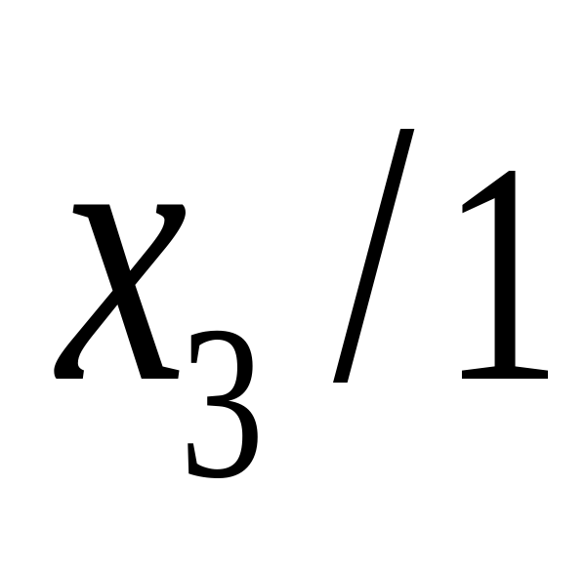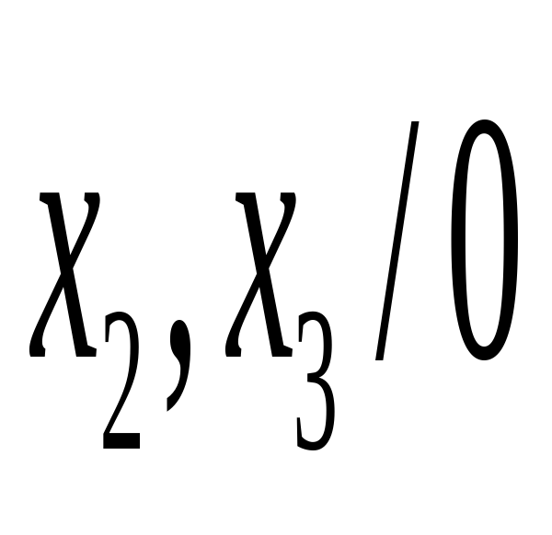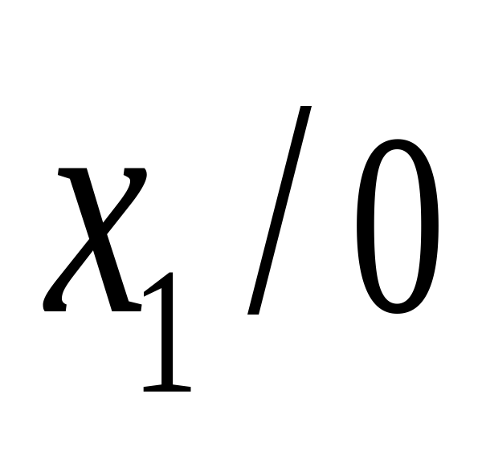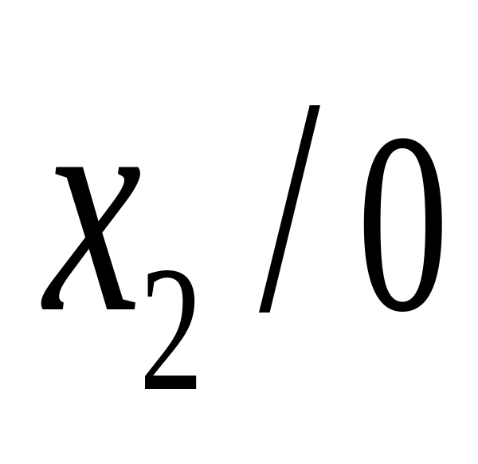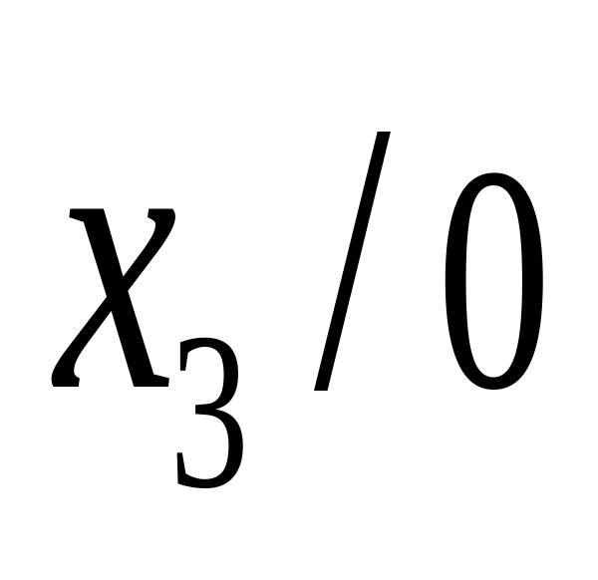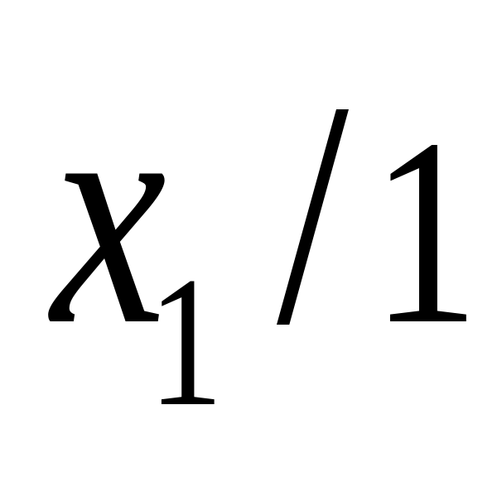
A
B
C
D
E
原始状态表为：
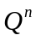 | 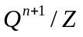
A | B/0 | A/0 | A/0
B | B/0 | C/0 | A/0
C | B/0 | A/0 | D/1
D | E/1 | A/0 | D/1
E | E/1 | C/0 | D/1

2、状态化简
已经是最简状态。
3、状态分配
根据状态分配的基本原则，得到A=000，B=001,C=010,D=011,E=111。
其二进制状态表如下：
000 | 001/0 | 000/0 | 000/0
001 | 001/0 | 010/0 | 000/0
010 | 001/0 | 000/0 | 011/1
011 | 111/1 | 000/0 | 011/1
111 | 111/1 | 010/0 | 011/1
4、选定触发器，确定控制函数和输出函数
选用D触发器。根据二进制状态表和D触发器激励表可以得到电路的输 出和激励状态表。如下：
 |  |  | 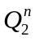 | 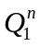 | 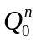 |  |  | 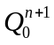 | 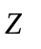 | 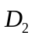 | 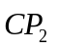 | 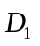 | 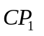 | 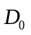 | 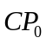
0 | 0 | 0 | 0 | 0 | 0 | 0 | 0 | 0 | 0 | d | 0 | d | 0 | d | 0
0 | 0 | 0 | 0 | 0 | 1 | 0 | 0 | 1 | 0 | d | 0 | d | 0 | d | 0
0 | 0 | 0 | 0 | 1 | 0 | 0 | 1 | 0 | 0 | d | 0 | d | 0 | d | 0
0 | 0 | 0 | 0 | 1 | 1 | 0 | 1 | 1 | 0 | d | 0 | d | 0 | d | 0
0 | 0 | 0 | 1 | 1 | 1 | 1 | 1 | 1 | 0 | d | 0 | d | 0 | d | 0
0 | 0 | 1 | 0 | 0 | 0 | 0 | 0 | 1 | 0 | d | 0 | d | 0 | 1 | 1
0 | 0 | 1 | 0 | 0 | 1 | 0 | 0 | 1 | 0 | d | 0 | d | 0 | d | 0
0 | 0 | 1 | 0 | 1 | 0 | 0 | 0 | 1 | 0 | d | 0 | 0 | 1 | 1 | 1
0 | 0 | 1 | 0 | 1 | 1 | 1 | 1 | 1 | 1 | 1 | 1 | d | 0 | d | 0
0 | 0 | 1 | 1 | 1 | 1 | 1 | 1 | 1 | 1 | d | 0 | d | 0 | d | 0
0 | 1 | 0 | 0 | 0 | 0 | 0 | 0 | 0 | 0 | d | 0 | d | 0 | d | 0
0 | 1 | 0 | 0 | 0 | 1 | 0 | 1 | 0 | 0 | d | 0 | 1 | 1 | 0 | 1
0 | 1 | 0 | 0 | 1 | 0 | 0 | 0 | 0 | 0 | d | 0 | 0 | 1 | d | 0
0 | 1 | 0 | 0 | 1 | 1 | 0 | 0 | 0 | 0 | d | 0 | 0 | 1 | 0 | 1
0 | 1 | 0 | 1 | 1 | 1 | 0 | 1 | 0 | 0 | 0 | 1 | d | 0 | 0 | 1
1 | 0 | 0 | 0 | 0 | 0 | 0 | 0 | 0 | 0 | d | 0 | d | 0 | d | 0
1 | 0 | 0 | 0 | 0 | 1 | 0 | 0 | 0 | 0 | d | 0 | d | 0 | 0 | 1
1 | 0 | 0 | 0 | 1 | 0 | 0 | 1 | 1 | 1 | d | 0 | d | 0 | 1 | 1
1 | 0 | 0 | 0 | 1 | 1 | 0 | 1 | 1 | 1 | d | 0 | d | 0 | d | 0
1 | 0 | 0 | 1 | 1 | 1 | 0 | 1 | 1 | 1 | 0 | 1 | d | 0 | d | 0

然后画卡诺图化简，得到控制函数和输出函数表达式。
画出逻辑电路图。

