Prequeities

1. Open JDK 17
2. Maven version 3.8.8
3. Database connection using MySQL version 8.0
4. In pom.xml, add below purpose for:
5. mysql-connector-j – for MySQL driver connector
6. spring-boot-starter-thymeleaf – for spring mvc web application using thymeleaf view (html)
7. springdoc-openapi-starter-webmvc-ui – for swagger api

Project Structure

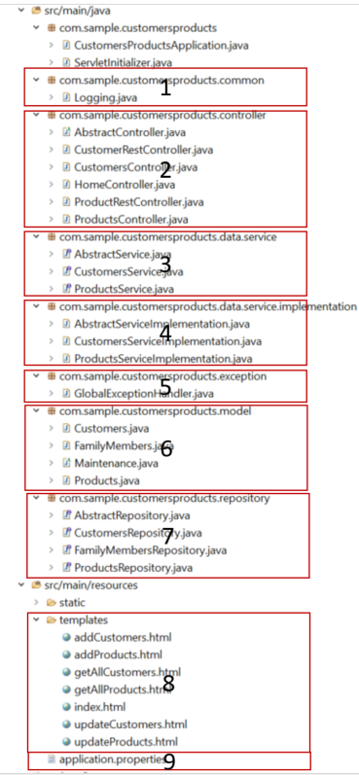

1. Common package to keep all the common method, example: logging method.
2. Controller package to keep all the controller such as controller and rest controller. Controller used for Spring MVC application to integrate with the view (html). Rest controller used for RESTful API.
3. Service package to keep all the service interface classes.
4. Service implementation package to keep all the service implementation classes.
5. Exception package to keep all the exception handle class and others custom exception classes.
6. Model package to keep all the model class which is integrate with JPA
7. Repository package to keep all the repository class for database query.
8. This folder is keep all the html or any others (view) like jsp for display web application and integrate with backend.
9. The properties file for this whole project, like connect which to which schema database, which database username, which database password, others spring configuration and so on.

UI

1. Index.html

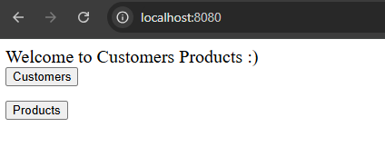

1. GetAllCustomers.html

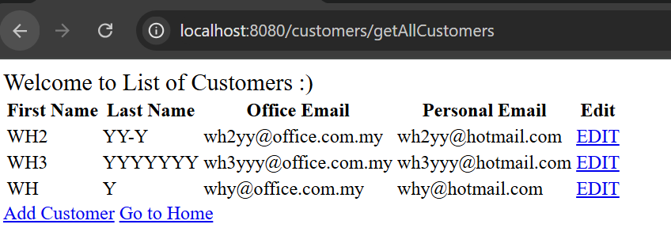

1. GetAllProducts.html

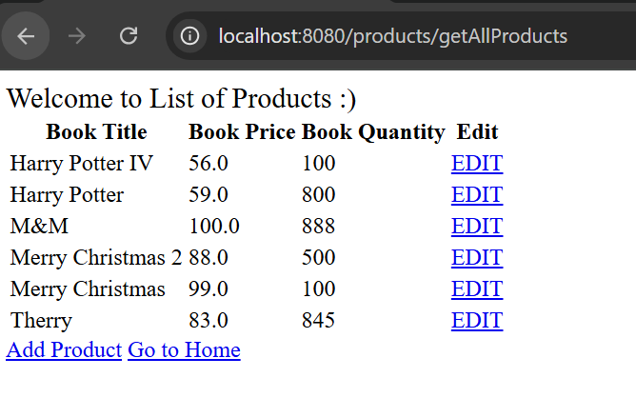

1. AddCustomers.html

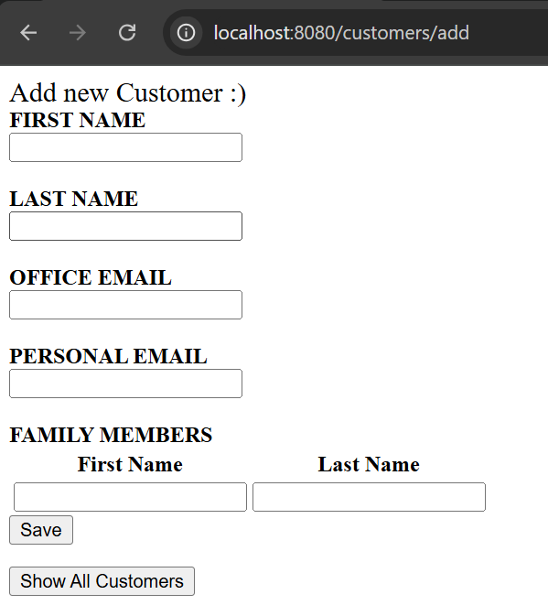

1. AddProducts.html

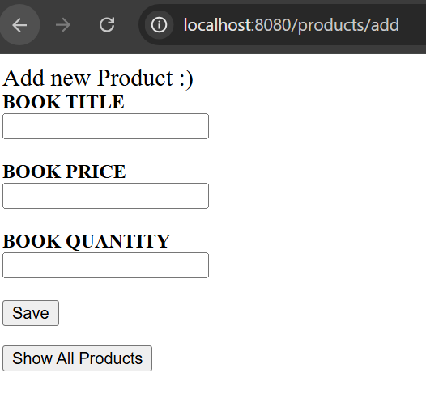

1. UpdateCustomers.html

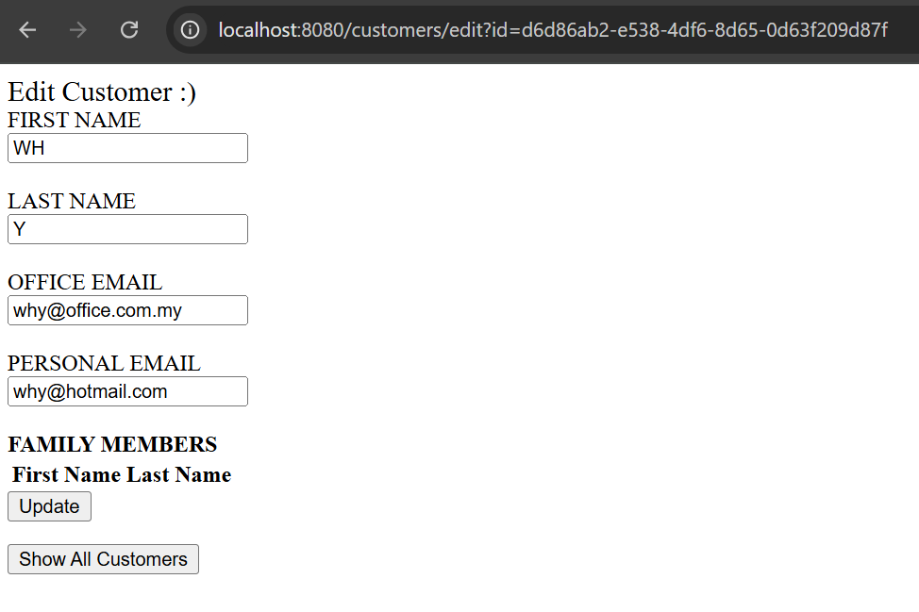

1. UpdateProducts.html

