**COLORFUSE**

**A close up of a logo

Description generated with very high confidence**

**Wireframe**

Throughout the 21st century, where different games came in development, we had decided to come up with a gentle twist for a specific existing application, “2Fuse”. Looking on the paradigm, there will be several functions that the user can interact with, let us start on the section below notification bar. Here, a display of remaining time, real-time update of score will be displayed. Simply, because this application objective, is to have the highest possible score within the allowed time. That being said, underneath this interface is the main course where the boxes are the continuous pop-up of different colors that the user should be able to combine to produce a great number of scores. Having that, on the last section of our paradigm, is the actual phone buttons. This will serve as a pause or exit for the application.

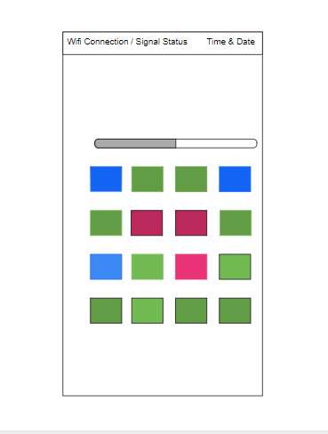

**Mockups**

Looking on this picture, this visualizes our continuous development of the application. Here, we have given a specified objective of this application whereas to present the boxes with full of three different colors. When the user was able to match the colors, they will be given a score, and this will be immediately replaced by another color – continuously. The time limit is also present which is located on the upper section that indicates the remaining chance of the user to earn more points and probably beat his/her highest score.

A screenshot of a cell phone

Description generated with high confidence

**Prototype**

This is the prototype of the application game called “ColorFuse". It is inspired of the game “2Fuse”, in which a user will match/combine a color in order to create another color and gain score. There are also 3 Boosters in the game. First is the Freeze, in which the timer stops in 10 secs. Then the Add Time, in which additional seconds will be added to the timer. These two is a booster in which the user can gain additional scores. The last booster is the Hint/Search, it will give you a hint, in order to match another color and gain scores.

There is also a X2 feature in the game. If you match the color with a X2, the score that you gained will be doubled. The goal of this game is to create more color and have the highest score.