Pima.te

The object is to “Find the best predictions for diabetes on the Pima.te data set”.

The Pima.te in in library MASS, it contains 8 rows, and 322 records.

We can see that in the data and finds out that the TYPE and other attributes did not show any arrangement so we can use 257 records as the training set and the other 65 as the testing set (80/20). And checking the baseline accuracy.

For easy interpretation and calculation of the odds ratios, we are introducing the dummy variables to the table.

Now, we have the ideal data which is about to analyze.

1.GLM

Using type as the objective, which is a dummy variable using 0 and 1 indicate the individual is a diabetes or not. Firstly, we use all the variables to do the logistic linear regression and can see in the summary that some attributes--- bp, skin, age are not related to the regression of having diabetes or not.

And we could do boxplot to show the relationship between type and attributes.

So, instead of doing step by step trying, we can use stepwise function to look for the ideal regression model.

By forward

Showing plot for forward_1

and we can see clearly in the Residual vs Fitted, there is a pattern, which indicates that the relationship between the TYPE and variables is not linear.

The result of glm1 and forwards is showed as followed, the dropping AIC and Residual deviance and degree of freedom showed the improvement of the model

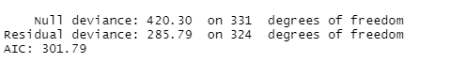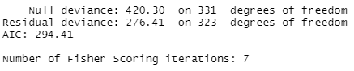

Now we are working on the test subset using it to predict the value of the type and compared it with the actual value.

After we done the glm(), the output is great, and after we done the prediction we got 80.59% accuracy when we set the Threshold = 0.46, and we can see in the ROC curve , it is a moderate model.

2. LDA

After, we set the group we could just using lda() function to do the analyze

Tab2 accuracy is 0.7313

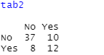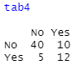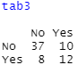

Tab3 accuracy is 0.7313

Tab4 accuracy is 0.7761