
A Secure Reversible Image Data Hiding with Encryption

A Research submitted in Partial Fulfillment of the Requirements for the Degree of Bachelor of Science (Engineering) in Computer Science and Engineering

Submitted By
Rupa Rani Das (ID: CE20025)
Session: 2019-2020
Dilruba Yeasmin Dipa (ID: CE21046)
Session: 2020-2021

Supervised By
Dr. Mahbuba Begum
Professor

Department of Computer Science and Engineering
Mawlana Bhashani Science and Technology University Santosh, Tangail-1902 Bangladesh

Approval

The research project titled “ A Secure Reversible Image Data Hiding Technique with Encryption” submitted by Rupa Rani Das, Student ID:CE20025 and Dilruba Yeasmin Dipa, Student ID:CE21046 to the Department of Computer Science and Engineering, Mawlana Bhashani Science and Technology University, Santosh, Tangail-1902, Bangladesh, has been accepted as satisfactory for the partial fulfillment of the requirements for the degree of Bachelors of Science (Engineering) in Computer Science and Engineering and approved as its style and contents.

Board of Examiners

…………………………………………………………………(Supervisor)

…………………………………………………………………(Examiner)

…………………………………………………………………(Examiner)

Declaration

Rupa Rani Das and Dilruba Yeasmin Dipa, here declared that the task presented in this thesis is the outcome of the investigation performed by us under the supervision of Dr. Mahbuba Begum, Professor, Department of Computer Science and Engineering (CSE), Mawlana Bhashani Science and Technology University, Santosh, Tangail-1902, Bangladesh. We further declare that no portion of this thesis or its component has been or are being considered for submission elsewhere in order to receive a degree or diploma.

Dr. Mahbuba Begum
Professor
Department of CSE, MBSTU …...………………………….
Santosh, Tangail-1902 Signature of Supervisor

Rupa Rani Das
Department of CSE, MBSTU …...………………………….
Santosh, Tangail-1902 Signature of Candidate

Dilruba Yeasmin Dipa
Department of CSE, MBSTU …...………………………….
Santosh, Tangail-1902 Signature of Candidate

Acknowledgment

First of all, we would like to express our deepest gratitude to Almighty Allah for giving us the strength and opportunity to come this far. Allah has been very kind to us, blessing us with everything we needed throughout this journey.
We sincerely appreciate our honorable supervisor, Dr. Mahbuba Begum, Professor in the Department of Computer Science and Engineering at Mawlana Bhashani Science and Technology University (MBSTU), for her guidance, support, and valuable ideas. She was very patient and kind to us. Her feedback and encouragement were truly helpful in completing this thesis.
We would also like to thank everyone in the Department of Computer Science and Engineering for their help and support. We are grateful to our parents, sisters, and brothers for their love and continuous support.
Finally, we gratefully acknowledge the authors and researchers whose valuable works have been studied and cited in this thesis.

Abstract

A large number of digital contents and multimedia data is transmitted through different communication channels every day. However, these communication channels are not always secure and may be accessed, modified, or attacked by unauthorized users. Unauthorized modification or deletion of image content can lead to serious security problems, including loss of data integrity, distribution of false information, alteration of original content, and reduced trustworthiness of digital images. To address these issues, Reversible Image Data Hiding with Encryption Technique is considered an effective and secure image protection technique that enables secure data embedding, transmission, and perfect recovery of the original image. In this thesis, we propose a secure and reversible image data hiding framework using dual encryption and adaptive embedding techniques. First, both the cover image and the secret image are encrypted using strong cryptographic algorithms to ensure data confidentiality and security. After encryption, the encrypted secret image data is embedded into the encrypted cover image using a reversible Least Significant Bit (LSB)-based embedding method combined with adaptive embedding and pixel permutation techniques. During the extraction stage, the embedded secret bits are separated from the encrypted cover image, and after decryption, both the original cover image and the secret image are recovered perfectly without any distortion. The proposed framework achieves high embedding capacity, high embedding efficiency, strong reversibility, and secure image transmission while preserving image quality. Experimental results on grayscale medical images demonstrate excellent visual quality with high PSNR and SSIM values, while maintaining a Bit Error Rate (BER) of zero, indicating perfect recovery of the secret image. The system also incorporates multiple layers of encryption and secure key generation mechanisms, providing high data confidentiality, strong data integrity, and enhanced protection against unauthorized access and tampering attacks.

Table of Contents
Approval ii
Declaration iii
Acknowledgment iv
Abstract v
List of Figures viii
List of Tables ix
List of Abbreviations x
Chapter 1 1
Introduction 1
1 .1 Background and Motivation 1
1.2 Objectives 2
1.3 Contributions 2
1.2 Organizations of the thesis 3
Chapter 2 4
Related Literature and Problem Statement 4
2.1 Literature Review 4
2.2 Problem Statement 7
Chapter 3 9
Theoretical Background 9
3.1 Reversible Image Data Hiding 9
3.2 Prediction and Encryption Techniques 9
3.3 Data Embedding and Key Management 9
3.4 Rationale and Benefits of the Proposed Hybrid Approach 10
Chapter 4 11
Methodology 11
4.1 Proposed Methodology 11
4.2 Key Generation Process: 13
Algorithm 1: Preprocessing and Key Generation 14
4.3 Encryption and Embedding Process: 15
Algorithm 2: Encryption and Embedding Process 17
4.4 Extraction and Decryption Process: 18
Algorithm 3: Extraction and Decryption Process 19
Chapter 5 20
Result Analysis and Discussion 20
5.1 Visual Performance of the Proposed Method 20
5.2 Security Metrics Analysis 22
5.3 Lossless Host Recovery Analysis 23
5.4 Embedding Capacity Analysis 24
5.5 Secret Image Recovery Performance Analysis 25
5.6 Embedding Rate Comparison with Existing Methods 26
5.7 Entropy Analysis 27
5.8 Correlation Analysis 28
5.9 Recovery Performance Analysis of Host Image 29
5.10 Computational Complexity Analysis 30
5.11 Summary of Results 31
Chapter 6 32
Conclusion and Future Work 32
6.1 Conclusion 32
6.2 Future Work 32
References 34

List of Figures

Figure 1.General Framework for Reversible Image data hiding. 1
Figure 2.Overview of System Architecture 11
Figure 3.Preprocessing and Key Generation Process 13
Figure 4.Encryption and Embedding Process 16
Figure 5.Extraction and Decryption Process 18
Figure 6.Different Host Images: (a) Lena (b) Baboon (c) Boat (d) Girlface (e) Barbara (f) Airplane (g) Couple (h) Zelda 20
Figure 7.Different Secret Images: (a) Breast Cancer (b) Chest X-ray (c) Kidney Cyst (d) Bone Fracture (e) Brain Tumor (f) Brain CT_ Scan 21
Figure 8. Visual quality of images:(a) Original host image(b) Secret image(c) Encrypted host image(d) Encrypted secret image(e)Embedded image(f) Recovered host image (g) Recovered secret image. 22
Figure 9. Embedding Capacity Analysis 24
Figure 10. Entropy Analysis of Cipher Images 27
Figure 11. Correlation Analysis of Cipher images 28
Figure 12. Recovery Performance Analysis of Host Image 29

List of Tables

Table 1.Overview of existing papers 6
Table 2: Security Analysis Metrics of the Proposed System 22
Table 3: Lossless Host Recovery Metrics of the Proposed Method 23
Table 4: Performance Analysis of Secret Image Recovery 25
Table 5: Comparison of Embedding Rate with Existing Methods by (BPP) 26

List of Abbreviations

RDH |  |  | Reversible Data Hiding
RDHEI |  |  | Reversible Data Hiding in Encrypted Images
LSB |  |  | Least Significant Bit
AES |  |  | Advanced Encryption Standard
CTR |  |  | Counter Mode
ECDH |  | Elliptic Curve Diffie–Hellman
HKDF |  | HMAC-based Key Derivation Function
MED |  | Median Edge Detector
PSNR |  | Peak Signal-to-Noise Ratio
SSIM |  | Structural Similarity Index Measure
MSE |  | Mean Squared Error
BER |  | Bit Error Rate
ROI |  | Region of Interest
ROI-RDH | Region of Interest Reversible Data Hiding
XOR |  | Exclusive OR
RGB |  | Red Green Blue
CPU |  | Central Processing Unit
GUI |  | Graphical User Interface
PNG |  | Portable Network Graphics
JPEG |  | Joint Photographic Experts Group
BPP |  | Bits Per Pixel
IoT |  | Internet of Things
AI |  | Artificial Intelligence
ML |  | Machine Learning
DNA |  | Deoxyribonucleic Acid
RSA |  | Rivest–Shamir–Adleman
SHA |  | Secure Hash Algorithm
API |  | Application Programming Interface
KDF |  | Key Derivation Function
ECB |  | Electronic Codebook
CBC |  | Cipher Block Chaining
GPU |  | Graphics Processing Unit

Chapter 1

Introduction

In this chapter, a brief introduction to A Secure Reversible Image Data Hiding technique with Encryption is presented. This chapter provides an overview of the research background, motivation, problem statement, objectives, contributions, and organization of the thesis. It also highlights the importance of secure data hiding and image protection in modern digital communication systems.

1 .1 Background and Motivation
Reversible image data hiding has emerged as a critical technique for securely embedding information in images at a time when the possibilities of data theft, unauthorized interception, and structural corruption are rapidly increasing. By embedding secret data into encrypted cover images, Reversible Image Data Hiding serves as a powerful mechanism for protecting sensitive information, particularly in domains such as medical, biometric, and military imaging [1, 2]. The need for Reversible image data hiding arises from the requirement to protect sensitive data while ensuring perfect recovery of the original content without compromising image quality, enabling privacy protection and integrity verification [3, 4] Modern encryption methods such as AES and ECC have gained significant attention for providing strong security in data transmission and storage [5].
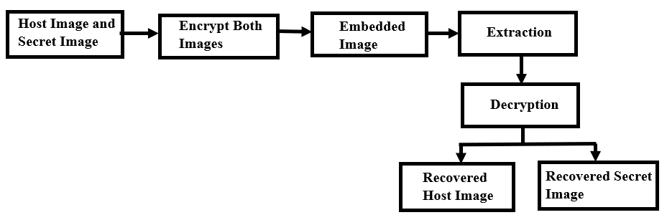
Figure 1.General Framework for Reversible Image data hiding.
Figure 1. shows how the secure image embedding system works. In this process, the host image and secret image are first encrypted and then combined to generate an embedded image. At the receiver side, the embedded image undergoes extraction and decryption, enabling the successful recovery of both the original host image and the secret image.
The motivation for this research stems from the limitations of existing RIDH techniques, which often struggle to balance robustness, reversibility, imperceptibility. However, after encryption, adding extra information to the image becomes difficult [6]. Early RDHEI methods mainly followed the Vacating Room After Encryption (VRAE) approach, where data is embedded after encrypting the image, but this method has limited embedding capacity due to the loss of pixel correlation [1,6].
To addresses these challenges, this thesis proposes an RDHEI framework with an auto-scaling and overflow-prevention embedding mechanism for high data-hiding capacity. The framework employs ECDH-384 key exchange and AES-CTR encryption to enhance security and data integrity [7,8,9]. It protects data security while ensuring lossless image recovery with perfect reconstruction quality (PSNR =∞, SSIM = 1.0) and accurate secret data extraction.

1.2 Objectives
The main objective of this research is to develop a secure and efficient hybrid reversible data hiding framework in encrypted images that ensures high embedding capacity, strong security, authentication, and perfect image recovery. The specific objectives are outlined as below:
- The main goal is to develop A Secure Reversible Image Data Hiding Technique using the RRBE architecture.
- To improve embedding capacity using MED prediction, adaptive embedding, and dynamic BPP allocation.
- To enhance security using block permutation, AES-CTR, and ChaCha20 encryption.
- To implement an adaptive secure data embedding technique for hiding secret information within encrypted images.
- To utilize ECDH-384 for secure key exchange.
- Our aim is to be able to recover the image without any loss and extract the secret data accurately.
- To evaluate performance using PSNR, MSE, SSIM, NC, BER, EC, and ER.
- To compare our Reversible Image Data Hiding method with existing methods to see how it does in terms of security, capacity, quality and efficiency.
These objectives are guiding us to develop and evaluate the proposed scheme. We hope to solve the problems of reversibility, robustness, security, efficiency and integrity in Reversible image Data Hiding technique.

1.3 Contributions
This thesis presents a novel approach to reversible data hiding, addressing key challenges in digital image security for sensitive applications such as medical imaging and multimedia protection. This research makes several important contributions to the field.
Major Contributions:

- Development of a Hybrid Reversible Image Data Hiding Security Framework.
- Improves reversibility using RRBE before encryption.
- Maximizes embedding capacity using MED prediction and adaptive BPP allocation embedding capacity.
- Secures image transmission using AES-CTR, block permutation, and ChaCha20 encryption.
- Reduces detectability using adaptive embedding instead of LSB substitution.
- Establishes secure key exchange using ECDH-384.
- Achieves lossless cover reconstruction and accurate secret recovery.
- Optimizes image quality, error rate, and embedding efficiency.
- Enhances security and robustness compared with conventional Reversible Image Data Hiding methods.

1.2 Organizations of the thesis
Chapter 2: Literature Review
This chapter reviews existing Reversible Image Data Hiding (RIDH) techniques, encryption algorithms, steganographic approaches, and related research works. It also discusses the limitations of existing methods.

Chapter 3: Theoretical Background
This chapter presents the theoretical concepts related to cryptography, steganography, reversible data hiding, image compression, and secure image communication systems that support the proposed Reversible Image Data Hiding framework.

Chapter 4: Proposed Methodology
This chapter explains the proposed Reversible Image Data Hiding framework in detail. The framework incorporates the RRBE architecture, MED prediction, adaptive embedding with dynamic BPP allocation, multi-stage encryption, adaptive modulo-based embedding, and the data extraction and image recovery process.

Chapter 5: Experimental Results and Analysis
This chapter presents simulation results, performance evaluation, visual analysis, and comparison with existing methods using PSNR, MSE, SSIM, BER, NC, and embedding rate.

Chapter 6: Conclusion and Future Work
The final chapter summarizes the research findings and evaluates the effectiveness of the proposed Reversible Image Data Hiding framework. It also suggests future improvements such as AI-based optimization, deep learning integration, and higher-capacity embedding techniques.

Chapter 2

Related Literature and Problem Statement

2.1 Literature Review
The field of image data hiding in encryption technique has gained a lot of attention because it can securely embed information into encrypted images. It also allows for the recovery of the original image after data extraction. Reversible image data hiding techniques are widely studied as they combine image security, privacy protection, and reversible reconstruction within a framework.
Several researchers have proposed high-capacity and efficient embedding techniques to improve the performance of reversible image data hiding systems. Malik et al. [1] introduced a multi-layer embedding strategy to increase embedding capacity while maintaining image reversibility and encryption security. Li et al. [2] developed a reversible data hiding method using Hamming code and unit detection to improve embedding accuracy and extraction reliability. Subramaniam [3] presented an analysis of different reversible data hiding approaches and highlighted the strengths and weaknesses of existing schemes. Kumar et al. [4] provided a survey discussing modern reversible image data hiding methods, challenges, and future research opportunities.
To enhance security during encrypted communication, several studies integrated cryptographic techniques into reversible image data hiding systems. Rehman et al. [5] proposed an AES-ECC security model for protecting sensitive data during transmission and storage. Venkatesh et al. [6] introduced a separable reversible data hiding approach based on encrypted pixel difference and vacating room after encryption, which improved embedding efficiency and information security. Ren et al. [7] proposed a MED-prediction and adaptive Huffman encoding method that achieved better compression and higher embedding performance. Chang [8] designed a block-level encryption and Huffman compression-based reversible data hiding technique to increase capacity and reduce redundancy.
Encoding and pixel prediction methods have also been explored for improving embedding performance. Gao et al. [9] proposed an image encoding and POB-based reversible data hiding method capable of achieving high embedding capacity. Yang et al. [10] enhanced reversible image data hiding performance using a pixel shifting mechanism to improve embedding quality and reversibility. Yang [11] introduced a data-hiders sharing algorithm that supports collaborative data embedding within encrypted images. Liu et al. [12] focused on reversible data hiding for remote sensing images and improved embedding performance under complex image structures.
Recent research has emphasized secret sharing, prediction, and adaptive embedding strategies. Saeidi and Mirza kuchaki [13] proposed an LWE-based sharing mechanism to improve encryption security in reversible data hiding. Vazhora Malayil et al. [14] developed a block-cyclic shifting-based reversible image data hiding method that enhanced embedding reliability and security during image transmission. Zhang et al. [15] introduced a block-based multi-predictor method that improved prediction accuracy and embedding efficiency. Zou et al. [16] utilized intrinsic correlation in block-based sharing to strengthen reversible data hiding performance over encrypted images.
Several studies also investigated optimization and interpolation-based embedding methods. Ayyappan et al. [17] developed a reversible data hiding and encryption framework for confidential image communication. Roselin kiruba [18] proposed a reversible data hiding method using optimization, interpolation, and binary image encryption techniques to improve image quality and embedding accuracy. Fan [19] introduced a high-capacity reversible data hiding scheme for encrypted binary images, achieving improved payload performance. Jiang et al. [20] designed a median edge detection and matrix-based secret sharing method that enhanced embedding security and robustness.
Prediction and compression-based approaches continue to play a major role in reversible image data hiding development. Yin et al. [21] proposed a pixel prediction and bit-plane compression method for data hiding in encrypted images. Gao et al. [22] introduced an EMD and PSIS-based embedding strategy to improve hiding capacity and extraction reliability. Anushiadevi et al. [23] developed a separable reversible data hiding approach using adjacent pixels to strengthen information security while preserving image quality. Zhang et al. [24] proposed horizontal and vertical pixel shifting with block partitioning to improve embedding flexibility and reversibility.
More recent studies focused on pixel mapping and block-level encoding techniques. Yang et al. [25] introduced a general pixel mapping-based reversible data hiding approach capable of improving embedding adaptability in encrypted images. Wang et al. [26] proposed a block-level pixel difference encoding method that achieved higher embedding performance and reduced distortion. Wang et al. [27] also developed a pixel shifting-based data hiding technique that enhanced embedding efficiency while preserving the reversibility of encrypted images.
Overall, existing studies demonstrate that reversible image data hiding has evolved significantly through the integration of encryption methods, pixel prediction strategies, adaptive embedding techniques, compression algorithms, and secret sharing mechanisms. Although many approaches have improved embedding capacity, reversibility, and security, challenges still remain in balancing payload size, computational complexity, image quality, and robustness. Therefore, further research is needed to develop more efficient and secure reversible image data hiding frameworks for encrypted image communication.

Table 1.Overview of existing papers
Reference & Year | Security Technique | Used Method (Keywords) | Experimental Results | Limitations (Keywords)
[1] Malik et al.  (2020) | Stream Cipher, Block Permutation | Multi-Layer Embedding, Prediction Error, Arithmetic Coding | • BPP: 3.59 (Lena), 4.18 (Airplane)  • PSNR: ∞  • BER/NC: 0 / 1.0 | Multi-layer operations increase computing time linearly.
[2] Li et al.  (2021) | Stream Encryption (RC4 / AES-like XOR) | (7, 4) Hamming Code, UnitSmooth Detection | • BPP: Max 0.443  • PSNR: ∞  • SSIM: 1.0  • BER/NC: 0 / 1.0 | Capacity drops drastically in textured/complex images.
[3] Jose & Subramaniam  (2020) | Comparative Assessment (Various) | Critical Framework Analysis, Multi-Class Review | Consolidates baseline PSNR, BPP, and execution times. | Review paper only; no standalone proposed algorithm.
[4] Kumar et al.  (2021) | Taxonomy Evaluation (Various) | State-of-the-Art Survey, Paradigm Evaluation, Open Challenges | Tabulates and evaluates historic framework benchmarks. | Survey paper only; provides no new practical algorithm.
[5] Rehman et al.  (2021) | Asymmetric Key Cryptography (AES + ECC) | Hybrid AES-ECC, Cloud Cryptography | • Execution: ~13.5ms (2MB)  • Avalanche Effect: High | Not RDHEI; lacks image processing or payload extraction.
[6] Venkatesh et al.  (2025) | Block-level Chaos Scrambling, Diffusion | VRAE, Encrypted Pixel Difference, Pixel Value Ordering | • BPP: High capacity  • PSNR: ∞  • SSIM: 1.0  • BER/NC: 0 / 1.0 | Complex pre-calculation required to vacate room after encryption.
[7] Ren et al.  (2023) | Permutation Cipher, Orthogonal Encryption | Multi-Prediction, Adaptive Huffman Encoding, Block Processing | • BPP: Higher embedding rate  • PSNR: ∞  • SSIM: 1.0  • BER/NC: 0 / 1.0 | High computational overhead from multi-prediction passes.
[8] Chen & Chang  (2021) | Block-level Exclusive-OR (XOR) Encryption | Block-level Encryption, Huffman Coding, Space Vacating | • BPP: 1.55 (Lena), 2.14 (Airplane)  • PSNR: ∞  • SSIM: 1.0  • BER/NC: 0 / 1.0 | Strict block-size structural dependencies.
[9] Gao et al.  (2020) | Bit-Plane Encryption, Pseudo-random Shuffling | JPEG-LS, Bit-Plane Encryption, POB System | • BPP: Avg >2.5 (Max >3.0)  • PSNR: ∞  • BER/NC: 0 / 1.0 | Highly reliant on spatial correlation of plaintext image.
[10] Ankur et al.  (2025) | Pixel Transfiguration, Stream Cipher Obfuscation | Difference Image Transfiguration, Pixel Scrambling | • BPP: Optimized capacity  • PSNR: ∞  • SSIM: 1.0  • BER/NC: 0 / 1.0 | Vulnerable to multi-image differential cryptanalysis attacks.

2.2 Problem Statement
Based on the analysis in section 2.1, several limitations remain despite recent progress:
  - Existing methods often suffer from high computational complexity, which increases processing time and reduces efficiency.
  - The embedding capacity decreases significantly when images contain complex textures or detailed regions.
  - Many studies provide only theoretical reviews and surveys, without proposing practical implementation frameworks.
  - Several secure encryption schemes focus on data security but do not support reversible image recovery and data extraction simultaneously.
  - Existing room-vacating approaches require complex pre-processing operations, making them difficult to implement efficiently.
  - Some techniques depend heavily on fixed block structures, reducing flexibility and adaptability to different image types.
  - Many methods rely strongly on the spatial correlation of original images, causing performance degradation for diverse image contents.
  - Certain encryption and embedding schemes remain vulnerable to advanced cryptanalysis attacks, creating security concerns for sensitive applications.
Motivated by the above research gaps, we have designed a hybrid reversible image data hiding framework to improve embedding capacity, image quality, and security simultaneously. Preserving the reversibility and integrity of encrypted images, the proposed system integrates secure encryption and adaptive embedding techniques to minimize distortion and improve extraction accuracy.

Chapter 3

Theoretical Background

3.1 Reversible Image Data Hiding
Reversible Image Data Hiding is a way to hide information in encrypted images. This method ensures that the original image can be restored after the hidden information is extracted. Reversible Image Data Hiding combines image encryption, secure communication, and reversible reconstruction. The main goal of Reversible Image Data Hiding is to maintain both data confidentiality and image reversibility.
This technique is different from conventional data hiding methods. It ensures that the original image can be recovered without any damage. The framework uses the Reserving Room Before Encryption architecture. This means that space is reserved in the image before it is encrypted. This approach improves the efficiency of embedding and reversibility. Reversible Image Data Hiding is very useful because it allows the original image to be restored perfectly.
The framework consists of several steps: space reservation, image encryption, data embedding, data extraction, and image recovery. Reversible Image Data Hiding is important for maintaining data confidentiality and ensuring that the image can be restored. The Reserving Room Before Encryption architecture provides several benefits, including higher embedding capacity, better image quality, reduced distortion, and improved reversibility.

3.2 Prediction and Encryption Techniques
The framework uses the Median Edge Detector predictor. This predictor estimates neighboring pixel values and generates prediction errors. The prediction errors are used for embedding and accurate image recovery. The framework also uses AES-CTR encryption to protect the image. AES is an encryption algorithm that is recognized for its security and efficiency.
The CTR mode enables fast processing and parallel encryption operations. Block permutation is also applied before encryption. This means that image blocks are rearranged randomly using cryptographic seeds. This process makes the image more random and improves its security. ChaCha20 encryption is used to secure the image before embedding. ChaCha20 is a stream cipher that offers high processing speed, strong security, and effective protection against timing attacks.

3.3 Data Embedding and Key Management
The framework uses a modulo-based embedding technique. This technique is different from Least Significant Bit substitution. Secret bits are embedded by modifying pixel values. The embedding process also uses texture-based pixel selection. This means that textured areas are selected for data hiding.
This approach minimizes distortion because changes in textured areas are less noticeable to the human eye. The framework also uses bits-per-pixel allocation. This determines the embedding capacity based on payload requirements and image characteristics. The framework uses Elliptic Curve Diffie–Hellman for key exchange. This provides strong security with relatively small key sizes.
Reversible Image Data Hiding is very important for secure communication. The integration of embedding, texture-based pixel selection, dynamic capacity allocation, and secure key exchange makes the framework highly secure. Reversible Image Data Hiding combines multiple techniques to provide strong security and reversibility. The framework is very useful for maintaining data confidentiality and ensuring that the image can be restored perfectly.

3.4 Rationale and Benefits of the Proposed Hybrid Approach
The proposed framework adopts a hybrid security approach by integrating reversible data hiding, encryption, adaptive embedding, and secure key exchange techniques into a unified framework. The main objective of this hybrid design is to improve security, embedding efficiency, reversibility, and image quality simultaneously.
The RRBE mechanism reserves embedding space before encryption, which improves reversibility and reduces embedding distortion. MED prediction supports efficient prediction error generation and reversible image reconstruction. AES-CTR encryption, block permutation, and ChaCha20 encryption strengthen image confidentiality and improve overall encryption security.
The adaptive modulo-based embedding technique, dynamic BPP allocation, and texture-based pixel selection improve embedding efficiency while maintaining high image quality. ECDH-384 key exchange securely establishes cryptographic keys between communicating parties.
The integration of these techniques provides several important benefits including enhanced security, high embedding capacity, improved image quality, strong reversibility, efficient embedding performance, and reliable multimedia protection. Therefore, the proposed framework offers an effective solution for secure reversible data hiding in encrypted images for modern multimedia communication systems.

Chapter 4

Methodology

4.1 Proposed Methodology
The proposed system presents A Secure Reversible Image Data Hiding with Encryption process framework based on the Reserving Room Before Encryption (RRBE) architecture. This framework presents a secure and Reversible Image Data Hiding with Encryption framework for confidential embedding of encrypted secret images into encrypted host images with perfect recovery of both images. To enhance security, embedding capacity, scalability, and reversibility, the framework introduces the Adaptive Multi-Layer Adaptive Payload System (AML-APS), which employs a dual-layer encryption mechanism for robust data protection. Our system uses security techniques such as Elliptic Curve Diffie-Hellman key exchange, HKDF-based key derivation, ChaCha20 encryption and AES-CTR encryption.
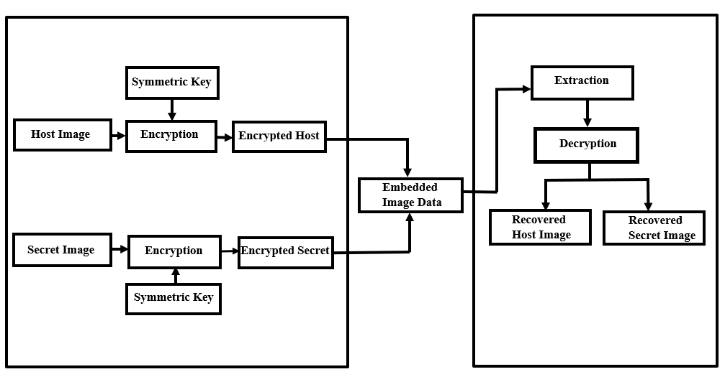
Figure 2.Overview of System Architecture

Figure 2. Shows that initially, a host image and a secret image are selected as input images. The embedding capacity of the host image is then evaluated to determine whether it can accommodate the secret image. If the secret image size exceeds the available embedding capacity, it is automatically resized using the Lanczos interpolation method. This resizing process prevents payload overflow, maintains system stability, and ensures successful embedding and recovery operations. Then both images are converted into grayscale image matrices and prepared for subsequent encryption and data hiding processes. After image preprocessing, a secure shared secret is established using the Elliptic Curve Diffie–Hellman (ECDH) key exchange protocol based on the SECP384R1 elliptic curve. The shared secret is expanded into independent cryptographic keys and random seeds, including an AES key for cover image encryption, a ChaCha20 key for secret image encryption, and random seeds required by the proposed system. The random seeds are used to control payload permutation and block permutation processes. After key generation phase, the host image and the secret image go through encryption procedure. First the host image is broken into blocks that do not overlap and these blocks are rearranged using a random code made from the shared secret. This makes the image look more random and reduces the connection between pixels. Then the rearranged host image is encrypted using an encryption method called AES in Counter mode with a 128-bit key made from the shared secret. This makes an encrypted host image that hides what the original host image looked like. At the time the secret image is encrypted using a method called ChaCha20. A 256-bit key made from the shared secret and a random code are used to encrypt the image. The encrypted secret image is then turned into a stream of bytes to make the payload. To make the payload the size of the image is stored as a header and added to the encrypted secret image data. The resulting stream of bits is then rearranged randomly using a code made from the shared secret. The bits are also flipped to make the payload more random. Finally, a header with the length of the payload is added to help the extract and rebuild the image correctly. After the payload is built the encrypted secret data are hidden into the encrypted host image. This is done using a system called Adaptive Multi-Layer Adaptive Payload System (AML-APS). First a special analysis is done on the encrypted host image to find areas with texture. These areas are better for hiding data. Based on how much data needs to be hidden and how much space's available a value that shows how many bits can be hidden per pixel is automatically decided. The payload bits are then. Hidden into the chosen pixels by changing their residue values. Before hiding the original values of the chosen pixels are kept as information. This makes sure that the original host image and the secret image can be perfectly recovered later. The hiding process creates the embedded image that contains the encrypted secret data, within the encrypted host image.
At the extraction phase, the embedded information is extracted from the embedded image using the embedding positions and adaptive embedding parameters generated during the embedding process. The selected pixels are analyzed, and the embedded bit stream is recovered by obtaining the corresponding residue values from the embedded image. The extracted bit stream is separated into the payload header and encrypted secret data. Then the payload is decoded by reversing the payload permutation and bit inversion operations. The header information is used to determine the size of the secret image, while the remaining payload bits are reconstructed into the encrypted secret image data. The encrypted secret image is decrypted using the ChaCha20 stream cipher with the corresponding secret key and nonce generated during the key derivation stage. This process restores the original secret image accurately. The original host image uses the backup values associated with the modified encrypted pixels are first restored, thereby reconstructing the encrypted host image in its pre-embedding state. Subsequently, AES-128 decryption in Counter (CTR) mode is performed using the corresponding encryption key and nonce. Finally, the inverse block permutation operation is performed to rearrange the image blocks and enable exacting reconstruction of the original host image. As a result, the proposed AML-APS framework achieves separable and reversible data hiding, allowing both the secret and the host images to be recovered accurately.
The algorithm of the proposed A Secure Reversible Image Data Hiding with Encryption framework is presented in the next section. It summarizes the complete procedural steps of encryption, embedding, extraction and recovery in a structured form.

4.2 Key Generation Process:
In this phase, the host image and secret image are prepared for further processing by converting them into grayscale format and checking embedding capacity of the host image. A secure shared secret is generated using the ECDH method for key exchange. Using the shared secret, multiple cryptographic keys are derived using HMAC-based HKDF method. These keys and random numbers keep everything scrambled and handled properly.

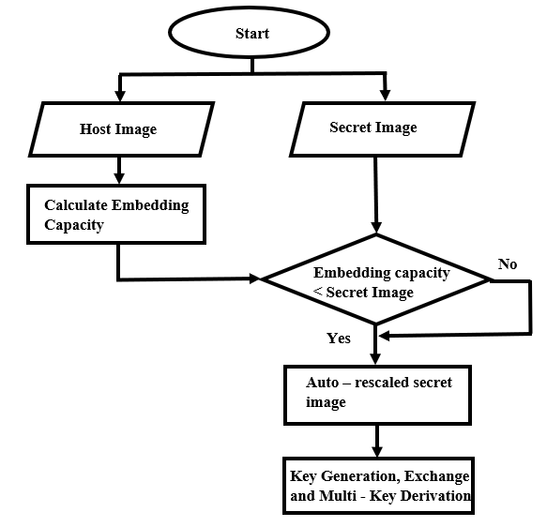
Figure 3.Preprocessing and Key Generation Process

Algorithm 1: Preprocessing and Key Generation

Input: Host image I (512*512), Secret image S
Output: AES key $K_{AES}$​, ChaCha20 key$K_{CH}$, permutation seeds ($Seed_{B}$,$Seed_{p}$)
Preprocessing Images:
Convert the Host and secret images into grayscale matrices:
I ← GrayScale (I)
S ← GrayScale (S)
If the secret image exceeds the embedding capacity, resize it adaptively:
S′ ← Resize (S)
such that
$$\left|S^{'}\right|≤\frac{\left(M × N\right)*BPP - 1024}{8}$$
where M×N is the host image size and BP is the embedding rate.
Key Generation:
Generate two random elliptic-curve private keys:
$d_{A}$← ECPrivateKey ()
$d_{B}$ ← ECPrivateKey ()
Compute the shared secret key using Elliptic Curve Diffie-Hellman (ECDH):
SS = $d_{A}$⋅ $Q_{B}$
$Q_{B}$​ =${ d}_{A}$ ⋅ ​G
Where,
and G is the elliptic-curve base point.
Key Derivation:
Derive the AES-128 key using HKDF-SHA256:

$K_{AES}$= $HKDF_{SHA256}$ ​(SS, "aes-host ")
Derive the ChaCha20 key using HKDF-SHA256:
$K_{CH}$= $HKDF_{SHA256}$ (SS, "chacha-sec")
Generate the payload permutation seed:
$Seed_{P}$ = Int (SHA256 (SS ∥ "perm") [0:8])

$Seed_{B}$ = Int (SHA256 (SS ∥ "block") [0:8])
Generate random nonces:
$N_{AES}$← Random (128)
$N_{CH}$ ← Random (128)

In Algorithm 1, the host and secret images are first converted into grayscale format to simplify secure processing and embedding operations. ECDH key exchange and HKDF-SHA256 are then used to generate strong cryptographic keys for AES and ChaCha20 encryption.

4.3 Encryption and Embedding Process:
The host image and secret image are encrypted using encryption algorithms separately to protect their contents. The encrypted secret image is then converted into a payload and prepared for embedding stage. The payload is hidden inside the encrypted cover image using the Adaptive Multi-Layer Adaptive Payload System (AML-APS) embedding method. This process produces the embedded image that securely contains the encrypted secret image data.
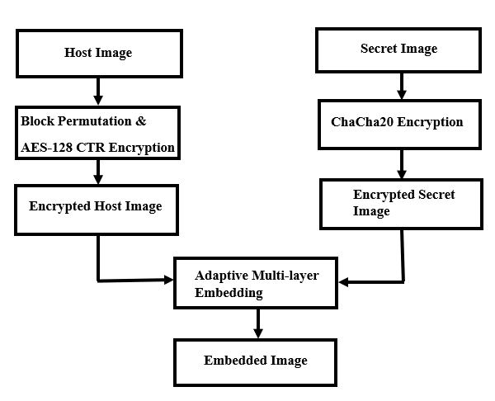
Figure 4.Encryption and Embedding Process

In Figure 4, AES encryption is used to securely protect the host image, while ChaCha20 encryption is applied to ensure secure transmission of the secret image. These encryption methods improve data security and help prevent unauthorized access during the embedding process.

Algorithm 2: Encryption and Embedding Process
Input: Host image I, Secret image S, Keys, Seeds, Nonce Output: Embedded image
Host Image Encryption
Divide I into non-overlapping blocks
Permute blocks using $Seed_{B}$
$I_{perm}$= π $Seed_{B}$ (I)
Encrypt using AES-CTR
$I_{enc}$= $AES_{CTR}$($I_{perm}$, $K_{AES},$ $N_{AES}$ ​)
Secret Image Encryption
Convert S into byte stream
Encrypt using ChaCha20
$S_{enc}$= ChaCha20(S, $K_{CH}$, ​$N_{CH}$)
Payload Formation
Combine size and encrypted secret:
P = Shape (S) ∥ $S_{enc}$
Convert to bitstream:
B = U N P A C K BITS (P)
Permute bits using $Seed_{P}$
B′ = $π_{seed}$ P (B) ⊕ 1
Embedding
Compute embedding capacity:
EC= ∣ I∣ × BPP
Embed B′ into encrypted cover:
$I_{embed}$ = Embed ($I_{enc}$, B′)

4.4 Extraction and Decryption Process:
In this stage, the embedded secret data is taken out from the embedded image. The extracted data is used to recover the encrypted secret image and then decrypt it to obtain the original secret image. The encrypted host image is also restored and decrypted. Finally, both the original host image and secret image are recovered
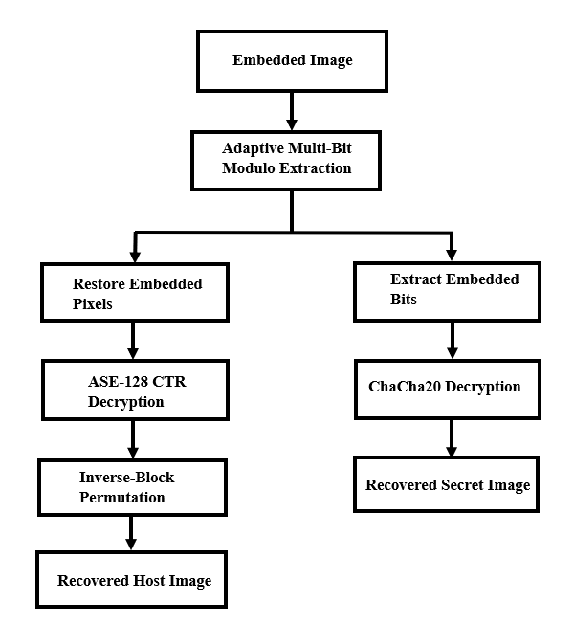
Figure 5.Extraction and Decryption Process

In Figure 5, the embedded data is extracted using adaptive multi-bit extraction while the encrypted host image is restored through AES-128 CTR decryption and inverse block permutation. ChaCha20 decryption is then applied to recover the original secret image securely and accurately.

Algorithm 3: Extraction and Decryption Process

Input: Embedded Image $I_{embed}$, Keys, Seeds, Nonce
Output: Recovered host image $I_{rec}$, Recovered secret image $S_{rec}$
Extraction
Extract embedded bits from $I_{embed}$
Recover payload using $Seed_{P}$
P = Parse (Extract ($I_{embed}$), $Seed_{P}$)
Separate payload:
P = (Shape (S), $S_{enc}$)
Secret Image Recovery
Decrypt secret image using ChaCha20:
$S_{rec}$= $ChaCha{20}^{-1}$($S_{enc}$, $K_{CH}$, ​$N_{CH}$)
Host Image Recovery
Restore encrypted cover image
Decrypt using AES-CTR:
$I_{rec}$ = $AES_{CTR}^{-1}$ ($I_{enc}$, $K_{AES},$ $N_{AES}$)
Output:
{$I_{rec}$, $S_{rec}$}

Chapter 5

Result Analysis and Discussion

This chapter represents the test results and performance evaluation of the Reversible Image Data Hiding with Encryption Technique. The experiments used grayscale images of size 512 × 512 pixels as host images. Medical images were used as secret images. The main goal of these experiments was to check how well the Reversible Image Data Hiding method works, how secure it is and how reliable it is. The RDHEI method was tested using various performance metrics including image quality, security, reversibility, embedding capacity, entropy, correlation, secret image recovery and computational complexity. We checked how well the RDHEI method works based on quality, security, reversibility, embedding capacity, entropy, correlation, secret image recovery and computational complexity. Our results show that the RDHEI method can successfully hide data in encrypted images. Both the secret image and the original host image can be recovered without any loss.

5.1 Visual Performance of the Proposed Method
Visual analysis of performance is an important part for evaluating a proposed system. This is a part of seeing how well the Reversible Data Hiding in Encrypted Images system works. It helps to examine the effects of encryption, data embedding and recovery on image appearance.
In this experiment, a grayscale image was used as the host image and a medical image was used as the secret image. The images were processed through different stages, including encryption, data embedding, extraction, and recovery. Different cover images and secret images which we used are present in Figure 6 and Figure 7.

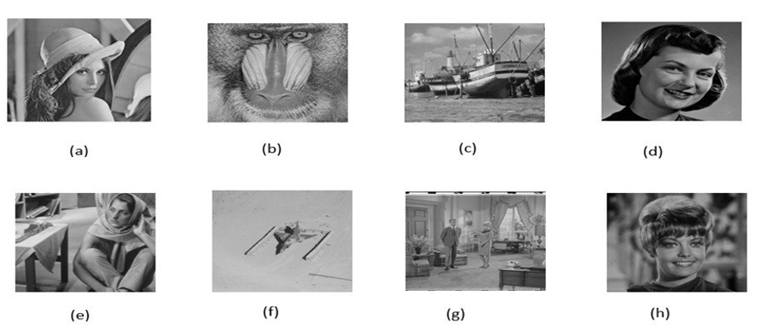
Figure 6.Different Host Images: (a) Lena (b) Baboon (c) Boat (d) Girlface (e) Barbara (f) Airplane (g) Couple (h) Zelda [28,29,30]

In Figure 6, different host images used in the experiment are shown, including Lena, Baboon, Boat, Girlface, Barbara, Airplane, Couple, and Zelda. These images serve as cover images for embedding secret data in the proposed method. Each image has different textures and structures, which helps in evaluating the performance of the system under varied conditions. Overall, Figure 6 represents the diverse set of host images used in this work.
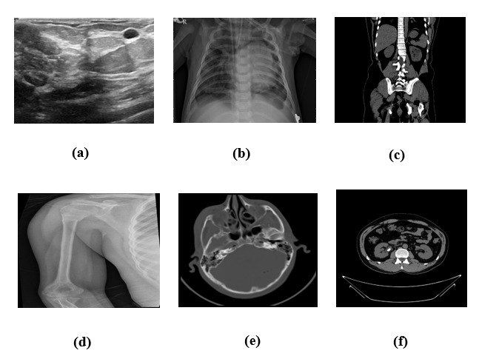
Figure 7.Different Secret Images: (a) Breast Cancer (b) Chest X-ray (c) Kidney Cyst (d) Bone Fracture (e) Brain Tumor (f) Brain CT_ Scan [28,29,30]

In Figure 7, different secret images used in the experiment are shown, including Breast Cancer, Chest X-ray, Kidney Cyst, Bone Fracture, Brain Tumor, and Brain CT Scan. These images represent sensitive medical data that are used as hidden information in the proposed system. Each image contains different types of clinical features, making the dataset more diverse and realistic. Overall, Figure 7 shows the set of secret images used for data embedding and testing.

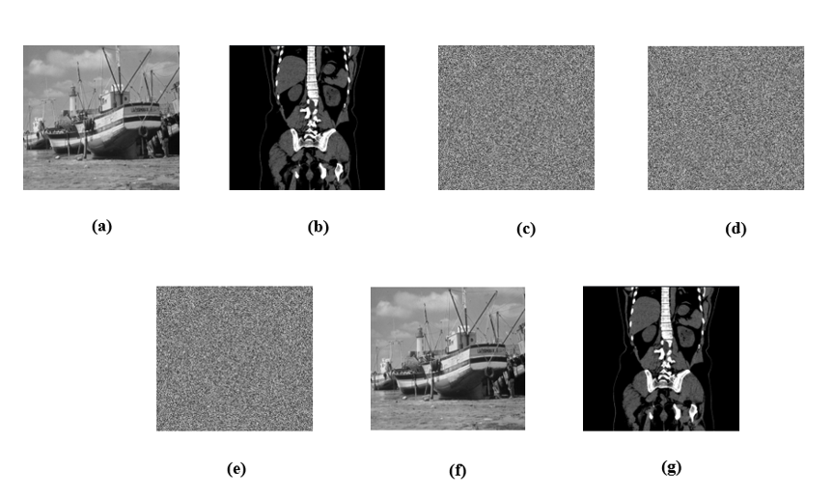
Figure 8. Visual quality of images:(a) Original host image(b) Secret image(c) Encrypted host image(d) Encrypted secret image(e)Embedded image(f) Recovered host image (g) Recovered secret image. [28,29,30]
Figure 8 shows us what the Reversible Image Data Hiding method looks like at stages of hiding and recovering data. Figure 1(a) shows the original host image, while Figure 1(b) represents the secret image. When we apply the encryption process to these pictures they change into encrypted forms. We can see the encrypted host picture in Figure(c) and the encrypted secret picture in Figure 1(d). Then, the encrypted secret data is put into the encrypted host picture to make the embedded picture, which is shown in Figure 1(e). The recovery stages of both images are shown in Figure 1(f) and Figure 1(g).

5.2 Security Metrics Analysis
This section evaluates the security performance of the proposed system using Peak Signal-to-Noise Ratio (PSNR) between the original host image and the encrypted image and the encrypted image and the marked-encrypted image. The security analysis metrics of the Proposed System are presented in Table 2.

Table 2: Security Analysis Metrics of the Proposed System
Host Image (512×512) | Encrypted PSNR (dB) | Marked-Encrypted PSNR (dB)
Lena | 9.24 | 9.25
Baboon | 9.64 | 9.65
Boat | 9.29 | 9.32
Girlface | 8.10 | 8.13
Barbara | 8.81 | 8.85
Airplane | 8.97 | 9.03
Zelda | 8.86 | 8.93
ridge | 8.77 | 8.83
Couple | 9.63 | 9.70

Table 5.1 shows that the PSNR values of nine 512×512 host images are shown in both encrypted and marked-encrypted states. PSNR is a way to measure the quality of an image. It checks how much an image is distorted during processing. slightly from 9.24 dB to 9.25 dB after data embedding. This is also true for images like Baboon, Boat, Girlface, Barbara, Airplane, Zelda, Ridge and Couple. These images show increases in their PSNR values. This means that adding data to an image does not distort it. These small differences in PSNR values mean that data embedding does not distort encrypted images. This shows that the proposed Reversible Image data Hiding method can add information without changing the look of encrypted images. In short, the results confirm that the proposed scheme keeps image quality stable after data embedding and hides data effectively with impact, on encrypted host images. The PSNR. The proposed Reversible Image Data Hiding method help to ensure that encrypted images remain useful. The method preserves the characteristics of encrypted images.

5.3 Lossless Host Recovery Analysis
The primary goal of RDHEI is to achieve perfect reconstruction of the original host image and secret image after data extraction. Table 3 presents the host recovery performance of the proposed method.

Table 3: Lossless Host Recovery Metrics of the Proposed Method
Image (512×512) | PSNR (dB) | MSE | SSIM | NC
Lena | ∞ | 0 | 1 | 1
Baboon | ∞ | 0 | 1 | 1
Boat | ∞ | 0 | 1 | 1
Girlface | ∞ | 0 | 1 | 1
Barbara | ∞ | 0 | 1 | 1
Airplane | ∞ | 0 | 1 | 1
Zelda | ∞ | 0 | 1 | 1
Bridge | ∞ | 0 | 1 | 1
Couple | ∞ | 0 | 1 | 1

Table 5.2 shows how well our RDHEI method works for recovering the image without any loss for nine standard test images that are 512×512 pixels. We used four metrics to check the quality: PSNR, MSE, SSIM and NC. The results are the same for all test images. For each image the recovered version has a PSNR value of ∞ dB, an MSE value of 0 an SSIM value of 1 and an NC value of 1. These are the possible values for recovering an image without any loss. The recovered image and the original image are identical pixel for pixel and the structure and details of the image are perfectly preserved. These consistent results across all test images show that our method is robust and reliable. Since all quality metrics reach their possible values, we can conclude that our Reversible Image Data Hiding scheme successfully recovers the original image without any distortion, loss of information or visual degradation. This confirms that our system is completely reversible and suitable, for applications where accurate and lossless image recovery is required. The proposed method delivers lossless recovery.

5.4 Embedding Capacity Analysis
The embedding capacity refers to the amount of secret information that can be embedded within the encrypted host image. We used some medical images with different sizes to see how well our method works. The results of embedding capacity of our proposed experiment are shown in Figure 9.

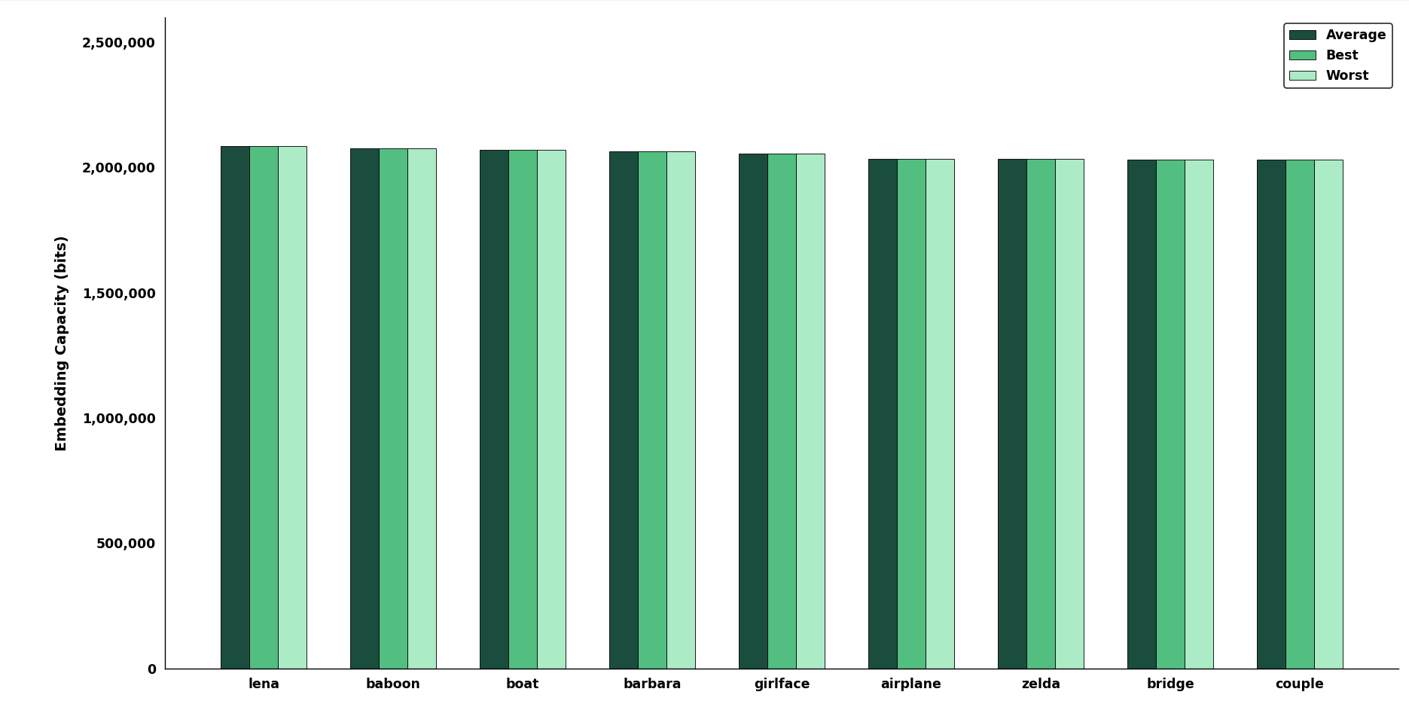
Figure 9. Embedding Capacity Analysis

In Figure 9, shows how well our Reversible Image Data Hiding method works for hiding information in nine standard test images that are 512×512 pixels. The methods embedding capacity is the amount of secret information that can be hidden in an encrypted image and still be recovered successfully. Our method does a job of hiding a lot of secret information in all the test images. The average, best and worst embedding capacities for each image are the same, which means our method works reliably. The embedding capacities range from about 2.03 million bits to 2.09 million bits for all the images we tested including: Lena, Baboon, Boat, Barbara, Girlface, Airplane, Zelda, Bridge, and Couple. There is no difference in how well our method works for different images. This means that how well our method hides secret information doesn't depend on what is in the image or how textured it's. The small differences between the worst cases show that our method is robust. Our method can hide over two million bits of information while keeping the image reversible and secure. This makes it suitable for sending amounts of confidential information in encrypted images. The results are consistent, across types of images. Our RDHEI method provides a stable embedding capacity.

5.5 Secret Image Recovery Performance Analysis
This section checks how well the RDHEI method works in getting secret images. For testing medical images of different sizes and types are used. The quality of recovery is measured using PSNR and Bit Error Rate (BER). The results are shown in Table 4.

Table 4: Performance Analysis of Secret Image Recovery
Secret Image | Image Size | PSNR (dB) | BER
Breast Cancer | 777 × 578 | ∞ | 0
Chest X-ray | 1024 × 680 | ∞ | 0
Kidney Cyst | 865 × 700 | ∞ | 0
Ultrasonogram of Fetus | 800 × 540 | ∞ | 0
Thyroid Cancer | 982 × 762 | ∞ | 0
Bone Fracture | 640 × 640 | ∞ | 0
Brain CT Scan | 650 × 650 | ∞ | 0
Brain Tumor | 512 × 512 | ∞ | 0
Kidney Stone | 512 × 512 | ∞ | 0

This table shows how well our RDHEI method works for medical secret images of various sizes. The dataset has medical images like X-ray CT scan, ultrasound and other diagnostic images. These are often used in healthcare where data integrity is very important. The performance is checked using two metrics: Peak Signal-to-Noise Ratio (PSNR) and Bit Error Rate (BER). PSNR measures how similar the original and recovered secret images look. BER shows the percentage of bits during recovery. Lower BER and higher PSNR mean reconstruction quality. The results show that all secret images get a PSNR and a BER of 0. This is true for all image sizes and types. Images like Breast Cancer (777×578) Chest X-ray (1024×680) Kidney Cyst (865×700) Ultrasonogram of Fetus (800×540) Thyroid Cancer (982×762) Bone Fracture (640×640) Brain CT Scan (650×650) Brain Tumor (512×512) and Kidney Stone (512×512) all have these results. These results mean that our method can perfectly recover all images without any distortion or bit errors. The steady performance across image types and resolutions confirms that Reversible Image Data Hiding with Encryption Technique is robust and reliable for medical image security applications. Exact recovery is crucial, in these applications.

5.6 Embedding Rate Comparison with Existing Methods

This section presents a comparative analysis of the embedding rate of the proposed method with existing papers result. The comparison is carried out in terms of bits per pixel (bpp) across standard host images. The comparison results are present in Table 5

Table 5: Comparison of Embedding Rate with Existing Methods by (BPP)
Image | Gao et al.  2020  [9] | Li et al.  2021  [12] | Chen &  Chang 2021  [10] | Ren et al.  2023  [2] | Ankur et al.  2025  [1] | Saeidi &  Mirzakuchaki  2025  [13] | Anushiadevi  et al. 2026  [23] | Proposed  Method
Baboon | 1.93 | 2.538 | 0.4690 | 1.1562 | 1.5122 | 0.1293 | 0.42 | 7.9231
Lena | 3.75 | 2.389 | 1.4005 | — | 3.1621 | — | — | 7.9504
Airplane | 4.54 | — | — | 3.7245 | 4.0237 | 0.1741 | — | 7.7532
Boat | 3.21 | — | — | — | — | 0.0430 | 1.00 | 7.9005
Barbara | 3.13 | — | 0.9526 | — | — | 0.1369 | — | 7.8762
Zelda | — | 2.475 | 1.5679 | — | — | — | — | 7.7532

The table 5. shows how the proposed RDHEI method does compared to other methods that are considered state of the art. We used six test images that're 512×512 pixels, including Baboon, Lena, Airplane, Boat, Barbara and Zelda to see how well the proposed RDHEI method works. We compared the proposed RDHEI method to methods like the ones from Gao et al. In 2020 Li et al. In 2021 Chen & Chang in 2021 Ren et al. In 2023 Ankur et al. In 2025 Saeidi & Mirzakuchaki in 2025 and Anushiadevi et al. In 2026 to see how data the proposed RDHEI method can hide. The results show that the proposed RDHEI method can hide a lot data than all the other methods. While other methods do not do well and hide less data in all the test images the proposed RDHEI method does a great job and hides around 7.75 to 7.95 bits per pixel. This is an improvement in hiding data. For example, when we used the Baboon image the proposed RDHEI method hid 7.9231 bits per pixel. The other methods only hid between 0.12 and 2.53 bits per pixel. We saw the thing with the Lena image, where the proposed RDHEI method hid 7.9504 bits per pixel the Airplane image where the proposed RDHEI method hid 7.7532 bits per pixel the Boat image where the proposed RDHEI method hid 7.9005 bits per pixel the Barbara image where the proposed RDHEI method hid 7.8762 bits per pixel and the Zelda image where the proposed RDHEI method hid 7.7532 bits per pixel. These results show that the proposed RDHEI method achieves higher embedding capacity than existing methods.

5.7 Entropy Analysis
Entropy is a statistical measure used to evaluate the randomness and unpredictability of image pixel values. An ideal encrypted image, the entropy value should be close to 8 for an 8-bit grayscale image, indicating maximum uncertainty. Higher entropy reflects the better security against statistical and cryptographic attacks. The entropy analysis of the encrypted host images is shown in Figure 10.

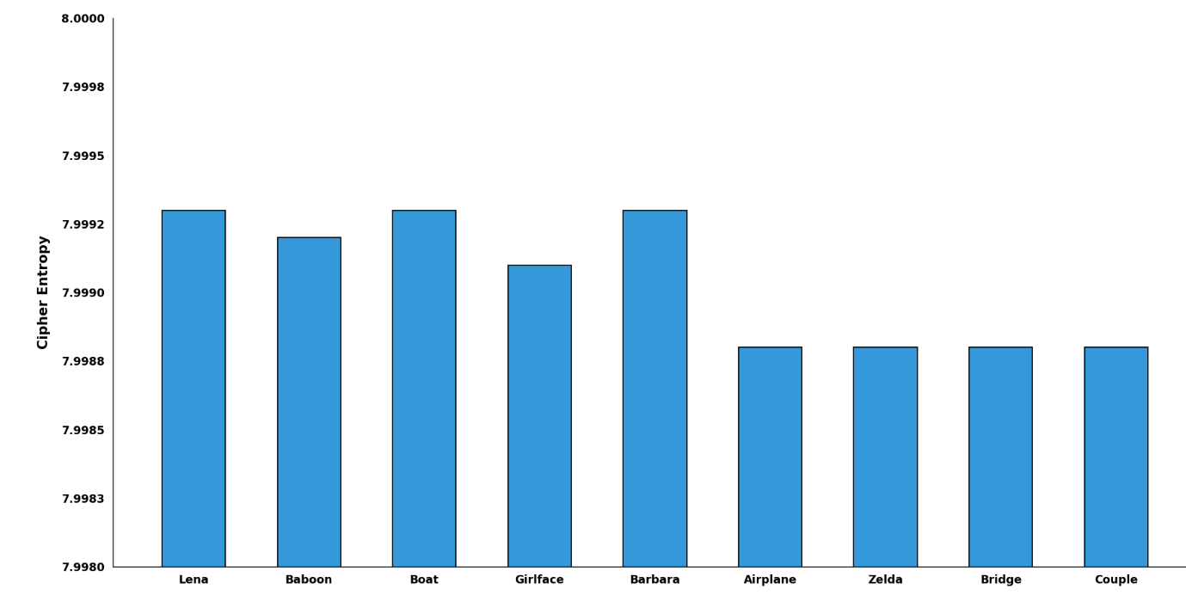
Figure 10. Entropy Analysis of Cipher Images

The Figure 10, shows a bar chart that checks how secure some cryptographic systems are. The vertical line on the measures something called Cipher Entropy and it goes from 7.9980 to 8.0000. The horizontal line at the lists nine test categories: Each category has a bar with a thin black outline. The chart shows the Cipher Entropy values for each category like this: Lena, Boat and Barbara have the values at around 7.9993. Baboon has a lower value, at around 7.9992 . Girlface has a value of around 7.9991. Airplane, Zelda, Bridge and Couple all have the value at around 7.9988. Overall, the chart shows that all tested images have Cipher Entropy values to the perfect score of 8.0000. The chart clearly indicates that Cipher Entropy values of all tested images are very close to a score.

5.8 Correlation Analysis
Correlation analysis describes the relationship between adjacent pixels in horizontal, vertical, and diagonal directions. Naturally, neighboring pixels typically exhibit high correlation. The effective encryption should significantly reduce this correlation. The experimental results show of correlation coefficients of adjacent pixels in the encrypted images is presented in Figure 11.

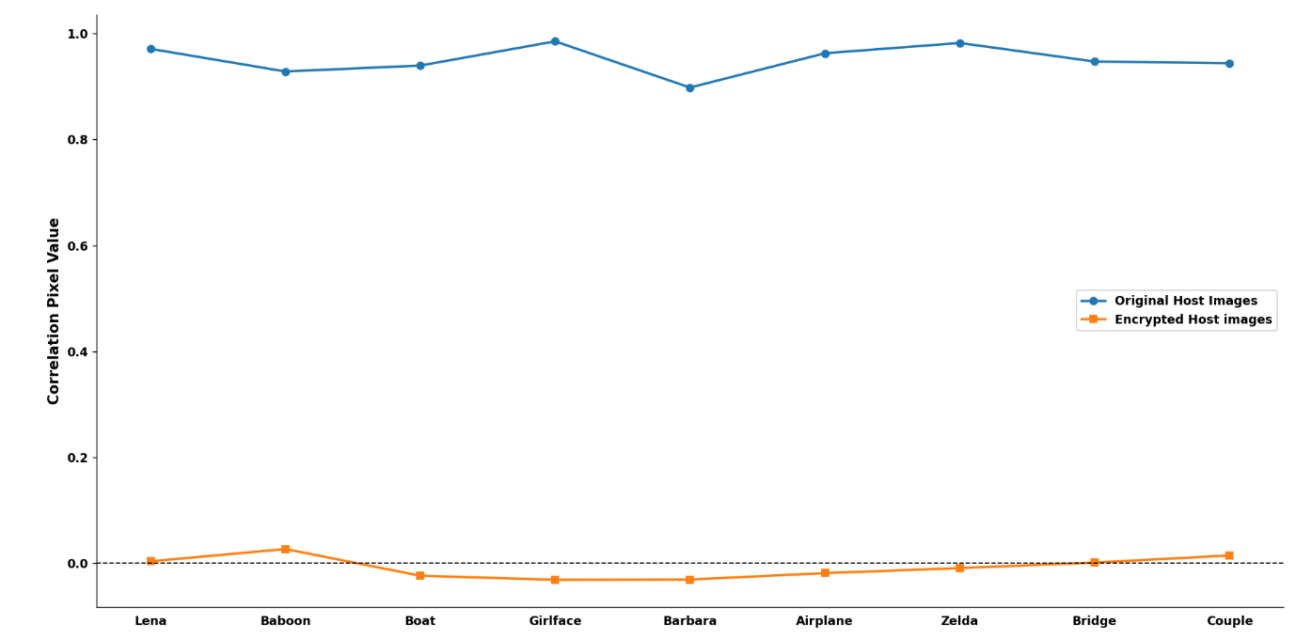
Figure 11. Correlation Analysis of Cipher images

Figure 11 shows how the pixels in nine test images are related before and after they are encrypted. The x-axis lists the test images, which're Lena, Baboon, Boat, Girlface, Barbara, Airplane, Zelda, Bridge and Couple. The y-axis shows the correlation between the pixels, which's a number between 0 and 1. There is a dashed line at zero to show what it would be like if the pixels were not related all.
The blue line is for the original host images. The similarity is high for all the images (0.90 to 0.99). This makes sense because pixels that are near each other in a picture usually look similar to each other. The similarity of pixels in images is something that we expect. The orange line is for the encrypted host images. The similarity is very low for these images (−0.03 to 0.03). This means that the encryption works well because the pixels do not look like they are related to each other anymore. The encryption of images is doing its job. Making the pixels look unrelated, to each other. The big difference between the encrypted images shows that the encryption method is good. It makes it hard for people to figure out the image by looking at how the pixels are related. This makes the image more secure. The encryption gets rid of the patterns in the image. Makes it look random. This helps keep the image safe, from people who might try to break the encryption.

5.9 Recovery Performance Analysis of Host Image
This section evaluates the effectiveness of the proposed reversible data hiding and encryption framework in recovering the original host image after the extraction and reconstruction processes. Since reversibility is a primary objective of the proposed method, the reconstructed host image should be identical to the original host image after extraction and decryption. The recovery performance analysis of host images results is presented in Figure 12.

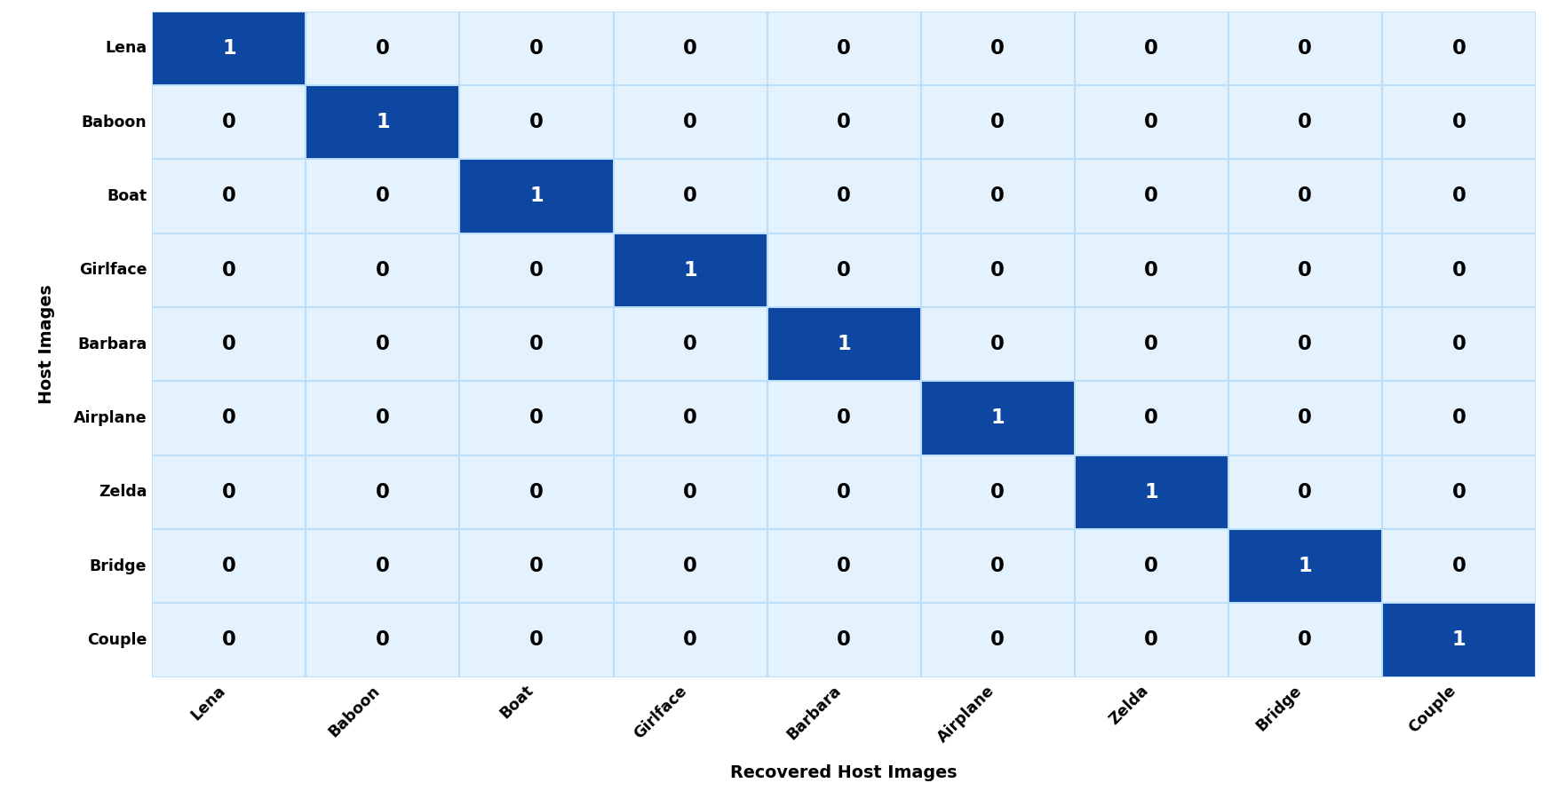
Figure 12. Recovery Performance Analysis of Host Image

Figure 12 shows the comparisons between the host images and recovered host images. The test images are Lena, Baboon, Boat, Girlface, Barbara, Airplane, Zelda, Bridge and Couple.
The matrix is set up with the images on the rows and the recovered images on the columns. The diagonal elements are all 1 which means each original image matches its image perfectly. You can see a line of 1s from the top left to the right of the matrix. All the other elements are 0 which means no recovered image is mistakenly matched with another image. This matrix shows that each recovered image is the same as its original image with no errors or mixing of images. The fact that there are no values besides 0 and 1 confirms that our recovery process keeps the image integrity intact and prevents any unwanted mixing of image information. The perfect match, between the recovered images validates that our framework is reversible. The results show that we can extract the embedded data and rebuild the image without losing any visual information. This matches the PSNR (∞) SSIM (1.0) and NC (1.0) values we reported earlier which also confirm that our method can recover images lossless. Overall Figure 5 shows that our framework can recover host images perfectly. This means we can rebuild all test images perfectly and confirms that our reversible data hiding and encryption process works well for applications where preserving the image content is crucial.

5.10 Computational Complexity Analysis
The computational complexity of the proposed Adaptive Multi-Layer Adaptive Payload Selection (AML-APS) based Reversible Data Hiding in Encrypted Images (RDHEI) framework was analyzed. This analysis helps evaluate its efficiency and scalability. The proposed method has five stages including host image encryption, secret image encryption, payload generation, data embedding and extraction, images recovery of host and secret. During cover image encryption the host image undergoes block permutation and AES-CTR encryption. For an image with N pixels both operations require a traversal of the image pixels. This results in a complexity of O(N). The secret image encryption process uses the ChaCha20 stream. It processes each image pixel only once yielding a complexity of O(M), where M denotes the number of image pixels. The payload generation stage includes bitstream formation, permutation and payload preparation. Each payload bit is processed once so the complexity remains linear O(M).
In data embedding the texture score of each cover image pixel is. Sorted. This helps identify suitable embedding locations. Texture score computation requires O(N) while sorting pixel scores requires O(N log N). So, the embedding stage has a complexity of O(N log N).This represents the computational cost of the proposed framework. The extraction phase retrieves the embedded payload from selected pixels. Reconstructs the secret bitstream. Since each embedded bit is processed once the extraction complexity is O(M). The host image recovery stage involves restoration of modified pixels. This is followed by AES decryption and inverse block permutation. These operations require a pass through the image and have a complexity of O(N)Here is a summary of the complexity of each processing stage:
Cover Image Encryption (AES-CTR + Block Permutation). O(N)
Secret Image Encryption (ChaCha20). O(M)
Payload Generation and Permutation. O(M)
Texture Score Computation. O(N)
Pixel Sorting for Embedding. O(NlogN)
Data Embedding. O(N)
Data Extraction. O(M)
Host Image Recovery. O(N)
The proposed framework exhibits linear computational behavior. The sorting operation during pixel selection contributes the highest computational cost of O(N log N). The overall computational complexity of the proposed AML-APS RDHEI framework can be expressed as O(N log N), where N represents the number of pixels in the host image. This result indicates that the proposed AML-APS method is computationally efficient and scalable for high-resolution images while maintaining lossless recovery embedding capacity and strong security performance. The Adaptive Multi-Layer Adaptive Payload Selection (AML-APS) framework seems efficient. The Reversible Data Hiding, in Encrypted Images (RDHEI) framework appears scalable.

5.11 Summary of Results
This chapter is about the evaluation and performance analysis of the Adaptive Multi-Layer Adaptive Payload Selection based Reversible Data Hiding in Encrypted Images framework. The results show that the proposed Adaptive Multi-Layer Adaptive Payload Selection based Reversible Data Hiding in Encrypted Images method is successful in achieving image encryption and high capacity data embedding. It also does data extraction and lossless image recovery. When we encrypt an image, it changes the image into a highly randomized encrypted image. This is clear from the reduction in pixel correlation and the increase in information entropy. The correlation coefficients of encrypted images are close to zero. This means that the Adaptive Multi-Layer Adaptive Payload Selection based Reversible Data Hiding in Encrypted Images method is strong against attacks and it hides the image content well. The analysis of the embedding performance shows that the proposed Adaptive Multi-Layer Adaptive Payload Selection based Reversible Data Hiding in Encrypted Images method achieves embedding capacity. It also maintains visual quality. The adaptive embedding mechanism uses the image characteristics to maximize the payload capacity. It does this without introducing distortion. The experimental results using standard test images confirm that the embedding process is robust and consistent.
The extraction and recovery analyses verify that the proposed Adaptive Multi-Layer Adaptive Payload Selection based Reversible Data Hiding in Encrypted Images framework is reversible. Both the secret image and the original host image are recovered after the extraction and decryption processes. This is shown by the performance metrics. These metrics include PSNR equals infinity MSE equals zero SSIM equals one point zero NC equals one point zero. Ber equals zero. These metrics indicate that the image information is preserved completely and the reconstruction error the proposed Adaptive Multi-Layer Adaptive Payload Selection based Reversible Data Hiding in Encrypted Images method is compared to other reversible data hiding approaches. It achieves higher embedding rates than many existing approaches. It also maintains security and recovery performance. The computational complexity analysis confirms that the framework is computationally efficient and scalable. The overall time complexity is O (N log N). The space complexity is O(N). Overall, the experimental findings show that the proposed Adaptive Multi-Layer Adaptive Payload Selection based Reversible Data Hiding in Encrypted Images framework is effective, reliable and practical. The combination of embedding capacity strong encryption security, perfect reversibility and computational efficiency makes the proposed Adaptive Multi-Layer Adaptive Payload Selection based Reversible Data Hiding in Encrypted Images method highly suitable, for secure image communication, medical image management, military data transmission, cloud storage security and other applications that require lossless data recovery and confidentiality.

Chapter 6

Conclusions and Future Work

6.1 Conclusions
This thesis presents a novel hybrid Reversible Data Hiding in Encrypted Images (RDHEI) framework designed to achieve secure image communication, efficient data embedding, and lossless image recovery. The proposed system was implemented and tested using the Python programming language in the PyCharm development environment. Several image processing and cryptographic libraries, including NumPy, Pillow, Matplotlib, Scikit-image. The proposed system combines several advanced techniques, including Reserving Room Before Encryption (RRBE), MED prediction, AES-CTR encryption, ChaCha20 encryption, block permutation, adaptive modulo-based embedding, and ECDH-384 secure key exchange within a unified framework.
The proposed framework improves embedding efficiency by reserving embedding space before encryption using MED prediction and adaptive embedding techniques. Multi-stage encryption mechanisms strengthen image confidentiality and improve overall security. The adaptive modulo-based embedding technique enhances embedding security while reducing detectability compared with conventional LSB-based methods. ECDH-384 secure key exchange further improves cryptographic security by generating secure shared keys for communication.
Experimental results demonstrate that the proposed framework achieves high PSNR, low MSE, high SSIM, strong NC values, low BER, and efficient embedding performance. The system also enables lossless reconstruction of the original cover image and accurate recovery of the hidden secret image. The proposed framework demonstrates that combining encryption and reversible embedding within a single architecture can significantly improve both security and embedding efficiency. The use of block permutation increases randomness in encrypted images, making unauthorized analysis more difficult. The framework preserves image quality while maintaining high embedding capability for secure multimedia applications.
The achieved results confirm that the proposed hybrid RDHEI system is reliable, secure, and suitable for practical secure communication environments. In conclusion, this research contributes significantly to the field of digital data security by proposing a reversible and secure framework that balances embedding capacity, computational complexity, and reconstruction accuracy.

6.2 Future Work
Although the proposed hybrid RDHEI framework achieves strong security, efficient embedding, and perfect reversibility, several improvements and extensions can be explored in future research.

- Extend the proposed framework from grayscale images to color images and high-resolution multimedia data and expand it for real-time secure communication systems, cloud computing, IoT devices, and wireless multimedia transmission to support broader real-world applications.
- Improve embedding location selection, prediction accuracy, embedding capacity, and embedding efficiency using deep learning, artificial intelligence techniques, and hybrid optimization approaches to enhance overall computational performance.
- Enhance encryption security and reduce computational complexity through the integration of advanced lightweight cryptographic algorithms for more secure and efficient data protection.
- Increase embedding capacity while maintaining high image quality and perfect reversibility, ensuring robust data hiding performance without compromising visual fidelity.
- Adapt and validate the proposed method for medical image security systems, including MRI, CT scan, ultrasound, and X-ray images, while evaluating performance using large benchmark datasets and advanced steganalysis analysis.
- Investigate hardware implementation and GPU-based acceleration to achieve high-speed processing and support secure multimedia applications in practical deployment environments.

References

[1] A. Malik, P. He, H. Wang, A. N. Khan, S. Pirasteh, and S. M. Abdullahi, "High-capacity reversible data hiding in encrypted images using multi-layer embedding," IEEE Access, vol. 8, pp. 148998–149010, 2020.
[2] L. Li, C.-C. Chang, and C.-C. Lin, "Reversible data hiding in encrypted image based on (7,4) Hamming code and UnitSmooth detection," Entropy, vol. 23, no. 6, p. 790, 2021.
[3] A. Jose and K. Subramaniam, "Comparative analysis of reversible data hiding schemes," IET Image Processing, vol. 14, no. 10, pp. 2011–2023, 2020.
[4] S. Kumar, A. Gupta, and G. S. Walia, "Reversible data hiding: A contemporary survey of state-of-the-art, opportunities and challenges," Applied Intelligence, vol. 52, no. 7,7406, 2022.
[5] S. Rehman, N. T. Bajwa, M. A. Shah, A. O. Aseeri, and A. Anjum, "Hybrid AES-ECC model for the security of data over cloud storage," Electronics, vol. 10, no. 21, p. 2673, 2021. DOI:
[6] V. Venkatesh, R. Anushiadevi, P. V. Meikandan, H. Mahalingam, and R. Amirtharajan, "Separable reversible data hiding by vacating room after encryption using encrypted pixel difference," Scientific Reports, vol. 15, p. 11916, 2025.
[7] H. Ren, G.-R. Bai, T.-T. Chen, Z. Yue, and R.-Y. Ren, "Reversible data hiding in encrypted images with multi-prediction and adaptive Huffman encoding," Scientific Reports, vol. 13, p. 23104, 2023.
[8] K.-M. Chen and C.-C. Chang, "High-capacity separable reversible data-hiding method in encrypted images based on block-level encryption and Huffman compression coding," Connection Science, vol. 33, no. 4, pp. 975–994, 2021.
[9] H. Gao, T. Gao, Z. You, and R. Cheng, "High capacity reversible data hiding in encrypted image based on image encoding and POB," Journal of the Franklin Institute, vol. 357, no. 13, pp. 9107–9126, 2020.
[10] C.-N. Yang, Y.-Q. Lu, S.-Y. Liu, and L. Xiong, "Enhanced reversible data hiding in encrypted images by pixel shifting," Journal of Visual Communication and Image Representation, vol. 99, 2025.
[11] C.-Y. Weng and C.-H. Yang, "Reversible data hiding in encrypted image using multiple data-hiders sharing algorithm," Entropy, vol. 25, no. 2, p. 209, 2023.
[12] R. Liu, Q. Zhou, J. Liu, Y. Zhang, Z. Hui, and X. Zhang, "Separable reversible data hiding in encrypted images for remote sensing images," Entropy, vol. 25, no. 12, p. 1632, 2023. DOI:
[13] Z. Saeidi and S. Mirzakuchaki, "Reversible data hiding in encrypted images using LWE-based secret sharing," Scientific Reports, vol. 15, p. 44819, 2025.
[14] M. Vazhora Malayil, P. P. Roy, S. Ahmed, V. Kebande, and B.-G. Kim, "A block-wise cyclic shifting-based reversible data hiding scheme (BCS-RDH) for secure medical image transmission," PeerJ Computer Science, vol. 12, p. e3709, 2026.
[15] H. Zhang, L. Li, and Q. Li, "Reversible data hiding in encrypted images based on block-wise multi-predictor," IEEE Access, vol. 9, pp. 56221–56232, 2021.
[16] J. Zou, W. Cao, N. Mu, S. Yi, Y. Zheng, Z. Gu, and Z. Hua, "Reversible data hiding over encrypted images via intrinsic correlation in block-based secret sharing," ACM Transactions on Multimedia Computing, Communications, and Applications, vol. 22, no. 1, pp. 1–21, 2026.
[17] S. Ayyappan, C. Lakshmi, and V. Menon, "A secure reversible data hiding and encryption system for embedding EPR in medical images," Current Signal Transduction Therapy, vol. 15, no. 2, pp. 124–135, 2020.
[18] R. Roselinkiruba, "Reversible data hiding using optimization, interpolation and binary image encryption techniques," Multimedia Tools and Applications, vol. 82, no. 23, pp. 35757–35780, 2023.
[19] M. Fan, "Reversible data hiding in encrypted binary image with high capacity," Multimedia Tools and Applications, vol. 85, p. 288, 2026.
[20] Z. Jiang, M. Zhang, W. Dong, C. Jiang, and F. Di, "Reversible data hiding algorithm in encrypted images based on adaptive median edge detection and matrix-based secret sharing, Applied Sciences, vol. 14, no. 14, p. 6267, 2024.
[21] Z. Yin, Y. Peng, and Y. Xiang, "Reversible data hiding in encrypted images based on pixel prediction and bit-plane compression," arXiv preprint arXiv:1911.01699, 2019. Available:
[22] Y. Gao, Z. Fu, X. Li, S. Li, and B. Yu, "Reversible data hiding in encrypted images based on EMD and PSIS," Journal of Information Security and Applications, vol. 98, p. 104405, 2026.
[23] R. Anushiadevi, V. Venkatesh, P. V. Meikandan, S. A. Banu, S. Subashanthini, and D. Ravichandran, "Separable reversible data hiding in an encrypted image using unaltered adjacent pixels to enhance information security," Peer-to-Peer Networking and Applications, 2026.
[24] X. Zhang, G. Lin, C. Yu, and X. Zhang, "Reversible data hiding in encrypted images based on horizontal and vertical pixel shifting and dynamic block partitioning," Journal of Electronics & Information Technology, 2026.
[25] C.-N. Yang, S.-Y. Liu, P.-C. Yu, C. Yu, and X. Zhang, "A general pixel mapping based reversible data hiding in encrypted images," 2026.
[26] Y. Wang, H. Li, and X. Zhang, "Reversible data hiding in encrypted images using adaptive block-level pixel difference encoding," Journal of Information Security and Applications, vol. 96, p. 104316, 2026.
[27] Y. Wang, H. Li, and X. Zhang, "Reversible data hiding in encrypted images using pixel shifting approach," Journal of Information Security and Applications, vol. 87, p. 103909, 2024.
[28] Prasun Roy, Natural Images Dataset, Kaggle. Available: https://www.kaggle.com/datasets/prasunroy/natural-images . Accessed: June 15, 2026.
[29] Hlevkin, Test Images Collection. Available: https://www.hlevkin.com/hlevkin/06testimages.htm . Accessed: June 15, 2026.
[30] USC SIPI Image Database. Available: https://sipi.usc.edu/database/ . Accessed: June 15, 2026.

