Thesis Related Flowchart Graph Images References:
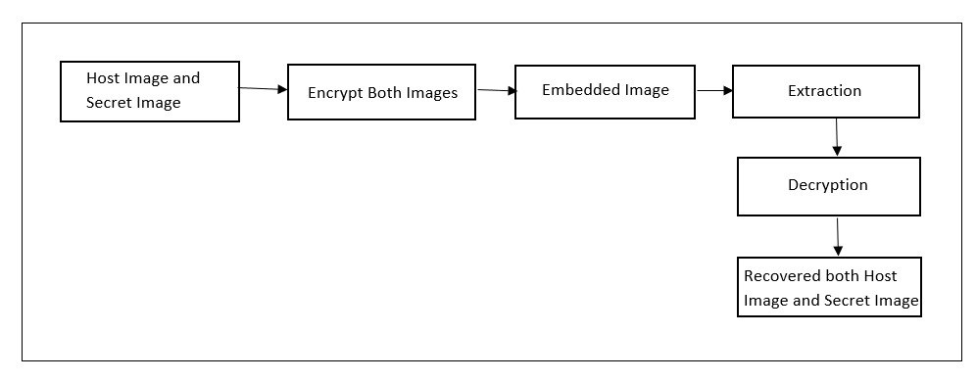




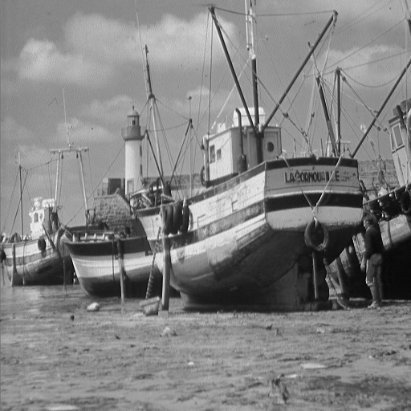
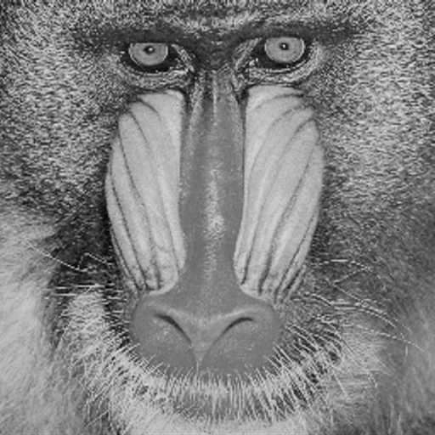


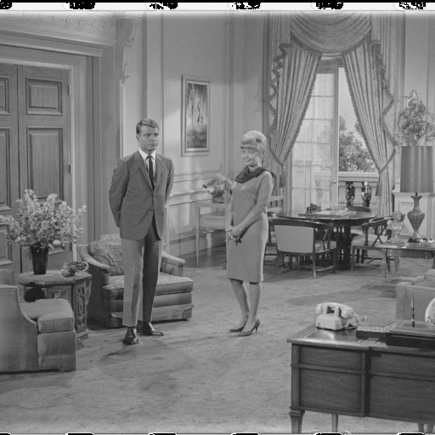
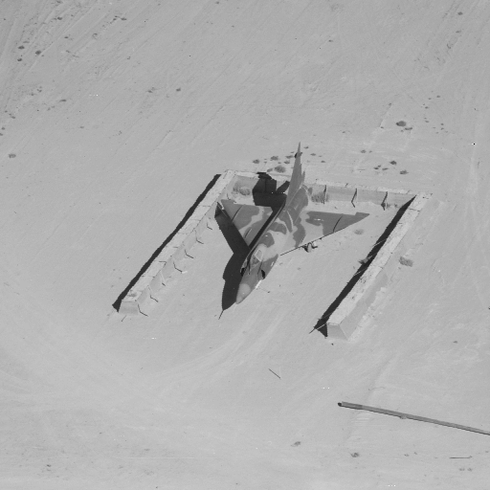
(a)
(c)
(f)
(i)
(e)
(h)
(g)
(d)
(b)
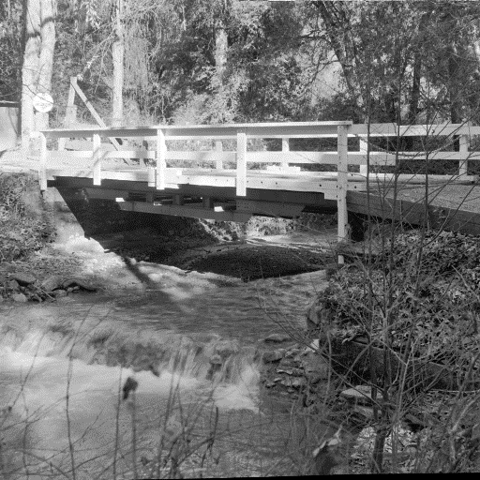


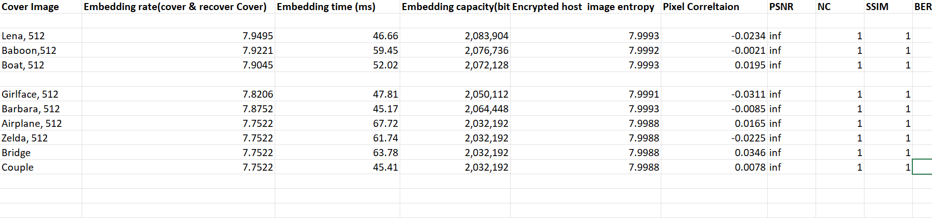

Comparing Embedding rate:
Images | Gao et al., 2020 | Li et al., 2021 | Chen & Chang., 21 | Ren et al., 2023 | Ankur et al., 2025 | Saeidi & Mirzakuchaki., 2025 | Anushiadevi et al., 2026 | Proposed Method
Baboon | 1.93 | 2.538 | 0.4690 | 1.1562 | 1.5122 | 0.1293 | 0.42 | 7.9231
Lena | 3.75 | 2.389 | 1.4005 |  | 3.1621 |  |  | 7.9504
Airplane | 4.54 |  |  | 3.7245 | 4.0237 | 0.1741 |  | 7.7532
Boat | 3.21 |  |  |  |  | 0.0430 | 1.00 | 7.9005
Barbara | 3.13 |  | 0.9526 |  |  | 0.1369 |  | 7.8762
Zelda |  | 2.475 | 1.5679 |  |  |  |  | 7.7532

Table 2. Security Metrics of the Proposed AML-APS Method (512 × 512 Images)

Image Name and Size(512*512) | Encrypted PSNR (dB) | Marked  Encrypted PSNR (dB) | Entropy of Cipher | Pixel Correlation  (Cipher) | Overflow
Lena | 9.24 | 9.25 | 7.9993 | -0.0234 | None
Baboon | 9.64 | 9.65 | 7.9992 | -0.0021 | None
Boat | 9.29 | 9.32 | 7.9993 | 0.0195 | None
Girlface | 8.10 | 8.13 | 7.9991 | -0.0311 | None
Barbara | 8.81 | 8.85 | 7.9993 | -0.0085 | None
Airplane | 8.97 | 9.03 | 7.9988 | 0.0165 | None
Zelda | 8.86 | 8.93 | 7.9988 | -0.0225 | None
Bridge | 8.77 | 8.83 | 7.9988 | 0.0346 | None
Couple | 9.63 | 9.70 | 7.9988 | 0.0078 | None

Table 3. Lossless Cover Recovery Metrics of the Proposed AML-APS Method

Image Name and Size(512*512) | PSNR (dB) | MSE | SSIM | NC | BER (Secret) | Recovery
Lena | ∞ | 0 | 1 | 1 | 0 | Lossless
Baboon | ∞ | 0 | 1 | 1 | 0 | Lossless
Boat | ∞ | 0 | 1 | 1 | 0 | Lossless
Girlface | ∞ | 0 | 1 | 1 | 0 | Lossless
Barbara | ∞ | 0 | 1 | 1 | 0 | Lossless
Airplane | ∞ | 0 | 1 | 1 | 0 | Lossless
Zelda | ∞ | 0 | 1 | 1 | 0 | Lossless
Bridge | ∞ | 0 | 1 | 1 | 0 | Lossless
Couple | ∞ | 0 | 1 | 1 | 0 | Lossless

Table 4. Comparison of Embedding Rates (bpp) with Existing RDHEI Methods

PSNR & SSIM :
Image | Roselinkiruba (Springer, 2023) | Proposed
Lena | 39.41 , 0.991 | Inf, 1
Baboon | 28.96 , 0.988
Peppers | 38.99, 0.981
Airplane | 35.21, 0.983
Boat | 35.02 , 0.981

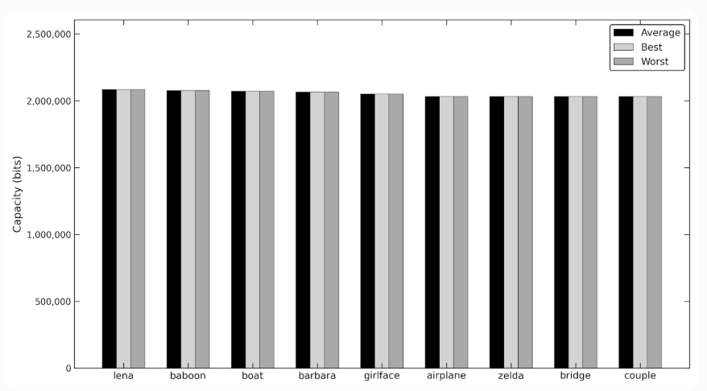
Figure 8. Average, best, and worst embedding capacities of the proposed method.
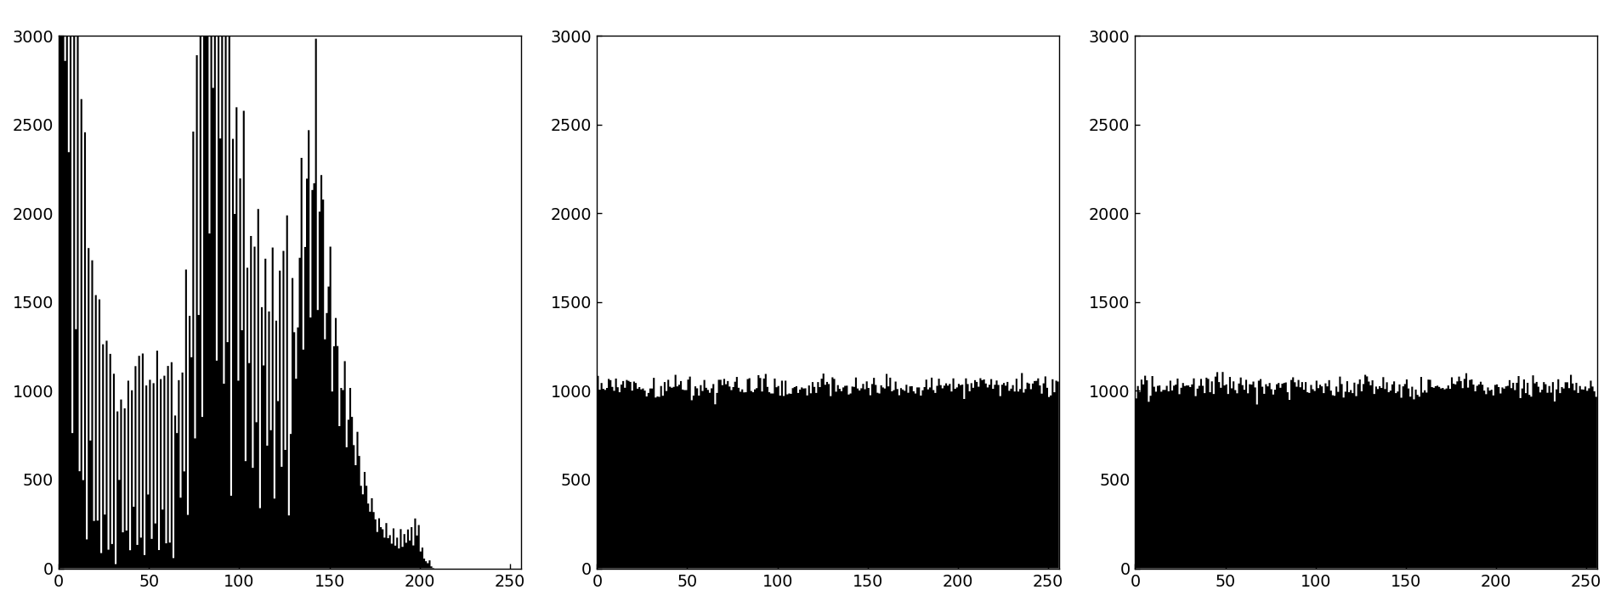

Figure 2: Histograms of girlface: (a) Original image; (b) Encrypted image; (c) Marked encrypted image
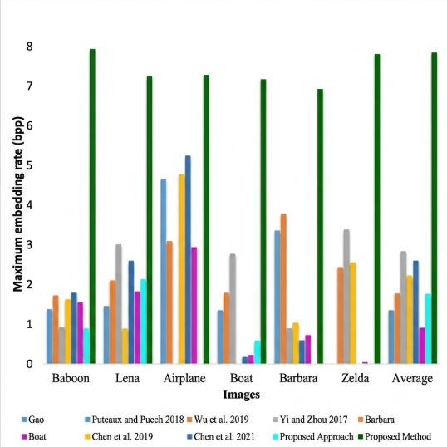
Figure 5: Comparison of maximum embedding rates (bpp) of the proposed method with existing RDHEI techniques.

(i)





(h)
(f)
(e)

(d)
(c)
(b)
(a)

(g)

Fig : Different Host Images: (a Lena (b)Baboon (c Boat (d)Girlface (e)Barbara (f)Airplane (g)Couple (h)Zelda (i)Bridge

Compsrisom theme :
Secret images link: Kaggle
Cover images :
( zelda, girlface, Barbara, bridge) : https://www.hlevkin.com/hlevkin/06testimages.htm
Others cover images : USC-SIPI dataset
Secret images link: Available at: https://www.kaggle.com/datasets/prasunroy/natural-images
Cover images :
( zelda, girlface, Barbara, bridge) : https://www.hlevkin.com/hlevkin/06testimages.htm
Others cover images : Available: https://sipi.usc.edu/database/
Key Generation:

Start

Seret Secret Image
Host Image

Calculate Embedding Capacity

Embedding capacity < Secret Image
Image?

No

Yes

Key Generation, Exchange and Multi - Key Derivation
Auto – rescaled secret image

Encryption & Embedding:
Host Image
Secret Image

.
Block Permutation &
AES-128 CTR Encryption
Encrypted Host Image
ChaCha20 Encryption
Encrypted Secret Image
Embedded Image
Adaptive Multi-layer Embedding

Extraction & Decryption:

Embedded Image
Adaptive Multi-Bit Modulo Extraction
Inverse-Block Permutation
ASE-128 CTR Decryption
Recovered Secret Image
ChaCha20 Decryption
Recovered Host Image
Restore Embedded Pixels
Extract Embedded Bits

Overall System Architecture:

Host Image
Encryption
Symmetric Key
Encrypted Host
Embedded Image Data
Symmetric Key

Extraction
Encrypted Secret
Encryption
Secret Image
Recovered Host Image
Recovered Secret Image
Decryption

MDPI – 2018

Host Image and Secret Image
Encrypt Both Images
Embedded Image
Decryption
Extraction
Recovered Host Image
Recovered Secret Image

Cipher Entropy of Test Images :
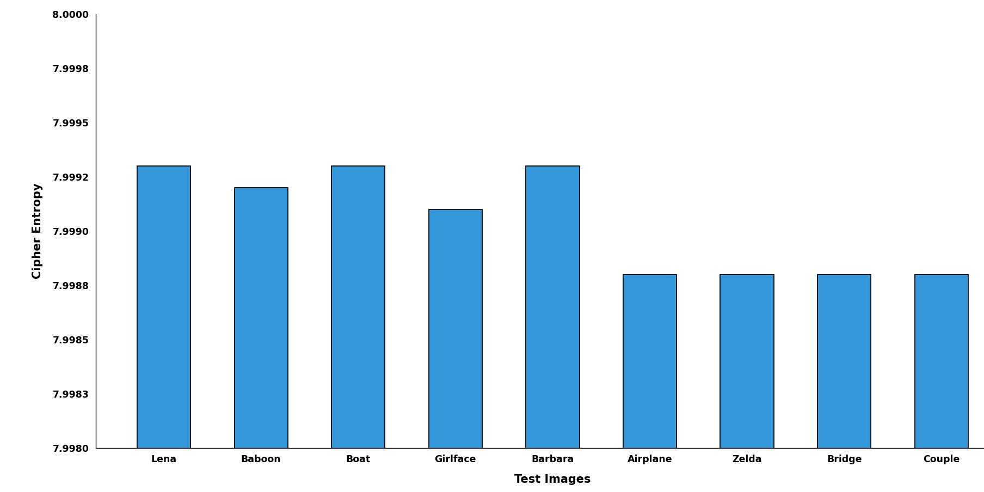

Correlation Comparison Chart: Clustered Line Chart
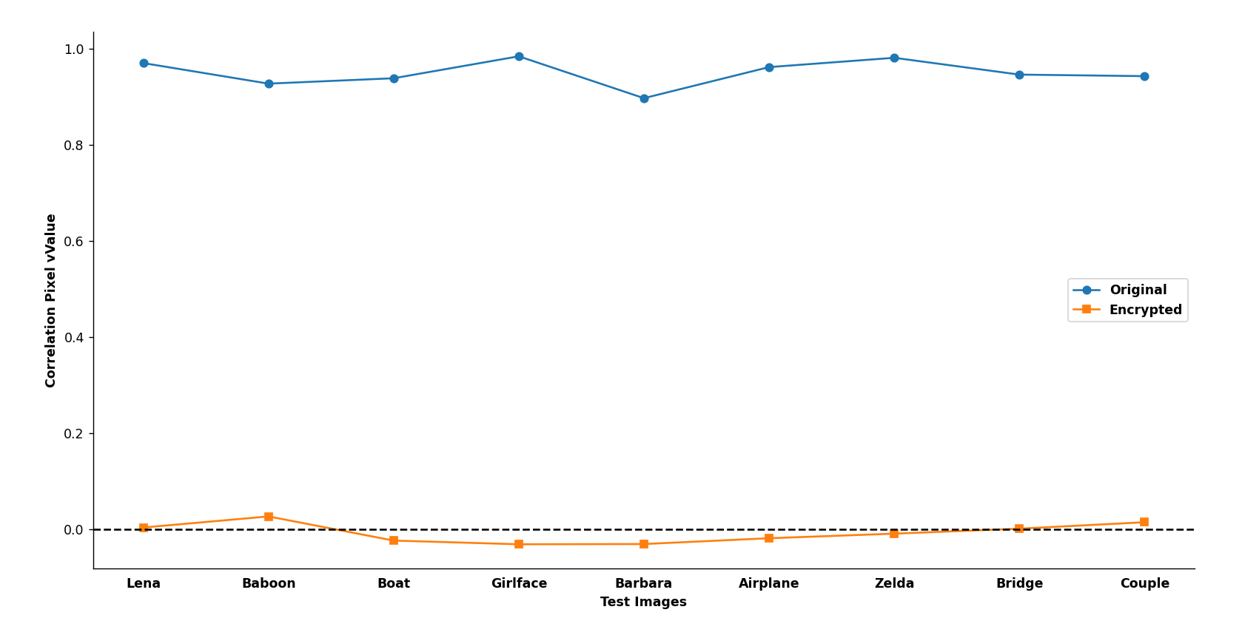

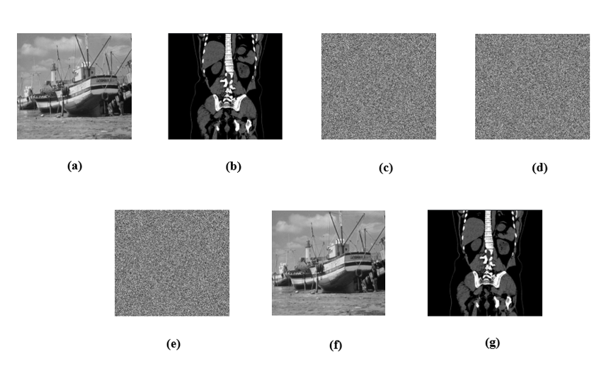
Figure 1: Visual quality of images:(a) Original host image(b) Secret image(c) Encrypted host image(d) Encrypted secret image(e)Embedded image(f) Recovered host image (i) Recovered secret image
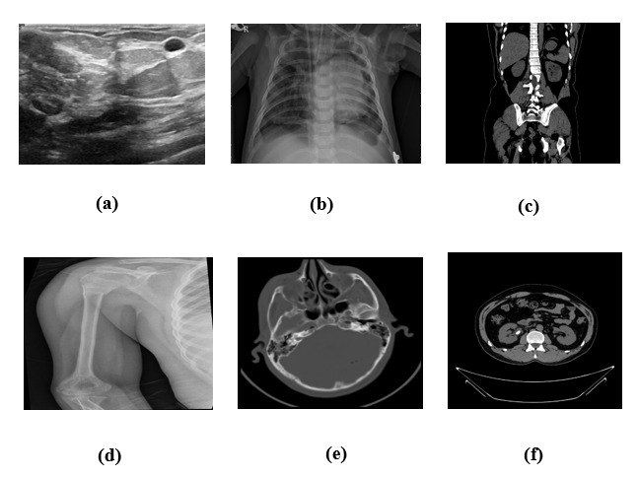
Figure: Different Secret Images: (a) Breast Cancer (b) Chest X-ray (c) Kidney Cyst (d) Bone Fracture (e) Brain Tumor (f) Brain CT_ Scan

References:
[1] A. Malik, P. He, H. Wang, A. N. Khan, S. Pirasteh, and S. M. Abdullahi, "High-capacity reversible data hiding in encrypted images using multi-layer embedding," IEEE Access, vol. 8, pp. 148998–149010, 2020.
[2] L. Li, C.-C. Chang, and C.-C. Lin, "Reversible data hiding in encrypted image based on (7,4) Hamming code and UnitSmooth detection," Entropy, vol. 23, no. 6, p. 790, 2021.
[3] A. Jose and K. Subramaniam, "Comparative analysis of reversible data hiding schemes," IET Image Processing, vol. 14, no. 10, pp. 2011–2023, 2020.
[4] S. Kumar, A. Gupta, and G. S. Walia, "Reversible data hiding: A contemporary survey of state-of-the-art, opportunities and challenges," Applied Intelligence, vol. 52, no. 7,7406, 2022.
[5] S. Rehman, N. T. Bajwa, M. A. Shah, A. O. Aseeri, and A. Anjum, "Hybrid AES-ECC model for the security of data over cloud storage," Electronics, vol. 10, no. 21, p. 2673, 2021. DOI:
[6] V. Venkatesh, R. Anushiadevi, P. V. Meikandan, H. Mahalingam, and R. Amirtharajan, "Separable reversible data hiding by vacating room after encryption using encrypted pixel difference," Scientific Reports, vol. 15, p. 11916, 2025.
[7] H. Ren, G.-R. Bai, T.-T. Chen, Z. Yue, and R.-Y. Ren, "Reversible data hiding in encrypted images with multi-prediction and adaptive Huffman encoding," Scientific Reports, vol. 13, p. 23104, 2023.
[8] K.-M. Chen and C.-C. Chang, "High-capacity separable reversible data-hiding method in encrypted images based on block-level encryption and Huffman compression coding," Connection Science, vol. 33, no. 4, pp. 975–994, 2021.
[9] H. Gao, T. Gao, Z. You, and R. Cheng, "High capacity reversible data hiding in encrypted image based on image encoding and POB," Journal of the Franklin Institute, vol. 357, no. 13, pp. 9107–9126, 2020.
[10] C.-N. Yang, Y.-Q. Lu, S.-Y. Liu, and L. Xiong, "Enhanced reversible data hiding in encrypted images by pixel shifting," Journal of Visual Communication and Image Representation, vol. 99, 2025.
[11] C.-Y. Weng and C.-H. Yang, "Reversible data hiding in encrypted image using multiple data-hiders sharing algorithm," Entropy, vol. 25, no. 2, p. 209, 2023.
[12] R. Liu, Q. Zhou, J. Liu, Y. Zhang, Z. Hui, and X. Zhang, "Separable reversible data hiding in encrypted images for remote sensing images," Entropy, vol. 25, no. 12, p. 1632, 2023. DOI:
[13] Z. Saeidi and S. Mirzakuchaki, "Reversible data hiding in encrypted images using LWE-based secret sharing," Scientific Reports, vol. 15, p. 44819, 2025.
[14] M. Vazhora Malayil, P. P. Roy, S. Ahmed, V. Kebande, and B.-G. Kim, "A block-wise cyclic shifting-based reversible data hiding scheme (BCS-RDH) for secure medical image transmission," PeerJ Computer Science, vol. 12, p. e3709, 2026.
[15] H. Zhang, L. Li, and Q. Li, "Reversible data hiding in encrypted images based on block-wise multi-predictor," IEEE Access, vol. 9, pp. 56221–56232, 2021.
[16] J. Zou, W. Cao, N. Mu, S. Yi, Y. Zheng, Z. Gu, and Z. Hua, "Reversible data hiding over encrypted images via intrinsic correlation in block-based secret sharing," ACM Transactions on Multimedia Computing, Communications, and Applications, vol. 22, no. 1, pp. 1–21, 2026.
[17] S. Ayyappan, C. Lakshmi, and V. Menon, "A secure reversible data hiding and encryption system for embedding EPR in medical images," Current Signal Transduction Therapy, vol. 15, no. 2, pp. 124–135, 2020.
[18] R. Roselinkiruba, "Reversible data hiding using optimization, interpolation and binary image encryption techniques," Multimedia Tools and Applications, vol. 82, no. 23, pp. 35757–35780, 2023.
[19] M. Fan, "Reversible data hiding in encrypted binary image with high capacity," Multimedia Tools and Applications, vol. 85, p. 288, 2026.
[20] Z. Jiang, M. Zhang, W. Dong, C. Jiang, and F. Di, "Reversible data hiding algorithm in encrypted images based on adaptive median edge detection and matrix-based secret sharing, Applied Sciences, vol. 14, no. 14, p. 6267, 2024.
[21] Z. Yin, Y. Peng, and Y. Xiang, "Reversible data hiding in encrypted images based on pixel prediction and bit-plane compression," arXiv preprint arXiv:1911.01699, 2019. Available:
[22] Y. Gao, Z. Fu, X. Li, S. Li, and B. Yu, "Reversible data hiding in encrypted images based on EMD and PSIS," Journal of Information Security and Applications, vol. 98, p. 104405, 2026.
[23] R. Anushiadevi, V. Venkatesh, P. V. Meikandan, S. A. Banu, S. Subashanthini, and D. Ravichandran, "Separable reversible data hiding in an encrypted image using unaltered adjacent pixels to enhance information security," Peer-to-Peer Networking and Applications, 2026.
[24] X. Zhang, G. Lin, C. Yu, and X. Zhang, "Reversible data hiding in encrypted images based on horizontal and vertical pixel shifting and dynamic block partitioning," Journal of Electronics & Information Technology, 2026.
[25] C.-N. Yang, S.-Y. Liu, P.-C. Yu, C. Yu, and X. Zhang, "A general pixel mapping based reversible data hiding in encrypted images," 2026.
[26] Y. Wang, H. Li, and X. Zhang, "Reversible data hiding in encrypted images using adaptive block-level pixel difference encoding," Journal of Information Security and Applications, vol. 96, p. 104316, 2026.
[27] Y. Wang, H. Li, and X. Zhang, "Reversible data hiding in encrypted images using pixel shifting approach," Journal of Information Security and Applications, vol. 87, p. 103909, 2024.
[28] Prasun Roy, Natural Images Dataset, Kaggle. Available: https://www.kaggle.com/datasets/prasunroy/natural-images . Accessed: June 15, 2026.
[29] Hlevkin, Test Images Collection. Available: https://www.hlevkin.com/hlevkin/06testimages.htm . Accessed: June 15, 2026.
[30] USC SIPI Image Database. Available: https://sipi.usc.edu/database/ . Accessed: June 15, 2026.

