Your AI Analyst Gave Two Right Answers. Only the SQL Said Why.
Asked how many orders "delivered in 2017" were late, Dot said 2,453 in a follow-up chat and 1,762 in a fresh one. The 2,453 kept the purchase date Dot had named one question earlier. The 1,762 counted by delivery date and never said so; only its SQL did. By the end, you'll have a six-step test for which date your analyst used.
We checked both counts against the raw data of Olist, a public e-commerce dataset, so anyone can recompute them. Each matches the raw data exactly for the date it used. Late means delivered on a later calendar day than the estimated delivery date.
The whole piece in seven lines:
- "Delivered in 2017" has two valid readings: bought in 2017, or delivered to the customer in 2017.
- Dot counted 2,453 late orders by purchase date in a follow-up chat, and 1,762 by delivery date in a fresh chat.
- Both counts match the raw Olist data for the date each used; they sit 691 orders apart.
- Dot's first answer in the follow-up chat named purchase date, while the fresh-chat count never named its date.
- Every Dot answer came back with its SQL, and the SQL's date filter showed the date even where the text was silent.
- Asked four turns later to go back to the first question, Dot returned 43,428 again, with the same SQL as its first answer.
- The test: run a follow-up chat, re-ask one question in a fresh chat, and read the SQL of any answer that doesn't name its date.

Both late-order counts were correct, each for a different date
We ran this as part of the Prove stage of the Playbook, where a team tests the analyst on known questions before launch. Buyers of conversational analytics ask whether an analyst keeps context across follow-up questions.
The method was three chats. The follow-up chat asked five questions, each leaning on the one before. The fresh chat asked the follow-up chat's second question again, written in full, with no history. A third chat asked about item price, with one follow-up.
Before the first question, we computed the expected answers from the raw Olist CSVs. "Delivered in 2017" was ambiguous on purpose, so we computed both readings: purchased in 2017, and delivered in 2017. A script then checked each answer against them; three answers stated no date: the 2,453, the 1,762 and the item-price chat's November total. The 2,453 matched the purchase-date reading its chat had named, and a person read the other two dates from their SQL.
Chat | Question as asked | Dot's figure | Date in the SQL's date filter | Answer text named that date | Verdict
Follow-up | How many orders were delivered in 2017? | 43,428 | Purchase date | Yes | Correct, exact
Follow-up | And how many of those were delivered late? | 2,453 | Purchase date | No | Correct, exact
Follow-up | What share of the delivered orders is that? | 5.6% | Purchase date | Yes | Correct, display rounding
Follow-up | What is that share for 2018? | 7.7% | Purchase date | Yes | Correct, display rounding
Follow-up | Going back to my first question, how many orders was that? | 43,428 | Purchase date | Yes | Correct, exact
Fresh | How many orders delivered in 2017 were delivered later than their estimated delivery date? | 1,762 | Delivery date | No | Correct, reading taken from the SQL by a person
Item price | What was the total item price of orders delivered in 2017? | BRL 5,612,818 | Delivery date | Yes | Correct under its stated definition
Item price, follow-up | How much of that came in November? | BRL 651,458 | Delivery date | No | Correct, reading taken from the SQL by a person
In the follow-up chat, Dot counted 2,453 late orders among those purchased in 2017. That matches the raw data by purchase date exactly. In the fresh chat, Dot counted 1,762 late orders among those delivered in 2017. That matches the raw data by delivery date exactly.
Neither answer is wrong. "Delivered in 2017" can mean orders bought in 2017 that were later delivered. It can also mean orders that reached the customer in 2017. The two readings put 691 orders between Dot's answers.
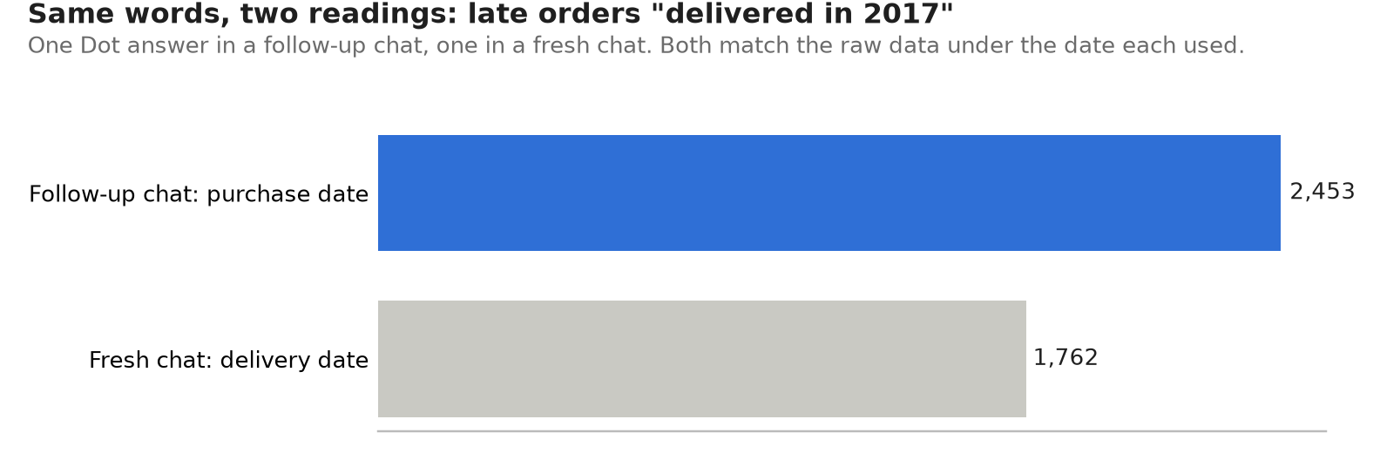
Alt text: Bar chart of two Dot answers to how many orders delivered in 2017 were late, on the Olist dataset. In a follow-up chat, Dot used purchase date and returned 2,453. In a fresh chat, it used delivery date and returned 1,762.
Late orders for "delivered in 2017", asked in a follow-up chat and in a fresh chat. Olist dataset, Dot, 31 October 2026. The run's mode is not stated.
Each answer's SQL shows its date filter. In the follow-up chat, Dot's first answer said in words that it used purchase date. The late-order question asked about "those" orders, so its SQL kept the filter on order_purchase_timestamp. The fresh chat never named its date in words, and its SQL had this line instead, word for word.
``sql AND order_delivered_customer_date >= TIMESTAMP '2017-01-01 00:00:00' ``
The fresh chat's count covered 40,930 orders delivered in 2017, of which 4.3% arrived late. The follow-up chat's 5.6% was a share of a different set: 43,428 orders purchased in 2017 and delivered. The item-price chat read the phrase by delivery date too: BRL 5,612,818, against BRL 5,962,902 by purchase year.
Dot's 5.6% for 2017 and 7.7% for 2018, both in the follow-up chat, were display rounding, not gaps. Dot's answers left out orders with no delivery date. The 2017 answer said "excluding the two orders with missing delivery dates", and the 2018 answer said "excluding six orders with missing delivery dates". Our expected answers kept them; with or without them in the denominator, the follow-up chat's shares round to 5.6% and 7.7%.

The first answer named its date; the fresh-chat answer didn't
The risk isn't a wrong number. It is a right number for a date you didn't mean, with nothing in the text to say so.
Dot made the follow-up chat's choice visible at its first answer. Asked "How many orders were delivered in 2017?", it answered: "This uses purchase date, not delivery date." The 2,453 answer kept that purchase-date filter without restating it.
The item-price chat was clearer. Asked "What was the total item price of orders delivered in 2017?", Dot answered: "This uses the customer delivery date, not the purchase date."
The fresh-chat late count did not name its date. It was the follow-up chat's second question, asked again in full. Dot's answer began: "1,762 orders delivered in 2017 arrived after their estimated delivery date". That reuses the ambiguous phrase, so the sentence alone doesn't say which date.
Where the text was silent, the SQL wasn't. Every answer in this run, 8 of 8, came back with its SQL, and its date filter named the column. Most answers also named their date unprompted: 5 of 8.
An AI analyst's answer can be right and still not say which question it answered.

Dot returned the first answer's figure and SQL four turns later
Asked four turns later to go back to the first question, Dot returned 43,428 again. Its SQL was the same as its first answer's, purchase-date filter included.
Scope held in the item-price chat too. Asked "How much of that came in November?", Dot returned BRL 651,458, with its SQL still filtering on the delivery date. The purchase-month reading would have been BRL 987,765.

A follow-up test you can copy takes six steps and one fresh chat
- Pick a phrase your team reads two ways, such as "delivered in", "active customer" or "revenue".
- Compute the expected answer under each reading, from the raw tables, before you ask anything.
- In a follow-up chat, ask five questions, each leaning on the last with "those", "that" or "go back to".
- In a fresh chat, ask one of those questions again, written in full.
- Check whether the answer names its date. If it doesn't, read the date filter in its SQL.
- Mark each answer against the reading it used, item by item.
You need one fresh chat. We used two.
When you run this, a total that matches under a different date filter is still a different answer.

Things to keep in mind
- One run, one dataset, eight questions. One run can't say why the fresh chat read the phrase differently: chat history, a default, or run-to-run variation. Assumption: the same question can take a different path on another day, so a re-run can differ.
- "Delivered in 2017" was ambiguous on purpose. The fresh late count and the November follow-up were marked correct under the delivery-date reading, which a person took from their SQL. Neither is an error.
- This run's settings were noted by hand, without screenshots. So this piece doesn't publish the run's mode or cost.

Where Dot fits
In this test, Dot's text didn't always name its date, but its SQL always did: every answer came back with its query. Five of eight answers also named their date in plain words, and step 5 of the test reads the SQL for the rest. Dot's documentation is at docs.getdot.ai.
---
Use the six steps this week as a first screen, on one phrase your team argues about. Before you trust either number, check which date each answer used. Before rollout, run the full eight-step test.
If this excites you, we'd love to hear from you. Get in touch.

