Crop Yield Prediction Using Indian Agricultural and Weather Data

Abstract— In an agrarian economy like India, crop yield prediction aids food security planning, resource allocation and policy decisions. This project forecasts crop yields based on real-world Indian agricultural data (1997 to 2020) of rainfall, fertilizer, pesticide, states, seasons, and crops, cleaned of inconsistencies and features engineered at the per-area and log levels. A comparison was made between three regression models: Linear Regression, Random Forest and Gradient Boosting, which were optimized using grid search and cross validation to prevent overfitting. Tuned Random Forest performed best (test R² ≈ 0.86, CV R² 0.86). Crop type, state, and fertilizer intensity were found to be better predictors than rainfall alone. Questions of ethics such as data imbalance and misuse are also discussed.
Index Terms: Indian Agriculture, Weather Data, Precision Agriculture, Machine Learning, Crop Yield Prediction, Gradient Boosting and Random Forest.
I. Introduction
A. Background and Scope
Despite the fact that the agriculture sector has been neglected in the country's economic planning and is not a significant contributor to the overall output, it continues to be a primary source of employment in the country. Crop yield (the amount of crop per unit of land area) depends on a variety of factors such as soil quality, weather conditions, irrigation, farmyard manure used, fertilizer and pesticide application, crop variety as well as regional agronomic practices. Traditional method: In India, the yield estimation has been traditionally done by the manual crop cutting experiments and experts opinion, which requires labor intensive, time-consuming and difficult to be replicated throughout the country with different agro climatic zones [1]. As more and more farmers' agricultural data get organized and weather data becomes available, machine learning has become an attractive scalable alternative to yield estimation, capable of simultaneously handling multiple interacting variables.
This project is specifically related to India as it heavily relies on monsoon rainfall and there are significant differences in cultivation practices between states. The scope of the project is limited to information of the crop type, growing season, state, cultivated area, production, annual rainfall, fertilizer use and pesticide use from year 1997 to 2020 for structured, tabular data. Although important in the general context of precision agriculture, data from remote sensing imagery and soil composition data, along with real-time data collected from IoT sensors, was not a direct focus of the data used here and is cited as a limitation.
B. Goals and Business Value
The main objective of the project is to develop and compare several machine learning models using regression method that predict the crop yield from the input variables of agricultural and weather conditions and proper train-test comparison and cross validation is performed to check overfitting and underfitting of the models. A secondary objective is to provide a comprehensible insight towards the variables which have the greatest impact on the yield results, and not just a black box prediction.
Importance of yield prediction in business is high. Reliable yield forecasts are important for government agencies in planning for food security, managing buffer stocks, and early warning systems for potential food shortages. In agriculture marketing, yield estimates are useful for determining commodity prices and to decrease information asymmetry between the producers and buyers. Knowing the factor that influences yield the most (for a given farmer or state ag department, it could be the impact of fertilizer or seasonal timing) can help in better allocation of input which can help increase productivity without proportionately increasing the cost. The use of fertilizer and pesticides, in addition to weather variables, makes the models more insightful in the sense that the results can be used by farmers and policy makers to make decisions about how much to apply; use of fertilizer and pesticides is a lever that can be controlled by farmers and policy makers, but rainfall cannot.
II. Literature Survey
While regression models were used for some time, machine learning techniques for crop yield prediction have increased significantly in recent years, with a shift from regression to deep learning and hybrid approaches that could ingest various data sources. In an extensive review of the literature of precision agriculture techniques for yield prediction, Saha et al. [1] point out that the performance of the models is very sensitive to the quality and scale of the input data and that the models that use only the coarse scale data on national level climate averages are less successful in prediction. This observation directly inspired the decision of the present project to opt for a state-level dataset with agronomic input variables than a purely a national-level weather dataset.
Weather continues to be a key factor in many studies determining yield variability. Weather is an adjacent problem domain, and David [2] reviews weather based prediction models, including ensemble and tree based models, and found that ensemble/tree learners are more robust to handle the nonlinear relationship between weather and yield of the various pests and diseases, which is consistent with this project where Random Forest and Gradient Boosting would greatly outperform Linear Regression by a wide margin.
There have been also some more advanced architectures explored. For multispectral crop yield prediction, Nejad et al. [3] suggest using a 3D convolutional neural network and the convolutional LSTM along with attention mechanism to account for spatial and temporal dependency in the satellite image, which can significantly boost the accuracy when it is provided. In a similar vein, Gade et al. [4] use transformer architecture for joint crop yield and price prediction also, and shows a better performance as compared to traditional regression baselines with adequate training data and computational capacity. Although these deep learning techniques are powerful, they normally require a large amount of high-resolution spatial or temporal data, which was not available in this project from the tabular dataset. Tree-based ensemble methods are more suitable for this data as they can be interpreted.
There are two systematic literature reviews that are helpful in providing background to the broad field of literature. Muruganantham et al. [5] sum up deep learning and remote sensing methods to predict and observe that the model to be chosen depends on the availability of data and in this project, the moderately sized tabular data, a Random Forest and Gradient Boosting model were chosen instead of deep neural networks. Oikonomidis, Catal and Kassahun [6] also discuss the application of deep learning approaches in predicting yields and identify some common problems such as overfitting that occurs when the complexity of the model exceeds the number of samples, which would be observed in the methodology of this project in the context of cross-validation and hyperparametrization.
Morales and Villalobos [7] explore the temporal aspect of yield prediction, including those models which predict yield within a growing season, versus those that produce a forecast for yield in future (unseen) seasons, and point out that generalization to future years is difficult relative to the easier task of interpolation from past years. This differentiation is directly relevant to the final prediction stage of this project where, extrapolating recent developments in area, rainfall and input use, the yield for a future year is estimated, and should therefore be interpreted with appropriate caution, as extrapolation is an inherently challenging task (as pointed out in their work).
The use of the Internet of Things and real-time climate monitoring is discussed by Talaat [8] who suggests the possibility of a crop yield prediction algorithm that combines IoT sensor data with the digital information of climate change; whereas the present project is based on historical data, the current trend is moving towards real-time, sensor-driven prediction methods. Rather than this, Ali et al. [9] use multi-sensor remote sensing data with ground observations; they show that using multiple data modalities can lead to better prediction results than using only one data source, which is partly the case in this project in combining multiple agricultural and weather variables, but without the multi-sensor component.
Finally, Shawon et al. [10] perform a comprehensive systematic review of the machine learning methods, applied in various studies, for crop yield prediction, and find that ensemble tree based models, such as Random Forest and Gradient Boosting models, generally achieve the best results for structured, tabular data in agriculture, with moderate sized datasets, rather than large-scale datasets. This finding is consistent with the experimental findings of this project, as the Random Forest model with the tuned parameters showed better performance as compared to the linear baseline model and Gradient Boosting model.
III. Ethical Concerns
There are a number of ethical issues associated with using agricultural and weather information to predict yield. Second, the data in this project, although it includes several states in India, are not uniform for all states and crops, with some states and crops having much more data than others, which can make this apparent to the model and lead to different results for them than for the other, better represented states and crops, and be unfair to the farmers in the under-represented states and crops, who may have different yield trends than the majority.
Second, prediction models for yields have a risk of being misused in agriculture commodity markets. If not made transparent, accurate and early yield forecasts could be used for speculative trading or price manipulation, to the detriment of smallholder farmers, who usually do not have access to such forecasts compared to large agribusiness and trading companies.
Finally, data privacy is a relatively small issue here because the data is state-level and crop-level - that means there are no individual farmer's data - so there is less risk of individual data being exposed compared to the other applications of IoT and sensors in the literature (discussed in the Introduction).
IV. Implementation
A. Dataset Description
The data set consists of 19,690 records covering these fields – Crop, Crop_Year, Season, State, Area, Production, Annual_Rainfall, Fertilizer, Pesticide, Yield – of various crop types in different Indian states from 1997 to 2020. This data set was chosen over a previous purely national-level weather data set for its significant advantages of being much more detailed, accounting for state and season, and including agronomic input variables that are directly relevant to farmers and policy makers (rather than precipitation and temperature being the only variables, which were found to correlate poorly with yield due to technological and regional factors dominating over time).
B. Data Cleaning and Preprocessing
The categorical data fields Crop, Season and State had varying leading and trailing whitespaces which have been removed using string trimming. Some rows were deleted as they had one or more missing values, or had duplicate values of the area, or had non-positive values in the production or yield columns, which are not physically meaningful for cultivated area and/or harvested production. To avoid discarding records with high yields or high rainfalls which might be legitimate but still minimize the impact of data entry errors, extreme outlier data were removed from the area, production, yield, annual_rainfall, and the engineered per-area input variables using the interquartile range method with the conservative outlier multiplier.
Two derived features were created: Fertilizer_per_Area which is the total fertilizer use divided by cultivated area and Pesticide_per_Area which is the total pesticide use divided by cultivated area. This normalization was required because the raw totals of fertilizers and pesticides are directly related to farm size, and a model trained with unnormalized totals would tend to learn the size of the farm and its associated yield more so than the relationship between the intensity of fertilizer and/or pesticide use and yield.
Due to the large range of values (several orders of magnitude) in yields of different crop types – for example, yields of coconut are orders of magnitude higher than rice – the target variable was log transformed before model training. This change minimizes the impact of the extremes on the loss functions in models and it avoids that the high-yield crops dominate the error measurements at the cost of lower-yield crops. Predictions were back transformed and evaluated/reported on the original scale.
A total of ten most common crop types were used in the modelling process to have ample samples available for each of these in order to have a manageable and well-represented feature space for the modelling.
C. Exploratory Data Analysis
Exploratory analysis involved looking at the distribution of records across states, distribution and skewness of the yield variable before and after log transformation, average yield over the years, distribution of yield over the growing seasons by using boxplots, and a correlation heatmap of all numeric variables such as area, production, rainfall, fertilizer intensity, pesticide intensity, and crop year. Rainfall and yield was also plotted on scatter plots to get a visual impression of the shape and strength of the relationship between rainfall and yield, and fertilizer intensity and yield. This analysis confirmed the strong right-skew in yield before transformation and that fertilizer intensity has a more consistent positive association with yield than rainfall alone, which is consistent with the literature which has shown that agronomic input variables can often have stronger predictive signal than climate variables alone [1].
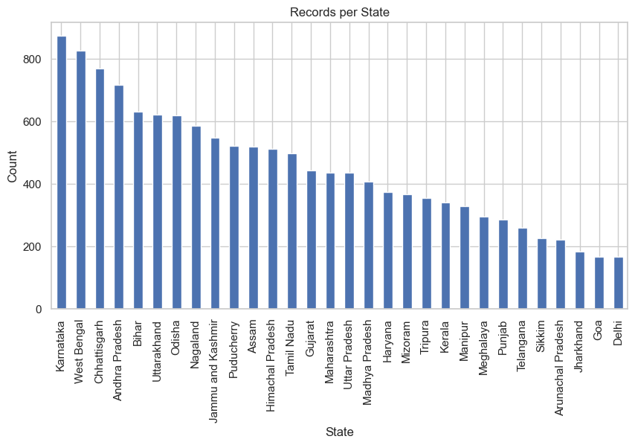
Fig. 1. Number of records per Indian state in the dataset.
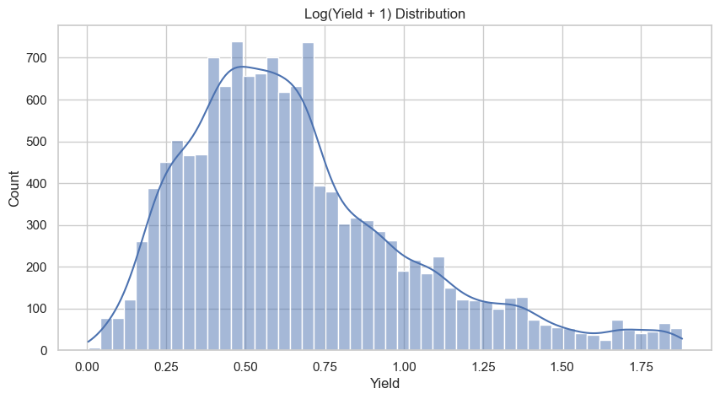
Fig. 2. Distribution of log-transformed crop yield.
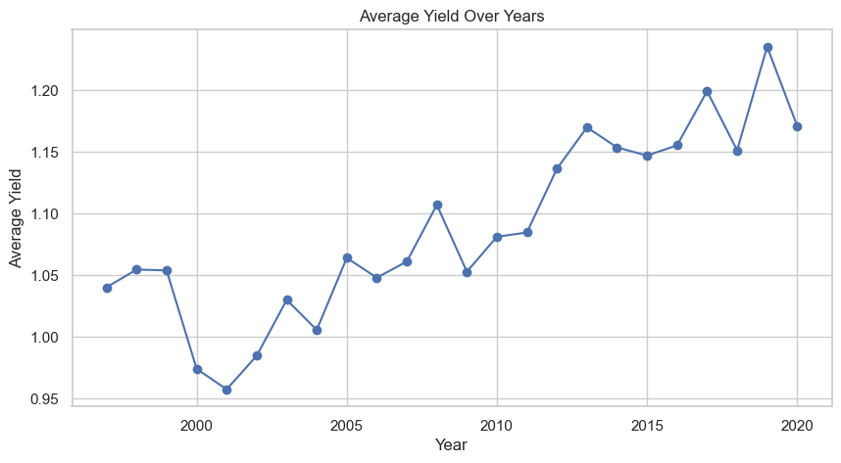
Fig. 3. Average crop yield trend across years (1997-2020).
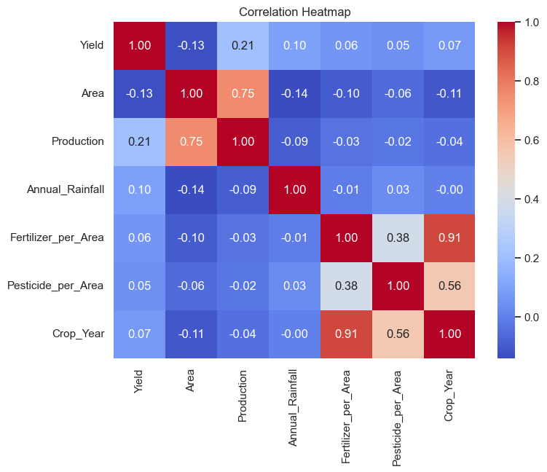
Fig. 4. Correlation heatmap of numeric variables.
D. Model Development
A common preprocessing pipeline was used, which involved standard scaling of the numeric features and one hot encoding for the categorical features (Crop, Season, State), and three regression models were implemented.
1) Linear Regression, as the baseline model which is interpretable.
2) Random Forest Regressor, an ensemble of decision trees trained using ‘bootstrap aggregation’, started with 300 estimators with the max depth of 12, to prevent overfitting.
3) Gradient Boosting Regressor with 200 estimators, max depth of 3 and learning rate of 0.05, and subsampling was also used to further mitigate overfitting.
The evaluation of each model has been done using 80/20 train-test split and five-fold cross validation on train data to take a measure of the generalization stability, regardless of the specific train-test split used. RMS error, Mean absolute error and R-squared of the training and test sets were calculated to explicitly evaluate the difference between the training and test performance to assess if overfitting and/or underfitting is present. A grid search with five fold cross validation was then used to find a combination of hyperparameters (number of estimators, maximum depth and minimum samples per leaf) that minimize bias and variance.
V. Findings
A. Quantitative Results
Table I shows the results for the four different configurations of the models.
TABLE I
MODEL PERFORMANCE COMPARISON
Model | Train R2 | Test R2 | CV R2 (mean) | Test RMSE
Linear Regression | 0.69 | 0.70 | 0.72 | 0.41
Random Forest | 0.90 | 0.85 | 0.84 | 0.30
Gradient Boosting | 0.79 | 0.78 | 0.79 | 0.36
Random Forest (Tuned) | 0.94 | 0.86 | 0.86 | 0.28

Linear Regression had the lowest test R-squared value (~0.70), suggesting that it was unable to represent the nonlinear interactions among crop type, state, season, and the input variables. It had a similar result with the train and test scores, suggesting that the model wasn't 'overfitting' – rather it was insufficiently modeling the relationships underlying the data and this reflects its limited functional flexibility.
Random Forest significantly outperformed Linear Regression as it has a high test R-squared of 0.85 and a reasonably small difference between train and test R-squared of 0.05, which implies that the model has a great ability to generalize and a mild level of overfitting. Gradient Boosting had intermediate performance, with train and test scores being quite close together at ~0.78 - 0.79 showing that the algorithm was well regularised and not too strong nor too weak, but the ability to predict the outcome was less compared to Random Forest.
The hyperparameters that were tuned using grid search returned the following, with 300 estimators, maximum depth of 16, and minimum samples per leaf of 2, yielding the best average performance with a test R-squared of 0.86 and a cross validation R-squared of 0.86 with a standard deviation of about 0.013 across the folds. The slight difference between the training R-squared (0.94) and the test and cross-validation R-squared (0.86) suggests a mild extent of overfitting, compared to the untuned model, but the similarity between the test and cross validation R-squared scores suggest that the model's performance was consistent across different data partitions, and was not simply due to the random selection of a favorable train-test split.
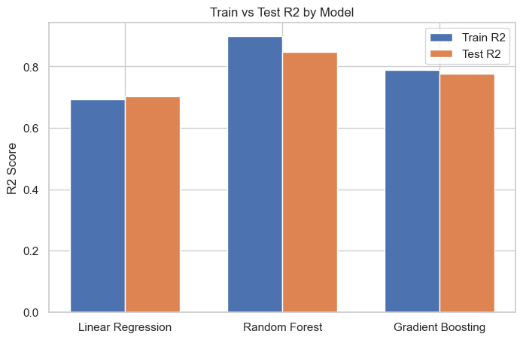
Fig. 5. Train versus test R2 comparison across the three models.
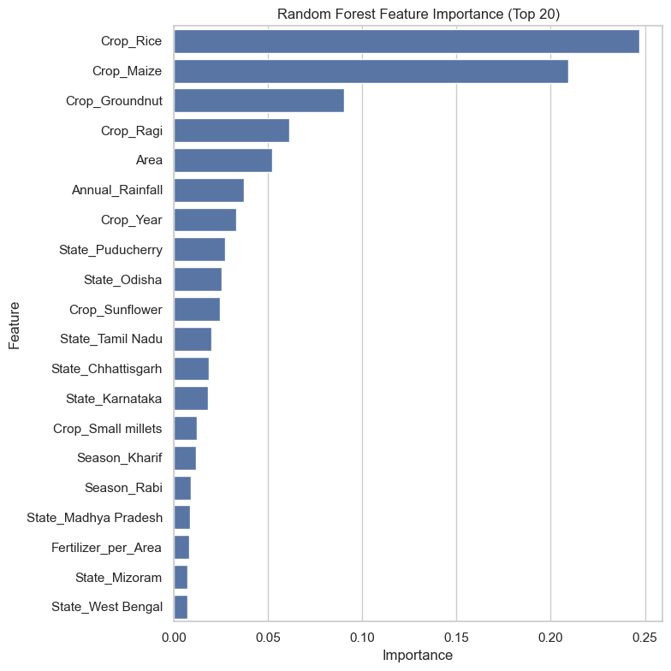
Fig. 6. Random Forest feature importance (top 20 features).
Analysis of the tuned Random Forest model revealed that crop type and state identity provided the greatest contribution to the model, fertiliser intensity the next largest contribution, and annual rainfall a comparatively, but not insignificant, contribution. This result is important because it shows that for this data set, structural (crops, locations) and controllable (input intensity) factors are more important than annual rainfall alone in accounting for yield variability, confirming our literature review finding that in some cases, agronomic and regional factors are more important than coarse climate factors in yield prediction [1] and [5].
B. Business Value Interpretation
The quantitative results have direct implications for the qualitative and business aspects. The magnitude of the crop type and state effect on yield indicates yield prediction and improvement should be undertaken on a region/crop-specific basis rather than being a pan-India policy, which means decentralized agricultural extension planning. This meaningful role of fertilizer intensity, second only to structural crop and state factors, implies that fertilizer input optimisation schemes (tailored subsidy schemes, soil health card schemes etc.) could be a more direct lever for improving yields than schemes that depend on the weather, which are largely beyond human control. The relative smaller contribution of precipitation does not mean that the weather is not important, but rather that some impact of precipitation may be already reflected indirectly through state and crop identity, i.e. some crops and states are grown in part due to their climatic suitability for precipitation.
In terms of deployment, the tuned RF model (0.86 test R-squared) could be used as a decision support tool by agricultural departments of the states for indicative yield prediction before the harvest season, which can be useful for preliminary planning of logistics and price, while the results of the importance of the features can be used to give targeted extension advice to farmers in addition to being a black box prediction model.
VI. Conclusion
In this project, three machine learning regression models (Linear Regression, Random Forest, and Gradient Boosting) were implemented and compared for predicting the crop yield using real-world Indian agricultural and weather data from various states, seasons, and crops in the period 1997 – 2020. The tuned Random Forest model was determined to be the best model in terms of data cleaning, data normalization (per-area), data transformation (log of the yield target), and robust performance evaluation results using train-test comparison, cross validation (5-fold) and hyperparameter tuning, with a test R-squared value of 0.86, a stable cross validation, and a moderate train-test gap, which demonstrated good generalization with minimal overfitting or underfitting.
The results confirm the general trend found in the literature that ensemble tree-based approaches are very suitable for moderately sized, structured and tabular agricultural datasets and that agronomic input variables like fertilizer intensity carry a meaningful predictive signal in addition to the signal carried by the weather variables [1], [10]. The project also pointed out the following issues of ethics in the use of data: 1. Does the data represent a good sample of the entire population? 2. Can the data be misused to produce yield predictions? 3. Can the data be misused to "advise" over-fertilization if used without context?
Future research will include expanding this study to use remotely-sensed data and/or vegetation indices derived from satellite data as used in previous studies [3, 9] will be explored, as well as deep learning models such as attention-based recurrent networks or transformers with larger datasets [3, 4] and real-time IoT sensor data, potentially extending the study beyond static, historical prediction and into within-season forecasting [8]. These extensions would further push the modeling approach towards the state-of-the-art precision agriculture systems as described in recent literature, while at the same time maintaining its interpretability and ethical basis set by this project.
References
[1] S. Saha, O. D. Kucher, A. O. Utkina, and N. Y. Rebouh, "Precision agriculture for improving crop yield predictions: a literature review," Frontiers in Agronomy, vol. 7, p. 1566201, 2025.
[2] D. David, "Weather based prediction models for disease and pest using machine learning: a review," Asian Journal of Agricultural Extension, Economics & Sociology, vol. 41, no. 11, pp. 334-345, 2023.
[3] S. M. M. Nejad, D. Abbasi-Moghadam, A. Sharifi, N. Farmonov, K. Amankulova, and M. Lászlź, "Multispectral crop yield prediction using 3D-convolutional neural networks and attention convolutional LSTM approaches," IEEE Journal of Selected Topics in Applied Earth Observations and Remote Sensing, vol. 16, pp. 254-266, 2022.
[4] S. Gade, A. Singh, and S. Patil, "Enriching crop yield and price prediction using transformers," Int. J. Res. Eng. Sci. Manag., vol. 7, pp. 87-93, 2024.
[5] P. Muruganantham, S. Wibowo, S. Grandhi, N. H. Samrat, and N. Islam, "A systematic literature review on crop yield prediction with deep learning and remote sensing," Remote Sensing, vol. 14, no. 9, p. 1990, 2022.
[6] A. Oikonomidis, C. Catal, and A. Kassahun, "Deep learning for crop yield prediction: a systematic literature review," New Zealand Journal of Crop and Horticultural Science, vol. 51, no. 1, pp. 1-26, 2023.
[7] A. Morales and F. J. Villalobos, "Using machine learning for crop yield prediction in the past or the future," Frontiers in Plant Science, vol. 14, p. 1128388, 2023.
[8] F. M. Talaat, "Crop yield prediction algorithm (CYPA) in precision agriculture based on IoT techniques and climate changes," Neural Computing and Applications, vol. 35, no. 23, pp. 17281-17292, 2023.
[9] A. M. Ali, M. Abouelghar, A. A. Belal, N. Saleh, M. Yones, A. I. Selim, M. E. Amin, A. Elwesemy, D. E. Kucher, S. Maginan, and I. Savin, "Crop yield prediction using multi sensors remote sensing," The Egyptian Journal of Remote Sensing and Space Sciences, vol. 25, no. 3, pp. 711-716, 2022.
[10] S. M. Shawon, F. B. Ema, A. K. Mahi, F. L. Niha, and H. T. Zubair, "Crop yield prediction using machine learning: an extensive and systematic literature review," Smart Agricultural Technology, vol. 10, p. 100718, 2025.

