Predicting Stroke Risk from Clinical Symptoms and Analysing Patient-Reported Experiences with Cardiovascular Risk Factor Management: A Comparative Machine Learning Study

Abstract - Cardiovascular disease and stroke continue to be major causes of morbidity and mortality throughout the world and the development of structured clinical data and unstructured patient stories provides an opportunity to use machine learning to improve cardiovascular risk prediction and analysis of patient experience. This study is a comparative machine learning investigation of two different data modalities that have a common cardiovascular health theme. This first data set is 10,981 structured clinical symptom records which are used to predict binary stroke risk. The second data set is a subset of patient-generated drug reviews consisting of 13097 reviews and is limited to the cardiovascular risk factor conditions: hypertension, high cholesterol, arrhythmia, diabetes, vascular disease, smoking cessation, obesity and weight management, and was used to predict patient sentiment from free text. The structured data set were later classified using four classification algorithms: K-Nearest Neighbours, Decision Tree, Random Forest and Support Vector Machine, with the latter classification algorithm demonstrating superior results, with an accuracy of 97.6% and a Cohen's Kappa of 0.947. The classifiers on review data were applied with two classifiers Multinomial Naive Bayes and Logistic regression with TF-IDF vectorisation which yielded the accuracy of 78.9% and Cohen's Kappa 0.442 respectively. Interpretability using SHAP value analysis, Random Forest feature importance and using the coefficients of logistic regression was carried out, indicating that age is the most important predictor of stroke risk and the terminology related to weight and smoking were the most important drivers of positive sentiment in cardiovascular medication reviews. Results show that the classification of symptoms in structured format is sufficient for a very detailed and precise identification of the risk of stroke, and that the identification of the sentiment expressed in free text medication reviews is a difficult, but still manageable, task with clear implications for the use of patient reported experience data in classical risk models.
I. Introduction
A. Motivation
Stroke and cardiovascular disease collectively, represent a large burden of disease globally and there is a very important public health goal for early detection of at-risk individuals using symptom-based screening. Meanwhile, patients are increasingly reporting their personal experiences with cardiovascular drugs and cardiovascular risk factors on the Internet, creating a wealth of data that is not fully utilized and which provides insights into how patients perceive the efficacy and side effects of cardiovascular drugs and how well they tolerate them. Combined with patient narratives – which are typically unstructured – these two data types provide a more complete view of cardiovascular health management than either clinical indicators or narrative alone.
B. Research Questions
The following two research questions are related to each other. First, how well can binary stroke risk be predicted from a set of well-defined clinical symptom indicators and which symptoms are most important to stroke risk prediction. Second, what proportion of sentiment can be predicted by the patient-authored reviews of medications relating to cardiovascular risk factor management and what linguistic features are predictive. A secondary goal is to compare the relative effectiveness, reproducibility and explainability of the modelling approaches used for each of the data types in line with data mining best practice guidance in this realm [9].
C. Contributions
This study provides a number of contributions. It offers a direct empirical comparison of four different classification algorithms, using a structured cardiovascular symptom set, and assessed by various performance metrics other than raw accuracy, such as macro F1-score, Cohen's Kappa, sensitivity and specificity. Uses text mining and sentiment classification on patient drug reviews within a subset of patient data that is filtered to include only data that is thematically coherent, with respect to the recognised cardiovascular risk factors. It can be used with either the structured or the text-based models and can give an explainability report of the features and terms that are contributing to each prediction based on SHAP. Lastly, it outlines a reproducible data extraction, cleaning, exploratory analysis, modelling and evaluation pipeline for both data modalities in the same study.
D. Paper Structure
Section II examines relevant literature concerning the use of machine learning in disease prediction, patient reported outcome analysis and cardiovascular risk modelling. Section III explains the methodology used for data mining which includes data preparations, feature engineering and model configurations for both datasets. The results of the evaluation, in terms of classification performance, interpretability findings, and sample level prediction results are given in Section IV. The findings, limitations and directions for future work are summarized in Section V.
II. Related Work
A. Prediction of diseases and patient-reported outcomes using machine learning.
The use of machine learning (ML) in the practical use of clinical data for predicting diseases has grown significantly. Alhumaidi et al. conducted a survey spanning various examples of disease prediction using real-world datasets, and found that many studies focusing on machine learning do not report on how class imbalance was addressed, nor on the validation strategy used [1] – in this study class imbalance is addressed via stratified sampling, and five-fold stratified cross-validation is used. Interpretability is an important consideration when training a model on patient-generated data: there is related research on patient-reported outcomes. Wójcik et al. noticed that more and more NLP algorithms are being used in combination with the data obtained from the structured questionnaires, but unfortunately most of the studies are based on small, and relatively restricted data sets gathered within a single institution [3]. Interpretability of models used for patient-reported data is crucial as clinicians and patients should trust and act upon the predictions the model makes [4] which is the reason for using SHAP and coefficient-based interpretability in this sentiment classification model. Structured and Text-based data are complementary and not redundant, which is why this study is designed to be structured and text-based; Milbourn et al. found that the combination of these types of data is often the best way to predict performance-based outcomes and patient-reported outcomes [2].
B. Clinical and patient text using Natural Language Processing
Mikołajewska and Masiak summarized the deep learning methods for natural language processing in psychiatric and neurological rehabilitation and reported that in moderate-sized domain-specific text corpora, the more straightforward bag-of-words and term frequency-inverse document frequency representations are still competitive baselines to more advanced architectures, especially where interpretability is important [5]. This is in line with the methodological decision of applying TF-IDF vectorisation and Logistic Regression and Naive Bayes to this data, as opposed to a deep neural architecture, in order to seek transparency and reproducibility.
C. AI in Stroke and cardiovascular prediction.
The following reviews are on AI throughout the stroke/cardiovascular care pathway. Awamleh et al. provided an overview of AI in stroke from prevention to treatment; while most prediction models include demographic factors, especially age, as one of the strongest predictors in their models, this study also found age to be one of the highest importance and SHAP values in stroke risk prediction. Both types of classifiers were evaluated in this study and Barouhou et al. showed that traditional classifiers (Support Vector Machines and ensemble tree methods) work well for symptom-based and tabular clinical data, while deep learning works well for imaging data [13].
The use of ensemble and kernel based methods like Random Forest and Support Vector Machine is also often found to be superior compared to simpler baseline methods in cardiovascular disease prediction [9] (as was the case for the Support Vector Machine in this study), because the continuous predictor of age is directly related to the disease. In the field of cardiovascular medicine, Khanna et al. provide a general overview of Artificial Intelligence, noting that in addition to diagnosis, an increasingly important area of application is the identification and management of risk factors [14] which spurred the focus on the drug review component on risk factor management. Large language models (LLMs) in cardiovascular and cerebrovascular disease (CVD) management have been explored by Chlorogiannis et al. who found that structured predictive tasks remain best performed by purpose-built supervised models trained on labelled data [7], thus justifying the supervised approach used here. In the field of HCM, Mohyeldin et al. have summarized the use of AI and noted that the use of interpretable feature attribution methods, such as SHAP analysis used in this study, are important for the use of personalised risk prediction in HCM [8].
D. Chronic Disease Risk Factors and Overall Clinical Prediction.
The drug review subset can be interpreted to be much broader than narrowly defined cardiovascular drugs; it includes reviews of those drugs which are known to impact modifiable cardiovascular risk factors like diabetes, cessation and obesity/weight management. Bandar and Lakmal surveyed the literature on diabetes risk prediction models ranging from traditional machine learning models to agentic artificial intelligence models, and found that traditional supervised classifiers are still the most reproducible methods for structured diabetes risk data [12] and that there is a need to include diabetes-related reviews in the cardiovascular risk factor subset. Pahlevani et al. surveyed the statistical and machine learning algorithms for patient discharge prediction, and common themes emerged: the need for transparency in the model, and the need to use more than one complementary evaluation metric [10]. In fact, age is the most prevalent in this study's stroke model, and Olender et al. analyzed machine learning techniques in predicting clinical outcomes in older adults; they found that the ensembles (Random Forest) are superior to single tree and distance based classifiers [11]. In the case of stroke risk classification, sensitivity and specificity were reported in this study, which is essential when the cost of false negative and false positive are not similar as pointed out by Wthaij and Chyad when studying intelligent systems for predicting hemodialysis patient's complications where the cardiovascular comorbidity was also extensive [15].
E. The location of the present study
Three themes emerge from the literature surveyed: structured clinical data is best suited to ensemble and kernel-based classifiers, with age often being a key, dominant predictor [1, 6, 9, 11, 13]; patient reported text needs particular natural language processing and careful interpretability [2, 3, 4, 5]; and multiple complementary metrics and explainability techniques are good practice rather than optional [8, 10, 15]. This study sits squarely in this space, as it utilizes conventional supervised classifiers and multi-metric evaluation with structured stroke symptom data, while using text classifiers with interpretability analysis with a thematically-filtered subset of patient-reported cardiovascular medication experiences.
F. Machine Learning for Related Chronic Disease Risk Factors
Since the drug review subset in this study goes beyond the narrow definition of cardiovascular drugs to also encompass diabetes, smoking cessation, obesity and weight management which are all recognised modifiable cardiovascular risk factors related work in the adjacent fields is relevant. Bandarajasekara and Lakmal present a comparative review of diabetes risk prediction models ranging from traditional machine learning methods to the newer agentic approach of artificial intelligence and recommend the traditional supervised classifiers for diabetes risk prediction of structured data [12]. This lends credence to the inclusion of Type 1 and Type 2 diabetes-related drug reviews in the cardiovascular risk factor subset analysed for this study, as there is a known clinical association between the management of diabetes and cardiovascular outcomes.
G. Clinical Decision Support and Patient Outcome Prediction in the General
Outside of cardiology and stroke, there are other general reviews of machine-learning applications in clinical decision support that give important context. Pahlevani et al. performed a systematic survey of statistical and machine learning approaches to predicting patient discharges and found the literature consistently suggests that the ideal approach is to have several complementary evaluation metrics, and be transparent about models [10]. In their study on predicting clinical outcomes by machine learning methods in older people, which is highly relevant to the present study as age is the most important predictor identified here, Olender et al. performed a systematic review and meta-analysis, and found that ensemble methods (Random Forest) generally perform better than single-tree or distance-based classifiers (Decision Trees and K-Nearest Neighbours) on structured geriatric clinical data [11]. Wthaij and Chyad looked at intelligent systems to predict complications in hemodialysis patients, another population with significant cardiovascular comorbidity, and found that in such situations, where the consequences of false negative and false positive outcomes are widely divergent, reporting all performance measures – including sensitivity and specificity (as done in this study for the stroke risk classification task) – is crucial [15].
III. Data Mining Methodology
This study takes a step-by-step approach in the fields of data mining, specifically the Cross-Industry Standard Process for Data Mining (CRISP-DM), and performs it parallel on two data sets with a common cardiovascular health theme.
A. Business Understanding
The goal is to build and compare machine learning applications to structured clinical symptom information and unstructured patient-reported medication experience information. The stroke task is treated as binary classification with the aim of predicting the "at-risk" status from the symptoms and age. The drug review task is formulated as a multi-class sentiment classification task with the goal of determining the sentiment (positive, neutral, or negative) from the drug review text and the numeric rating from the same drug review.
B. Data Understanding
There are 70,000 stroke risk records across 18 columns which include 14 binary symptom indicators, a continuous age variable, a continuous stroke risk percentage, and a binary at-risk target. A stratified sample of 11,000 records was sampled to match the scale of the structured dataset to that of the text dataset and maintain the class balance.
The drug review data set contains a training and test set, and includes a total of 215,063 records in seven columns: drug name, condition, review text, numeric rating, date, and usefulness count. On initial inspection, it was found that there were 1,194 condition values missing and 86,585 duplicate reviews.
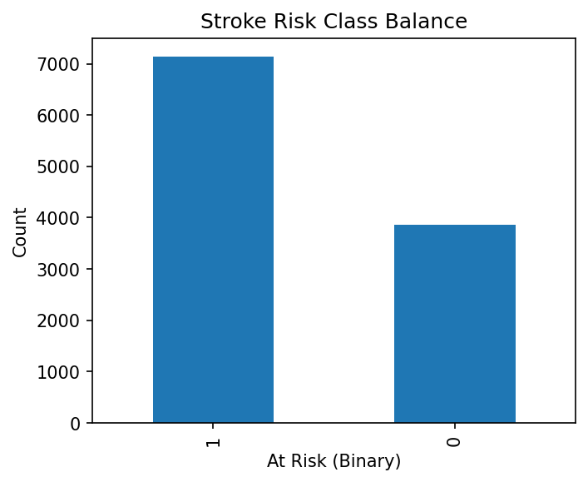
Fig. 1. Stroke risk class balance.
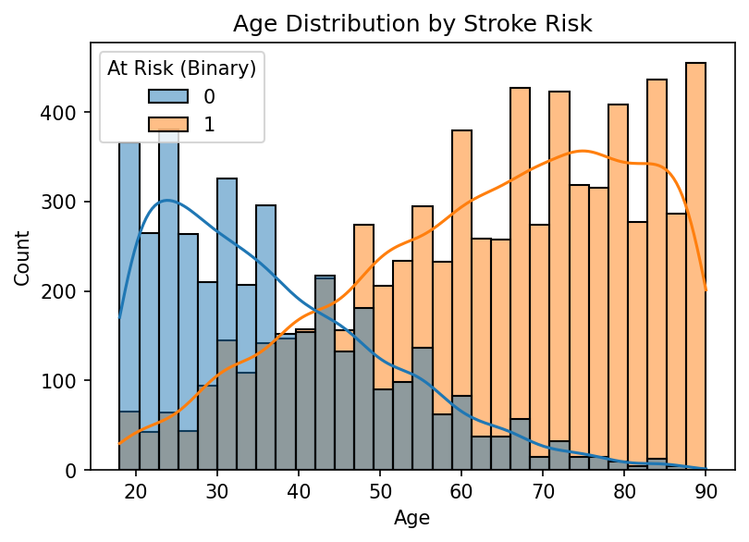
Fig. 2. Age distribution by stroke risk.
C. Data Preparation
The stroke data was dropped if it included a missing value, although it was found that there were no missing values in the data sampled from this data. Nineteen duplicate rows were deleted and 10 981 rows were left for modelling. The stroke risk percentage column was also removed from the feature set, to avoid the issue of target leakage.
In the drug review data, the data instances where review, rating, or condition value was missing were excluded and duplicate data were removed based on exact text match. Review text has been sanitized by stripping HTML character entity encoding, stripping out non-alphabetic characters, stripping out repeated whitespace and converting to lower case. The rating was transformed into a sentiment label, in three categories: positive: scores of seven or more, neutral: scores of four to six, and negative: scores of less than four. Reviews less than three words were not included. This left only 127,764 records in the corpus which were usable.
A subset of cardiovascular risk factors was created by filtering the condition field on eighteen key words related to direct cardiovascular conditions (heart, hypertension, blood pressure, cardio, cholesterol, arrhythmia, angina, coronary and stroke) and recognised modifiable cardiovascular risk factors (diabetes, diabetic, vascular, thrombosis, embolism, lipidemia, triglyceride, atrial, smoking cessation, obesity, weight loss). This resulted in 13097 reviews, with an average word count of 82.75, which was larger and longer than the minimum word count and length. Weight loss, obesity, hypertension, type 2 diabetes, smoking cessation, and hyperlipidaemia were the most common conditions, followed by a number of more specific conditions, such as atrial fibrillation, diabetic peripheral neuropathy, arrhythmia, angina and heart failure.
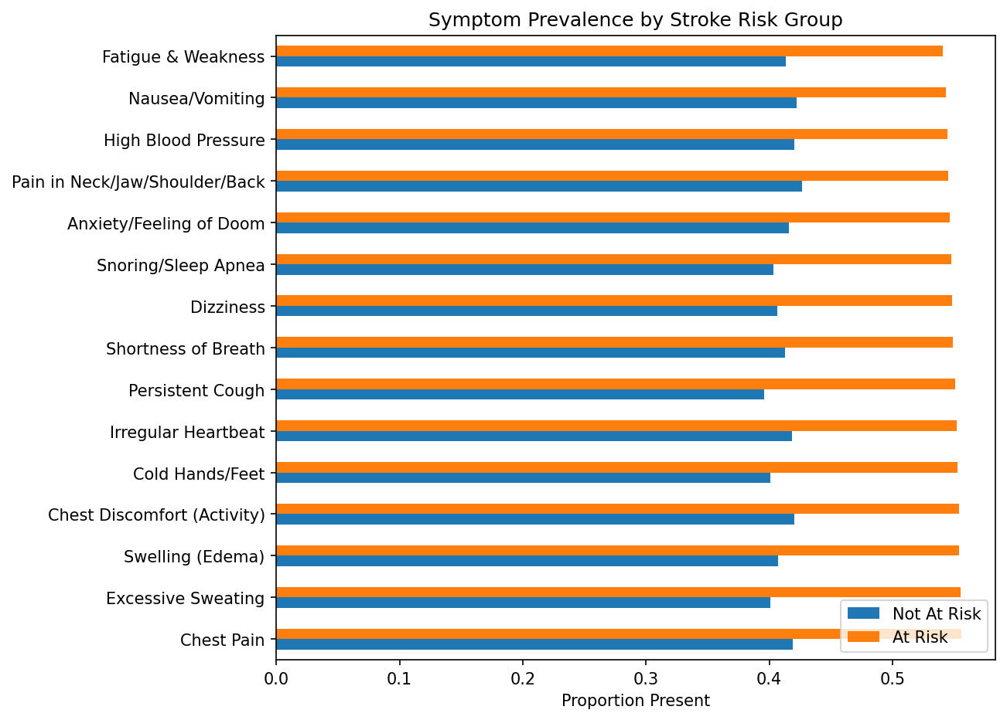
Fig. 3. Symptom prevalence by stroke risk group.
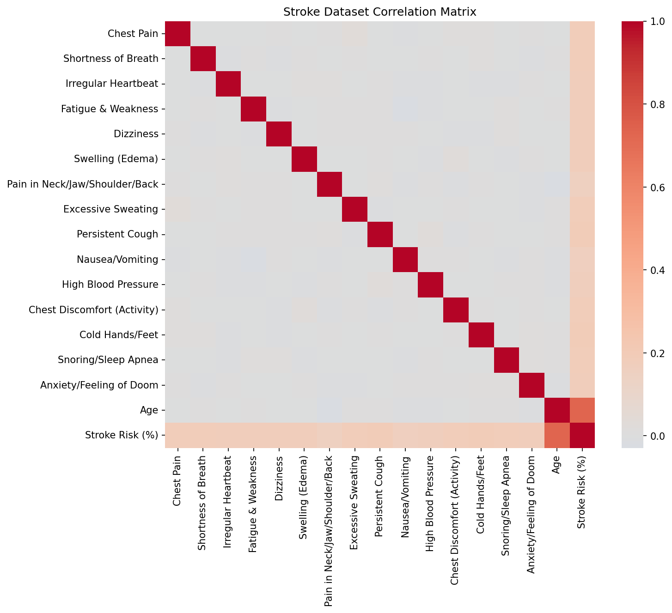
Fig. 4. Stroke dataset correlation matrix.
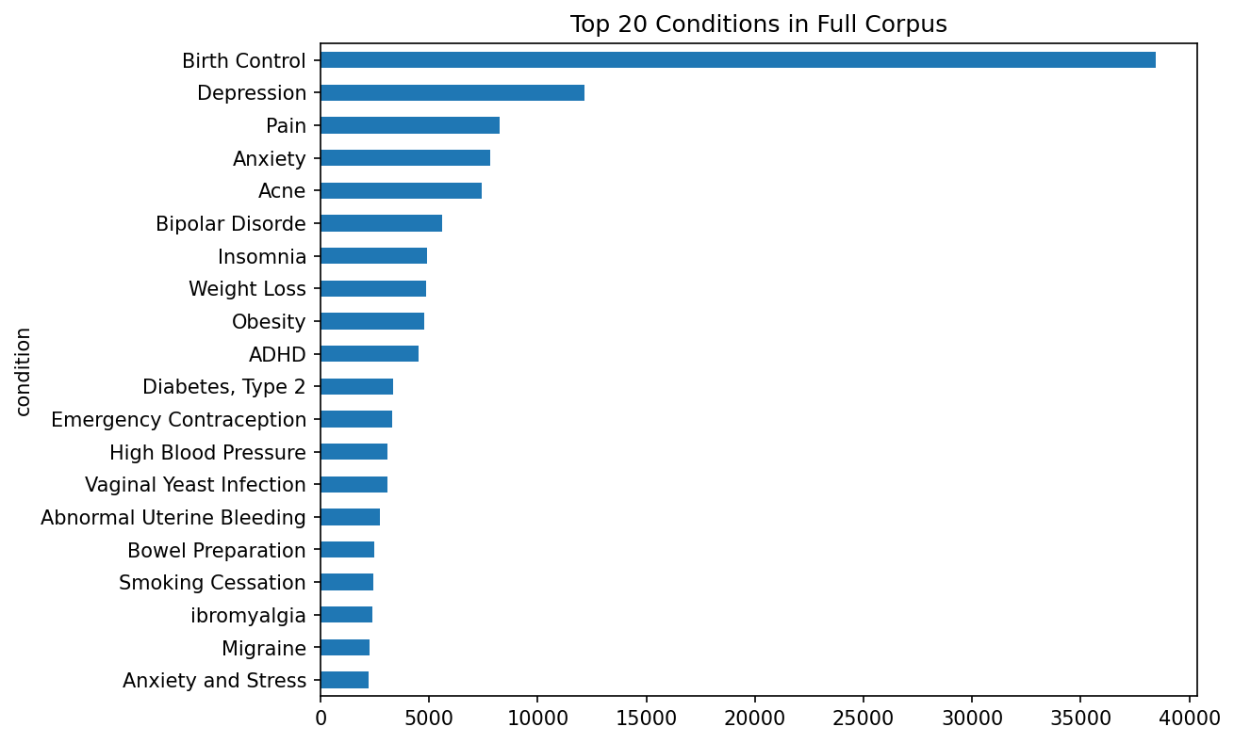
Fig. 5. Top 20 conditions in full drug review corpus.
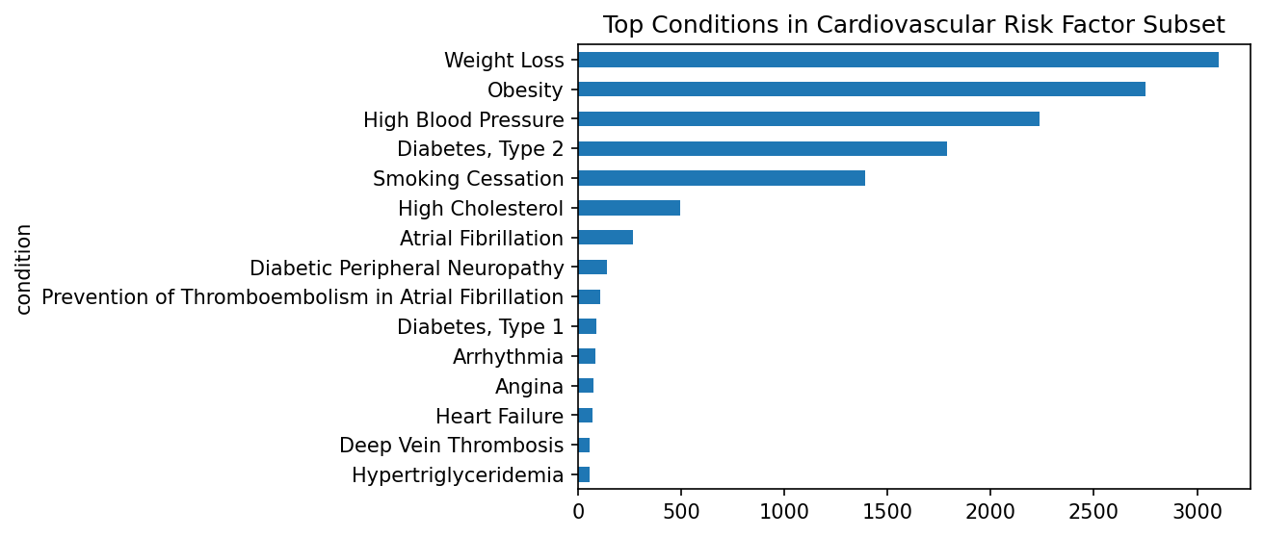
Fig. 6. Top conditions in cardiovascular risk factor subset.
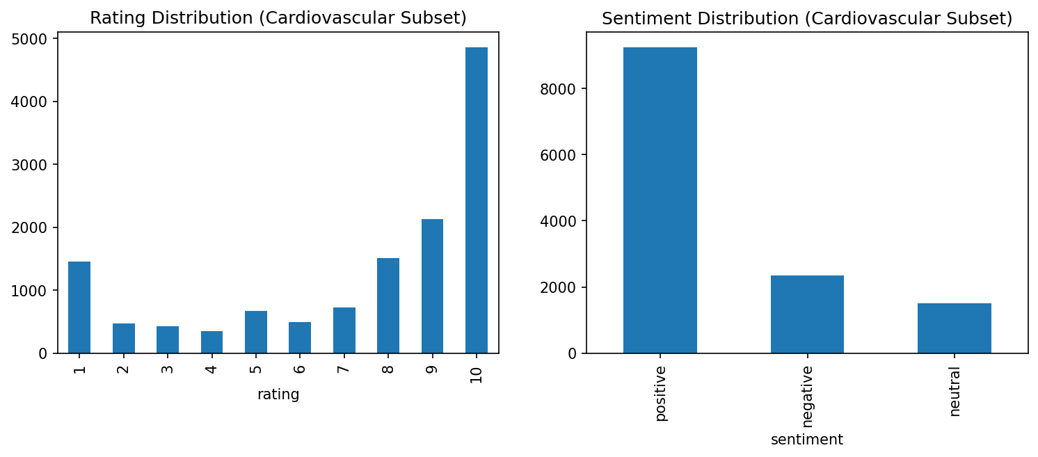
Fig. 7. Rating and sentiment distribution, cardiovascular subset.
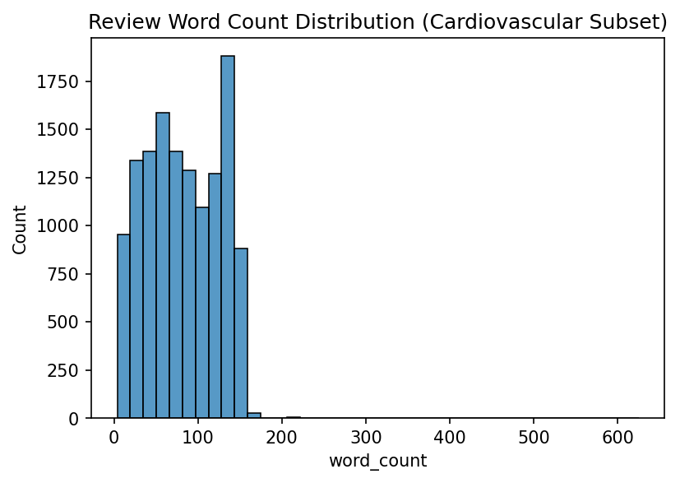
Fig. 8. Review word count distribution, cardiovascular subset.
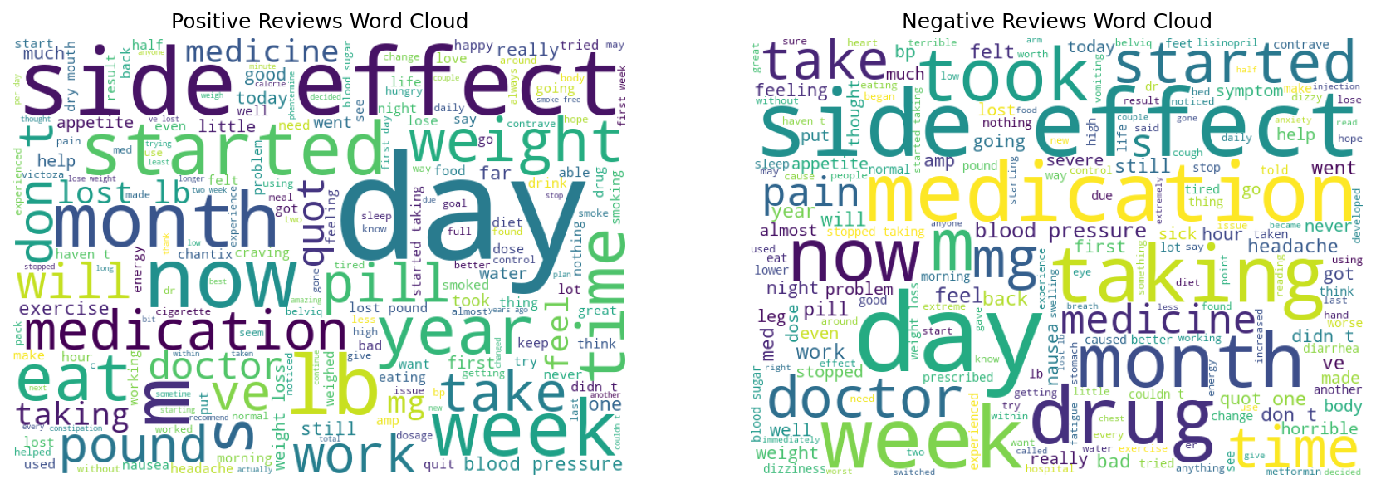
Fig. 9. Positive vs. negative review word clouds, cardiovascular subset.
D. Modelling
The dataset was then divided in 80-20 ratio with stratification for stroke and feature scaling was done for distance based and margin based classifiers. The four algorithms tested were K-Nearest Neighbours (KNN) with K = 7, Decision Tree (DT) with max depth as 8, Random Forest (RF) with 200 trees and Support Vector Machine (SVM) with radial basis function (RBF) kernel. The stability of macro F1 score has been evaluated with 5-fold stratified cross-validation.
The cardiovascular subset was divided 80:20 by sentiment label to result in 10,477 training and 2,620 test reviews for the drug review task. TF-IDF vectorisation was done with only the top 15 thousand unigram and bigram terms that had the minimum document frequency of three. Multinomial Naive Bayes and Logistic Regression classifiers have been trained.
E. Interpretability
Feature importance analysis of Random Forest and SHAP (tree based explainer analysis) were used to determine which symptom indicators had the greatest impact on stroke classification. Logistic Regression coefficients were visually reviewed for the text task and an SHAP linear explainer was applied to an independent test sample.
F. Evaluation Strategy
Accurate performance of the model was evaluated with the following metrics: accuracy, macro F1-score, Cohen's kappa, sensitivity and specificity for the stroke task; and accuracy, macro F1-score, and Cohen's kappa for the sentiment task, in line with best practice advice that multiple metrics are necessary to evaluate the accurate performance of the model [10, 15]. All the six trained models confusion matrices were created. Sample level prediction demonstrations were performed for the best performing model for each task by making predictions on a random sample of held out test records, and comparing predicted and actual labels.
IV. Evaluation
A. Stroke Risk Classification Results
Table I shows the performance of the stroke risk classification.
Model | Accuracy | F1 (Macro) | Kappa | Sensitivity | Specificity
KNN | 0.893 | 0.880 | 0.760 | 0.942 | 0.803
Decision Tree | 0.843 | 0.829 | 0.659 | 0.864 | 0.803
Random Forest | 0.925 | 0.917 | 0.833 | 0.962 | 0.857
SVM | 0.976 | 0.973 | 0.947 | 0.985 | 0.958

The Support Vector Machine showed the best performance in all measures, and had near-perfect agreement beyond chance. As expected, the performance of the Decision Tree was the weakest, followed by K-Nearest Neighbours and the Random Forest was the second strongest, being an ensemble and margin-based method. For all four models, sensitivity was higher than specificity, a desirable ratio for a screening test where the importance of identifying people at risk is greater than of avoiding false-positives. They were all well tracked on the test set with standard deviations < 0.008, meaning that it was not a result of one particular split and that the performance of all four models remained stable.
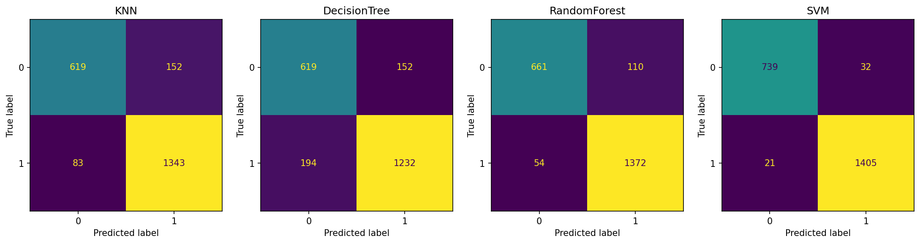
Fig. 10. Confusion matrices for KNN, Decision Tree, Random Forest, and SVM.
B. Interpretability for the Risk of Stroke
With the results of Random Forest feature importance, the age is the most important feature and attains about 49.8% of the total importance which is more than fourteen times of the next important feature. The remaining importance was spread relatively evenly with each of the fourteen symptom indicators accounting for 3.3% to 3.4% of the remaining importance. SHAP analysis also identified this trend, as age was the highest mean absolute SHAP value at ~0.256, over five times the next latest ranked feature of excessive sweating at ~0.050. The good agreement between the two independent interpretability procedures strongly indicates that the age is the main factor contributing to the predictions, which is in line with the stroke prediction literature as a whole [6].
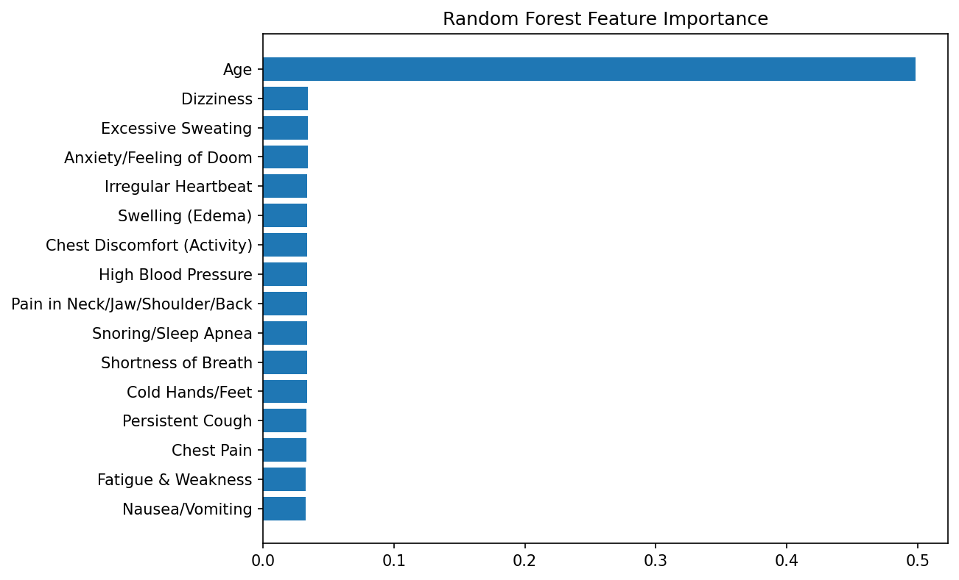
Fig. 11. Random Forest feature importance.
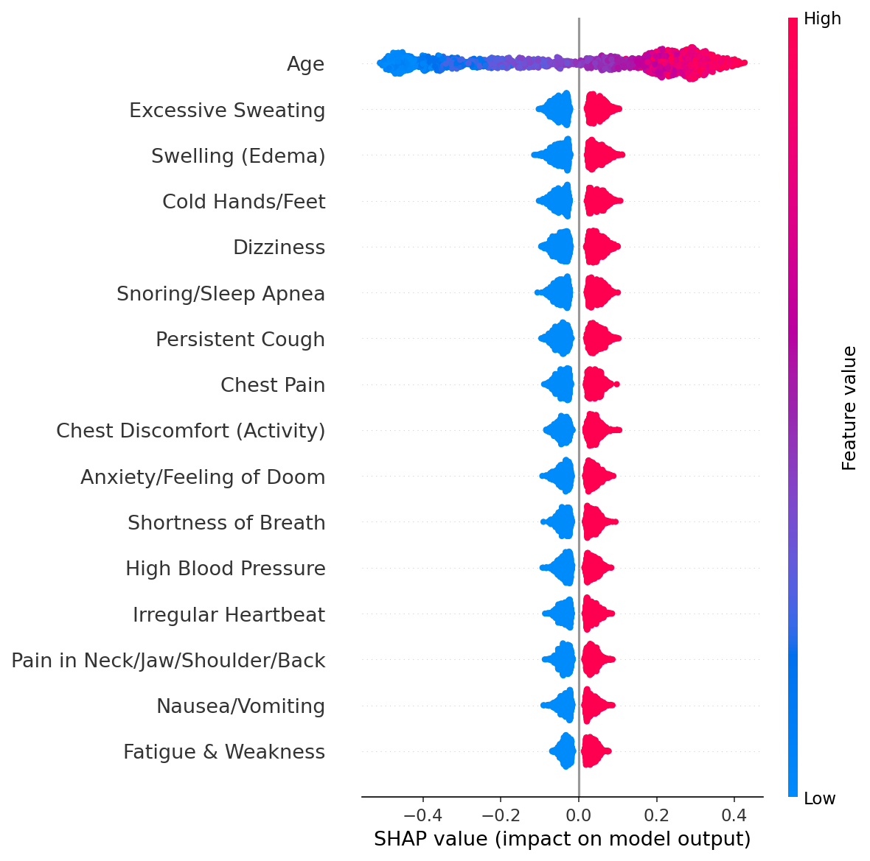
Fig. 12. SHAP summary plot for stroke risk model.
C. Drug Review Sentiment Classification Results
Table II. The results of the Drug Review Sentiment Classification performance are displayed.
Model | Accuracy | F1 (Macro) | Kappa
Naive Bayes (TF-IDF) | 0.746 | 0.417 | 0.235
Logistic Regression (TF-IDF) | 0.789 | 0.528 | 0.442

Logistic Regression has performed better on all the metrics as compared to Naive Bayes. Cohen's kappa and macro F1-score along with accuracy are important for imbalanced patient-reported text data [10, 15] and the difference in accuracy and macro F1-score is particularly noticeable for Naive Bayes, suggesting that this is accuracy padding for per-class performance due to the imbalance of sentiment classes in this subset.
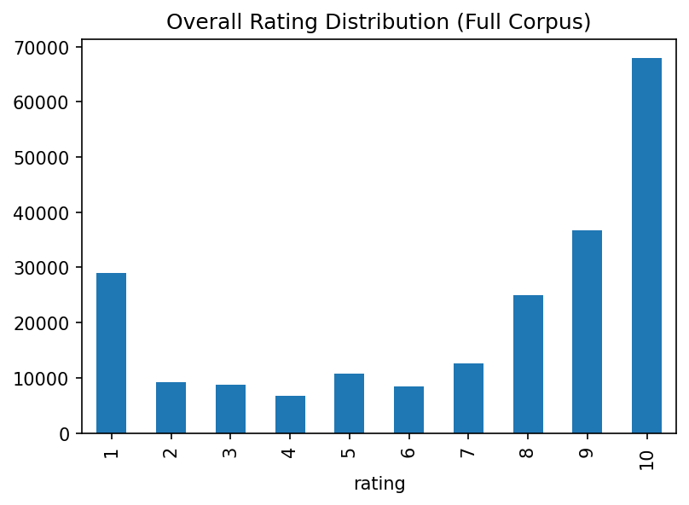
Fig. 13. Overall rating distribution, full corpus.
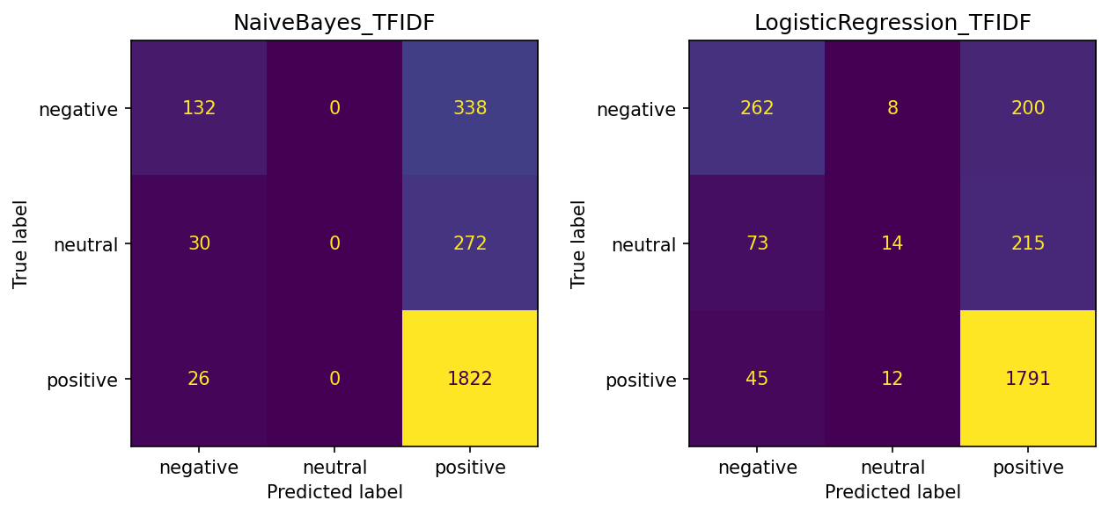
Fig. 14. Confusion matrices for Naive Bayes and Logistic Regression.
D. Drug Review Sentiment Interpretability
The top positive-sentiment words in this subset – as identified by Logistic Regression – were lbs and pounds, meaning that the language of weight-related outcomes is predominant in positive sentiment when considering only this subset, which was not surprising as weight loss and obesity were the most prevalent focus of the reviews. Other highly positive words such as great, love, have lost, amazing, smoking, no side, best, works and smoked were also included; the latter three words signifying successful weight loss, successful smoking cessation and absence of side effects form the dominant positive sentiment signal. This is also supported by SHAP linear explainer analysis, which identified lbs, pounds, great and works as the top four terms in the analysis, along with no side and smoking.
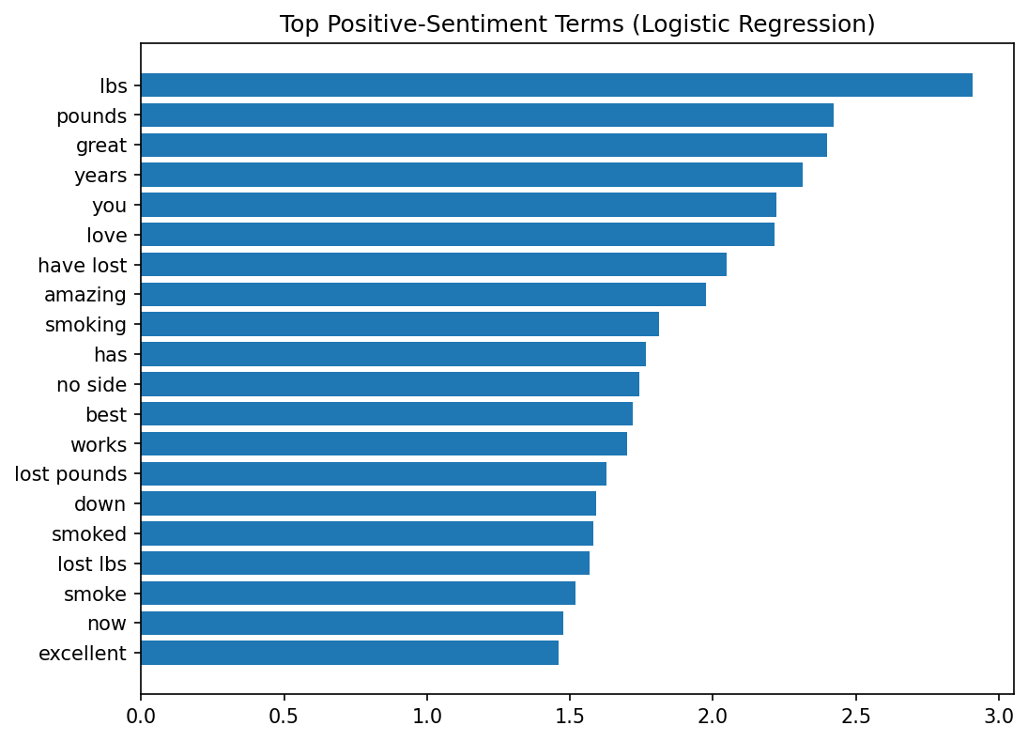
Fig. 15. Top positive-sentiment terms, Logistic Regression coefficients.
E. Sample-Level Prediction Demonstration
Each of the best-performing models (SVM for the stroke risk and LR for the sentiment) was tested on a random sample of 10 held-out test records from each of the datasets. For stroke risk, this contrasted the age, true status, predicted status and predicted probability for each sampled individual, in an open transparent way, so that it provides a case-by-case illustration of the classification behaviour, beyond the aggregate statistics. For sentiment, this involved comparing a sample of each of the sampled reviews with the sentiment label assigned by the tool, and the patient's true sentiment; this helped to trace the alignment and divergence of patient sentiment to the sentiment predicted by the tool, and was suggested as a complement to aggregate metrics for non-technical stakeholders [4].
V. Conclusion and Future Work
A. Conclusion
This study was a comparative investigation of two types of machine learning—one on structured clinical symptom information and the other on unstructured patient-reported medication experience information—which shared a common domain of cardiovascular health. In the stroke risk data set the Support Vector Machine had the best performance among four algorithms with 97.6% accuracy and a Cohen's Kappa of 0.947, and the interpretation analysis of the models found that age was always the most important predictor. The results of Logistic Regression on the cardiovascular risk factor drug review dataset demonstrate the superiority of this method over Naive Bayes method for sentiment classification with 78.9% accuracy and Cohen's kappa score of 0.442; weight related and smoking cessation related terminology proved to be the top contributors for positive sentiment. These findings demonstrate a stark difference between these two types of data: structured symptom data provides a relatively easy but highly accurate and stable task and free text patient narrative data provides a challenging but still tractable one that requires careful consideration of class imbalance and multi-metric evaluation.
B. Limitations
The stroke risk data set is a simulated symptom-checklist data set without the missingness and comorbidities properties of actual clinical data, which are consistent with the concerns of data quality in the real world data literature [1]. The cardiovascular risk factor subset was identified using a keyword-based filter; this could have included reviews that were only indirectly related to cardiovascular pathology (e.g., reviews of weight loss in general) and/or reviews that used non-standard terminology to exclude relevant reviews. The sentiment label based on the rating is a simplified version which doesn't take into the consideration of the sentiment being really mixed in moderate ratings. Finally, the results of the text classification measurement show that there is still significant potential for improvement especially for the neutral sentiment class.
C. Future Work
In the future, it would be interesting to use pretrained transformer-based embeddings for the drug review domain and compare the results with the TF-IDF baseline used here, inspired by related clinical text domains [5]. Use of real data in the electronic health record to extend stroke risk evaluation would give a better test of generalisability [1]. A fusion of the structured symptom features and the features obtained from text might be investigated as a real multi-modal extension to the model. Lastly, since there are more weight-related words than smoking-related words in the positive sentiment category, future studies may look at whether there are systematic differences in sentiment trends between the individual categories of positive conditions or if the subset of positive conditions can be considered undifferentiated.
References
[1] N. H. Alhumaidi, D. Dermawan, H. F. Kamaruzaman, and N. Alotaiq, "The use of machine learning for analyzing real-world data in disease prediction and management: Systematic review," JMIR Medical Informatics, vol. 13, no. 1, p. e68898, 2025.
[2] E. Milbourn, J. Lai, D. L. Robinson, D. C. Ackland, and P. V. S. Lee, "Wearable technology and machine learning for prediction of performance-based and patient-reported outcome measures: A systematic review," Sensors, vol. 26, no. 4, p. 1218, 2026.
[3] Z. Wójcik, V. Dimitrova, L. Warrington, G. Velikova, and K. Absolom, "Using artificial intelligence to predict patient outcomes from patient-reported outcome measures: A scoping review," Health and Quality of Life Outcomes, vol. 23, no. 1, p. 37, 2025.
[4] M. Pruski, S. Willis, and K. Withers, "A narrative review of the use of PROMs and machine learning to impact value-based clinical decision-making," BMC Medical Informatics and Decision Making, vol. 25, no. 1, p. 250, 2025.
[5] E. Mikołajewska and J. Masiak, "Deep learning approaches to natural language processing for digital twins of patients in psychiatry and neurological rehabilitation," Electronics, vol. 14, no. 10, p. 2024, 2025.
[6] M. Awamleh, M. Hamad, A. Jariri, and M. Selim, "Artificial intelligence in stroke management: From prevention to treatment," Digital Health, vol. 12, p. 20552076261433849, 2026.
[7] D. D. Chlorogiannis, A. Apostolos, A. Chlorogiannis, L. Palaiodimos, G. Giannakoulas, S. Pargaonkar, S. Xesfingi, and D. G. Kokkinidis, "The role of ChatGPT in the advancement of diagnosis, management, and prognosis of cardiovascular and cerebrovascular disease," in Healthcare, vol. 11, no. 21, p. 2906, 2023.
[8] M. Mohyeldin, F. O. Mohamed, M. Molina, M. F. Towfig, A. M. Mustafa, A. H. Elhussein, F. Alamin, M. Khaja, and P. Jadhav, "Artificial intelligence in hypertrophic cardiomyopathy: Advances, challenges, and future directions for personalized risk prediction and management," Cureus, vol. 17, no. 7, 2025.
[9] M. A. Naser, A. A. Majeed, M. Alsabah, T. R. Al-Shaikhli, and K. M. Kaky, "A review of machine learning's role in cardiovascular disease prediction: Recent advances and future challenges," Algorithms, vol. 17, no. 2, p. 78, 2024.
[10] M. Pahlevani, M. Taghavi, and P. Vanberkel, "A systematic literature review of predicting patient discharges using statistical methods and machine learning," Health Care Management Science, vol. 27, no. 3, p. 458, 2024.
[11] R. T. Olender, S. Roy, and P. S. Nishtala, "Application of machine learning approaches in predicting clinical outcomes in older adults: A systematic review and meta-analysis," BMC Geriatrics, vol. 23, no. 1, p. 561, 2023.
[12] K. R. I. Bandara and H. K. I. S. Lakmal, "Diabetes risk prediction models: A comparative review of traditional machine learning, and agentic AI approaches," (preprint).
[13] A. Barouhou, L. Benhlima, and S. Bah, "Unlocking the potential of deep learning in brain stroke prognosis: A systematic literature review," Artificial Intelligence Review, vol. 58, no. 12, p. 375, 2025.
[14] K. Khanna, D. Vats, P. Grover, R. Kumari, and S. Srivastava, "The role of artificial intelligence in cardiovascular medicine: A systematic review," International Journal of Medical and Pharmaceutical Research, vol. 7, pp. 95-96, 2026.
[15] A. K. Wthaij and A. M. Chyad, "A review of intelligent system for predicting complications in hemodialysis patients using machine learning techniques," Journal of Al-Qadisiyah for Computer Science and Mathematics, vol. 18, no. 2, pp. 477-488, 2026.

