**SIMULATED AND MEASURED RESULTS**

The measured s11 and gain of the filter-antenna are compared to simulated results in Fig. 7. The measured is below 25 dB across the entire bandwidth. The measured s11 bandwidth of 16.3% is close to the simulated bandwidth of 14%. The 0.4% difference between the measured and simulated resonant frequencies—i.e., 2.46 and 2.45 GHz, respectively—is mainly due to the loss tangent of the substrate and the fabrication tolerances. The measured gain is 2.41 dBi at 2.45 GHz, which is very close to the simulated 2.53 dBi. In order to study the radiation property of the proposed filter-antenna, surface current distributions of the filter-antenna at 2.45 GHz are given in Fig. 8. It can be noticed that the currents flow through the T -shaped antenna without changing the direction, and the strongest currents are distributed on the long horizontal strip. This indicates that the filter-antenna can obtain nearly omnidirectional radiation pattern in the yz - plane. The measured and simulated total-field radiation patterns at 2.45 GHz in the xy and yz - planes are presented in Fig. 9. The radiation pattern in the yz -plane is nearly omnidirectional with peak gain of 1.31 dBi.

**SNIPPETS FROM SIMULATION**

5.1 : Microstrip three-pole filter Model

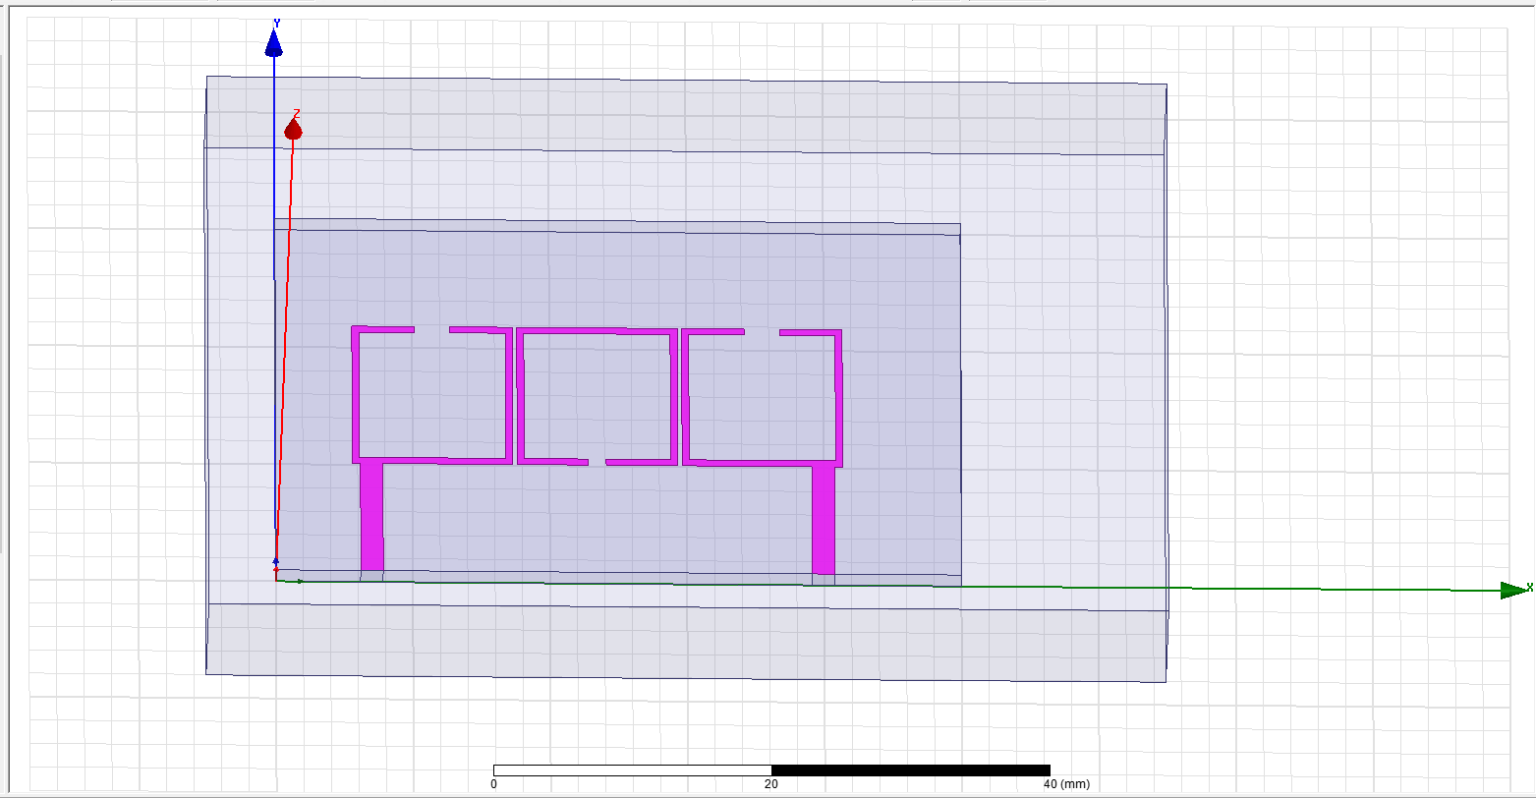

5.2 : Integrated three-pole filter-antenna Model

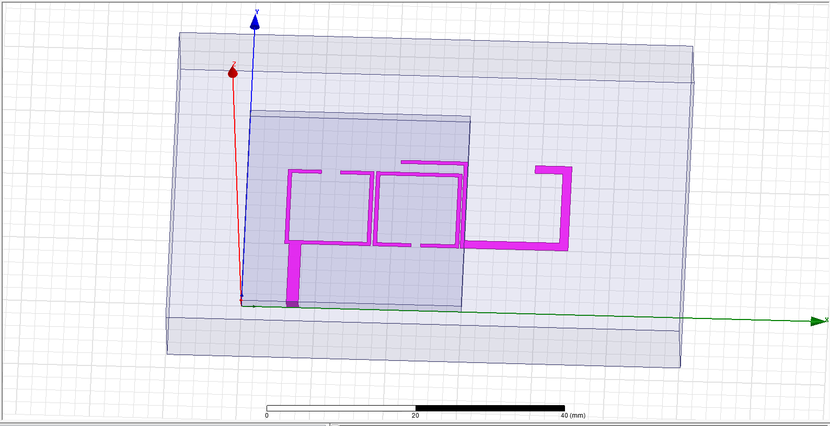

5.3 : S11 parameter for Integrated three-pole filter-antenna

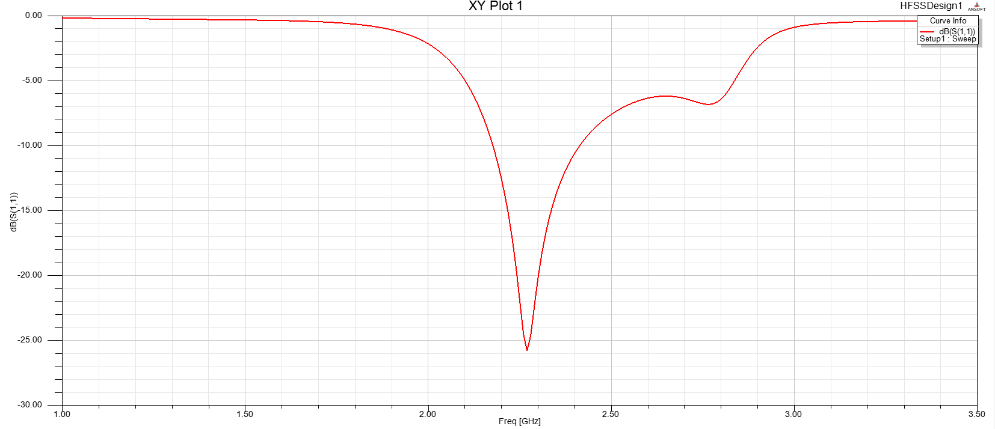

5.4 : VSWR for Integrated three-pole filter-antenna

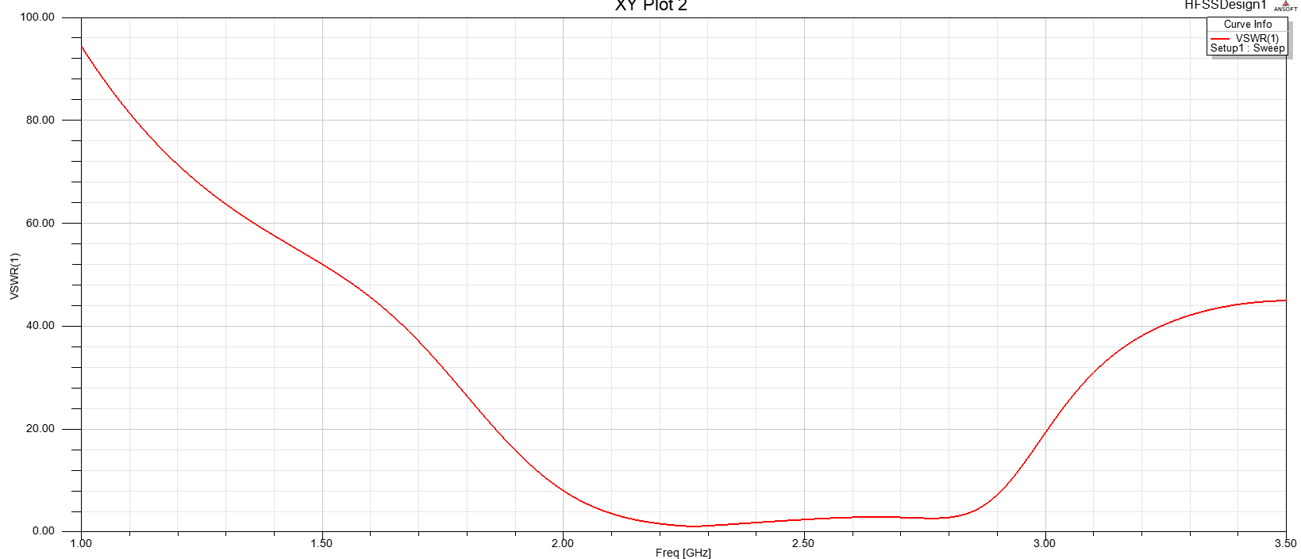

5.5 : S11 and S21 parameter for Microstrip three-pole filter

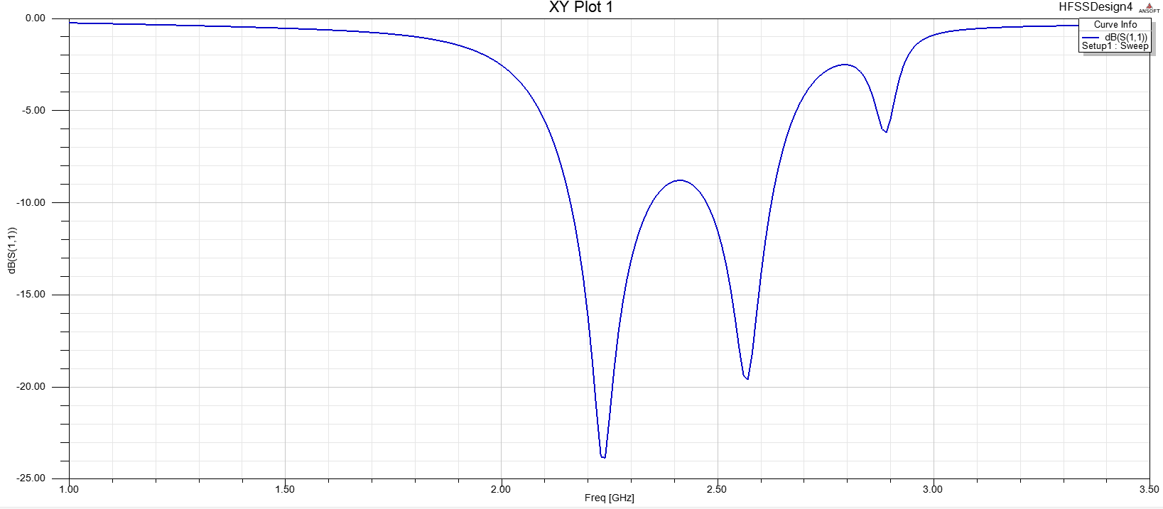

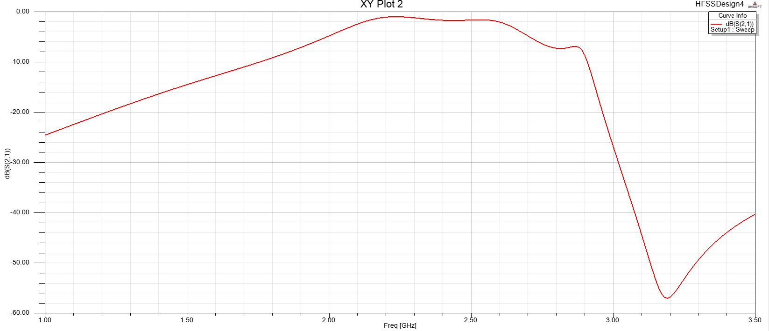

5.6 : VSWR for Integrated Microstrip three-pole filter

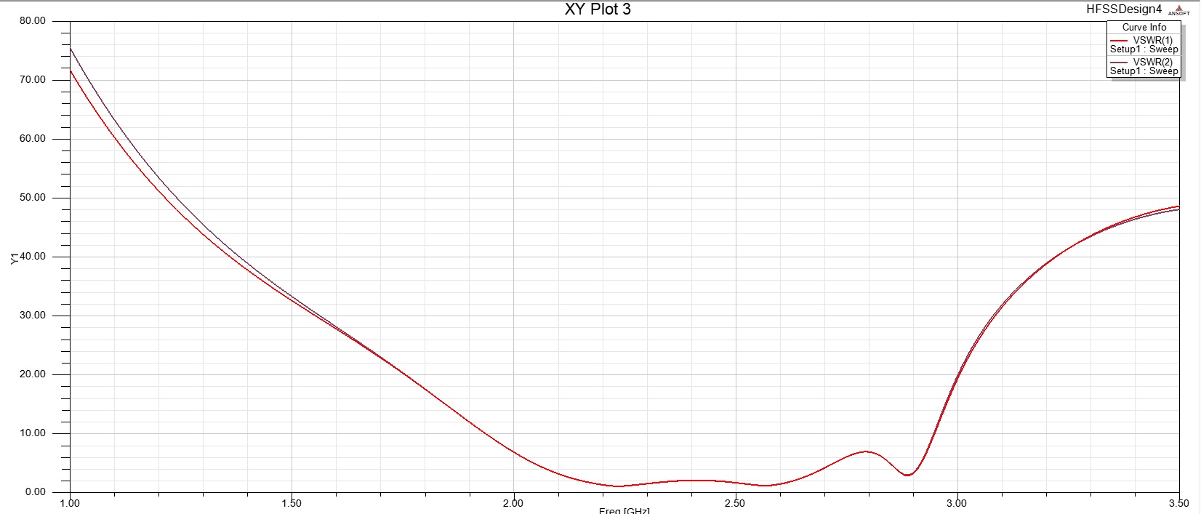

**V. Figures of References**

