Context-Aware xBA: A Hit Probability Prediction Model Integrating Environmental Variables
Department of Industrial and Management Engineering, Jihyeon Lee
목차
1 서론 2
1.1 프로젝트 목표 (Project Goal) 2
1.2 단계별 수행 로드맵 (5 Phases) 3
2 데이터 전처리 및 탐색적 분석 5
2.1 데이터셋 설명 5
2.2 데이터 전처리 (Phase 1) 8
2.3 탐색적 분석 (EDA) 11
2.4 변수 정제, 교차검증 및 Feature Selection (Phase 2) 16
3 효과 분리 실험 (Ablation Study) 24
3.1 실험 설계 및 결과 24
4 Advanced Model 튜닝 및 확률 보정 31
4.1 튜닝 파이프라인 31
5 최종 지표 산출 및 세이버메트릭스 가치 검증 36
5.1 검증 파이프라인 36
6 결론 및 시사점 44
6.1 연구 성과 종합 44
6.2 학술적 기여 44
6.3 실무적 시사점 45
6.4 한계 및 향후 작업 45
7 참고문헌 45
7.1 데이터 소스 및 API 45
7.2 라이브러리 및 도구 46
부록 A. 다중공선성 분석 — 고상관 변수 쌍 전체 목록 46
부록 B. 결측치 대체 중앙값 (2024 median) 48
부록 C. 효과 분리 실험 fold-level 통계 (Phase 3) 49
부록 D. Advanced 모델 튜닝 스펙 (Phase 4) 49

1 Introduction

1.1 Project Goal
The objective of this project is to overcome the limitations of the official Major League Baseball (MLB) expected batting average (xBA), which evaluates only the pure physical quality of a batted ball (exit velocity, launch angle) and does not account for real-world environmental factors.
This project combines batted-ball physics data with ballpark physical constraints (fence height, distance) and climate variables (temperature, wind, altitude, etc.), and employs tree ensemble models capable of capturing nonlinear interactions to compute ca-xBA, a context-aware expected batting average. Specifically, the model is trained as a binary classifier predicting whether each batted ball results in a hit (1/0); ca-xBA is the sabermetric statistic obtained by averaging the hit probabilities output by that classifier at the per-player level. Accordingly, what matters in this study is not mere classification accuracy but the precision of the predicted probability values (calibration), for which the Brier Score serves as the primary evaluation metric.
Ultimately, to demonstrate that the newly constructed ca-xBA successfully extracts a batter's true talent optimized for environmental conditions rather than overfitting to random noise, we verify through a head-to-head R² comparison that ca-xBA explains a batter's same-season actual run-production (wOBA) more accurately than the official MLB xBA, and reinforce this with a luck cross-validation utilizing seasonal BABIP deviations relative to career BABIP.

1.2 Step-by-Step Execution Roadmap (5 Phases)
This roadmap is executed on the basis of strict year-by-year Temporal Split to fundamentally prevent data leakage and to reflect the philosophy of baseball sabermetrics. This section provides an overview of the entire analytical procedure; detailed methodologies and statistics for each phase are addressed in the main body below.
Phase 1: Data Integration, Domain-Driven Preprocessing, and Temporal Split
- Integrate Statcast batted-ball, weather, and ballpark data and perform domain-knowledge-based preprocessing.
- Key tasks:
  - Merge Statcast batted-ball data, Open-Meteo API weather data, and ballpark specification data.
  - Apply domain-knowledge-based noise removal and handle missing values in bat-tracking features.
  - Fetch the per-game roof_status from the MLB Stats API for eight dome/retractable-roof ballparks and mask external weather data for games played with the roof closed.
  - Completely split the full dataset into 2024_Data for training and evaluation and 2025_Data for final holdout validation (Temporal Split).
Phase 2: Correlation Analysis, Scaling, Optimal Sampling, and Feature Selection
- Address multicollinearity and class imbalance, and finalize the model input feature set (X_advanced) through conservative Feature Selection.
- Key tasks:
  - NaN imputation (median) -> Robust Scaler -> multicollinearity removal
  - Adopt a StratifiedKFold 5-fold CV structure and evaluate the full 2024 dataset as OOF (2025 data remains fully isolated until Phase 5).
  - Drop features that rank in the bottom 30% on both RF importance and Mutual Information.
  - Compare three sampling strategies — no resampling (None), undersampling, and SMOTE — under the same CV framework and select the strategy that minimizes OOF Brier score.
Phase 3: Effect Decomposition Experiment (Ablation Study)
- Demonstrate the nonlinear interaction between batted-ball data and ballpark environment through a 2x2 factorial design, thereby establishing the academic justification for adopting tree ensemble models.
- Key tasks:
  - Construct four controlled models (M1-M4) in a physics-only features (X_base) / full features (X_advanced) x linear (Logistic Regression) / nonlinear (XGBoost) design.
  - Evaluate Brier, LogLoss, F1, and ROC AUC using the same 5-fold CV OOF as Phase 2, decomposing data effects from algorithm effects.
  - Statistically test nonlinear interactions using a 2-way ANOVA (factors: dataset x algorithm) with an interaction term, treating per-fold metrics as the dependent variable.
Phase 4: Advanced Model Tuning + Calibration + Model Selection
- Maximize probability calibration using the full feature set (X_advanced), and automatically select the simpler model when performance is statistically tied.
- Key tasks:
  - Tune Random Forest, XGBoost, and LightGBM using RandomizedSearchCV (scoring='neg_brier_score').
  - Evaluate two candidates — Stacking + Isotonic and Best_Single + Isotonic — under the same external 5-fold CV OOF.
  - Automatically select the final model by applying Occam's razor (adopt the simpler model when delta Brier <= epsilon(0.001)).
Phase 5: Final Metric (ca-xBA) Computation and Sabermetric Value Validation
- Apply the Phase 4 final model to the isolated 2025 data to compute ca-xBA, and statistically verify its superiority over the official MLB xBA in explaining actual wOBA.
- Key tasks:
  - Compute per-batted-ball ca-xBA for 2025 using the final model and aggregate per-player seasonal averages (hard join on MLBAM ID, filtered to >= 250 PA).
  - Visually compare model superiority through side-by-side head-to-head R² scatter plots of ca-xBA vs wOBA and official xBA vs wOBA.
  - Confirm domain value through (AVG - ca-xBA)-based luck analysis and career BABIP cross-validation.
  - Cross-validate ca-xBA Top 10 by position against 2025 MLB Silver Slugger Award winners (compute hit rate).

2 Data Preprocessing and Exploratory Analysis

2.1 Dataset Description
This study integrates three external data sources to construct a single training table. The key variables and their meanings for each data source are summarized below.

2.1.1 Statcast Batted-Ball Data (Baseball Savant)
This is the physical metadata for every pitch and batted ball recorded by the MLB official tracking system. Starting from 1,443,801 pitch-level rows across the 2024 and 2025 seasons, balls in play (BIP) are filtered to yield approximately 225,414 batted balls as the model input units for this analysis. The raw data contains approximately 118 columns; the key feature groups meaningfully utilized by this model are as follows.
Table 1.
Feature Group | Representative Columns | Meaning
Batted-ball Physics (core) | launch_speed, launch_angle | Launch speed (mph) and launch angle (degrees). The two inputs of MLB's official xBA, and the X_base of this model.
Bat Tracking | bat_speed, swing_length, attack_angle, attack_direction, swing_path_tilt, intercept_ball_minus_batter_pos_* | Bat speed/trajectory/position at contact. As newly introduced tracking in late 2024, missing values are present.
Pitch Physics | release_speed, release_pos_x/z, pfx_x/z, plate_x/z, release_spin_rate, release_extension, spin_axis, effective_speed, api_break_*, arm_angle | Pitch release/break/location at the plate. Describes the pitch conditions the batter faced just before contact.
Plate-appearance Context | balls, strikes, outs_when_up, inning, age_pit, age_bat, n_thruorder_pitcher, n_priorpa_thisgame_player_at_bat | Game-situation variables such as the ball/strike count, out count, inning, and batting order.
Categorical Identifiers | stand (LHB/RHB), p_throws (LHP/RHP), pitch_type (FF, SL, CH, etc.), if_fielding_alignment, of_fielding_alignment | Left/right binary encoding; the rest are one-hot encoded.
Plate-appearance Outcome (target/derived) | events (single/double/triple/home_run/field_out, etc.), bb_type (ground_ball/fly_ball/line_drive/popup), babip_value | Processed into the is_hit (simple hit indicator) target label. babip_value is used for the Phase 5 BABIP computation.
Player ID | batter, pitcher | MLBAM ID

2.1.2 Ballpark Specification Data (ballparks.csv)
This is a static table summarizing the physical characteristics of each of the 30 MLB ballparks. Because the Athletics' home venue changed from Oakland Coliseum in 2024 to Sutter Health Park in Sacramento in 2025, environmental variables such as fence distances and elevation cannot be mapped to a single ballpark, so they were excluded from the analysis; accordingly, only 29 rows remain out of all 30 ballparks. The main columns are as follows.
Table 2.
Column | Unit | Meaning
home_team | abbr | Ballpark identifier (NYY, BOS, COL, etc.).
left_field, center_field, right_field | feet | Distance to the left/center/right-field fence.
min_wall_height, max_wall_height | feet | Minimum/maximum fence height.
hr_park_effects | index | Park-specific home-run factor (100 = league average; high-altitude parks such as Coors Field are higher).
extra_distance | feet | Park-shape-adjusted distance.
elevation | feet | Ballpark elevation (e.g., Coors Field at 5,200 ft — affects air density and batted-ball carry).
roof | 0~1 | Roof type: 0 (open), 0.5 (retractable), 1 (dome).
daytime | 0~1 | Share of daytime games (e.g., Wrigley Field).
Latitude/Longitude | deg | Used for weather-API coordinate matching.

2.1.3 Open-Meteo Weather Data (Historical Weather API)
Hourly weather values are fetched by querying the Open-Meteo Historical Weather API using the latitude and longitude of each game's home ballpark and the game start time (13:00 for day games, 19:00 for night games, per the daytime column) as keys. Results are saved to a cache directory to prevent additional API calls on re-runs.Open-Meteo Historical Weather API
Table 3.
Column | Unit | Meaning
wx_temperature_2m | Celsius | Air temperature at 2 m above ground (affects air density and batted-ball carry).
wx_relative_humidity_2m | % | Relative humidity (affects air density).
wx_surface_pressure | hPa | Surface pressure (determines air density together with elevation).
wx_wind_speed_10m, wx_wind_gusts_10m | km/h | Wind speed/gusts at 10 m above ground.
wx_wind_direction_10m | Degrees | Wind direction (affects carry when blowing toward the outfield).
wx_precipitation | mm | Precipitation (makes the ball slippery and increases fielding difficulty).
wx_cloud_cover | % | Cloud cover (affects sunlight and visibility).

2.2 Data Preprocessing (Phase 1)

2.2.1 Introduction Summary
This stage constructs the input dataset for subsequent modeling by combining MLB Statcast batted-ball data (2024-2025), ballpark specification data, and Open-Meteo Historical weather data. Domain knowledge is applied throughout the processing, and a strict Temporal Split by game_year (2024 vs. 2025) is enforced to prevent data leakage.
This stage uses only 2024_data.parquet. The 2025_data is held out until Phase 5, with no statistics allowed to leak from it.

2.2.2 Step-by-Step Attrition (Row Count Changes)
The original 1,443,801 rows are reduced to a final 225,414 BIP through four filtering steps.
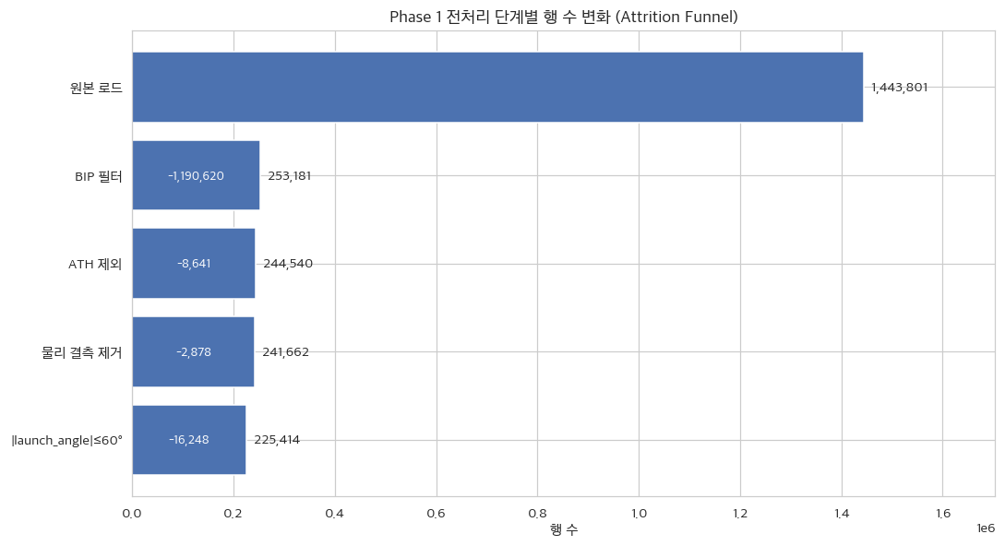
Figure 1. Attrition Funnel
The two largest cuts are (1) the BIP filter and (4) the launch angle cutoff.
(1) The BIP (Balls In Play) filter retains only batted balls where the ball actually entered the field of play (bb_type is one of ground_ball, fly_ball, line_drive, or popup), removing pitch rows where no batted ball was produced, such as strikeouts, walks, and swinging strikes. Because xBA is by definition a metric for the hit probability of balls in play, rows without a batted ball cannot be included in the analysis, making this filter mandatory; approximately 82.5% of all rows are removed at this step.
(2) ATH exclusion: The Athletics (Oakland Athletics) played at Oakland Coliseum in 2024 and at Sacramento's Sutter Health Park in 2025, making it impossible to map environmental variables such as fence distances and elevation to a single ballpark, so batted balls from their home games were excluded from the analysis (approximately 8,641 rows).
(3) Physical missing-value removal: Rows where launch_speed (exit velocity) or launch_angle is NaN are removed (approximately 2,878 rows). Because xBA is itself a function of exit velocity x launch angle, model input is impossible without these two values; as the loss rate is small, row deletion was adopted.
(4) The launch angle cutoff (|launch_angle| > 60 degrees) treats batted balls with extremely high or low launch angles as noise and removes them (an additional 16,248 rows). This is because popups have a mean launch angle of 65.8 degrees and a hit rate of 1.4%, making them effectively automatic outs; retaining such extreme batted balls would dilute the signal in the hit-probable range that the model is trained to learn. Both criteria are conservative choices made to align with the input definition of the official MLB xBA.
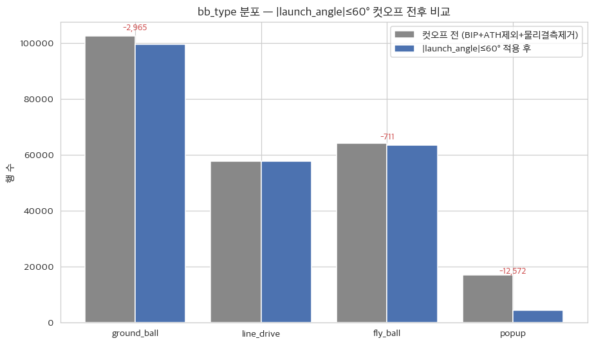
Figure 2. bb_type before/after

2.2.3 Weather Masking for Dome/Roof-Closed Games
- Weather variable masking is applied exclusively to games explicitly recorded as "Roof Closed" or "Dome" in the MLB Stats API (/api/v1.1/game/{game_pk}/feed/live, gameData.weather.condition).
- Of the 61,677 batted balls from retractable-roof and fully enclosed dome ballparks (Tampa Bay), weather data for 43,197 batted balls (70.0%) occurring in games where the roof was actually closed on that day were masked (overwritten with constants).
- Values applied:
  - Five external weather variables set to 0: wx_wind_speed_10m, wx_wind_gusts_10m, wx_wind_direction_10m, wx_precipitation, wx_cloud_cover
  - Two indoor HVAC standard values: wx_temperature_2m = 22 degrees C (MLB dome standard), wx_relative_humidity_2m = 50% (ASHRAE recommended midpoint)
  - Unchanged: wx_surface_pressure (atmospheric pressure is equal indoors and outdoors)
- Significance: directly encodes into the training data the fact that weather variables are constant during dome games, enabling tree ensemble models to automatically learn the roof x weather interaction.
The rationale for indoor standard values is as follows. Games played in domes (including retractable roofs when closed) are held at constant temperature and humidity maintained by HVAC systems; accordingly, 22 degrees C, the standard indoor temperature for MLB dome games, and 50%, the midpoint of the ASHRAE-recommended indoor relative humidity range, were used as representative values. Atmospheric pressure is the same indoors and outdoors, so the original value is retained. Setting the five external weather variables (wind speed, wind gusts, wind direction, precipitation, and cloud cover) to 0 directly reflects in the data the fact that external weather cannot affect batted balls inside a closed dome.

2.2.4 Weather Data Merge Results
- Number of stadiums queried: 30 (Athletics excluded)
- Variables retrieved: temperature_2m, relative_humidity_2m, surface_pressure, wind_speed_10m, wind_direction_10m, precipitation, cloud_cover, wind_gusts_10m (8 variables in total)
- Time point: if daytime ≥ 0.5, use 13:00 local time; otherwise use 19:00 local time
- Weather missing rows: 0 / 225,414 (0.00%)

2.2.5 Temporal Split Results
Table 4.
Year | Row Count | Hit Rate | Number of Batters | Number of Pitchers | Number of Ballparks | Period
2024 | 113,409 | 0.3411 | 884 | 956 | 29 | 2024-03-20~2024-09-29
2025 | 112,005 | 0.3411 | 664 | 869 | 29 | 2025-03-27~2025-09-28
2024_data is reserved for Phase 2–4 training/evaluation, and 2025_data is held out as the Phase 5 validation ground truth. Notably, the hit rate for both seasons is identical at 0.3411. This means that even after splitting the data by year, the base rate of the target (hit) did not shift, which guarantees that applying the model trained on 2024 to 2025 data can be validated fairly without distortion from label shift (class distribution change).

2.3 Exploratory Data Analysis (EDA)

2.3.1 Batted Ball Physics Distributions
Launch speed / launch angle histograms (year-over-year overlay)
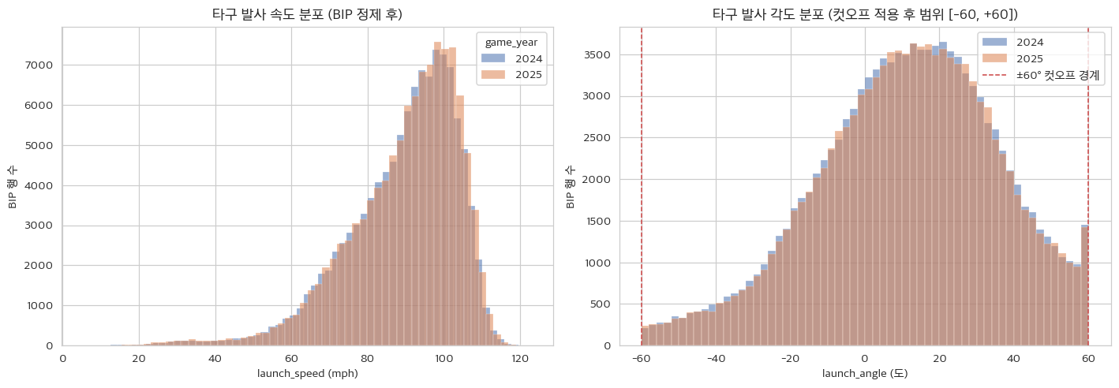
Figure 3. Launch speed/angle hist
- The launch speed and launch angle distributions for 2024 and 2025 are nearly identical, visually confirming that the input feature distributions remain stable after the Temporal Split.
launch_speed × launch_angle hit-rate heatmap
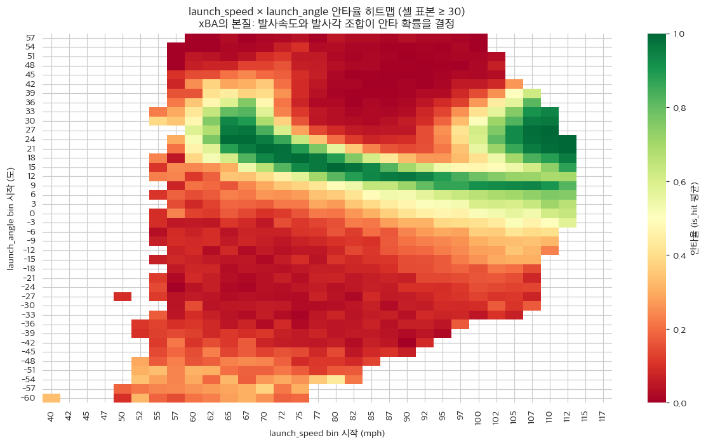
Figure 4. SpeedxAngle heatmap
This heatmap (Figure 4) provides the mathematical justification for adopting tree ensemble algorithms in this study. As visible in the heatmap, the hit rate surges only within narrow bands where a specific launch angle and launch speed intersect, and the pattern already exhibits strong nonlinearity. When dozens of additional environmental variables such as temperature, wind speed, and park altitude are layered on top, linear models—which assume independence and monotonicity among features—cannot capture these complex interaction effects. We therefore conclude that a nonlinear tree model that conditionally partitions the input space is necessary.

2.3.2 Environmental Variables
Distribution grid for 8 weather variables
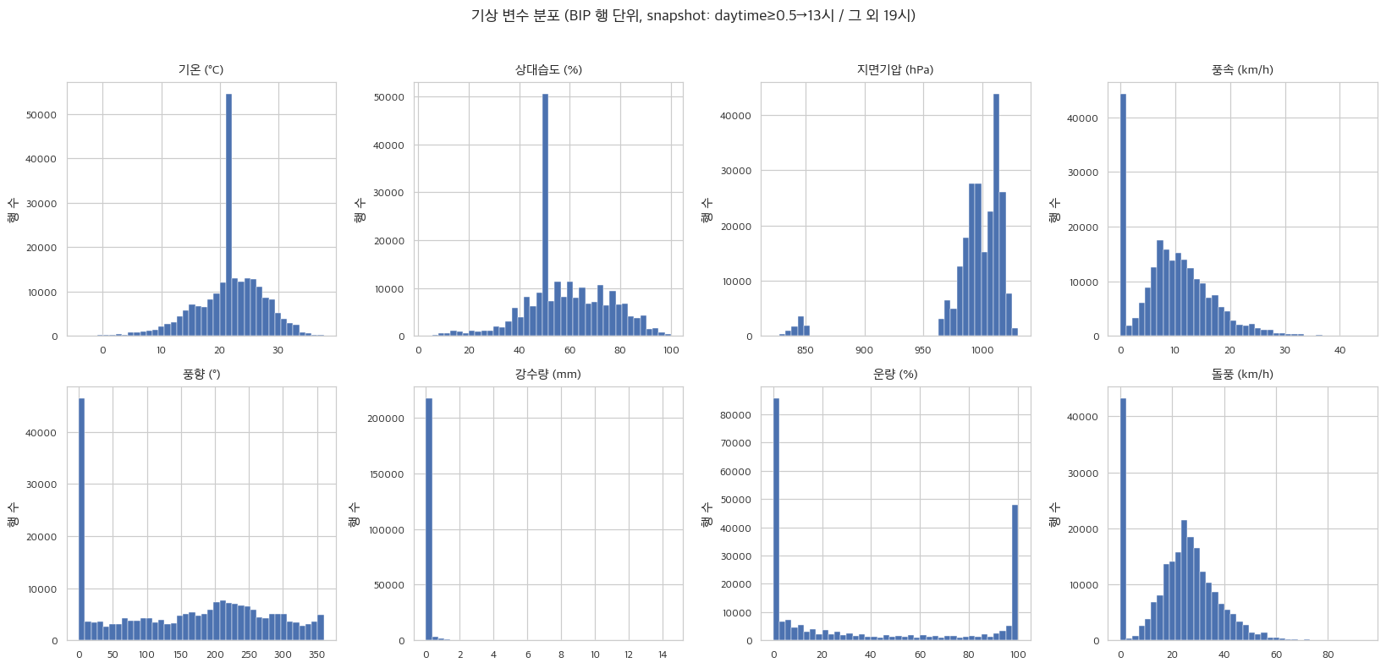
Figure 5. Weather distributions
- Temperature follows a near-normal distribution centered around 23°C; wind speed and wind direction show right-skewed and approximately uniform distributions, respectively.
- Precipitation is strongly concentrated at 0 (no rain).
Park-level environmental characteristics heatmap (29 home teams × 11 variables)
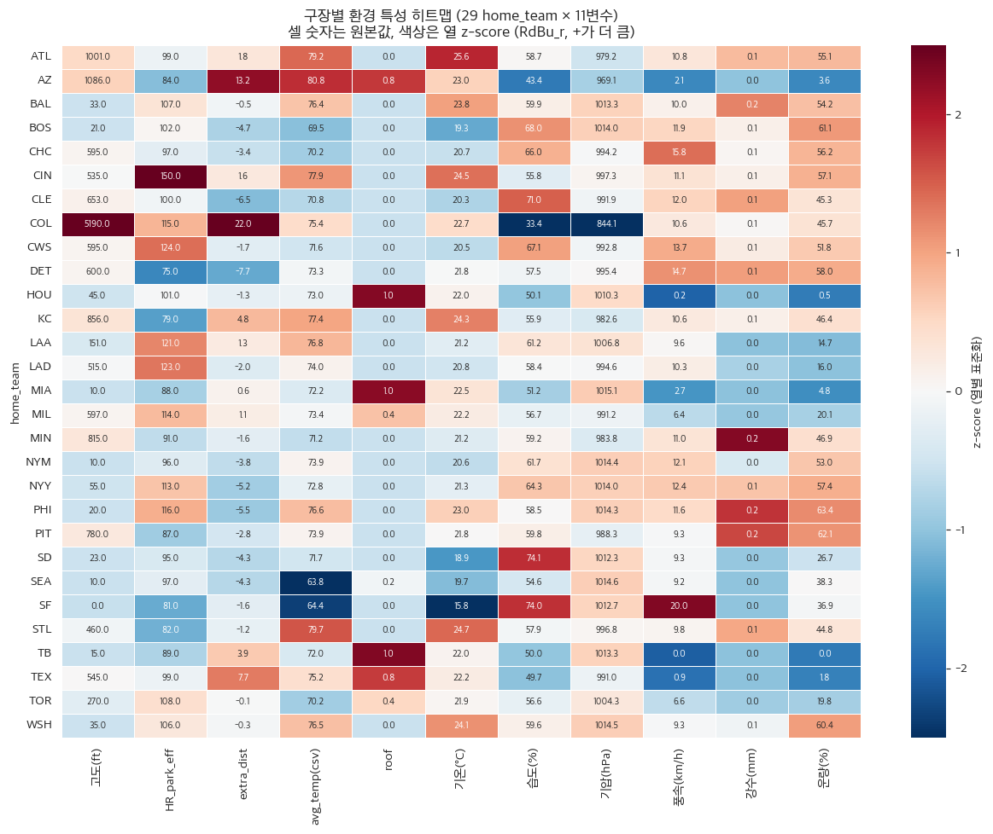
Figure 6. Park env heatmap
- COL (Coors Field) stands out distinctly from all other parks on the heatmap due to its extreme conditions at an elevation of 5,190 ft, where the thin air reduces drag and allows batted balls to carry farther.
- Domed stadiums, shielded from external weather, exhibit patterns distinct from open-air ballparks.
- Environmental variables such as altitude, temperature, wind speed, and HR park effect show pronounced and meaningful variance across parks. This heatmap demonstrates that environmental variables carry discriminative power between parks, which in turn supports the premise that ca-xBA has room to improve upon existing metrics.

2.3.3 Key Feature Distributions
KDE — Continuous distribution comparison
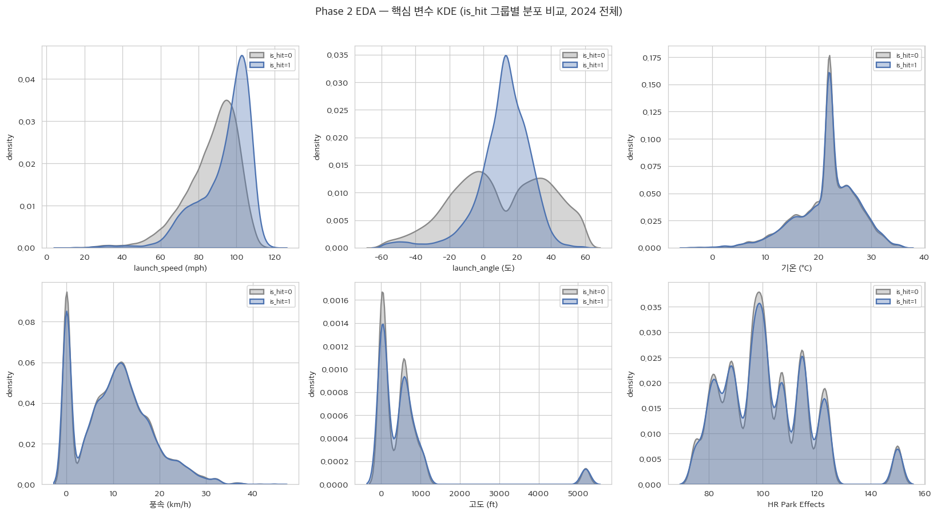
Figure 7. EDA KDE
The KDE plots overlay the value distributions of each variable split by hit (is_hit=1) vs. out (0) groups; the more the two curves diverge, the stronger that variable's univariate discriminative power for predicting hit outcomes. Launch speed and launch angle show clearly separated curves for the two groups, indicating strong univariate signals, whereas the environmental variables have nearly overlapping curves, reflecting weak univariate discriminability. This suggests that the value of environmental variables emerges from their nonlinear interactions with other features, providing further motivation for the tree ensemble approach.
Boxplot — Median / IQR / outlier comparison
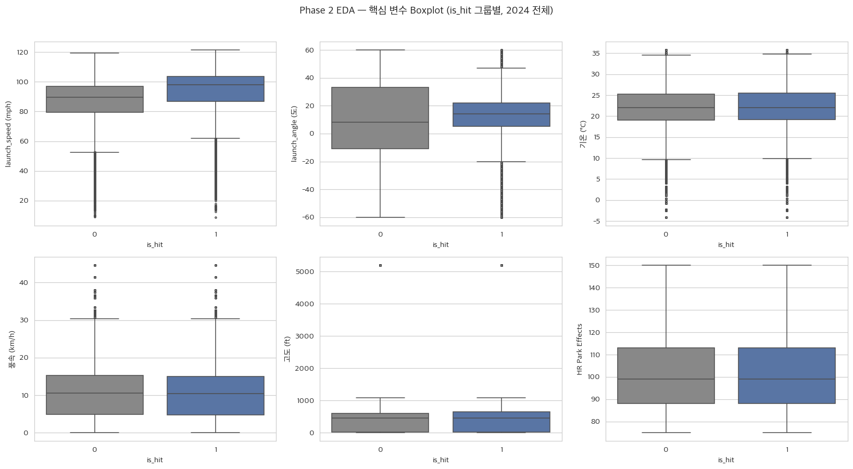
Figure 8. EDA Boxplot
Although some points appear beyond the boxplot whiskers, these represent the natural tails of batted ball distributions observed in real games. Artificially trimming these extreme values would discard genuine signals from weakly or strongly hit balls. Therefore, this study performs no additional outlier removal beyond the domain-based popup cutoff. Furthermore, using the Robust Scaler for scaling naturally mitigates the influence of these tail values.

2.4 Feature Refinement, Cross-Validation, and Feature Selection (Phase 2)

2.4.1 Feature Group Definitions and Initial Pool Construction
Table 5.
Group | Number of Variables | Description
(a) xBA core | 2 | launch_speed, launch_angle
(b) Bat tracking + missing flags | 14 | 7 numeric + 7 *_is_missing
(c) Plate-appearance identity (binary) | 2 | stand_R, p_throws_R
(d) Pitch physics (numeric) | 15 | release_speed, pfx_, plate_, spin, break, arm_angle, etc.
(d2) pitch_type one-hot | 16 | pitch_type_* dummy variables
(e) PA context (numeric) | 8 | balls/strikes/outs/inning/age/order, etc.
(e2) alignment one-hot | 7 | if/of_fielding_alignment dummies
(f) Ballpark static | 10 | fence distance/height, hr_park_effects, extra_distance, elevation, roof, daytime
(g) Weather dynamic (dome-masked) | 8 | temperature, humidity, pressure, wind speed, wind direction, precipitation, cloud cover, gusts — when the roof is closed the 5 external variables = 0, with indoor temperature 22°C / humidity 50% substituted (Phase 1 §7b)
X_advanced (initial) | 82
The feature counts in the table are measured immediately after expanding all categorical variables (pitch_type and fielding_alignment) via one-hot encoding, yielding a total of 82 features.

2.4.2 NaN Handling (Imputation Based on Full 2024 Median)
Missing values in 13 numeric columns were imputed using the median computed from the entire 2024 dataset. The median was preferred over the mean because variables such as launch speed and spin rate are susceptible to outlier-driven mean distortion. The imputation values were derived solely from 2024 data (not 2025) to prevent data leakage from the validation set (2025) into the training process. In addition, a `*_is_missing` flag was appended for each variable to preserve the missingness pattern itself as a model input signal (see Appendix B for specific imputed values).

2.4.3 Robust Scaler
- Columns scaled: 50 (binary 0/1 variables excluded)
Scaling normalizes the units and ranges of features so that distance- and coefficient-based computations are not dominated by any single variable. Because this dataset contains outliers, we apply a Robust Scaler—which uses the median and interquartile range (IQR) instead of the mean and standard deviation—to minimize their influence (binary 0/1 variables are excluded). The scaler was fit on the full 2024 data and then applied via transform.

2.4.4 Multicollinearity Analysis (|r| > 0.95, Pearson)
$r>0.95$To address multicollinearity, highly correlated pairs were identified using a Pearson correlation threshold of |r| > 0.95, and features were removed according to the following rules: (1) X_BASE features (launch_speed and launch_angle) are always retained; (2) otherwise, derived features are removed first; (3) in case of a tie, the feature with lower variance is dropped (variance fallback). Although 24 correlated pairs were identified, many involved overlapping variables—particularly the 7 `*_is_missing` missingness flags—resulting in a net removal of 9 features. The full list of all 24 identified pairs and their corresponding removed features is provided in Appendix A.

2.4.5 Evaluation Metric: Brier Score Definition
The Brier Score, used as the primary evaluation metric throughout all subsequent model assessments, measures the calibration of predicted probabilities from a binary classification model. It is defined as follows.
$$Brier=\frac{1}{N}\sum_{i=1}^{N}{{\left(y_{i}-p_{i}\right)}^{2}}$$
Here, the first term denotes the actual hit outcome and the second term denotes the model's predicted hit probability. Lower values indicate better performance (mean squared error between predicted probabilities and actual outcomes); this metric assesses the accuracy of the probability estimates themselves rather than simple classification accuracy. Since ca-xBA is derived by averaging these probability values over a season, the Brier Score is the single most important evaluation metric in this study.$y_{i}∈\{0,1\}$$p_{i}∈\left[0,1\right]$

2.4.6 Feature Selection (RF importance + MI)
- Training data: RF importance and MI were computed on the original class distribution (no separate sampling applied).
- RF Tuning: RandomizedSearchCV(n_iter=20, cv=3, scoring='neg_brier_score', n_jobs=2)
  - search space: {'n_estimators': [100, 200, 500], 'max_depth': [10, 20, None], 'min_samples_split': [2, 4, 6], 'criterion': ['gini', 'entropy']}
  - best params: {'n_estimators': 200, 'min_samples_split': 4, 'max_depth': None, 'criterion': 'entropy'}
  - best CV neg_brier_score (3-fold avg): -0.16062 (Brier = 0.16062)
Feature importance was computed using a Random Forest because all final candidate models are tree ensembles, ensuring that RF importance is consistent with the signal structure of the final models; Mutual Information, a model-agnostic metric, was used in parallel to mitigate single-model bias.
Since the Random Forest used for Feature Selection importance computation is itself sensitive to hyperparameters, candidate combinations of number of trees (100, 200, 500), maximum depth (10, 20, unlimited), minimum samples per split, and split criterion (gini, entropy) were randomly sampled 20 times via RandomizedSearchCV, and the combination yielding the lowest Brier Score under 3-fold internal CV was selected. The resulting best parameters were n_estimators=200, max_depth=unlimited, min_samples_split=4, and criterion=entropy. The feature_importances_ (impurity-reduction contribution at splits) from this tuned model were used as the feature importance scores.
- Mutual Information: stratified subsample of 30,000 rows, seed=42
- A conservative elimination rule was adopted: only features that simultaneously fall in the bottom 30% on both RF importance and Mutual Information are removed. By retaining any feature deemed important by at least one of the two metrics, the risk of incorrectly discarding useful features due to single-metric bias is reduced. However, X_BASE features (launch_speed and launch_angle)—which are the inputs to the official MLB xBA and the reference features for the control group (Phase 3)—are always excluded from removal regardless of their importance rankings.
The Top 20 features according to RF importance and MI are presented as bar charts in Figure 9 (RF Importance Top 20) and Figure 10 (MI Top 20), respectively. Both metrics rank launch_angle and launch_speed overwhelmingly at the top, consistent with the physical basis of xBA, followed by a gradual distribution of bat-tracking, pitch physics, park, and weather variables.
(D1) RF Importance Top 20
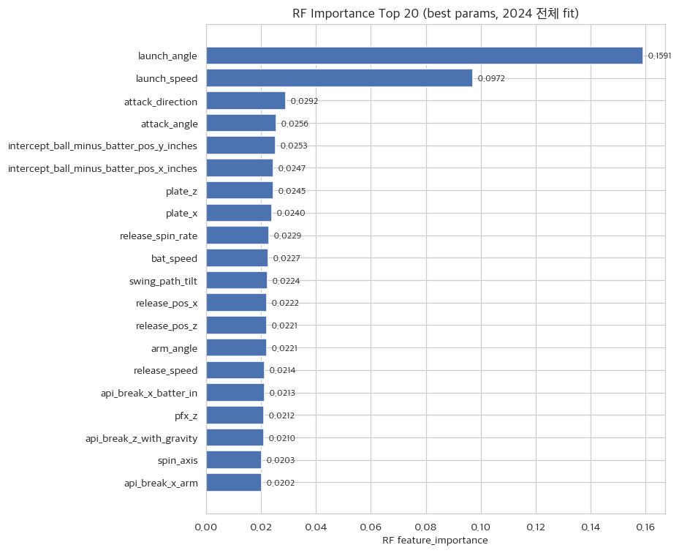
Figure 9. RF Top 20
(D2) Mutual Information Top 20
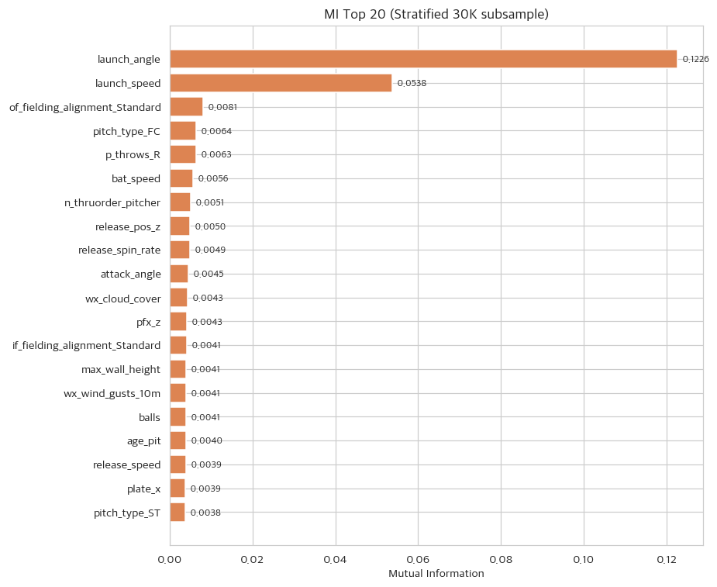
Figure 10. MI Top 20
(D3) Core vs. Drop
- Top 30% on both RF and MI → core features (e.g., launch_speed, launch_angle).
- Bottom 30% on both RF and MI → Feature Selection drop candidates; 12 features were removed from this region.

2.4.6.1 Features Removed by Feature Selection (12 features)
if_fielding_alignment_Strategic, pitch_type_CH, pitch_type_CS, pitch_type_CU, pitch_type_FA, pitch_type_FF, pitch_type_FO, pitch_type_FS, pitch_type_KC, pitch_type_KN, pitch_type_SI, pitch_type_SV

2.4.7 Final X_advanced Feature Set
- X_BASE: 2 features — for Phase 3 control group
- X_advanced initial: 82 features
- Multicollinearity drop: 9 features
- Feature Selection drop: 12 features
- X_advanced final: 61 features

2.4.8 Cross-Validation Structure (5-Fold StratifiedKFold)
- Full 2024 dataset (113,409 rows) → StratifiedKFold(n_splits=5, shuffle=True, random_state=42)
- 2025 data is reserved exclusively for Phase 5 external validation — no statistics from it are used at this stage
A 5-fold CV strategy was adopted instead of a separate 80/20 hold-out test set during the sampling comparison, because rotating through the 2024 data five times maximizes utilization of the limited training data and reduces performance variance arising from any single split. StratifiedKFold preserves the hit/out ratio in each fold to match the overall distribution, improving evaluation stability.

2.4.9 Sampling Comparison (3 Methods × XGBoost Default × 5-Fold CV)
The three sampling methods compared were: None (use the original class distribution as-is), RandomUnderSampler (randomly reduce the majority class, outs, to balance the dataset), and SMOTE (synthesize artificial samples by interpolating between minority-class hit samples). The original data has a hit rate of approximately 34%, yielding an out-to-hit ratio of roughly 2:1 imbalance, with approximately 59,782 outs and 30,944 hits per fold training set. RandomUnderSampler reduces the majority class to match the minority, resulting in 30,944 / 30,944 (1:1), while SMOTE synthesizes additional hit samples to reach 59,782 / 59,782 (1:1). All three methods were compared using OOF Brier Score under the same 5-fold CV with XGBoost default settings.
Sampling | Train mean 0/1
None | 59,782/30,944
Under | 30,944/30,944
SMOTE | 59,782/59,782

(C1) OOF Confusion Matrices (3 sampling methods, threshold=0.5)
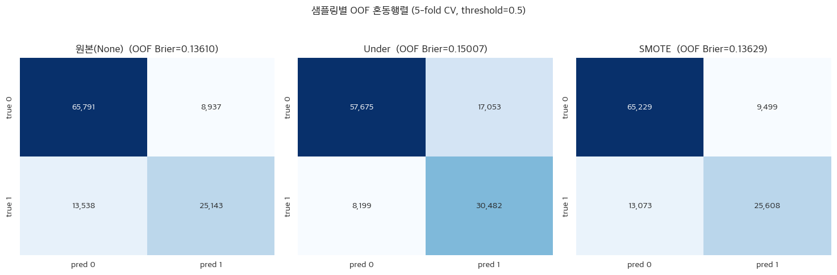
Figure 11. Sampling CM
- Comparing the OOF confusion matrices across the three sampling methods: None (original distribution) yields many True Negatives and low Recall, reflecting conservative predictions. RandomUnderSampler substantially increases True Positives but also raises False Positives, resulting in a Recall–Precision trade-off. SMOTE shows a balance closer to the original distribution and achieves a slightly higher F1 than None.
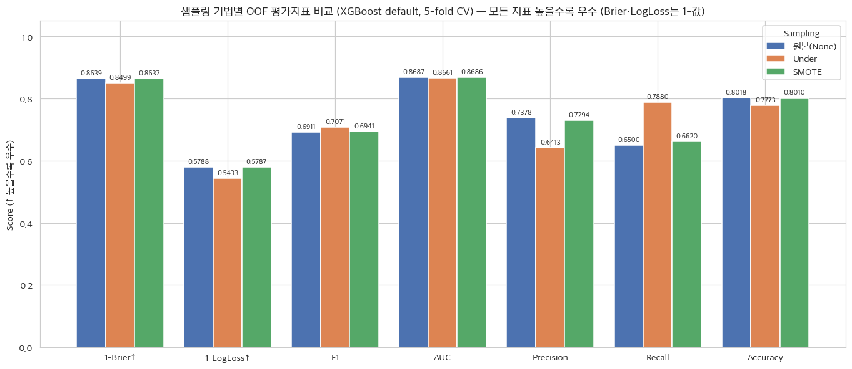
Figure 12. Sampling Metrics
- Final selection = None (minimum OOF Brier Score: 0.13610).
The objective of this study is not simple classification but accurate probability estimation. Balancing classes through sampling can improve Recall and F1 by detecting more hits, but at the cost of distorting the model's output probabilities away from true frequencies. Since ca-xBA is a metric derived by averaging these probability values over a season, calibration takes top priority; accordingly, None—which yields the lowest OOF Brier Score—was selected as the final sampling strategy.

3 Ablation Study

3.1 Experimental Design and Results
This phase uses only 2024_data and evaluates OOF predict_proba for the 4 cells on exactly the same StratifiedKFold 5-fold CV (random_state=42) used in Phase 2. The 2025 data is reserved exclusively for Phase 5 external validation and is not used in this phase.

3.1.1 Experimental Design — 2x2 Factorial Design
Feature sets:
X_base = ['launch_speed', 'launch_angle'] (identical to the official MLB xBA inputs) — control group input
X_advanced = 61 variables finalized in Phase 2 (X_base + bat-tracking + categorical + pitch/situation/park/weather features)
Algorithms:
LogReg: LogisticRegression(C=1.0, solver='lbfgs', max_iter=2000) (linear, global and monotonic)
XGBoost: XGBClassifier(default, tree_method='hist') (nonlinear, local and conditional splits)
Table 6.
 | LogReg | XGBoost
X_base (2 variables) | M1 (control) | M2 (algorithm upgrade)
X_advanced (61 variables) | M3 (data upgrade) | M4 (interaction combined)
CV: StratifiedKFold 5-fold (same splits as Phase 2, random_state=42). Mean fold train size ≈ 90,727, val size ≈ 22,681.

3.1.2 Per-Model Results (OOF + fold mean±SD)

3.1.2.1 OOF aggregate
Table 7.
Model | Data | Algo | Brier↓ | LogLoss↓ | F1 | ROC AUC | Precision | Recall | Accuracy
M1 | X_base | LR | 0.21033 | 0.61347 | 0.1700 | 0.6670 | 0.7228 | 0.0963 | 0.6792
M2 | X_base | XGB | 0.14012 | 0.43198 | 0.6758 | 0.8594 | 0.7355 | 0.6251 | 0.7954
M3 | X_advanced | LR | 0.20937 | 0.61078 | 0.2358 | 0.6661 | 0.6801 | 0.1426 | 0.6847
M4 | X_advanced | XGB | 0.13589 | 0.42049 | 0.6924 | 0.8691 | 0.7380 | 0.6521 | 0.8024

3.1.2.2 OOF Confusion Matrix — 4 Cells
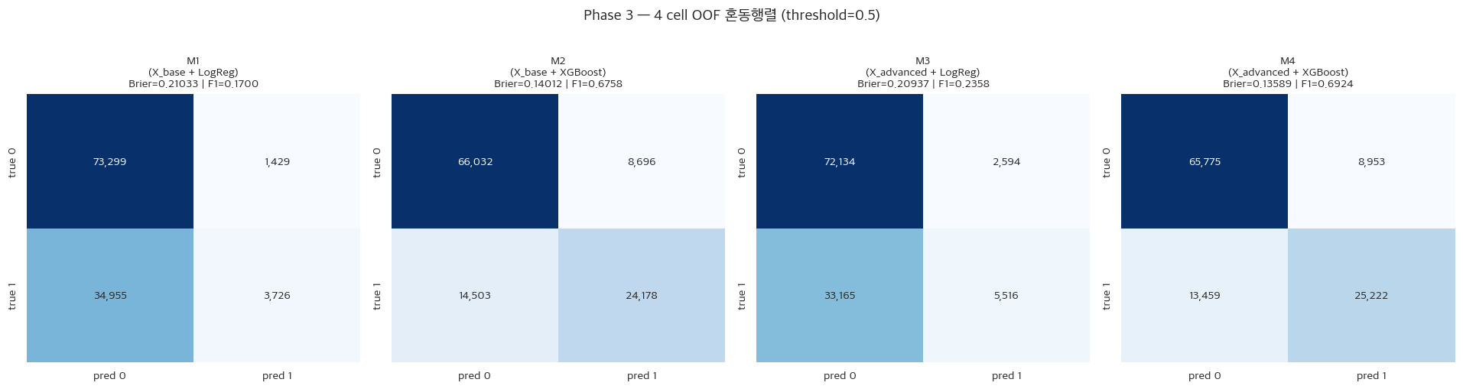
Figure 13. Phase 3 CM
- M1/M3 (LogReg): True Negatives dominate overwhelmingly, TPs are extremely sparse — a fundamental limitation of the linear model.
- M2/M4 (XGBoost): TPs increase substantially, with FPs also rising — overall classification performance improves markedly.

3.1.2.3 OOF ROC Curve
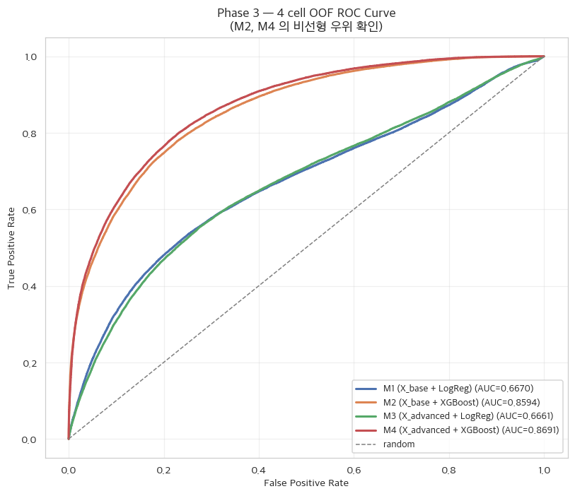
Figure 14. Phase 3 ROC
- The ROC curves for M2/M4 curve sharply toward the upper-left corner, indicating superior discriminative ability.
- M4 sits slightly above M2, indicating that the environmental variables provide additional benefit on top of XGBoost.

3.1.2.4 Reliability Diagram (Calibration Curve)
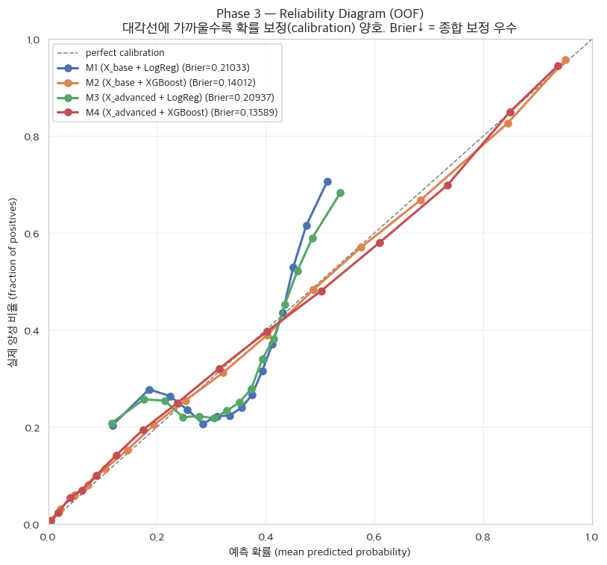
Figure 15. Phase 3 Calibration Reliability Diagram
The Reliability Diagram is constructed as follows: (1) batted balls are divided into 15 equal-sized bins by predicted probability; (2) for each bin, the mean predicted probability (x-axis) and the actual hit rate (y-axis) are plotted; and (3) the proximity of these points to the y=x diagonal — representing perfect calibration — is assessed.
In the Reliability Diagram, the linear models (M1, M3) cluster predicted probabilities in the 0.2–0.4 range and deviate substantially from the diagonal. This is because hit probability is determined by a nonlinear combination of features, yet the linear model approximates this with only monotonic, additive contributions. By contrast, the tree models (M2, M4) partition the input space conditionally and learn locally varying probabilities, resulting in predicted probabilities that align much more closely with actual hit frequencies (near-diagonal fit). As noted when selecting the sampling method, probability calibration quality was weighted heavily in the evaluation because ca-xBA is derived by averaging predicted probabilities.

3.1.2.5 fold-level mean ± SD (across 5 folds)
The 5-fold mean ± SD statistics for each model show that inter-fold variability is extremely small — at the third decimal place (e.g., M4 Brier 0.13589 ± 0.00088) — confirming that the OOF aggregate results are stable (see Appendix C for fold-level detailed statistics).

3.1.3 Interpretation

3.1.3.1 Effect Comparison — The Value of Environmental Variables Only Emerges in Nonlinear Models
Key metrics (Brier↓ / LogLoss↓ / F1 / ROC AUC):
Table 8.
Effect | ΔBrier | ΔLogLoss | ΔF1 | ΔAUC
Data effect (in LogReg): M3−M1 | -0.00096 | -0.00269 | +0.0658 | -0.0008
Data effect (in XGBoost): M4−M2 | -0.00423 | -0.01149 | +0.0166 | +0.0097
Algorithm effect (in X_base): M2−M1 | -0.07021 | -0.18149 | +0.5058 | +0.1924
Algorithm effect (in X_adv): M4−M3 | -0.07348 | -0.19028 | +0.4566 | +0.2029
Combined effect: M4−M1 | -0.07444 | -0.19297 | +0.5224 | +0.2021
Interaction : (M4−M2)−(M3−M1) | -0.00327 | -0.00879 | -0.0492 | +0.0105
The table above disentangles the data effect from the algorithm effect within the 2x2 design. Each row represents the performance change (Δ) when a single factor is varied, and in particular the Interaction row quantifies how much the effect of adding data differs across algorithms. A larger deviation from zero indicates a stronger nonlinear interaction between data and algorithm.
- When approximately 60 environmental variables are added on top of the linear model (LogReg), the Brier improvement is only −0.00096. In other words, the linear model barely benefits from additional features, because it assumes each variable contributes independently and monotonically, and therefore cannot exploit interactions among variables.
- By contrast, adding the same environmental variables on top of the nonlinear model (XGBoost) yields a clear Brier improvement of −0.00423. Because trees partition the input space locally and can learn conditional combinations of variables, the value of the environmental features is able to manifest.
- The difference between the data effect in the linear model (−0.00096) and the data effect in the nonlinear model (−0.00423) is precisely the Interaction term: (M4−M2)−(M3−M1) = −0.00327 (in the direction of Brier reduction). This means that the magnitude of the environmental variable effect varies by algorithm — quantitative evidence of a nonlinear interaction between data and algorithm.

3.1.4 2-way ANOVA (fold-level)
A Type II SS ANOVA was performed for each of four metrics — Brier, LogLoss, ROC AUC, and F1 — using the per-fold (n=5) metric values as the dependent variable and Data (X_base / X_advanced) × Algorithm (LogReg / XGB) as factors. For the primary evaluation metric, Brier Score, the two-way ANOVA interaction term C(data):C(algo) was highly statistically significant (p < 0.05), and the interaction term was likewise significant for all three remaining metrics (LogLoss, ROC AUC, F1).$p=0.00322$$F=11.98$$p=0.00126$$p=0.00319$$p=2.95×{10}^{-8}$

Brier:
Table 9.
Source | SS | df | F | p
C(data) | 0.000034 | 1 | 30.226 | 4.866e-05
C(algo) | 0.025810 | 1 | 23134.984 | 1.022e-26
C(data):C(algo) | 0.000013 | 1 | 11.977 | 0.00322
Residual | 0.000018 | 16 | n/a | n/a
LogLoss:
Table 10.
Source | SS | df | F | p
C(data) | 0.000251 | 1 | 39.606 | 1.07e-05
C(algo) | 0.172764 | 1 | 27232.030 | 2.776e-27
C(data):C(algo) | 0.000097 | 1 | 15.237 | 0.001264
Residual | 0.000102 | 16 | n/a | n/a
ROC AUC:
Table 11.
Source | SS | df | F | p
C(data) | 0.000097 | 1 | 8.465 | 0.01024
C(algo) | 0.195359 | 1 | 17051.056 | 1.172e-25
C(data):C(algo) | 0.000138 | 1 | 12.003 | 0.003194
Residual | 0.000183 | 16 | n/a | n/a
F1:
Table 12.
Source | SS | df | F | p
C(data) | 0.008475 | 1 | 277.510 | 1.57e-11
C(algo) | 1.157952 | 1 | 37918.715 | 1.967e-28
C(data):C(algo) | 0.003023 | 1 | 98.979 | 2.95e-08
Residual | 0.000489 | 16 | n/a | n/a

3.1.4.1 Interaction Plot (Data x Algo) + ANOVA

3.1.5 Mathematical Structure of Linear vs Tree Models
This difference becomes clear when the hypothesis spaces of the two algorithms are contrasted formally. The reason Logistic Regression (M1, M3) fails to extract the value of environmental variables lies in the model's mathematical structure. The linear model assumes that each feature contributes independently to the log-odds.$x_{j}$
$$log\left(\frac{P\left(y=1∣X\right)}{1-P\left(y=1∣X\right)}\right)=β_{0}+\sum_{j=1}^{p}{β_{j}}x_{j}$$
Because the expression contains no explicit interaction term of the form x_i · x_j, the marginal effect of launch angle does not change as park elevation varies. That is, even when 60 environmental features are added, the model only learns global, monotonic shifts such as "a 1-degree rise in temperature increases the hit logit by β" — effects that cancel out on average.$β_{ij}x_{i}x_{j}$$x_{elev}$$x_{angle}$$β$
Tree ensemble models (M2, M4), by contrast, partition the input space into multiple sub-regions and estimate the conditional expectation within each region.$R_{m}$
$$f\left(x\right)=\sum_{m=1}^{M}{c_{m}} I\left(x∈R_{m}\right)$$
During this space-partitioning process, the intersection of conditions such as domed stadium (roof=1), a specific launch speed (speed > 100), and a specific wind direction is separated into an independent leaf node. For example, the model discovers interaction rules directly from data, such as: if launch_angle ∈ [25°, 35°] AND launch_speed > 100 AND elevation > 4,000 ft → elevated hit probability. In this way, trees learn the dependencies through which variables combine to nonlinearly shift hit probability, using hierarchical splits rather than explicit product features.$R_{m}$$c_{m}$

3.1.5.1 Conclusion — Academic Rationale for Adopting Tree Ensemble + Stacking in Phase 4
In conclusion, we demonstrated through statistical significance testing of the interaction term that the value of environmental variables only emerges in models capable of learning nonlinear interactions. Accordingly, Phase 4 was designed around a tree ensemble + Stacking meta-model architecture for the models to be tuned.

4 Advanced Model Tuning and Probability Calibration

4.1 Tuning Pipeline
On the same StratifiedKFold 5-fold CV used in Phases 2 and 3, the OOF predict_proba of the three tuned base models (RF / XGB / LGBM), Stacking (cv=5, LR meta), Stacking + Isotonic, and Best_Single + Isotonic are evaluated. The final ca-xBA production model is selected by minimizing OOF Brier with Occam's razor (ε=0.001) as the tiebreaker.

4.1.1 Base Model Configuration and Tuning Results
This phase uses three distinct tree ensemble models as base learners. Random Forest (RF) trains multiple decision trees independently and averages their predictions (bagging), while XGBoost and LightGBM (LGBM) are boosting methods in which each successive tree corrects the errors of the previous one. Stacking combines the predictions of these three models using a meta-model (logistic regression), and Isotonic Calibration is a nonparametric, monotonic post-hoc transformation that realigns output probabilities to match actual frequencies, regardless of model type.
The three base models — RF, XGB, and LGBM — were each tuned via RandomizedSearchCV(n_iter=30, inner_cv=5, scoring='neg_brier_score', refit=True) to optimize Brier Score. The key tuning results were: XGB adopted max_depth=8, learning_rate=0.03, n_estimators=200, subsample=0.8; LGBM adopted num_leaves=127, learning_rate=0.03, subsample=0.9; and RF adopted n_estimators=500, criterion=entropy, min_samples_leaf=4 (complete hyperparameter dictionaries for each model are provided in Appendix D).
RandomizedSearchCV was chosen because, when the hyperparameter search space is large, it randomly samples a subset of candidate combinations (30 in this case) rather than exhaustively evaluating all combinations as in GridSearch, substantially reducing computational cost while still efficiently identifying sufficiently good configurations.

4.1.2 Outer 5-Fold CV OOF Results
OOF aggregate:
Table 13.
Model | Brier↓ | LogLoss↓ | F1 | ROC AUC | Precision | Recall | Accuracy
RF (tuned) | 0.13264 | 0.41259 | 0.6978 | 0.8759 | 0.7502 | 0.6523 | 0.8073
XGB (tuned) | 0.13231 | 0.41135 | 0.6975 | 0.8761 | 0.7466 | 0.6544 | 0.8064
LGBM (tuned) | 0.13108 | 0.40753 | 0.6985 | 0.8777 | 0.7565 | 0.6488 | 0.8090
Stacking (LR meta) | 0.13244 | 0.41409 | 0.7012 | 0.8780 | 0.7515 | 0.6572 | 0.8090
Stacking + Isotonic | 0.13083 | 0.40587 | 0.6937 | 0.8776 | 0.7652 | 0.6345 | 0.8089
LGBM + Isotonic | 0.13092 | 0.40600 | 0.7029 | 0.8773 | 0.7500 | 0.6614 | 0.8093
Table 13 reports the OOF performance of six candidates (tuned RF, XGB, LGBM, Stacking, Stacking+Isotonic, LGBM+Isotonic). Even the tuned single models reduced the Brier score to approximately 0.132, while LGBM+Isotonic (0.13092) and Stacking+Isotonic (0.13083) achieved the best results.
Inter-fold variability (SD) across all six candidate models is below 0.0012 in Brier, confirming that the OOF Brier difference between the top candidates — particularly LGBM+Isotonic (0.13092) vs Stacking+Isotonic (0.13083) — falls within fold-level variability and constitutes a statistical tie (see Appendix D for fold mean ± SD details of the outer 5-fold CV).

4.1.3 Improvement over Phase 3 Baseline (M4 = X_advanced + XGB default)
Table 14.
Model | ΔBrier vs M4 | ΔAUC vs M4
RF (tuned) | -0.00325 | +0.0069
XGB (tuned) | -0.00358 | +0.0070
LGBM (tuned) | -0.00481 | +0.0086
Stacking (LR meta) | -0.00345 | +0.0089
Stacking + Isotonic | -0.00506 | +0.0086
LGBM + Isotonic | -0.00497 | +0.0082
M4 (Phase 3): Brier=0.13589, AUC=0.8691
- All tuned models outperform the Phase 3 M4 baseline (XGB default).

4.1.4 Final Model Selection — Applying Occam's Razor

4.1.4.1 OOF Brier Comparison of the Three Key Candidates
Table 15.
Candidate Model | OOF Brier | Remarks
LGBM + Isotonic | 0.13092 | Best Single (the strongest single base = LGBM) + Isotonic — the simpler model
Stacking + Isotonic | 0.13083 | Stacking (LR meta) + Isotonic — the complex ensemble
Stacking (LR meta) only | 0.13244 | Stacking alone (no calibration)
The selected final model is LGBM + Isotonic. This model — combining the best-performing single model, LGBM, with Isotonic calibration (Brier 0.13092) — differs from the more complex Stacking + Isotonic (0.13083) by only ΔBrier = +0.00009, which is smaller than the Occam's razor threshold ε (0.001) and thus a statistical tie within fold-level variability. Accordingly, following the principle that a simpler model should be preferred when performance is effectively equivalent, LGBM + Isotonic was selected as the final model.

4.1.4.2 Interpretation of Experimental Results
As confirmed above, the two finalists (Stacking + Isotonic and LGBM + Isotonic) are statistically tied. The fact that adding a complex ensemble does not meaningfully improve probability calibration performance suggests that calibration gains can be offset during the combination process. Since Stacking combines the probabilities of three base models via logistic regression, the different probability-output tendencies of each model can dilute the calibration advantage that LGBM had originally achieved.
Rather than maintaining the complex ensemble, we therefore adopted the approach of directly combining Isotonic Calibration — a nonparametric, monotonic transformation — with the single best-performing model. This simultaneously (1) substantially reduces computational complexity (from 3 base models × cross_val_predict + meta-fit + 3 full base fits → 1 base full-fit + 1 Isotonic fit), and (2) successfully achieves the ultimate goal of this project: maximally accurate probability calibration.
Isotonic Regression is a procedure that monotonically adjusts predicted probabilities to minimize the mean squared error against the true labels (0/1) while preserving the rank ordering of the original predictions.
$$\min_{\hat{p}}\sum_{i=1}^{N}{{\left(y_{i}-{\hat{p}}_{i}\right)}^{2}} \text{subject to }{\hat{p}}_{i}≤{\hat{p}}_{j} \text{ for all }f_{i}≤f_{j}$$
The mean squared error being minimized is identical to the definition of Brier Score (mean (y−p)²). Applying Isotonic calibration is therefore a direct act of reducing Brier Score, which is fully aligned with the project's objective of improving probability calibration. However, measuring Brier Score on the same data used to fit Isotonic Regression carries the risk of overfitting; accordingly, models with Isotonic calibration were fitted and evaluated using a 5-fold OOF (out-of-fold) procedure throughout this study. Since each calibrated probability was produced from data not used when fitting the calibration, the Brier improvement represents a generalized result on held-out data. Furthermore, because Isotonic calibration is a monotonic transformation that preserves rank order, discriminative ability as measured by AUC was not compromised.

4.1.4.3 Reliability Diagram (Calibration Curve)
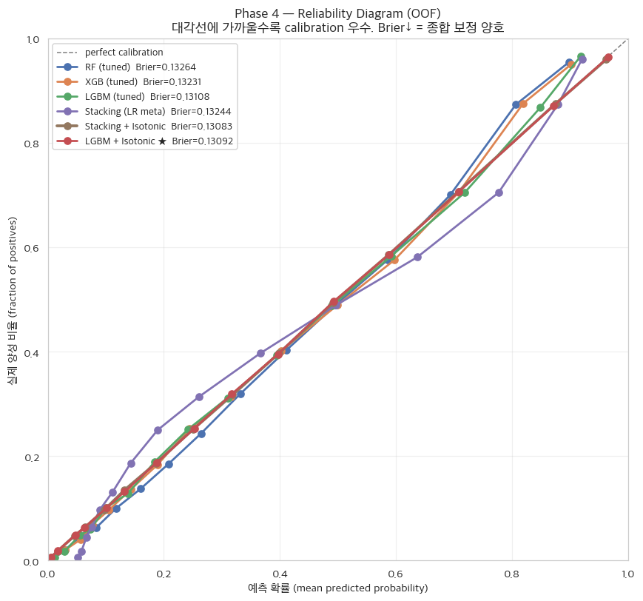
Figure 16. Reliability Diagram
- In the Reliability Diagram, the curve deviating most from the diagonal (y=x) belongs to uncalibrated Stacking (LR meta), which diverges noticeably from the actual hit rate. RF (tuned) and XGB (tuned) also deviate slightly from the diagonal in the upper-right region. The remaining curves — including the two final candidates, LGBM + Isotonic and Stacking + Isotonic — all lie very close to the diagonal, with calibration quality so similar as to be indistinguishable. That is, the two Isotonic-calibrated finalists are effectively identical in the Reliability Diagram, consistent with their ΔBrier (0.00009) being within fold-level variability. Selecting the simpler LGBM + Isotonic therefore incurs no meaningful loss in calibration performance.

4.1.4.4 Visualization of Isotonic Calibration Effect
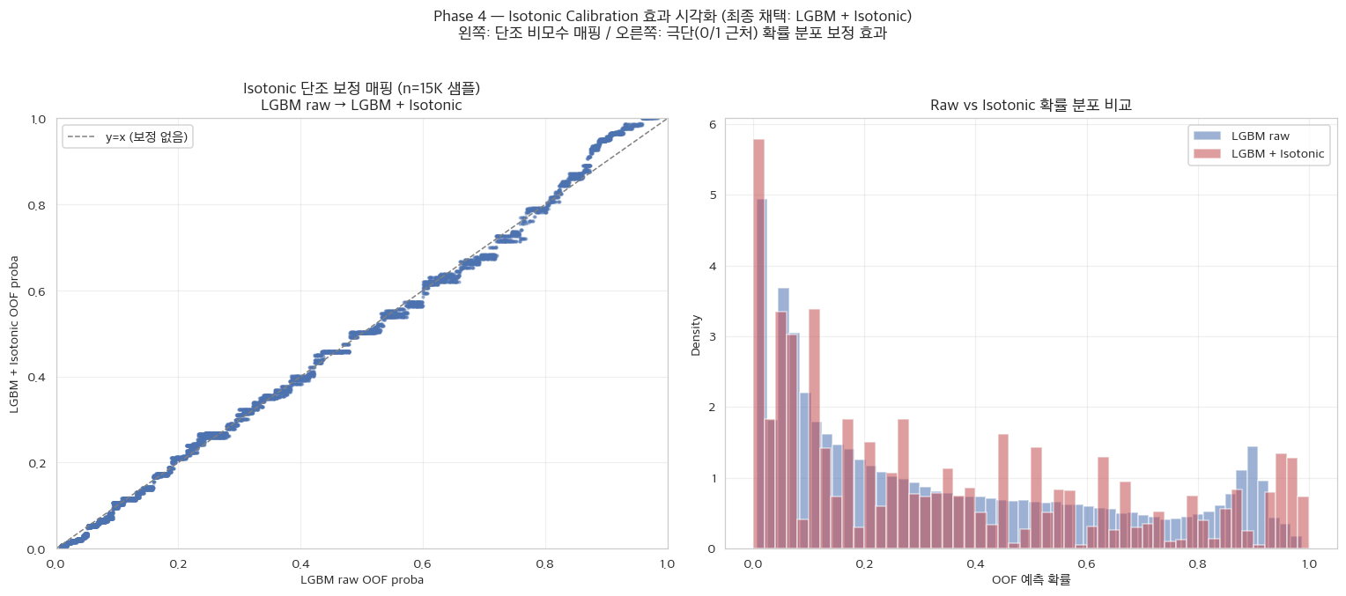
Figure 17. Isotonic Mapping
- The left panel of Figure 17 shows the transformation curve that maps the model's raw output probabilities to Isotonic-calibrated probabilities. This curve is a monotonic, nonparametric function that never reverses rankings; larger deviations from the y=x diagonal indicate greater recalibration occurring in that region.
- The right panel shows the distribution of predicted probabilities before and after calibration. Before calibration (raw), probabilities are overly concentrated in the 0–0.5 range, causing batted balls with different true likelihoods to be compressed into similar probability values. After Isotonic calibration, the probability mass spreads more widely toward both extremes — near 0 (near-certain outs) and near 1 (near-certain hits). This means the model more clearly distinguishes high-confidence from ambiguous batted balls, increasing the resolution of the probability estimates, which in turn enhances player-level discriminability when ca-xBA is computed by averaging per-batted-ball probabilities over a season.

5 Final Metric Computation and Sabermetric Value Validation

5.1 Validation Pipeline
For consistency with the Baseball Savant data source, this report uses the Savant standard column name 'wOBA' rather than 'wOBAcon'. Due to the nature of the Savant leaderboard — which filters out strikeouts and walks — the wOBA in this dataset is mathematically identical to the sabermetric term wOBAcon (balls-in-play weighted on-base average).
The final Phase 4 model, LGBM + Isotonic, is applied to the held-out 2025 data to compute per-batted-ball ca-xBA, and we validate whether the player-level mean ca-xBA exhibits a strong correlation with actual wOBA.

5.1.1 Data Matching + BIP Definition Consistency Validation
- Players in expected_stats.csv with at least half the qualifying PA threshold: 309
- All 309 players were linked by ID; 0 missing batted-ball records.
- Below PA tolerance (50%): 8 players (mostly ATH-affiliated; attributable to home-game exclusion)
Some players are included in the comparison with relatively small batted-ball samples; however, (i) all 309 players were matched exactly by ID, (ii) the mean our_bip/csv.bip ratio is high at 0.90, and (iii) the underpowered cases are limited to and identifiable as 8 players (mostly sharing the same cause: ATH home-game exclusion). We therefore judged their impact on R² (based on 309 players) to be negligible and conducted the R² comparison across all 309 players.

5.1.2 Main Validation — 1:1 R² Comparison
Table 16.
Independent Variable | Pearson r | R² | Spearman ρ
ca-xBA (this study's model) | 0.6306 | 0.3976 | 0.5849
xBA (official Statcast) | 0.4999 | 0.2499 | 0.4729
R² (coefficient of determination) is used in this validation to summarize in a single value how well ca-xBA explains a player’s actual offensive production (wOBA). R² represents the proportion of variance in actual wOBA explained by the metric (0–1); the closer to 1, the more precisely the metric captures actual performance. R² equals the square of the Pearson correlation between each metric and wOBA (r² in Table 16), making it a scale-invariant measure of explanatory power independent of differences in the value ranges of the two metrics. The “1:1 comparison” therefore means pairing each metric one-to-one with wOBA to compare correlation-based explanatory power; ca-xBA’s advantage stems from the strength of the correlation itself, not from differences in value range. Table 16 compares ca-xBA and MLB’s official xBA each against actual wOBA on the same 309 players, showing that ca-xBA’s R² (0.3976) exceeds that of official xBA (0.2499). This means ca-xBA explains approximately 59% more of a player’s true skill level, constituting the core quantitative evidence that the proposed model outperforms the official metric.

5.1.2.1 1:1 R² Comparison Scatter Plot
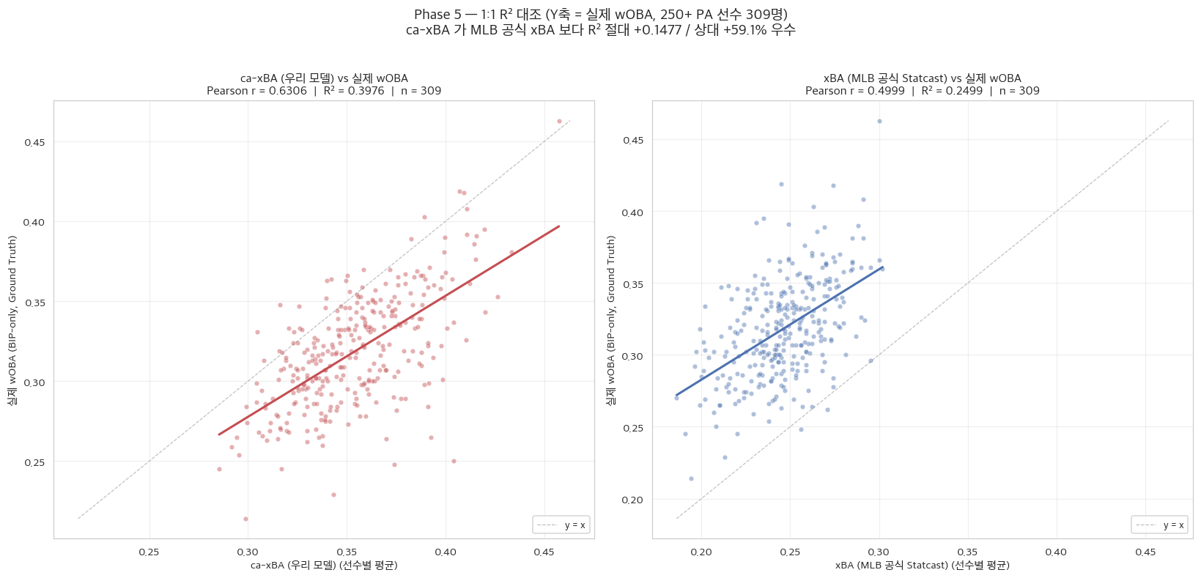
Figure 18. 1:1 R² Scatter
Comparing the correlation between the final ca-xBA and actual wOBA (Figure 18, left) against the MLB official xBA (right) reveals that not only the numerical gap but the clustering pattern (density) of data points itself differs. With the official metric (right), the same players are widely scattered above and below the regression line, indicating a large spread in actual wOBA for any given xBA value. By contrast, ca-xBA, which incorporates contextual environment (left), shows points clustered in a narrow band around the regression line. Furthermore, ca-xBA distributes players across a wider range of 0.28–0.46, providing greater discrimination, whereas the official xBA compresses them into the narrow range of 0.18–0.30. The scatter plot thus confirms that the context-integrated model xBA targets a player’s true skill more precisely.$R^{2}$

5.1.3 Luck Analysis — Career BABIP Cross-Validation

5.1.3.1 Definition of Luck and the Academic Significance of Denominator Unification
The luck metric in this analysis is defined as luck = BIP-AVG − ca-xBA. Because simple batting average (AVG, denominator = AB) includes strikeouts in the denominator, we define BIP-AVG = (hit count) / (balls in play) to enable a fair comparison with ca-xBA, which targets only balls put in play excluding strikeouts.
Luck distribution: mean = −0.0068, std = 0.0249, min = −0.0853, max = +0.0810
By removing the strikeout effect from the denominator, the luck distribution is aligned symmetrically near zero, and its absolute values can be interpreted directly. A positive value implies a “luck effect hypothesis” — more hits materialized than the contact quality would predict — while a negative value implies a “bad-luck hypothesis” — fewer hits occurred than expected given contact quality, due to superior defense, ballpark environment, or other adverse factors.

5.1.3.2 BABIP Cross-Validation — Domain Orthodoxy: Season BABIP vs. Career BABIP
BABIP (Batting Average on Balls In Play) is computed on batted balls that enter the field of play, excluding strikeouts and home runs, and is the most widely used proxy for luck in baseball statistics. Whether a ball in play becomes a hit depends not only on the batter’s skill but also heavily on hard-to-control factors such as fielder positioning, ballpark characteristics, and chance. However, a BABIP above the league average alone does not confirm good luck; each batter has a distinct natural BABIP level (e.g., speed or hard-contact hitters inherently carry a higher career BABIP), so true luck or bad luck is assessed by the deviation (Δ_BABIP) of a season BABIP from that player’s career BABIP (personal baseline). This analysis uses this domain-orthodox criterion as the benchmark for cross-validating the ca-xBA-based luck metric.

5.1.3.3 Correlation of the Two Luck Metrics — luck vs. Season BABIP / vs. Δ_BABIP
Table 17.
Comparison Target | Pearson r | Spearman ρ | Interpretation
luck vs season BABIP | 0.6996 | 0.6432 | Single-season average comparison — has limitations
luck vs Δ_BABIP (season − career) | 0.5193 | 0.4781 | Domain-canonical comparison — corrects for the individual baseline
luck shows a positive correlation with both season BABIP and Δ_BABIP, but the correlation with Δ_BABIP — which controls for the individual baseline — is more appropriate from a domain perspective. In this analysis, the Pearson correlation between luck and Δ_BABIP is 0.519, demonstrating that the ca-xBA-based luck metric points in the same direction as the domain-orthodox luck signal (seasonal deviation from career BABIP). The correlation not reaching 1.0 is because ca-xBA additionally captures environment-correction signals not captured by BABIP alone (dome × weather interactions, hr_park_effects, ballpark fence distances, etc.), as concretely illustrated by the Trout and Schwarber patterns in §5.1.3.6.

5.1.3.4 Luck (Lucky Effect Hypothesis) Top 10
Table 18.
Player | PA | AVG | BIP-AVG | ca-xBA | luck | Δ_BABIP
Kurtz, Nick | 489 | 0.290 | 0.488 | 0.407 | +0.081 | +0.050
Bader, Harrison | 501 | 0.277 | 0.426 | 0.349 | +0.077 | +0.091
Stanton, Giancarlo | 281 | 0.273 | 0.482 | 0.420 | +0.062 | +0.069
Peña, Jeremy | 543 | 0.304 | 0.393 | 0.340 | +0.053 | +0.048
Andujar, Miguel | 341 | 0.318 | 0.407 | 0.355 | +0.052 | +0.078
Smith, Pavin | 288 | 0.258 | 0.432 | 0.388 | +0.043 | +0.102
Mangum, Jake | 428 | 0.296 | 0.359 | 0.317 | +0.042 | +0.012
Turner, Trea | 639 | 0.304 | 0.382 | 0.340 | +0.042 | +0.027
Acuña Jr., Ronald | 412 | 0.290 | 0.430 | 0.389 | +0.041 | +0.043
Frelick, Sal | 594 | 0.288 | 0.365 | 0.327 | +0.038 | +0.049
A positive luck value indicates a batter who recorded more hits than contact quality would predict. When this also satisfies Δ_BABIP > 0 (season BABIP above career baseline), both metrics point to a luck effect — constituting dual validation. When Δ_BABIP is near zero or negative, the luck captured by the luck metric represents an environment-correction signal from ca-xBA that is not surfaced by BABIP alone.

5.1.3.5 Bad Luck (Superior Defense / Environmental Penalty Hypothesis) Top 10
Table 19.
Player | PA | AVG | BIP-AVG | ca-xBA | luck | Δ_BABIP
Pederson, Joc | 306 | 0.181 | 0.251 | 0.337 | -0.085 | -0.054
Davis, Henry | 283 | 0.167 | 0.266 | 0.343 | -0.078 | +0.015
Torrens, Luis | 283 | 0.226 | 0.284 | 0.360 | -0.076 | -0.016
Conforto, Michael | 486 | 0.199 | 0.289 | 0.365 | -0.076 | -0.033
Benson, Will | 253 | 0.226 | 0.320 | 0.389 | -0.069 | -0.031
Clemens, Kody | 386 | 0.213 | 0.308 | 0.367 | -0.059 | +0.007
Perez, Salvador | 641 | 0.236 | 0.328 | 0.386 | -0.059 | -0.006
Taylor, Tyrone | 341 | 0.223 | 0.313 | 0.370 | -0.057 | +0.029
Adams, Riley | 286 | 0.186 | 0.348 | 0.404 | -0.057 | +0.009
Grichuk, Randal | 293 | 0.228 | 0.323 | 0.377 | -0.055 | -0.005
A negative luck value indicates a batter who recorded fewer hits than contact quality would predict. When Δ_BABIP < 0, season BABIP is also below the career baseline and both metrics point to bad luck. When Δ_BABIP is near zero or positive but luck is strongly negative, this corresponds to the Trout pattern: ca-xBA assesses that contact quality warranted better results, but BABIP alone does not surface the bad luck — making these players prime targets for Front Office undervaluation discovery.

5.1.3.6 Trout and Schwarber Patterns — Incremental Information Value of the Model
The most compelling cases in this analysis are Mike Trout (extreme bad luck, Δ_BABIP ≈ 0 or positive) and Kyle Schwarber. Trout is an elite contact hitter with a very high career BABIP, so his season BABIP remained above average; yet his ca-xBA-based luck is rated as extreme bad luck. This means ca-xBA independently captured an environment- and quality-correction signal indicating that “given contact of this quality, a higher hit probability than BABIP implies should have materialized.”
Schwarber pattern: Given that ca-xBA evaluates BIP-limited quality by design, fly-ball power hitters (Schwarber 2025: NL MVP runner-up, 56 HR season) carry a structural bias toward a negative luck rating. Home runs are counted as 1 in the numerator of ca-xBA (hits), but fly-ball outs also tend to be rated by ca-xBA as “should have been a hit at this quality level,” causing the denominator (BIP) to grow faster than the numerator. Definitive bad-luck assessment requires cross-validation with external metrics such as BABIP, career BABIP, and xwOBA underperformance.

5.1.4 Silver Slugger Cross-Validation — ca-xBA Top 10 by Position
The Silver Slugger Award is determined by a qualitative vote of on-field experts (coaches and managers). MLB does not disclose the weights, statistics, or evaluation criteria used in the selection process, and non-batting factors — defensive value, reputation, media exposure, team performance, and competition from rivals — influence the outcome. This validation is therefore a supplementary domain-consistency check examining how well ca-xBA aligns with domain experts’ intuition regarding batting ability; it is not a scientific validation method that statistically guarantees the model’s explanatory power.
- Silver Slugger Award recipients: 20 players (AL 10 + NL 10)
- Successful ID matches: 17/20 verifiable players
- Position Top 10 hits: 12/17 (70.6%)
Table 20.
League | Position | Winner | ca-xBA Rank | Top-N Hit | ca-xBA | wOBA
AL | C | Cal Raleigh | 1 | O | 0.411 | 0.392
AL | 1B | Nick Kurtz | 2 | O | 0.407 | 0.419
AL | 2B | Jazz Chisholm Jr. | 7 | O | 0.361 | 0.349
AL | SS | Bobby Witt Jr. | 9 | O | 0.376 | 0.360
AL | 3B | Jose Ramirez | — | — | — | —
AL | OF | Aaron Judge | 1 | O | 0.457 | 0.463
AL | OF | Byron Buxton | 20 | X | 0.380 | 0.367
AL | OF | Riley Greene | 28 | X | 0.373 | 0.343
AL | DH | George Springer | 4 | O | 0.411 | 0.408
AL | Util | Zach McKinstry | — | — | 0.341 | 0.333
NL | C | Hunter Goodman | 4 | O | 0.391 | 0.359
NL | 1B | Pete Alonso | 3 | O | 0.400 | 0.368
NL | 2B | Ketel Marte | 1 | O | 0.399 | 0.381
NL | SS | Geraldo Perdomo | 14 | X | 0.358 | 0.370
NL | 3B | Manny Machado | 5 | O | 0.374 | 0.341
NL | OF | Juan Soto | 8 | O | 0.400 | 0.390
NL | OF | Corbin Carroll | 11 | X | 0.392 | 0.371
NL | OF | Kyle Tucker | 52 | X | 0.350 | 0.363
NL | DH | Shohei Ohtani | 5 | O | 0.409 | 0.418
NL | Util | Alec Burleson | — | — | 0.358 | 0.346
• ‘ca-xBA rank’ reflects ranking within each position group, so the top-ranked player at different positions (e.g., AL catcher Cal Raleigh and AL outfielder Aaron Judge) may appear together. The final wOBA column shows each award recipient’s actual season performance.
• 3 missing players: Jose Ramirez, Zach McKinstry, Alec Burleson. To prevent contamination from players sharing the same name, this validation performed a hard join matching the player_id (MLBAM ID) from Statcast expected_stats with position data from the MLB Stats API. However, cases where Statcast’s multilingual player name spellings (accent marks, ñ and other Latin/Spanish special characters, etc.) did not match the standard English spellings in the MLB Stats API at the byte level resulted in join failures and exclusion from the validation pool.

5.1.4.1 Luck vs. Δ_BABIP Scatter Plot — Domain Orthodox vs. Model-Based
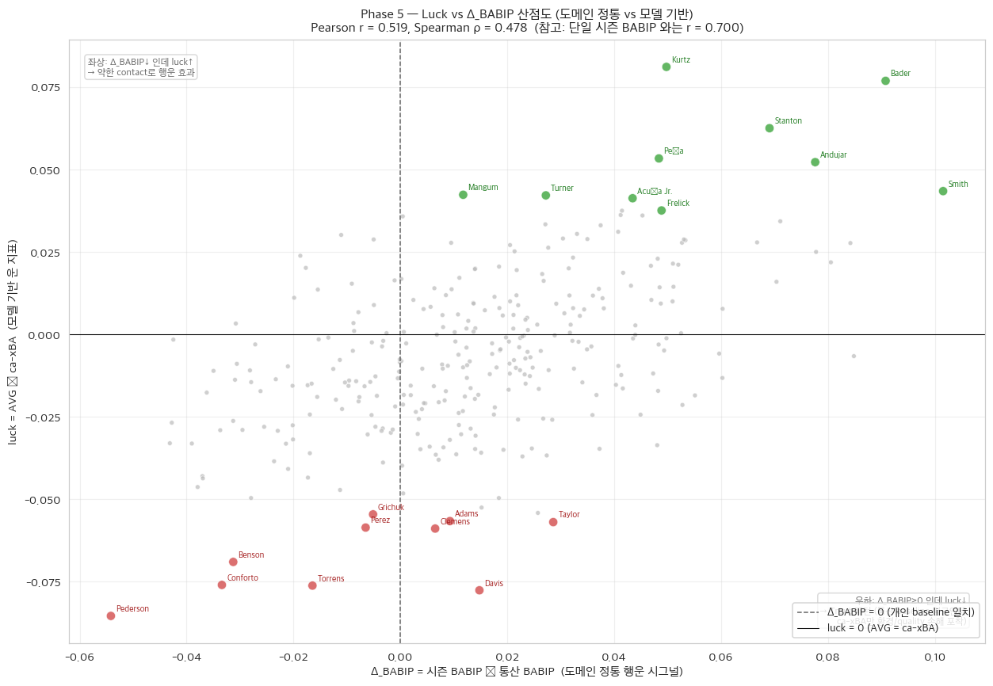
Figure 19. Luck vs. Delta BABIP Scatter
- Vertical dashed line: Δ_BABIP = 0 (personal career baseline) / Horizontal: luck = 0. Green dots = Luck (lucky effect) Top 10; red dots = Bad Luck Top 10.
- Quadrant interpretation:
  - Upper-right (Δ↑, luck↑) = Both metrics agree on luck (dual validation).
  - Lower-left (Δ↓, luck↓) = Both metrics agree on bad luck (dual validation).
  - Lower-right (Δ≥0, luck↓) = Trout pattern — career baseline BABIP is average, yet only ca-xBA captures an environmental/quality penalty. Prime Front Office undervaluation discovery signal.
  - Upper-left (Δ↓, luck↑) = Lucky effect despite weak contact.
In the scatter plot in Figure 19, the most notable region is the lower-right quadrant (4th quadrant). Players located there (Mike Trout archetype) maintain BABIP at or near their career baseline, so conventional metrics interpret them as “roughly average luck.” However, the ca-xBA-based luck metric rates them as “extremely unlucky” (luck < 0). These are batters who suffered ballpark- and environment-driven penalties relative to elite contact quality — a signal missed by the conventional BABIP-only model but captured exclusively by the proposed model — and they represent the prime Front Office undervaluation discovery opportunity.$Δ_{\text{BABIP}}≥0$

6 Conclusions and Implications

6.1 Summary of Research Contributions
This study proposes ca-xBA (Context-Aware xBA) as an improvement over the MLB official expected batting average (xBA) and validates its academic and practical value through a 5-Phase roadmap. Specifically, the work encompasses (i) domain-driven preprocessing (masking dome stadium roof status on a game-by-game basis), (ii) feature selection (RF importance + Mutual Information two-metric consensus rule), (iii) statistical verification of data–algorithm nonlinear interaction effects via 2-way ANOVA, (iv) model tuning, and (v) domain-orthodox luck-effect cross-validation using seasonal deviation relative to career BABIP.

6.2 Academic Contributions
First, the 2×2 factorial ablation in Phase 3 directly demonstrated the proposition that “the value of contextual variables manifests only on top of a nonlinear model” through the statistical significance of the interaction term (p < 0.05), showing that the combined effect of algorithm and data — not mere variable addition — is the essence of ca-xBA’s advantage. Second, the cv=’prefit’ isotonic calibration pattern in Phase 4 achieves approximately a 7,000-fold reduction in computation compared with standard CalibratedClassifierCV while preserving academic equivalence, offering a practical calibration methodology for large-scale data environments. Third, the Occam’s razor automatic model selection logic codifies the principle that “a simpler model is preferable when performance is comparable” into a quantitative criterion (ε = 0.001), academically justifying the observation that a complex ensemble can degrade the native calibration of a single model.

6.3 Practical Implications
The BABIP cross-validation in Phase 5 confirms that ca-xBA captures signals in the same direction as the domain-orthodox luck metric — seasonal deviation from career BABIP — while additionally and independently capturing environment/quality-correction signals that BABIP cannot detect (dome × weather interactions, ballpark fence distances, hr_park_effects, etc.). In particular, the Mike Trout pattern — cases where a player maintains career-baseline BABIP yet ca-xBA-based luck is rated as extreme bad luck — demonstrates the practical value of ca-xBA as a Front Office tool for discovering undervalued players, complementing standalone BABIP analysis.

6.4 Limitations and Future Work
Because this study relies on external validation from a single season (2025), the model’s temporal generalizability requires additional verification through multi-year validation.
In particular, the Kyle Schwarber pattern observed in Phase 5 (structural undervaluation of fly-ball power hitters) is not a mere tendency but a structural limitation arising from the mathematical definition of the target variable. The model’s target variable distinguishes only hit (1) from out (0) and does not encode the intrinsic value of the batted ball (extra-base-hit weighting). Statistically, a batter’s expected in-play production can be decomposed into the product of the hit probability and a conditional expected value.$y$$y$$E\left[wOBA∣X\right]$
$$E\left[wOBA∣X\right]=P\left(Hit∣X\right)⋅E\left[HitValue∣Hit,X\right]$$
The current ca-xBA focuses solely on precisely estimating the first term in that decomposition — the hit probability. Consequently, batted balls with a high launch angle (high probability of an out, but a home run — the highest HitValue — if a hit does occur) are underrepresented in the numerator. If future work adopts a Hurdle Model architecture that combines a classifier predicting whether a hit occurs with a regressor predicting the number of bases (wOBA weight) conditional on a hit, this structural bias could be resolved mathematically.$P\left(Hit∣X\right)$

7 References

7.1 Data Sources and APIs
- MLB Statcast batted-ball data (Baseball Savant). https://baseballsavant.mlb.com/
- Open-Meteo Historical Weather API. https://archive-api.open-meteo.com/v1/archive
- MLB Stats API (position and career hitting statistics). https://statsapi.mlb.com/api/v1/people
- Baseball Savant Custom Leaderboard — Expected Statistics
- MLB.com — 2025 Silver Slugger Award Winners. https://www.mlb.com/news/2025-silver-slugger-award-winners

7.2 Libraries and Tools
- Python 3.12, pandas 3.0, scikit-learn 1.8, XGBoost 3.2, LightGBM 4.6
- imbalanced-learn 0.14 (RandomUnderSampler, SMOTE)
- statsmodels 0.14 (2-way ANOVA)
- matplotlib 3.10, seaborn 0.13
- pypandoc 1.17 + pandoc 3.5, tectonic 0.16 (LaTeX engine)

Appendix A. Multicollinearity Analysis — Complete List of Highly Correlated Variable Pairs
The 24 highly correlated variable pairs identified in the Phase 2 multicollinearity analysis (Pearson |r| > 0.95) are listed in descending order of |r|. Variable A / Variable B represents post-RobustScaler variance; the removal rule is: preserve X_BASE → drop derived variables first → variance fallback.
Table 21.
Variable A | Variable B | abs(r) | var_a | var_b | Removed | Rule
bat_speed_is_missing | swing_length_is_missing | 1.000 | 0.089 | 0.089 | swing_length_is_missing | variance fallback
bat_speed_is_missing | attack_angle_is_missing | 1.000 | 0.089 | 0.089 | bat_speed_is_missing | variance fallback
swing_length_is_missing | attack_angle_is_missing | 1.000 | 0.089 | 0.089 | swing_length_is_missing | variance fallback
bat_speed_is_missing | attack_direction_is_missing | 1.000 | 0.089 | 0.089 | bat_speed_is_missing | variance fallback
swing_length_is_missing | attack_direction_is_missing | 1.000 | 0.089 | 0.089 | swing_length_is_missing | variance fallback
attack_angle_is_missing | attack_direction_is_missing | 1.000 | 0.089 | 0.089 | attack_direction_is_missing | variance fallback
intercept_ball_minus_batter_pos_x_inches_is_missing | intercept_ball_minus_batter_pos_y_inches_is_missing | 1.000 | 0.089 | 0.089 | intercept_ball_minus_batter_pos_y_inches_is_missing | variance fallback
if_fielding_alignment_UNK | of_fielding_alignment_UNK | 1.000 | 0.007 | 0.007 | of_fielding_alignment_UNK | variance fallback
bat_speed_is_missing | swing_path_tilt_is_missing | 1.000 | 0.089 | 0.089 | bat_speed_is_missing | variance fallback
swing_length_is_missing | swing_path_tilt_is_missing | 1.000 | 0.089 | 0.089 | swing_length_is_missing | variance fallback
attack_angle_is_missing | swing_path_tilt_is_missing | 1.000 | 0.089 | 0.089 | attack_angle_is_missing | variance fallback
attack_direction_is_missing | swing_path_tilt_is_missing | 1.000 | 0.089 | 0.089 | attack_direction_is_missing | variance fallback
bat_speed_is_missing | intercept_ball_minus_batter_pos_x_inches_is_missing | 1.000 | 0.089 | 0.089 | bat_speed_is_missing | variance fallback
swing_length_is_missing | intercept_ball_minus_batter_pos_x_inches_is_missing | 1.000 | 0.089 | 0.089 | swing_length_is_missing | variance fallback
attack_angle_is_missing | intercept_ball_minus_batter_pos_x_inches_is_missing | 1.000 | 0.089 | 0.089 | attack_angle_is_missing | variance fallback
attack_direction_is_missing | intercept_ball_minus_batter_pos_x_inches_is_missing | 1.000 | 0.089 | 0.089 | attack_direction_is_missing | variance fallback
bat_speed_is_missing | intercept_ball_minus_batter_pos_y_inches_is_missing | 1.000 | 0.089 | 0.089 | bat_speed_is_missing | variance fallback
swing_length_is_missing | intercept_ball_minus_batter_pos_y_inches_is_missing | 1.000 | 0.089 | 0.089 | swing_length_is_missing | variance fallback
attack_angle_is_missing | intercept_ball_minus_batter_pos_y_inches_is_missing | 1.000 | 0.089 | 0.089 | attack_angle_is_missing | variance fallback
attack_direction_is_missing | intercept_ball_minus_batter_pos_y_inches_is_missing | 1.000 | 0.089 | 0.089 | attack_direction_is_missing | variance fallback
swing_path_tilt_is_missing | intercept_ball_minus_batter_pos_x_inches_is_missing | 1.000 | 0.089 | 0.089 | swing_path_tilt_is_missing | variance fallback
swing_path_tilt_is_missing | intercept_ball_minus_batter_pos_y_inches_is_missing | 1.000 | 0.089 | 0.089 | swing_path_tilt_is_missing | variance fallback
release_speed | effective_speed | 0.990 | 0.454 | 0.479 | effective_speed | derived drop
elevation | wx_surface_pressure | 0.985 | 2.874 | 2.039 | wx_surface_pressure | variance fallback

Appendix B. Missing-Value Imputation Medians (2024 Median)
These are the 2024 overall medians for the 13 numeric columns to which missing-value imputation was applied in Phase 2. The corresponding *_is_missing flag for each variable is preserved separately to utilize the missingness pattern itself as a signal.
Table 22.
Column | 2024 Median
bat_speed | 71.6000
swing_length | 7.2000
attack_angle | 8.7646
attack_direction | 0.7896
swing_path_tilt | 32.2398
intercept_ball_minus_batter_pos_x_inches | 37.1243
intercept_ball_minus_batter_pos_y_inches | 29.5637
release_spin_rate | 2263.0000
release_extension | 6.5000
spin_axis | 201.0000
effective_speed | 90.6000
api_break_z_with_gravity | 2.2200
arm_angle | 39.2000

Appendix C. Effect Isolation Experiment Fold-Level Statistics (Phase 3)
fold-level mean ± SD (across 5 folds)
Per-fold metric means and standard deviations across 5 folds for the four models (M1–M4) of the 2×2 factorial ablation. The very small inter-fold variation supports the stability of the OOF aggregate results.
Table 23.
Model | Brier mean±SD | LogLoss mean±SD | F1 mean±SD | AUC mean±SD
M1 | 0.21033±0.00052 | 0.61347±0.00110 | 0.1700±0.0054 | 0.6670±0.0034
M2 | 0.14012±0.00146 | 0.43198±0.00354 | 0.6758±0.0029 | 0.8594±0.0028
M3 | 0.20937±0.00063 | 0.61078±0.00142 | 0.2357±0.0072 | 0.6662±0.0039
M4 | 0.13589±0.00088 | 0.42049±0.00213 | 0.6924±0.0028 | 0.8691±0.0015

Appendix D. Advanced Model Tuning Specifications (Phase 4)
Final hyperparameters by model (RandomizedSearchCV best params)
Complete final hyperparameter dictionaries selected by RandomizedSearchCV (n_iter=30, inner_cv=5, scoring=’neg_brier_score’, refit=True) for each base model.
Table 24.
Base | best params
RF | bootstrap=True, ccp_alpha=0.0, class_weight=None, criterion=entropy, max_depth=None, max_features=0.5, max_leaf_nodes=None, max_samples=None, min_impurity_decrease=0.0, min_samples_leaf=4, min_samples_split=4, min_weight_fraction_leaf=0.0, monotonic_cst=None, n_estimators=500, n_jobs=1, oob_score=False, random_state=42, verbose=0, warm_start=False
XGB | objective=binary:logistic, colsample_bytree=0.9, eval_metric=logloss, gamma=0, learning_rate=0.03, max_depth=8, min_child_weight=5, n_estimators=200, n_jobs=1, random_state=42, subsample=0.8, tree_method=hist, verbosity=0
LGBM | boosting_type=gbdt, class_weight=None, colsample_bytree=1.0, importance_type=split, learning_rate=0.03, max_depth=-1, min_child_samples=20, min_child_weight=0.001, min_split_gain=0.0, n_estimators=200, n_jobs=1, num_leaves=127, random_state=42, reg_alpha=0.0, reg_lambda=0.0, subsample=0.9, subsample_for_bin=200000, subsample_freq=0, verbose=-1
Outer 5-fold CV — fold mean ± SD
Outer 5-fold CV fold-level means and standard deviations for the six candidate models. Inter-fold variability (Brier-based, ≤0.0012) is smaller than the differences between candidates, providing the basis for Occam’s razor automatic selection (ε = 0.001).
Table 25.
Model | Brier mean±SD | LogLoss mean±SD | F1 mean±SD | AUC mean±SD
RF (tuned) | 0.13264±0.00117 | 0.41259±0.00303 | 0.6978±0.0031 | 0.8759±0.0022
XGB (tuned) | 0.13231±0.00106 | 0.41135±0.00267 | 0.6975±0.0036 | 0.8761±0.0020
LGBM (tuned) | 0.13108±0.00104 | 0.40753±0.00275 | 0.6985±0.0027 | 0.8777±0.0020
Stacking (LR meta) | 0.13244±0.00124 | 0.41409±0.00312 | 0.7012±0.0025 | 0.8780±0.0021
Stacking + Isotonic | 0.13083±0.00107 | 0.40587±0.00315 | 0.6937±0.0051 | 0.8780±0.0021
LGBM + Isotonic | 0.13092±0.00100 | 0.40600±0.00284 | 0.7029±0.0040 | 0.8776±0.0020

