# 1

‘My son, please tell me a story.’

Isaiah smiles. ‘Mother sent me to call you. She wishes to begin preparing dinner and my children demand to know when their grandfather will arrive.’ His voice carries the same warmth as that of his father, redolent of nutmeg and coffee, with the deeper timbre of one accustomed to public speaking.

Joshua is sitting at the far end of the Ekpe House, his feet over the edge of the cliff, watching the setting sun facetted in red and gold reflected on the clear waters of the Akwayafe River murmuring below.

Even as the city has grown, stretching further towards the cliffs at the edges of the forests, this sacred space has maintained its presence. In the evenings, after his walk around the old city walls, Joshua likes to sit here, watching the waters and thinking on memory; of those who have passed, and those beyond reach.

Isaiah always knows to find him here.

He sits alongside him, their legs touching, enjoying the gentle presence, each of the other. Taking his father’s hands, he marvels once more at the stories written there in its subtle tracery of scars. Joshua’s skin is wrinkled and the flesh and bone within somehow lesser than he remembers, but still Isaiah can feel their strength and compassion.

‘I grow old,’ says Joshua, and chuckles.

‘Not so much,’ smiles Isaiah. ‘All that has changed is that now it is you who asks stories of me.’

A song like a caress rises in melody from the market where people have gathered to enjoy the deepening evening. Behind, the rumble and clatter of conversation, trade, and meals being shared. Before, the call of birds and hoot of monkeys crashing through the forest over the river and into the shadows beyond.

‘What story would you hear, my father?’ asks Isaiah.

‘My grandchildren tell me you have been working on a new one. Of Usan Abasi? You experiment with the old tales?’

Isaiah laughs. ‘There are no surprises in our family. I was saving that for your seventieth birthday. How did you get them to tell you?’

Joshua grins. ‘I bribed them with a plate of their aunt Asha’s samosas. And a good son would honour his father by ensuring he receives his present before everyone else.’

Isaiah shakes his head, smiling. ‘It is cruel that the storyteller did not get a taste of those samosas.’

He mock-sighs, nodding. ‘Very well, and I shall find another way to surprise you.’

# Isaiah’s tale Usan Abasi’s Lament

In the memory of the sacred grove the ceremonial procession was always led by a teenage girl in her first flush of womanhood. In her right hand, she carried Ika, the split sword of divination.

At the rear of the procession was the high priest. In his left hand, he held the egg-stone, unbreakable except during the ceremony to follow. He was flanked on either side by the chalk-bearers; four priests carrying the white, blue, purple and red chalks.

And, in between, youths of all ages would sing, carrying raffia fronds, swords and cow horns, and beating the drums of Ekpe.

They would begin their journey in the old city of Calabar, passing Creek Town and along the secret path known only to the priests of Ekpe. At night, they would rest and the high priest would teach of the ceremony, of the reason for it, of its dangers if it were not to be carried out perfectly, and of the tasks which each must perform to ensure its completion.

On the final day of their journey, they would wash in Enwang, the sacred spring gushing from between rocks at the entrance to the grove. There the priests would shave their heads and dress in white overalls, their wrists and ankles wrapped in white bracelets. The young men and women would inscribe their bodies with *nsibidi* writings in white chalk, and dress in white loin-cloths.

Prepared, they would begin the ceremony, singing as they walked barefoot though the grove.

*Ndem Efik, se nnyin imọwuhọ ida, Abasi Abasi*

*Anansa Ikañ, se nnyin imọwuhọ ida, Abasi Abasi*

*Afia añwan, se nnyin imowuho, ida Abasi Abasi*

*Ata Ọkpọ Uruan, se nnyin imọwuhọ ida Abasi Abasi*

*Ukọñ Esuk, se nnyin imọwuhọ ida, Abasi Abasi*

*Anantigha Eñwañ, se nnyin imọwuhọ ida, Abasi Abasi*

*Añwakañ, se nnyin imọwuhọ ida, Abasi Abasi*

*Ọkpọrọ! Ọkpọrọ! Ebe itip itip, ñwan itip itip*

*Itip itip iba idiaha ñkpọ enyọñ utañ*

At a certain place, deep within the grove, they would descend into a wide valley obscured by dense cloud. On this day, the cloud would lift, revealing a vast termite mountain rising from the forest, its upper reaches too distant to see, its flanks tawny brown and deepening to darkness in the mists at its summit.

Toward noon, timed so that the sun would be directly behind the peak of the termite mountain, the procession would reach the entrance to the shrine hidden within a folded passageway. The small round entry would be veiled in a living fabric; termites anchoring themselves to the edges of the walls and then thousands more gripping on to each other.

The lead girl would take up her sword and strike once at the termites, slicing open the entrance. The procession would then continue, bowing down within the low tunnel, into the depths of the termite mountain.

There, eventually, to arrive in the cathedral of Usan Abasi.

A moment of silence as the youths, only ever visiting once, sighed or gasped at the enormity of an open space lit in a tapestry of fluorescent termites, their abdomens glowing blue and white against the cool moist darkness of the earthen walls. The silence of the interior broken only by the gentle rustling of hundreds of thousands of worker termites bringing nectar to those which fluoresce, to sustain them during the ardours of the ceremony.

The high priest would be joined by the high priestess and they would lead the procession to the altar at the far end of the cathedral. Behind the altar was an enormous spreading oboti tree, pink flowers emerging from amongst large green leaves. Upon the altar was a glowing brass bowl.

The high priestess would bring forth a jug of water collected from the Enwang spring, and pour it into the bowl. A pad of grass would be placed at the bottom of the bowl and the chalk-bearers would form up at the corners of the altar.

Only once he was certain all was correct, and the singing had reached a perfect tone, would the high priest raise the egg-stone, tap it seven times against the edge of the bowl and place it on the pad of grass within the waters of Enwang.

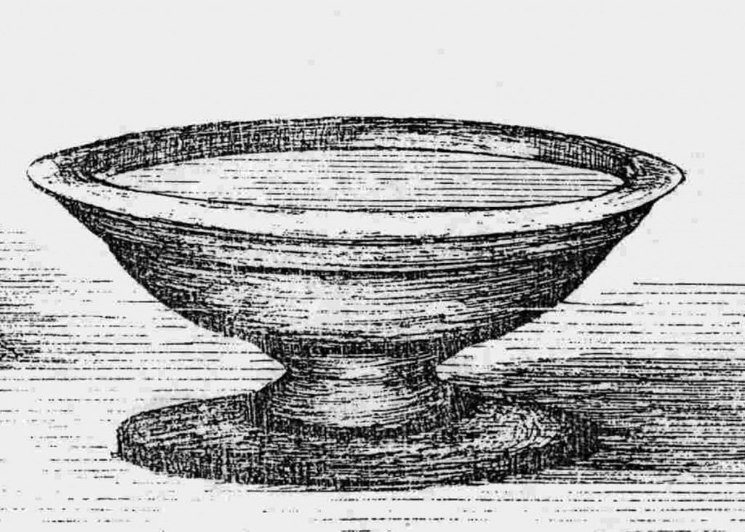

Then, if all had been done as required, the termites would take up the tone of the singers and their song would rise into the very heights of the mountain. The fluorescent tapestry would shift, now white, now blue, now purple, red, and back to white.

And the egg-stone would open in seven concentric layers, releasing a clear fluid which floated to the top of the water in the bowl.

One by one, each of the chalk-bearers would offer their chalk to the high priest; first the white, then the blue, then purple, and last red. He would crumble each to powder and add it to the bowl. Then they sang and waited for the colour to change.

If their offering was accepted, and the ceremony complete, the liquid would turn a rich yellow as if of the yolk of an egg.

Each of the ceremony participants would take a small brass spoon and dip it once in the bowl and sip of the yellow liquid.

Once all had drunk, the termites would come down from the walls and form four columns, transferring the remaining contents of the bowl out into the vast chambers beneath the mountain where they lived.

As the bowl dried, the egg-stone would reform, hardening once more. Unbreakable until the next ceremony a year hence.

The liquid formed during the ceremony for Usan Abasi offers a gift of foretelling, and each of the participants would feel warmth fill their hearts and minds. There is no single moment of knowledge, merely an awareness which would last for many years, guiding each towards the appropriate decision under any circumstance.

It was during this period that Calabar became a prosperous and enlightened city.

But the curse of Usan Abasi was soon upon them, for it happened that a young man – jealous of his brother winning the opportunity to participate in the ceremony – slew him and took his place.

On that day, the waters in the bowl of Usan Abasi turned red and the high priest began to wail in terror, for he knew then that all would be lost.

In the ceremony the year after, the egg-stone failed to open.

And times were dark in Calabar as order fell and the Awbong, with their machets and violence, fought for control of the towns within the city.

Still the high priest kept up the tradition of setting out to perform the ritual. But the egg-stone never opened and, on his death, the memory of the ceremony and of its importance was lost.

Deep in the termite mountain, the termite matrix-mind trembled as the last of the precious yellow fluid ran out.

For Usan Abasi was no ordinary *ndem*. He was the servant of the Sky God, Abasi, who thought to challenge his power and was cursed for it, transformed into a brass bowl and placed as a prisoner within the termite mountain, to be tended by them forever.

It is the yellow yolk of the egg-stone which permits the termites to maintain their control over Usan Abasi – to daily polish the vessel and keep him wrapped in slumber – and, without this, the brass began to tarnish.

Gradually, Usan Abasi began to stir.

And, one day, almost a century after the last successful ceremony, Usan Abasi awoke.

He sat on the edge of the altar, looking about his cathedral, listening to the quiet rustle of the working termites, and considering his options.

‘For one,’ he said, his voice brassy in the blue-white light from the nervous fluorescent termites, ‘I cannot go outside for I have no wish for the Sky God to notice my presence.

‘For two, I am cold.

‘For three, I am hungry.’

He set the termites to collect food for him, carrying fruit and meat raw from the jungle and laying it upon his altar. He wrinkled his nose at having to eat uncooked flesh but, his stomach gurgling, he overcame his resistance.

His cold, however, they could do nothing for. One such as Usan Abasi is raised in the blazing presence of the Sky God, and the earth – even within the warmth of a termite mountain – is a cold place.

Usan Abasi shivered, swaddled in animal pelts. He blocked the chimneys at the peak of the mountain with animal bones and skulls. He begged for hot soups, but to no avail, for the termites have no cooking fires.

He tried distracting himself, wandering the depths of the chambers where the termites lived, staring at the endless fungal farms where they tended their crops, the processing chambers where their harvest was chewed into a rich paste, the nursery where workers tended the next generation, and returning to his cathedral where he sat, shivering and growing bored with his prison and his meals.

He sighed and rubbed his belly as he remembered the soups of his youth; of *egusi*, catfish pepper soup, or *miyan kuka* made from the leaves of the baobab. Oh, the feasts he enjoyed when he sat in the court of the Sky God.

‘There is nothing for it,’ he said when he could bear his cold and his salivating agony no longer. ‘I shall have to teach them the secret of fire.’

He called out to the billions of termites, to the matrix-mind formed by the interactions of a special cast of workers, demanding they attend his lessons.

The matrix-mind of the termite mountain is not like the mind of people or even of ndem. It is static and laboured. Perfect for maintaining order and ensuring the patterns of a thousand years are maintained exactly, but slow to absorb new ideas or adapt to change.

Even as the yellow liquid from the last ceremony had run out, the matrix-mind had directed workers to continue polishing the bowl of Usan Abasi. Somewhere was the knowledge that this was their single purpose, but there was no understanding of what to do should a ceremony fail.

Now that Usan Abasi had been released, the termites were directionless and yielded easily to his demands. As long as these demands remained simple, that is.

To fetch something was straightforward. To rebuild parts of the cathedral so that Usan Abasi may have furniture, trivial. Carrying water, drop-by-drop, was no great challenge for a workforce numbering in the billions.

But fire . . . Ah, that is where the matrix-mind of the termites struggled.

In vain did Usan Abasi explain the nature of oxidation, of the process that occurs when a combustible fuel undergoes a chain reaction in combination with oxygen and heat. He described the need for convection to ensure a steady supply of oxygen and the removal of combustion by-products so that the flame may continue burning. He sketched in the dust on the floor of the cathedral, drawing for them a series of chambers where they could safely gather the methane produced during the endless conversion of fungi into paste by the workers. He drew channels, leading gas to his chambers where it would be lit to produce heat. He explained the need for safety, for fire is volatile, and a termite mountain has vast stores of methane. He shivered as he pointed at the bath they had made for him, filled with cold water. He sobbed as he recited his favourite recipes, his stomach churning in pain, his body bowed low in exhaustion.

He wore his voice hoarse, speaking long into the days and nights, repeating endlessly the pattern of fire and food and heat until he was certain this was some new torture devised by the Sky God to ensure his suffering.

One particularly cold day, as he sat near the entrance to his cathedral, looking wistfully at the rain falling and running in rivers from amongst the trees outside, he heard a faint rumbling and stirring from the bowels of the termite mountain.

He flinched away from the entrance, terrified that the Sky God may have caught a glimpse of him and come to exact further revenge. Once inside, though, he felt a strange sensation. Something which plucked and ruffled the fur and feathers of his mane and made his skin pucker.

It was warmth! Tepid, certainly, but warmth!

He scrambled back towards his altar, jets of flame burning around the edges of the cathedral walls. Upon the altar was a bowl of rich pepper soup, steaming hot and waiting for him. Around the bath, flames burned, heating the water within.

“Hotter! Hotter!” he cried, thrilling that – finally – he would make of his prison a home.

He devoured the soup, dabbing at the bath with a paw, willing it to warm faster.

Eventually, as the waters boiled and steam rose, he delicately stepped into his bath.

And was filled with disappointment. For the water was still too cold for him.

Cold food is one thing, but a cold bath?

He howled long into the night.

When he was calm once more, he captured a methane molecule in his paws and stared deeply at the energy bound within its atomic bonds. He drew diagrams in the dust, calculating chemical transformations, the need for containment and storage, and devising distillation and condensation techniques.

Resting his buttocks on a jet of flame to keep warm, his tail plumes flicking above his ears, he kept at his task until he felt ready to call forth the termite matrix-mind once more.

He began in patience, knowing that it would be a slow process. He felt confident, though, that if the termites could grasp fire, they would eventually grasp the mechanism of converting methane into liquid rocket fuel.

He could not know how slow.

Years passed and Usan Abasi kept at his task. His voice crumbled, becoming a mere whisper. His feathers faded and his fur became matted. He shivered even amidst the flames jetting from his altar.

He persisted.

On a particular morning, as he lay in troubled rest, the termite matrix-mind came before him, greatly excited.

‘What is it?’ he whispered.

A mound of termites churned in the dust at his feet, a capped spout emerging in their midst. As Usan Abasi watched, a tiny specialist glowing termite walked to the top of the cap and waited there. Termites gathered around it and bit into the spout, breaking the cap.

The glowing termite expanded and exploded.

A jet of pure blue flame burned like a pale sun from the spout.

And Usan Abasi knew real warmth.

He nodded, feeling utterly weary. He collapsed to the floor and curled his body around the spout, feeling heat enter his bones, restoring his well-being.

Usan Abasi fell into the deep rest of complete contentment.

When he awoke, there were flames. All around him.

The ground tremored. The walls shook. Termites ran about randomly, scrambling to maintain purchase. The floor seemed to glow and steam.

‘No, no, no!’ shouted Usan Abasi, his voice unheard beneath the grinding and shifting of the mountain.

Somewhere, something had failed. The flame had leapt back down into the depths where the liquid methane was stored. Walls had cracked under pressures too vast to contain. Air and expanding liquid mixed. The volatile mixture contacting the flames further up, boiling and melting passages and chambers into a seething molten fluid.

Pressure continued building until, with a final furnace howl, the top of the termite mountain exploded, shattering it, hurling magma across the sacred grove and driving smoke and flame almost to the edge of space.

The eruption was so enormous it flung termites high into the sky and distributed them across the great plains of the continent.

The termite matrix-mind was destroyed, leaving only the remnants of a memory; of the need to build a mountain and chambers within. Never again would so vast a colony come together in one place.

Tiny earthen mounds rose all across the grasslands as termites instinctively continued their mission.

And Usan Abasi follows them, covering the mound flanks in animal skins and plugging the chimneys with bones and skulls, before burrowing inside so that he may hide from the Sky God, so that he may find warmth.

# 2

Joshua laughs. ‘That is a good story, thank you.’ Shaking his head, ‘but poor Usan Abasi. You have made him so small.’

‘We should never be in awe of our gods,’ says Isaiah.

‘Neither should we underestimate their dangers,’ smiles Joshua, squeezing his son’s hand. ‘You are set on this race?’

‘Yes,’ nodding and looking towards where the sun is setting. ‘It will be a great adventure.’

‘Will you see the Souls?’

‘I hope so. Calisto swears that he can navigate us directly beneath each of them.’

‘Would that I were younger,’ says Joshua. ‘To be on the first Ewuru solar yacht, sailing so close to the sun —’ gripping Isaiah’s hand ‘— you promise you will be safe?’

‘Yes father,’ laughing. ‘We are taking the slowest, safest route between the Souls. We will be well.’

Joshua stares wistfully at the horizon.

‘You miss Samara?’ asks Isaiah.

Joshua nods, smiling. ‘Everyone.’

He makes as if to rise. ‘Come, shall we go?’

‘There is no rush. Shall we wait? Look, the sun is about to set,’ says Isaiah, holding his father’s hand.

And so, with their feet hanging over the edge and the song of the water below, they watch as the last embers of the day turn the horizon to purple and gold.

# Author’s note

I enjoyed revisiting the world I explored in my first novel, *Lament for the Fallen*. Ewuru feels a very gentle place when set against the context of 2017.

This short story serves as both a stand-alone companion to the novel’s paperback release on 1 June 2017, and as a bridge between my first and third novels. No prizes for what that story will be about.

If you wish to learn more about ndem-worship in Efik culture, you should visit the Efik Eburutu website at <http://efikeburutu.org> where you will find a wealth of information on their traditions and history. The ceremony and song in *Usan Abasi’s Lament* are sourced from there.

And, as always, a song to complement the tale:

‘Sirata’, Ma Ya – Habib Koité [*Usan Abasi’s Lament*]

You can find a list of my novels and short-stories on <https://gavinchait.com>.

@GavinChait, May 2017