读书心得

/km/summary/km_summary_main/kmSummaryMain.do?method=add&templateId=13ec11cc1e477bbda5eb59448eeaa864&s_css=ekp9_yahei

住工通讯

/moduleindex.jsp?nav=/sys/news/tree.jsp&main=%2Fsys%2Fnews%2Fsys_news_main%2FsysNewsMain.do%3Fmethod%3DlistChildren%26type%3Dcategory%26categoryId%3D13e44333a62dfcb670cc1a2437998578%26status%3D30

工作沟通

页面链接

/resource/jsp/portlet.jsp?portlet=&pageType=myJoin

食堂公示

/moduleindex.jsp?nav=/km/doc/tree.jsp&main=%2Fkm%2Fdoc%2Fkm_doc_knowledge%2FkmDocKnowledge.do%3Fmethod%3DlistChildren%26categoryId%3D1443d505a024601c56b7c02427aa1a04

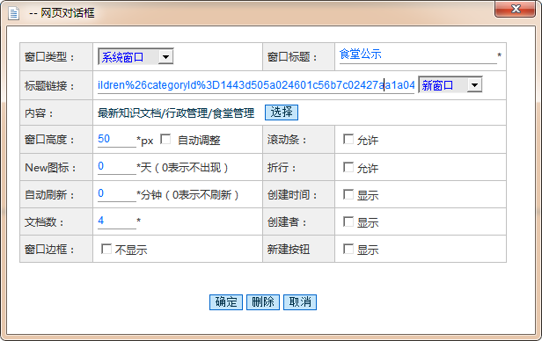

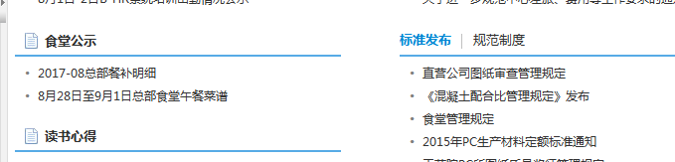

行业动态

系统窗口

/resource/jsp/portlet.jsp?portlet=sys-news:sysNewsMain.portlet.withHead&cateid=13e40960e57d949f212e7974c9db5238&rowsize=!{rowsize}

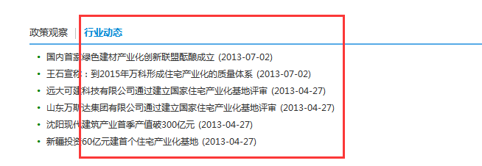

//////////////////////////////////////////////////////////////////////////////////////////////////////



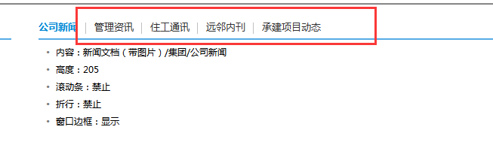

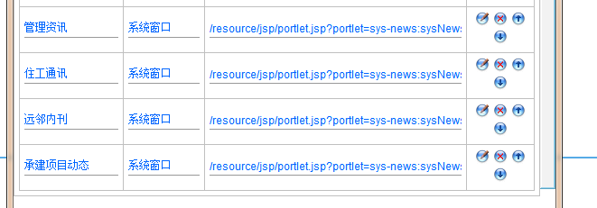

管理资讯 系统窗口 /resource/jsp/portlet.jsp?portlet=sys-news:sysNewsMain.portlet.sysNewsMain&cateid=13f4047e170e72013e5790b45d886a9f&rowsize=!{rowsize}

住工通讯 系统窗口

/resource/jsp/portlet.jsp?portlet=sys-news:sysNewsMain.portlet.sysNewsMain&cateid=13e44333a62dfcb670cc1a2437998578&rowsize=!{rowsize}

远邻内刊

/resource/jsp/portlet.jsp?portlet=sys-news:sysNewsMain.portlet.sysNewsMain&cateid=13e4435124145d7c9f639444dc2a0c3d&rowsize=!{rowsize}

承建项目动态

resource/jsp/portlet.jsp?portlet=sys-news:sysNewsMain.portlet.withHead&cateid=1487c13309ea6a6a594107a4445a6747&rowsize=!{rowsize}





工作日志

/km/summary/km_summary_main/kmSummaryMain.do?method=add&s_css=ekp9_yahei