IE582 Advanced Engineering Analytics

HW 3

Due 10/21/2019 (submit in Canvas by 11:59 pm)

1. Train three single layer perceptron with a threshold logic unit with the perceptron learning algorithm in Python/R to learn (you will need to code the learning algorithm):

1. The AND gate
2. The OR gate
3. The XOR gate (y=1 if x1=1, x2=0 or x1=0, x2=1 else y=0)

For all three cases, the initial conditions are $w_{1}=0,w_{2}=0$, $θ=0.5,α=0.1$, the maximum step is 50. Use the sequence of $\left[x_{1}=0,x_{2}=0\right],\left[x_{1}=0,x_{2}=1\right],\left[x_{1}=1,x_{2}=0\right],\left[x_{1}=1,x_{2}=1\right]$ during the learning. Show the detailed information during the learning including step, value of $x_{1},x_{2},w_{1},w_{2},θ$, for instance:

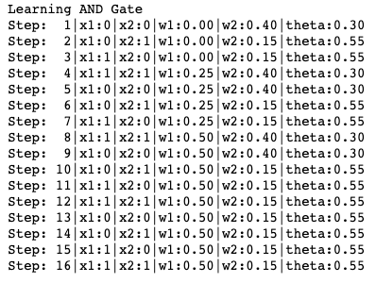

Show if the algorithm is able to converge and explain why the algorithm is not able to learn it if it is not converged (On page 2, you can find details of the example used in Note Neural Networks-II)

2. Implement a perceptron model with one hidden layer and sigmoid activation functions to learn the XOR gate in Python(sklearn)/R and plot the decision boundary.

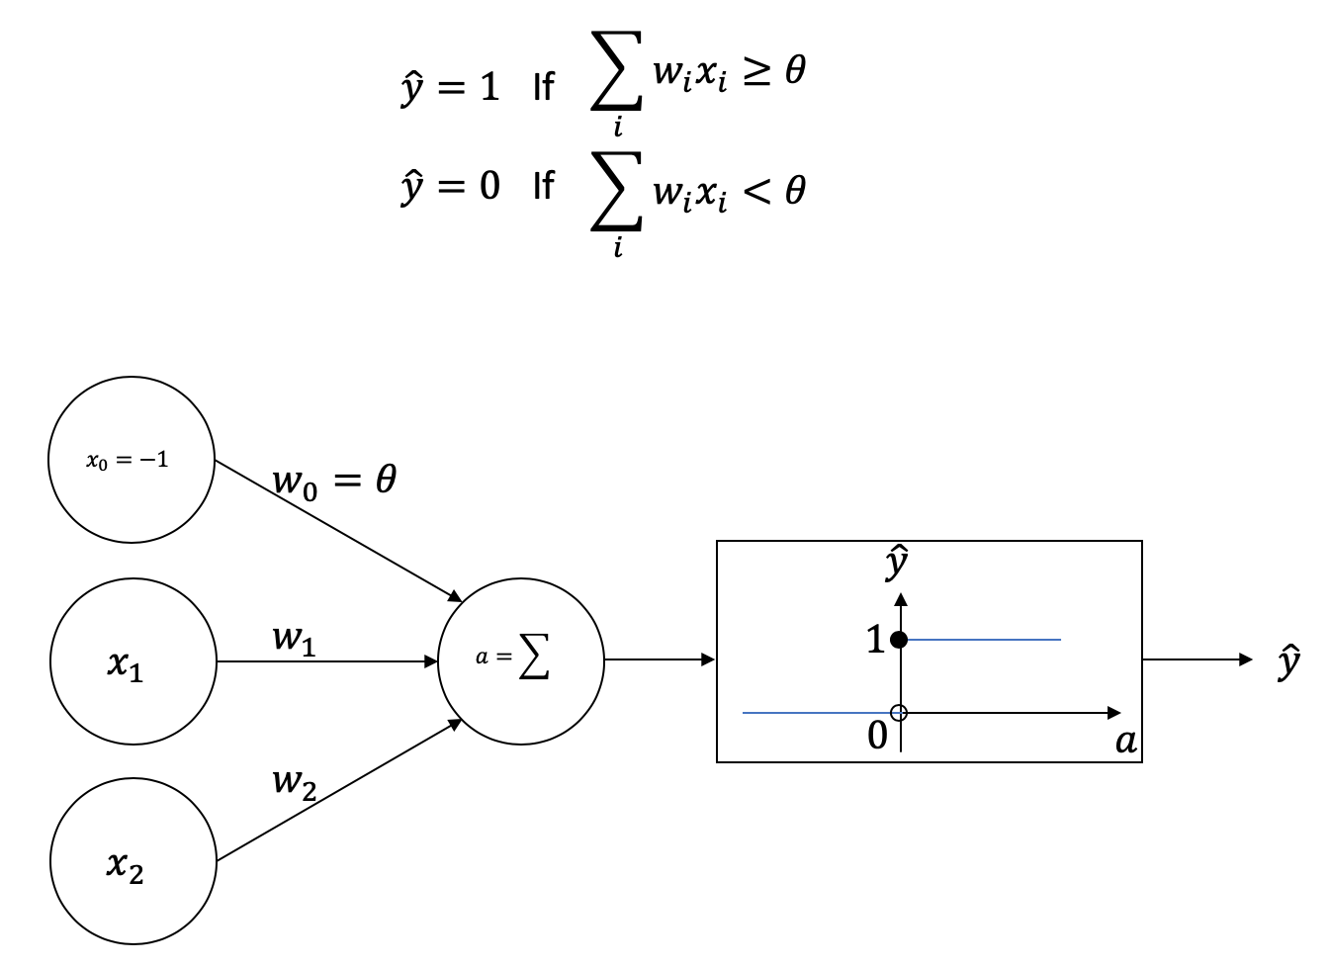

Figure 1: A Binary Classification Using A Single Layer Perceptron with A Threshold Logic Unit

The objective is finding values of $w_{1},w_{2}$ and $θ$ so that the output of the perceptron matches the true class.

**Example** (Completed version of the example on page 11 of Note Neural Networks-II)

Initial values $w_{1}=0,w_{2}=0.4$, $θ=0.3$, and $α=0.25$.

Step 1:

Inputs: $x_{1}=0,x_{2}=0$, $w_{1}=0,w_{2}=0.4$, $θ=0.3$

True class: $y=0$

${θx}_{0}+w_{1}x_{1}+{w_{2}x}_{2}=−0.3×1+0×0+0.4×0=−0.3<0$

$\hat{y}=0$

${w'}_{1}=w_{1}+α\left(y−\hat{y}\right)\left(0\right)=0$

${w'}_{2}=w_{2}+α\left(y−\hat{y}\right)\left(0\right)=0.4$

$θ^{'}=θ+α\left(y−\hat{y}\right)\left(−1\right)=0.3$

Step 2:

Inputs: $x_{1}=0,x_{2}=1$, $w_{1}=0,w_{2}=0.4$, $θ=0.3$

True class: $y=0$

${θx}_{0}+w_{1}x_{1}+{w_{2}x}_{2}=−0.3×1+0×0+0.4×1=0.1≥0$

$\hat{y}=1$

${w'}_{1}=w_{1}+α\left(y−\hat{y}\right)\left(0\right)=0$

${w'}_{2}=w_{2}+α\left(y−\hat{y}\right)\left(1\right)=0.4+0.25\left(−1\right)\left(1\right)=0.15$

$θ^{'}=θ+α\left(y−\hat{y}\right)\left(−1\right)=0.3+0.25\left(0−1\right)\left(−1\right)=0.55$

Step 3:

Inputs: $x_{1}=1,x_{2}=0$, $w_{1}=0,w_{2}=0.15$, $θ=0.55$

True class: $y=0$

${θx}_{0}+w_{1}x_{1}+{w_{2}x}_{2}=−0.55×1+0×1+0.15×0=−0.55<0$

$\hat{y}=0$

${w'}_{1}=w_{1}+α\left(y−\hat{y}\right)\left(1\right)=0$

${w'}_{2}=w_{2}+α\left(y−\hat{y}\right)\left(0\right)=0.15$

$θ^{'}=θ+α\left(y−\hat{y}\right)\left(−1\right)=0.55$

Step 4:

Inputs: $x_{1}=1,x_{2}=1$, $w_{1}=0,w_{2}=0.15$, $θ=0.55$

True class: $y=1$

${θx}_{0}+w_{1}x_{1}+{w_{2}x}_{2}=−0.55×1+0×1+0.15×1=−0.3<0$

$\hat{y}=0$

${w'}_{1}=w_{1}+α\left(y−\hat{y}\right)\left(1\right)=0+0.25\left(1−0\right)\left(1\right)=0.25$

${w'}_{2}=w_{2}+α\left(y−\hat{y}\right)\left(1\right)=0.15+0.25\left(1−0\right)\left(1\right)=0.4$

$θ^{'}=θ+α\left(y−\hat{y}\right)\left(−1\right)=0.55+0.25\left(1−0\right)\left(−1\right)=0.3$

Step 5:

Inputs: $x_{1}=0,x_{2}=0{,w}_{1}=0.25,w_{2}=0.4$, $θ=0.3$

True class: $y=0$

${θx}_{0}+w_{1}x_{1}+{w_{2}x}_{2}=−0.3×1+0.25×0+0.4×0=−0.3<0$

$\hat{y}=0$

${w'}_{1}=w_{1}+α\left(y−\hat{y}\right)\left(0\right)=0.25$

${w'}_{2}=w_{2}+α\left(y−\hat{y}\right)\left(0\right)=0.4$

$θ^{'}=θ+α\left(y−\hat{y}\right)\left(−1\right)=0.3$

Step 6:

Inputs: $x_{1}=0,x_{2}=1{,w}_{1}=0.25,w_{2}=0.4$, $θ=0.3$

True class: $y=0$

${θx}_{0}+w_{1}x_{1}+{w_{2}x}_{2}=−0.3×1+0.25×0+0.4×1=0.1≥0$

$\hat{y}=1$

${w'}_{1}=w_{1}+α\left(y−\hat{y}\right)\left(0\right)=0.25+0.25\left(0−1\right)\left(0\right)=0.25$

${w'}_{2}=w_{2}+α\left(y−\hat{y}\right)\left(1\right)=0.4+0.25\left(0−1\right)\left(1\right)=0.15$

$θ^{'}=θ+α\left(y−\hat{y}\right)\left(−1\right)=0.3+0.25\left(0−1\right)\left(−1\right)=0.55$

Step 7:

Inputs: $x_{1}=1,x_{2}=0{,w}_{1}=0.25,w_{2}=0.15$, $θ=0.55$

True class: $y=0$

${θx}_{0}+w_{1}x_{1}+{w_{2}x}_{2}=−0.55×1+0.25×1+0.15×0=−0.3<0$

$\hat{y}=0$

${w'}_{1}=w_{1}+α\left(y−\hat{y}\right)\left(1\right)=0.25$

${w'}_{2}=w_{2}+α\left(y−\hat{y}\right)\left(0\right)=0.15$

$θ^{'}=θ+α\left(y−\hat{y}\right)\left(−1\right)=0.55$

Step 8:

Inputs: $x_{1}=1,x_{2}=1{,w}_{1}=0.25,w_{2}=0.15$, $θ=0.55$

True class: $y=1$

${θx}_{0}+w_{1}x_{1}+{w_{2}x}_{2}=−0.55×1+0.25×1+0.15×1=−0.15<0$

$\hat{y}=0$

${w'}_{1}=w_{1}+α\left(y−\hat{y}\right)\left(1\right)=0.25+0.25\left(1−0\right)\left(1\right)=0.5$

${w'}_{2}=w_{2}+α\left(y−\hat{y}\right)\left(1\right)=0.15+0.25\left(1−0\right)\left(1\right)=0.4$

$θ^{'}=θ+α\left(y−\hat{y}\right)\left(−1\right)=0.55+0.25\left(1−0\right)\left(−1\right)=0.3$

Step 9:

Inputs: $x_{1}=0,x_{2}=0{,w}_{1}=0.5,w_{2}=0.4$, $θ=0.3$

True class: $y=0$

${θx}_{0}+w_{1}x_{1}+{w_{2}x}_{2}=−0.3×1+0.5×0+0.4×0=−0.3<0$

$\hat{y}=0$

${w'}_{1}=w_{1}+α\left(y−\hat{y}\right)\left(0\right)=0.5$

${w'}_{2}=w_{2}+α\left(y−\hat{y}\right)\left(0\right)=0.4$

$θ^{'}=θ+α\left(y−\hat{y}\right)\left(−1\right)=0.3$

Step 10:

Inputs: $x_{1}=0,x_{2}=1{,w}_{1}=0.5,w_{2}=0.4$, $θ=0.3$

True class: $y=0$

${θx}_{0}+w_{1}x_{1}+{w_{2}x}_{2}=−0.3×1+0.5×0+0.4×1=0.1≥0$

$\hat{y}=1$

${w^{'}}_{1}=w_{1}+α\left(y−\hat{y}\right)\left(0\right)=0.5$

${w'}_{2}=w_{2}+α\left(y−\hat{y}\right)\left(1\right)=0.4+0.25\left(0−1\right)\left(1\right)=0.15$

$θ^{'}=θ+α\left(y−\hat{y}\right)\left(−1\right)=0.55$

Step 11:

Inputs: $x_{1}=1,x_{2}=0{,w}_{1}=0.5,w_{2}=0.15$, $θ=0.55$

True class: $y=0$

${θx}_{0}+w_{1}x_{1}+{w_{2}x}_{2}=−0.55×1+0.5×1+0.15×0=−0.05<0$

$\hat{y}=0$

${w^{'}}_{1}=w_{1}+α\left(y−\hat{y}\right)\left(1\right)=0.5$

${w'}_{2}=w_{2}+α\left(y−\hat{y}\right)\left(0\right)=0.15$

$θ^{'}=θ+α\left(y−\hat{y}\right)\left(−1\right)=0.55$

Step 12:

Inputs: $x_{1}=1,x_{2}=1{,w}_{1}=0.5,w_{2}=0.15$, $θ=0.55$

True class: $y=1$

${θx}_{0}+w_{1}x_{1}+{w_{2}x}_{2}=−0.55×1+0.5×1+0.15×1=0.1>0$

$\hat{y}=1$

${w^{'}}_{1}=w_{1}+α\left(y−\hat{y}\right)\left(1\right)=0.5$

${w'}_{2}=w_{2}+α\left(y−\hat{y}\right)\left(1\right)=0.15$

$θ^{'}=θ+α\left(y−\hat{y}\right)\left(−1\right)=0.55$

Step 13:

Inputs: $x_{1}=0,x_{2}=0{,w}_{1}=0.5,w_{2}=0.15$, $θ=0.55$

True class: $y=0$

${θx}_{0}+w_{1}x_{1}+{w_{2}x}_{2}=−0.55×1+0.5×1+0.15×1=−0.55<0$

$\hat{y}=0$

${w^{'}}_{1}=w_{1}+α\left(y−\hat{y}\right)\left(0\right)=0.5$

${w'}_{2}=w_{2}+α\left(y−\hat{y}\right)\left(0\right)=0.15$

$θ^{'}=θ+α\left(y−\hat{y}\right)\left(−1\right)=0.55$

Step 14:

Inputs: $x_{1}=0,x_{2}=1{,w}_{1}=0.5,w_{2}=0.15$, $θ=0.55$

True class: $y=0$

${θx}_{0}+w_{1}x_{1}+{w_{2}x}_{2}=−0.55×1+0.5×0+0.15×1=−0.4<0$

$\hat{y}=0$

${w^{'}}_{1}=w_{1}+α\left(y−\hat{y}\right)\left(0\right)=0.5$

${w'}_{2}=w_{2}+α\left(y−\hat{y}\right)\left(1\right)=0.15$

$θ^{'}=θ+α\left(y−\hat{y}\right)\left(−1\right)=0.55$

Step 15:

Inputs: $x_{1}=1,x_{2}=0{,w}_{1}=0.5,w_{2}=0.15$, $θ=0.55$

True class: $y=0$

${θx}_{0}+w_{1}x_{1}+{w_{2}x}_{2}=−0.55×1+0.5×1+0.15×0=−0.05<0$

$\hat{y}=0$

${w^{'}}_{1}=w_{1}+α\left(y−\hat{y}\right)\left(1\right)=0.5$

${w'}_{2}=w_{2}+α\left(y−\hat{y}\right)\left(0\right)=0.15$

$θ^{'}=θ+α\left(y−\hat{y}\right)\left(−1\right)=0.55$

Step 16:

Inputs: $x_{1}=1,x_{2}=1{,w}_{1}=0.5,w_{2}=0.15$, $θ=0.55$

True class: $y=1$

${θx}_{0}+w_{1}x_{1}+{w_{2}x}_{2}=−0.55×1+0.5×1+0.15×1=−0.1≥0$

$\hat{y}=1$

${w^{'}}_{1}=w_{1}+α\left(y−\hat{y}\right)\left(1\right)=0.5$

${w'}_{2}=w_{2}+α\left(y−\hat{y}\right)\left(1\right)=0.15$

$θ^{'}=θ+α\left(y−\hat{y}\right)\left(−1\right)=0.55$

As all four cases are classified correctly, the parameters are converged!

$w_{1}=0.5,w_{2}=0.15$, $θ=0.55$