Group #4
Generative AI: IT-372-DL1
Jan 25, 2026
Hussna Azamy
Wiam Salih & Ali Channan

Step 1: Data Set

Step 2:
Prompt A (Profiling):
This dataset contains financial and demographic snapshots of 100 college students, capturing how they earn, spend, and stress about money. Each student record includes their age, major, how many hours a week they work, their monthly income and expenses, whether they maintain a budget, their savings and credit card debt balances, and a self-reported financial stress score on a 1–9 scale. The data is fully complete with no missing values and covers a wide variety of majors, though notably over half the students are spending more than they make each month.

Manual Exploration:
After manually exploring this dataset, I haven’t found any discrepancies. The dataset still contains the same information covered by the AI output. There are 100 college students capturing how they earn, spend, and stress about money. There are no null values or missing values, and the data itself contains everything covered by the chatbot and all the necessary information.

Prompt B (Cleaning plan):
This cleaning plan prioritizes structural integrity and analytical readiness. The priority handles privacy risk by handling the student ID, followed by fixing encoding issues with binary and categorical fields. Most of the work focuses on the major column, which needs consolidation to be usable, and on deriving new columns that make implicit financial stress signals like negative cash flow explicit. Validation checks across related columns (hours vs. income, savings vs. debt) guard against silent logical errors, and range checks on the stress score ensure the target variable is accurate before any modeling begins.

Prompt C (Metrics):
The strongest segmentation cuts are average financial stress by major discipline and median net cash flow by work-hour band, both of which quickly identify which student groups are most at risk. On the relationship side, the association between having a budget and actual net cash flow is more interesting than the obvious debt-stress correlation, since it tests whether budgeting changes behavior or is just a stated intention. A savings rate distribution rounds things out as a useful quality check. The one missing metric worth adding is the correlation between financial stress and savings rate students who save even modestly may report noticeably lower stress, and that could be the most actionable finding in the dataset.

Prompt D (Hypotheses):

H1: If a student works more than 20 hours per week, then their financial stress level will be lower than average, because higher income reduces the gap between earnings and expenses that drives financial anxiety.
H2: If a student has a positive net cash flow, then their savings amount will be meaningfully higher than those with negative cash flow, because students who earn more than they spend have surplus capital available to set aside rather than absorb into debt.
H3: If a student maintains a budget, then their financial stress will be lower regardless of income level, because the act of tracking spending creates a sense of control that reduces anxiety independent of actual financial outcomes.
The third hypothesis is particularly interesting in the context of building an analytical toolkit around this dataset. If budgeting reduces stress independently of income, it suggests that behavioral interventions not just financial ones could move the needle on student wellbeing. A toolkit designed to predict or segment financial stress would need to treat has_budget not just as a demographic flag but as a potential moderating variable, one that could interact with income, debt, and cash flow in meaningful ways. Testing H3 first would also help determine whether the stress prediction model needs separate branches for budgeters and non-budgeters, or whether a single model captures the relationship cleanly.

Step 3:
Prompt E (Clean it):
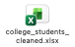

Prompt F (Summary table):
Metric | Overall | Part-Time (<15h/wk) | Mid-Time (15-25h/wk) | High-Time (>25h/wk) | Has Budget | No Budget
Sample Size (n) | 100 | 48 | 45 | 7 | 48 | 52
SEGMENTATION METRICS
Avg Financial Stress (1-9) | 5.59 | 7.65 | 4.07 | 1.29 | 3.44 | 7.58
Median Net Cash Flow ($) | $-30 | $-50 | $170 | $540 | $175 | $-50
% Over Budget | 53% | 97.9% | 13.3% | 0% | 4.2% | 98.1%
SAVINGS & INCOME METRICS
Avg Savings Rate (%) | 37.9% | 6.3% | 54.8% | 145.1% | 71.4% | 6.9%
Avg Credit Card Debt ($) | $201 | $347 | $75 | $0 | $31 | $357
Avg Monthly Income ($) | $917 | $658 | $1,075 | $1,678 | $1,182 | $673
RELATIONSHIP METRICS (Pearson r)
Corr: Stress vs Savings Rate | -0.911 | -0.880 | -0.877 | -0.429 | -0.917 | -0.877
Corr: Stress vs Credit Card Debt | 0.816 | -0.091 | 0.788 | N/A | 0.753 | -0.150
QUALITY / BEHAVIOR METRIC
% With Budget | 48% | 0% | 91.1% | 100% | 100% | 0%

Prompt G (Insights):
<paste the 3 insights, your selected visualization chart (paste as a screenshot), and your paragraph here.>
Insight 1: Work Hours Are the Strongest Predictor of Financial Stress
Insight 2: Budgeting Behaviour Divides the Dataset Almost Perfectly in Two
Insight 3: Savings Rate Has a Near-Perfect Negative Correlation with Stress (r = −0.911)
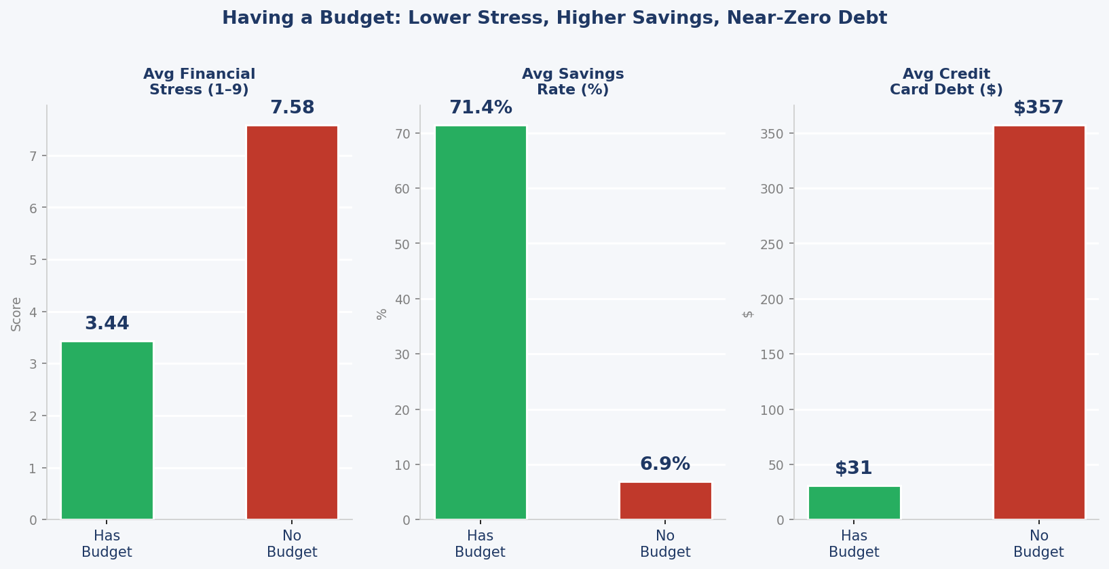

Insight 2 is the best visualization because it’s a proof of concept in the entire dataset. Students who maintain a budget report a stress score of just 3.44 compared to 7.58 for those who don't, while also saving at a rate of 71.4% versus 6.9% and carrying $31 in credit card debt versus $357. The numbers don't just correlate; they tell a complete story which is that good financial habits create a measurable buffer between students and financial anxiety. This makes Insight 2 the natural anchor for our work focused on financial wellness, because it shows that the solution isn't necessarily earning more it's behaving differently with what you already have. Which is why our toolkit will act as a compass for students navigating financial security.

Prompt H (Actions):
Action 1 — Start a monthly budget before the semester begins
Action 2 — Set a minimum savings target of 20% of monthly income
Action 3 — Increase working hours to at least 15 per week if circumstances allow

Action 1 fits the financial literacy toolkit concept best because it is the most teachable, scalable, and immediately actionable of the three. Increasing work hours depends on employer’s availability, academic schedules, and personal capacity factors a toolkit cannot control. Raising a savings rate is a worthy goal but requires income headroom that many part-time students simply don't have yet. Budgeting, by contrast, costs nothing, requires no external conditions to be met, and is a skill that can be taught, practiced, and improved regardless of how much a student earns.
Step 4: Memo

1. PURPOSE
This memo summarizes what a 100-student financial dataset reveals about the relationship between everyday money habits and financial stress. The goal is to give part-time student workers clear, evidence-based guidance on the behaviors that most reliably reduce financial anxiety without requiring a higher income or a finance degree.

2. DATASET & SAMPLE
The dataset contains 100 college students across roughly 100 majors, aged 19–24. Each record captures monthly income, monthly expenses, weekly work hours, savings amount, credit card debt, budget status, and a self-reported financial stress score on a 1–9 scale. The sample skews toward part-time workers: 48 students work fewer than 15 hours per week, 45 work 15–25 hours, and just 7 work more than 25 hours. Forty-eight students maintain a budget; 52 do not.

3. METHOD
The dataset was cleaned and enriched with derived variables including net cash flow (income minus expenses), a binary over-budget flag, and a savings rate (savings divided by income). Metrics were then calculated for the full sample and five key segments: three work-hour bands and two budget-status groups. Pearson correlations were computed between financial stress and both savings rate and credit card debt.

4. KEY FINDINGS
- Budgeting is the single strongest behavioral divide. Students who maintain a budget report an average stress score of 3.44 versus 7.58 for those who do not more than double. Budgeters also save at 71.4% versus 6.9% and carry just $31 in credit card debt compared to $357 for non-budgeters.
- Savings rate predicts stress with near-perfect linearity. The Pearson correlation between savings rate and financial stress is r = −0.911. Students saving above 20–30% of their income consistently score below 5 on the stress scale, suggesting even modest savings habits create a meaningful psychological buffer.
- Working hours matter but there is a clear threshold. Part-time students (<15h/wk) average a stress score of 7.65 and a 97.9% over-budget rate. Moving into the 15–25 hour band drops stress to 4.07 and the over-budget rate to 13.3% a shift that correlates directly with having income that covers basic expenses.

5. RECOMMENDED ACTIONS
- Build a budget before the semester starts. Map fixed costs against your expected take-home pay and set a hard limit on discretionary spending. Success metric: achieve a positive net cash flow within 60 days.
- Target a savings rate of at least 20%. Even on $658/month the average part-time income in this dataset that means setting aside roughly $130 before non-essential spending. Success metric: maintain 20%+ for three consecutive months.
- Aim for at least 15 work hours per week where possible. The data shows this is the threshold where over-budget rates drop from 97.9% to 13.3%. Success metric: track net cash flow monthly and target a positive balance within the first full month.

6. LIMITATIONS & DATA RISKS
The dataset is small (n=100) and likely synthetic, which limits the generalizability of any findings. The high-time worker group contains only 7 students, so those figures should be interpreted with caution. Causality cannot be established: students who budget may simply have more stable financial circumstances to begin with. Financial stress is self-reported and therefore subjective. Privacy risk is low given the cleaned dataset removes all student identifiers, but the combination of major, age, and financial data remains a sensitive profile.

7. NEXT STEPS
The clearest next step is to test whether a structured budgeting intervention delivered as a short digital toolkit moves stress scores over a single semester. A follow-up survey of the same students at the start and end of semester would allow a simple before-and-after comparison. Expanding the dataset to 500+ students across multiple institutions would also strengthen the statistical case for the budgeting effect and allow discipline-level segmentation that the current sample size does not support.

Step 5:

Category | Julius AI | AI Tool from Step 2
Pros (2) | • Explained exactly how to compute each metric  • Offered to immediately run computations, generate visualizations, and export a report | • Already had session context from earlier steps, so metrics built on previously validated findings  • Metrics were more interpretive and actionable
Cons (2) | • More technical and formula-heavy  • Felt more like a data science tool than a student-friendly assistant | • Did not explain computation methods  • Fewer metrics proposed
Unique features the other tool does NOT have (2) | • Offered a Lorenz curve / Gini index for income inequality  • Offered built-in export to CSV or PDF report directly from the analysis | • Tied metrics back to the specific niche  • Flagged a "bonus metric" gap on its own

Step 6:
GitHub Repository Links:
Wiam's GitHub: https://github.com/wiamsalih/Spring2026_Group4_AI_Projects
Ali's GitHub: https://github.com/alichannan76/Spring2026_Group4_AI_Projects

