|  |
| --- |
| CMIS 141 / 4025 |
| Assignment 2 |
| Conditions |

|  |
| --- |
| Holt, William  9-6-2022 |

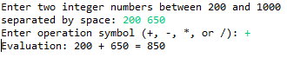Test Case 1.

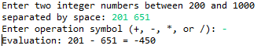Test Case 2.

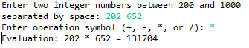Test Case 3.

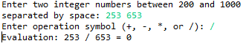Test Case 4.

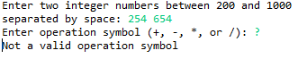Test Case 5.

Test Cases:

|  |  |  |  |
| --- | --- | --- | --- |
| **Input** | **Expected Output** | **Actual Output** | **Pass/Fail** |
| Number 1 = 200  Number 2 = 650  Operation = + | Enter two integer numbers between 200 and 1000 separated by space: 200 650  Enter operation symbol (+, -, *, or /): +  Evaluation: 200 + 651 = 850 | Enter two integer numbers between 200 and 1000 separated by space: 200 650  Enter operation symbol (+, -, *, or /): +  Evaluation: 200 + 651 = 850 | **PASS** |
| Number 1 = 201  Number 2 = 651  Operation = - | Enter two integer numbers between 200 and 1000 separated by space: 201 651  Enter operation symbol (+, -, *, or /): -  Evaluation: 201 - 651 = -450 | Enter two integer numbers between 200 and 1000 separated by space: 201 651  Enter operation symbol (+, -, *, or /): -  Evaluation: 201 - 651 = -450 | **PASS** |
| Number 1 = 202  Number 2 = 652  Operation = * | Enter two integer numbers between 200 and 1000 separated by space: 202 652  Enter operation symbol (+, -, *, or /): *  Evaluation: 202 * 652 = 131704 | Enter two integer numbers between 200 and 1000 separated by space: 202 652  Enter operation symbol (+, -, *, or /): *  Evaluation: 202 * 652 = 131704 | **PASS** |
| Number 1 = 253  Number 2 = 653  Operation = / | Enter two integer numbers between 200 and 1000 separated by space: 253 653  Enter operation symbol (+, -, *, or /): /  Evaluation: 253 / 653 = 0 | Enter two integer numbers between 200 and 1000 separated by space: 253 653  Enter operation symbol (+, -, *, or /): /  Evaluation: 253 / 653 = 0 | **PASS** |
| Number 1 = 254  Number 2 = 654  Operation = ? | Enter two integer numbers between 200 and 1000 separated by space: 254 654  Enter operation symbol (+, -, *, or /): ?  Not a valid operation symbol | Enter two integer numbers between 200 and 1000 separated by space: 254 654  Enter operation symbol (+, -, *, or /): ?  Not a valid operation symbol | **PASS** |