|  |
| --- |
| CMIS 141 / 4025 |
| Assignment 2 |
| Conditions |

|  |
| --- |
| Holt, William  9-6-2022 |

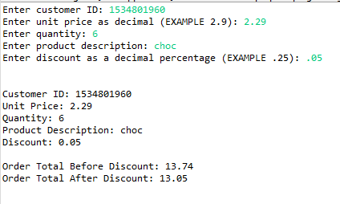Test Case 1.

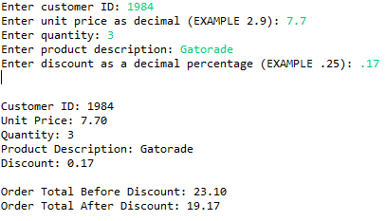Test Case 2.

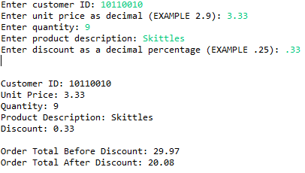Test Case 3.

Test Cases:

|  |  |  |  |  |
| --- | --- | --- | --- | --- |
| **Case #** | **Input** | **Expected Output** | **Actual Output** | **Pass/Fail** |
| **1** | custid: 1534801960  price: 2.29  quantity: 6  description: choc  discount: .05 | Customer ID: 1534801960  Unit Price: 2.29  Quantity: 6  Product Description: choc  Discount: 0.05  Order Total Before Discount: 13.74  Order Total After Discount: 13.05 | Customer ID: 1534801960  Unit Price: 2.29  Quantity: 6  Product Description: choc  Discount: 0.05  Order Total Before Discount: 13.74  Order Total After Discount: 13.05 | **PASS** |
| **2** | custid: 1984  price: 7.7  quantity: 3  description: Gatorade  discount: .17 | Customer ID: 1984  Unit Price: 7.7  Quantity: 3  Product Description: Gatorade  Discount: 0.17  Order Total Before Discount: 23.10  Order Total After Discount: 19.17 | Customer ID: 1984  Unit Price: 7.7  Quantity: 3  Product Description: Gatorade  Discount: 0.17  Order Total Before Discount: 23.10  Order Total After Discount: 19.17 | **PASS** |
| **3** | custid: 10110010  price: 3.33  quantity: 9  description: Skittles  discount: .33 | Customer ID: 10110010  Unit Price: 3.33  Quantity: 9  Product Description: Skittles  Discount: 0.33  Order Total Before Discount: 29.97  Order Total After Discount: 20.08 | Customer ID: 10110010  Unit Price: 3.33  Quantity: 9  Product Description: Skittles  Discount: 0.33  Order Total Before Discount: 29.97  Order Total After Discount: 20.08 | **PASS** |