|  |
| --- |
| CMIS 141 / 4025 |
| Assignment 3 |
| Loops |

|  |
| --- |
| Holt, William  9-13-2022 |

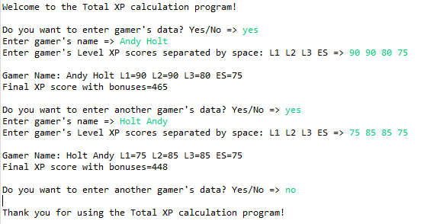Test Case 1.

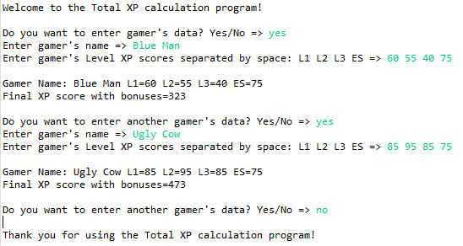Test Case 2.

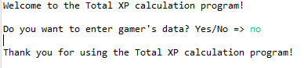Test Case 3.

Test Cases:

|  |  |  |  |
| --- | --- | --- | --- |
| **Input** | **Expected Output** | **Actual Output** | **Pass/Fail** |
| yes  Andy Holt  90 90 80 75  Holt Andy  75 85 85 75 | Gamer Name: Andy Holt L1=90 L2=90 L3=80 ES=75  Final XP score with bonuses=465  Gamer Name: Holt Andy L1=75 L2=85 L3=85 ES=75  Final XP score with bonuses=448 | Gamer Name: Andy Holt L1=90 L2=90 L3=80 ES=75  Final XP score with bonuses=465  Gamer Name: Holt Andy L1=75 L2=85 L3=85 ES=75  Final XP score with bonuses=448 | **Pass** |
| yes  Blue Man  60 55 40 75  Ugly Cow  85 95 85 75 | Gamer Name: Blue Man L1=60 L2=55 L3=40 ES=75  Final XP score with bonuses=323  Gamer Name: Ugly Cow L1=85 L2=95 L3=85 ES=75  Final XP score with bonuses=473 | Gamer Name: Blue Man L1=60 L2=55 L3=40 ES=75  Final XP score with bonuses=323  Gamer Name: Ugly Cow L1=85 L2=95 L3=85 ES=75  Final XP score with bonuses=473 | **Pass** |
| no | Thank you for using the XP calculation program! | Thank you for using the XP calculation program! | **Pass** |