**Description**

|  |  |  |
| --- | --- | --- |
| *Luminaire Type* | : | **Recessed Adjustable Downlight** |
| *Luminaire Reference* | : | **Reggiani – Mood Pro Adjustable Round (X.GP12H.HW31) or Equal** |
| *Lamp* | : | **LED 8.5/725lm/32°/2700K/ IP20/CRI>90** |
| *Lamp Reference* | : | **LED by Manufacture** |
| *Gears* | : | **LED Power Supply**  **Remote Electronic Transformer**  **Dimmable DALI (or with Helvar Driver Dimmable to 0,1%)** |
| *Accessories* | : | Honeycomb (REQ)  **DL-AC** |

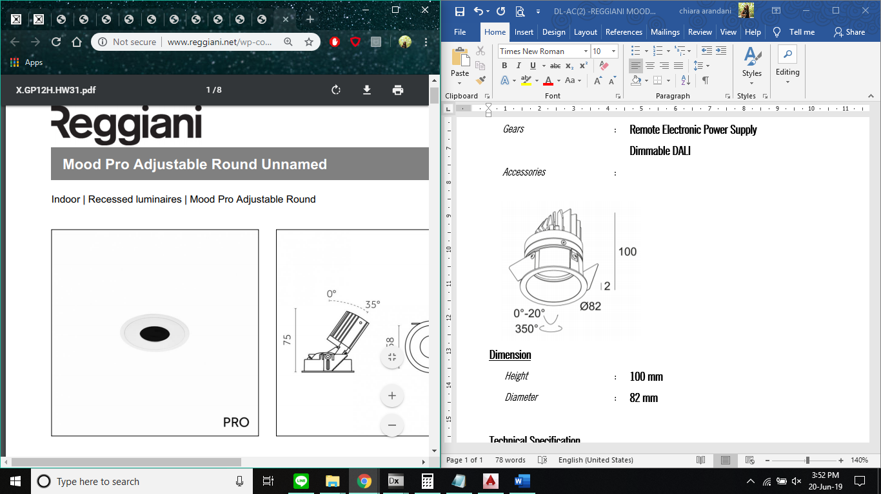 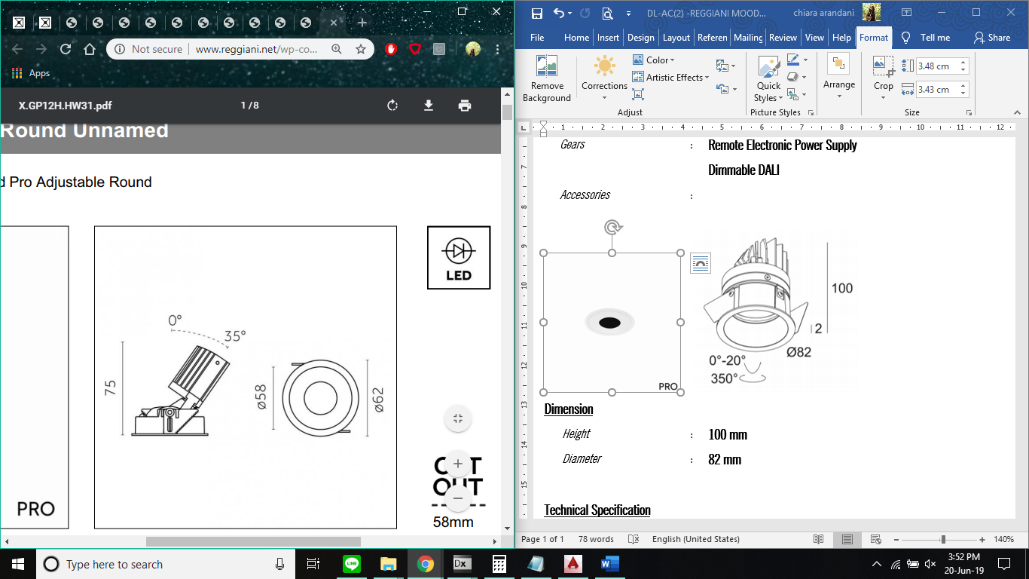\

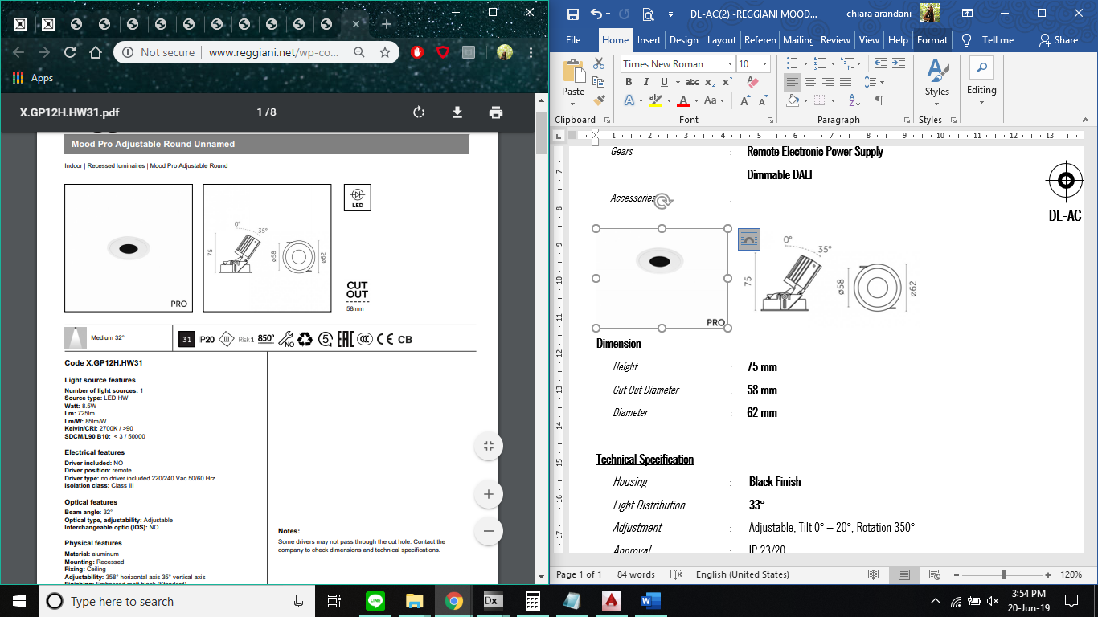

**Dimension**

|  |  |  |
| --- | --- | --- |
| *Height* | : | **75 mm** |
| *Cut Out Diameter* | : | **58 mm** |
| *Diameter* | : | **58 mm (62 mm)** |

**Technical Specification**

|  |  |  |
| --- | --- | --- |
| *Housing* | : | **Black Finish (TBC with ID or match to ceiling finish)** |
| *Light Distribution* | : | **32°** |
| *Adjustment* | : | Adjustable, Tilt 0° – 35°, Rotation 358° |
| *Approval* | : | IP 20 |
| *Transformer* | : | Remote Electronic Transformer  Dimmable DALI by Manufacture (or with Helvar Driver Dimmable to 0,1%) |

**Installation Manual**

Same as DL-B.CR.2