**Description**

|  |  |  |
| --- | --- | --- |
| *Luminaire Type* | : | **LED Line Linear wall washer Recessed (minimal frame/trimless )** |
| *Luminaire Reference* | : | **IGUZZINI LASER BLADE XS wall washer Q606-47 or equal** |
| *Lamp* | : | **LED WARMWHITE/3000K/10Watt/780lm/wallwasher/CRI 90/DALI**  **LL-W1** |
| *Lamp Reference* | : | **By manufacture** |
| *Gears* | : | **DIMMABLE DALI LED control gear (by manufacture)** |
| *accessories* | : | **-** |

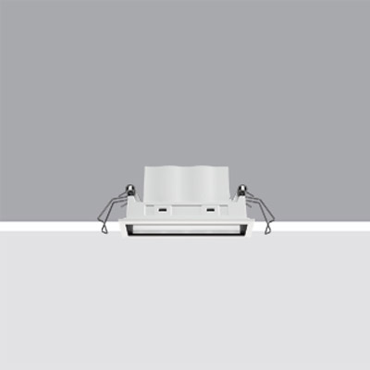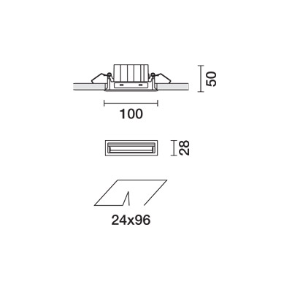



**Dimension**

|  |  |  |
| --- | --- | --- |
| *Width* | : | **28mm** |
| *Length* | : | **100 mm** |
| *Opening* | : | **24x60mm** |
| *Recessed depth* | : | **50 mm** |
| *Weight* | : | **0.25Kg** |
|  |  |  |

**Technical Specification**

|  |  |  |
| --- | --- | --- |
| *Housing* | : | Die cast aluminium finih, black  **Integrated black anti glare** |
| *Lamp Holder* | : | **By manufacture** |
| *Trim/frame* | : | **Trimless** |
| *Light Distribution* | : | Wall washer distribution |
| *Approval* | : | **IP 20** |
| *Transformer* | : | **DIMMABLE DALI LED Control gear (By manufacture )**  **location should be coordinated on site** |

**Photometric data of**

