**Description**

|  |  |  |
| --- | --- | --- |
| *Luminaire Type* | : | **Recessed Adjustable Downlight** |
| *Luminaire Reference* | : | **DELTA – DIRO ST OK LED 92733 (202 292 811 922 B) or Equal** |
| *Lamp* | : | **LED 7.1-10.4W/350-500mA-DC/743-1032lm(685lm)/33°/2700K/IP23/IP20/CRI>90** |
| *Lamp Reference* | : | **LED by Manufacture** |
| *Gears* | : | **LED Power Supply**  **Remote Electronic Transformer**  **Dimmable DALI Suggested by Manufacture (or Dimmable to 0,1%)** |
| *Accessories* | : |  |

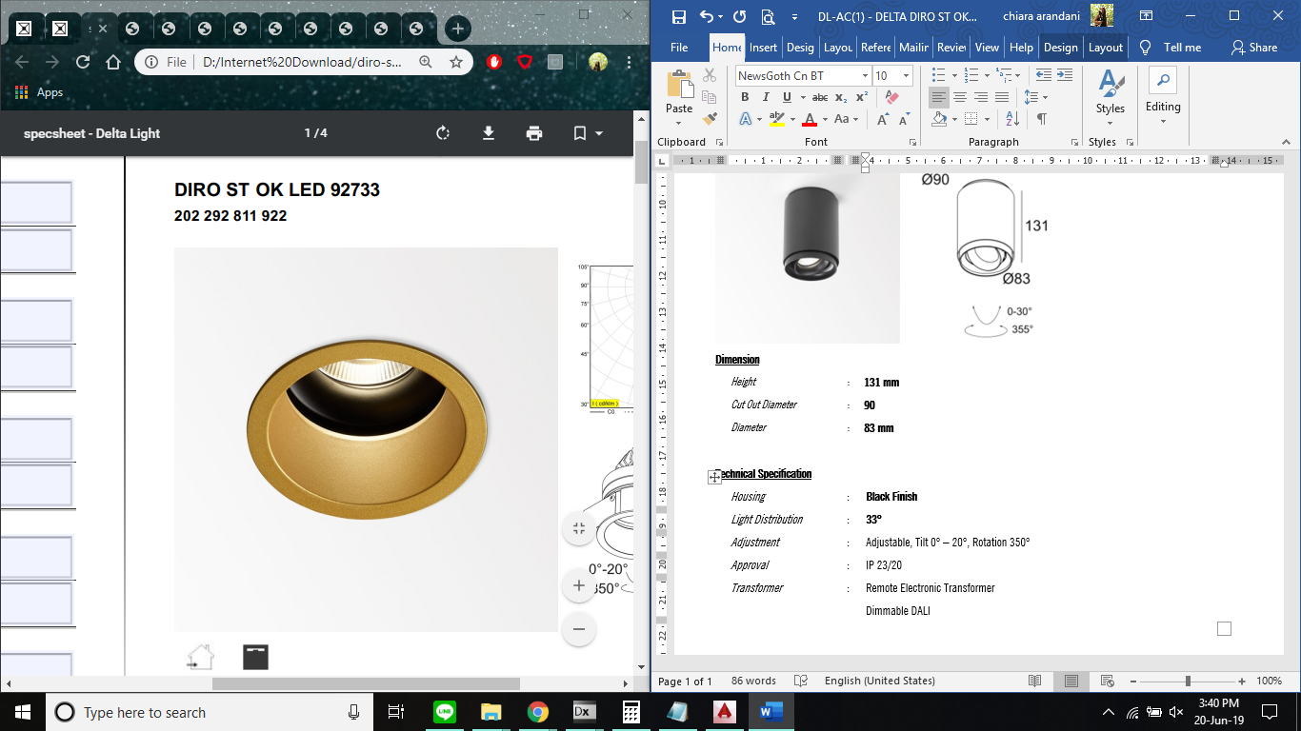 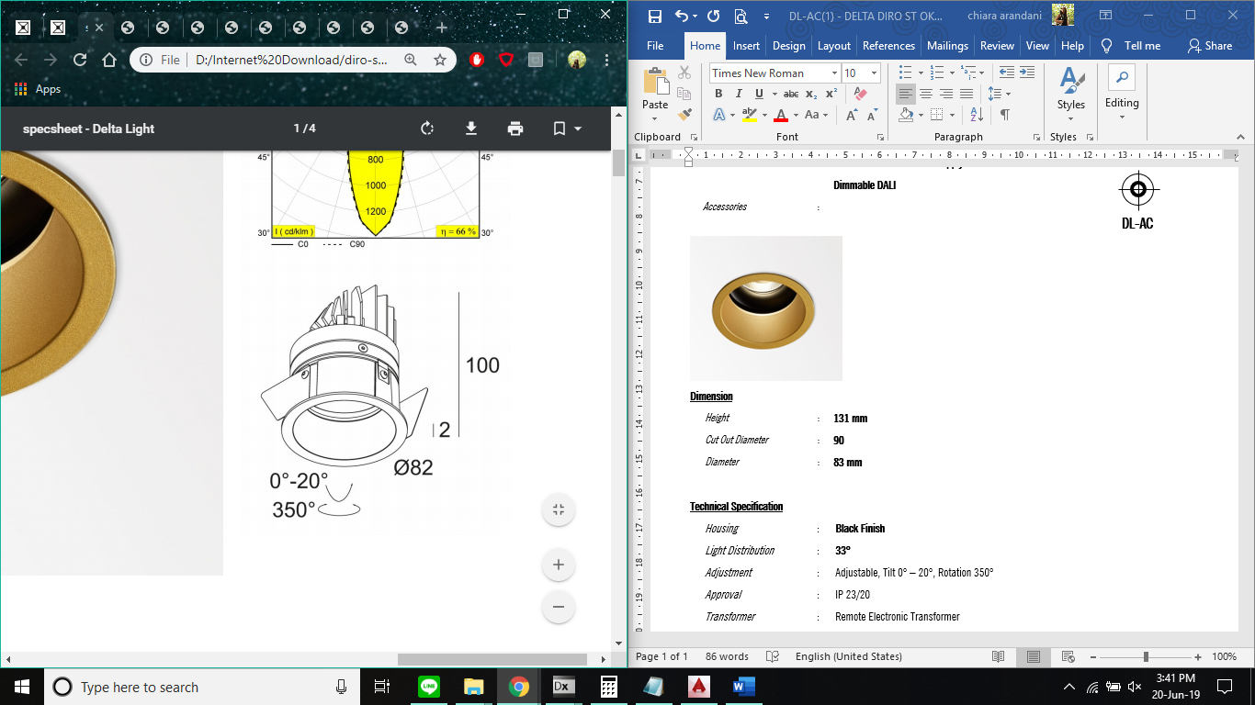

**DL-AC**

**Dimension**

|  |  |  |
| --- | --- | --- |
| *Height* | : | **100 mm** |
| *Cut Out Diameter* | : | **76 mm** |
| *Diameter* | : | **82 mm** |

**Technical Specification**

|  |  |  |
| --- | --- | --- |
| *Housing* | : | **Black Finish** |
| *Light Distribution* | : | **33°** |
| *Adjustment* | : | Adjustable, Tilt 0° – 20°, Rotation 350° |
| *Approval* | : | IP 23/20 |
| *Transformer* | : | Remote Electronic Transformer  Dimmable DALI Suggested by Manufacture (or Dimmable to 0,1%) |

**Photometric**

