**Description**

|  |  |  |
| --- | --- | --- |
| *Luminaire Type* | : | **Linear Downlight on Surface Mounted Profile** |
| *Luminaire Reference* | : | **DELTA – M-DOT.COM M4 92732 DIM5 (23355 9225 B-B) or Equal** |
| *Lamp* | : | **4xLED 1.4W/48V-DC/153lm(112lm)/32°/2700K/IP20/CRI>90** |
| *Lamp Reference* | : | **LED by Manufacture** |
| *Gears* | : | **LED Power Supply**  **Remote Electronic Transformer**  **Dimmable DALI Suggested by Manufacture (or Dimmable to 0,1%)** |
| *Accessories* | : | **DL-32** |

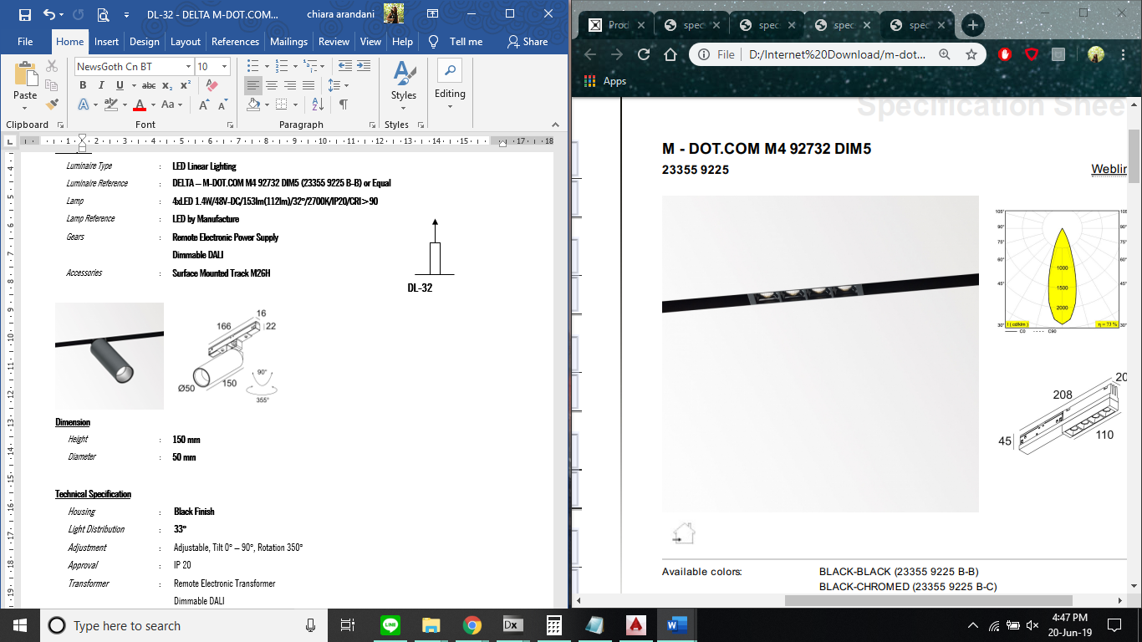 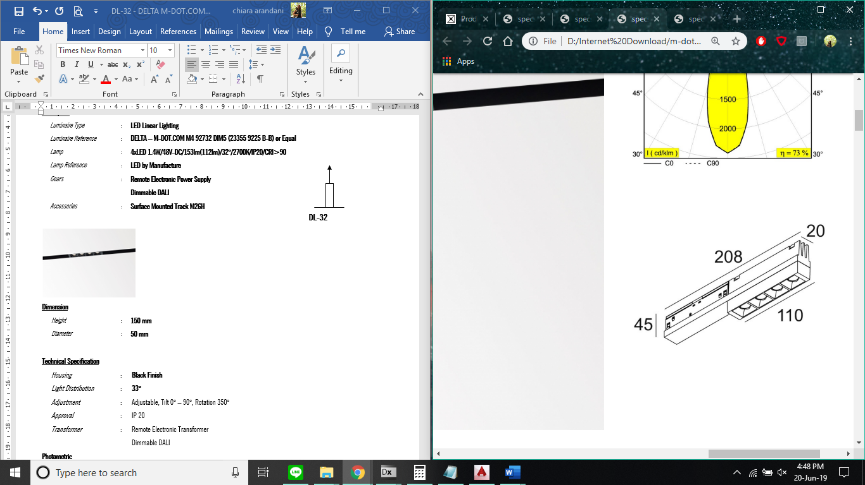

**Dimension**

|  |  |  |
| --- | --- | --- |
| *Height* | : | **45 mm** |
| *Width* | : | **20 mm** |
| *Length* | : | **110 mm (208 mm)** |

**Technical Specification**

|  |  |  |
| --- | --- | --- |
| *Housing* | : | **Black-Black Finish** |
| *Light Distribution* | : | **32°** |
| *Adjustment* | : | Non-Adjustable |
| *Approval* | : | IP 20 |
| *Transformer* | : | Remote Electronic Transformer  Dimmable DALI Suggested by Manufacture (or Dimmable to 0,1%) |

**Photometric**

