|  |  |
| --- | --- |
| **Politechnika Świętokrzyska w Kielcach**  **Wydział Elektrotechniki, Automatyki i Informatyki** | |
| **Technologieobiektowe - projekt** | |
| Etap 4 | |
| **Mateusz Bonar**  **Wiktor Wójcik**  **Damian Kozakowski**  **1ID21A** |  |

**Podczas tego Etapu zostało wykonano:**

Część React zostało wykonane skończone oczyty czasów wykorzystujące podczas testowania w Selenium, czyli czasy początku oraz koniec renderowania na widoku ( Mateusz Bonar)

Część Angular zostało wykonane skończone oczyty czasów wykorzystujące podczas testowania w Selenium, czyli czasy początku oraz koniec renderowania na widoku ( Wiktor Wójcik )

Rozwiniecie części projektu testującego Selenium (Damian Kozakowski)

Przygotowanie raportu (Mateusz Bonar / Wiktor Wójcik / Damian Kozakowski)

**Statystyki projektu**

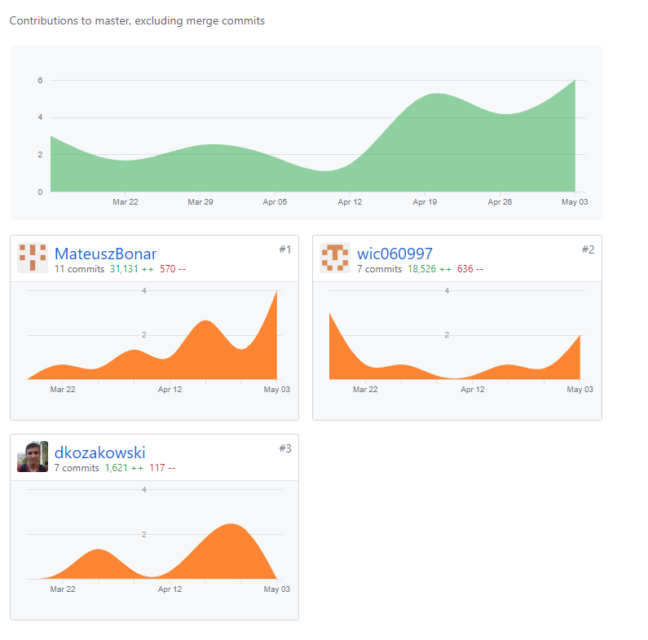

|  |  |  |  |
| --- | --- | --- | --- |
| **Nazwa Pliku** | **06.04.2020 19:44** | **20.04.2020 23:22** | **04.05.2020 23:24** |
| BackendJava\.mvn\wrapper\MavenWrapperDownloader.java | 118 | 118 | 118 |
| BackendJava\.mvn\wrapper\maven-wrapper.jar | 330 | 330 | 330 |
| BackendJava\.mvn\wrapper\maven-wrapper.properties | 2 | 2 | 2 |
| BackendJava\BackendJava.iml |  | 134 | 134 |
| BackendJava\HELP.md |  | 22 | 22 |
| BackendJava\mvnw | 322 | 322 | 322 |
| BackendJava\mvnw.cmd | 182 | 182 | 182 |
| BackendJava\pom.xml | 69 | 69 | 69 |
| BackendJava\src\main\java\pl\technologieobiektowe\backendjava\BackendJavaApplication.java | 14 | 14 | 14 |
| BackendJava\src\main\java\pl\technologieobiektowe\backendjava\TestData.java | 59 | 59 | 59 |
| BackendJava\src\main\java\pl\technologieobiektowe\backendjava\TestsController.java | 42 | 42 | 42 |
| BackendJava\src\main\java\pl\technologieobiektowe\backendjava\WebSecurityConfig.java | 16 | 16 | 16 |
| BackendJava\src\main\resources\application.properties | 1 | 1 | 1 |
| BackendJava\src\test\java\pl\technologieobiektowe\backendjava\BackendJavaApplicationTests.java |  | 13 | 13 |
| BackendJava\target\classes\application.properties |  | 1 | 1 |
| Etap_1\dane.txt | 33 | 33 | 33 |
| Etap_2\Raport.docx |  | 550 | 550 |
| Etap_2\statisticsfiletools_1.0.0.jar |  | 62 | 62 |
| Etap_3\Raport.docx |  |  | 392 |
| Etap_3\~$Raport.docx |  |  | 1 |
| FrontAngular\.editorconfig | 16 | 16 | 16 |
| FrontAngular\README.md | 27 | 27 | 27 |
| FrontAngular\angular.json | 132 | 132 | 132 |
| FrontAngular\browserslist | 12 | 12 | 12 |
| FrontAngular\e2e\protractor.conf.js | 32 | 32 | 32 |
| FrontAngular\e2e\src\app.e2e-spec.ts | 23 | 23 | 23 |
| FrontAngular\e2e\src\app.po.ts | 11 | 11 | 11 |
| FrontAngular\e2e\tsconfig.json | 13 | 13 | 13 |
| FrontAngular\karma.conf.js | 32 | 32 | 32 |
| FrontAngular\package-lock.json | 13560 | 13560 | 13560 |
| FrontAngular\package.json | 47 | 47 | 47 |
| FrontAngular\src\app\app-routing.module.ts | 11 | 16 | 16 |
| FrontAngular\src\app\app.component.html | 534 | 1 | 1 |
| FrontAngular\src\app\app.component.scss | 0 | 0 | 0 |
| FrontAngular\src\app\app.component.spec.ts | 35 |  |  |
| FrontAngular\src\app\app.component.ts | 10 | 14 | 14 |
| FrontAngular\src\app\app.module.ts | 18 | 33 | 33 |
| FrontAngular\src\app\home-page\home-page.component.html |  | 7 | 7 |
| FrontAngular\src\app\home-page\home-page.component.scss |  | 0 | 43 |
| FrontAngular\src\app\home-page\home-page.component.ts |  | 27 | 27 |
| FrontAngular\src\app\shared\models\data.model.ts |  | 8 | 8 |
| FrontAngular\src\app\shared\models\textS.model.ts |  | 3 | 3 |
| FrontAngular\src\app\table\choose-table\choose-table.component.html |  |  | 9 |
| FrontAngular\src\app\table\choose-table\choose-table.component.scss |  |  | 0 |
| FrontAngular\src\app\table\choose-table\choose-table.component.ts |  |  | 18 |
| FrontAngular\src\app\table\dynamic-table\dynamic-table.component.html |  | 1 | 25 |
| FrontAngular\src\app\table\dynamic-table\dynamic-table.component.scss |  | 0 | 0 |
| FrontAngular\src\app\table\dynamic-table\dynamic-table.component.ts |  | 22 | 27 |
| FrontAngular\src\app\table\static-table\static-table.component.html |  | 53 | 53 |
| FrontAngular\src\app\table\static-table\static-table.component.scss |  | 0 | 0 |
| FrontAngular\src\app\table\static-table\static-table.component.ts |  | 15 | 15 |
| FrontAngular\src\app\table\table.component.html |  | 13 | 11 |
| FrontAngular\src\app\table\table.component.scss |  | 0 | 44 |
| FrontAngular\src\app\table\table.component.ts |  | 20 | 20 |
| FrontAngular\src\app\table\table.module.ts |  | 13 | 14 |
| FrontAngular\src\app\table\table.routing.ts |  | 20 | 22 |
| FrontAngular\src\app\text\dynamic-text\dynamic-text.component.html |  | 1 | 1 |
| FrontAngular\src\app\text\dynamic-text\dynamic-text.component.scss |  | 0 | 0 |
| FrontAngular\src\app\text\dynamic-text\dynamic-text.component.ts |  | 16 | 16 |
| FrontAngular\src\app\text\static-text\static-text.component.html |  | 8 | 8 |
| FrontAngular\src\app\text\static-text\static-text.component.scss |  | 6 | 6 |
| FrontAngular\src\app\text\static-text\static-text.component.ts |  | 27 | 31 |
| FrontAngular\src\app\text\text.component.html |  | 13 | 13 |
| FrontAngular\src\app\text\text.component.scss |  | 0 | 0 |
| FrontAngular\src\app\text\text.component.ts |  | 19 | 19 |
| FrontAngular\src\app\text\text.module.ts |  | 18 | 18 |
| FrontAngular\src\app\text\text.routing.ts |  | 20 | 20 |
| FrontAngular\src\assets\jsonDataTable.json |  | 2998 | 2998 |
| FrontAngular\src\assets\text.json |  | 1 | 1 |
| FrontAngular\src\environments\environment.prod.ts | 3 | 3 | 3 |
| FrontAngular\src\environments\environment.ts | 16 | 16 | 16 |
| FrontAngular\src\favicon.ico | 11 | 11 | 11 |
| FrontAngular\src\index.html | 13 | 13 | 13 |
| FrontAngular\src\main.ts | 12 | 12 | 12 |
| FrontAngular\src\polyfills.ts | 63 | 63 | 63 |
| FrontAngular\src\styles.scss | 1 | 1 | 1 |
| FrontAngular\src\test.ts | 25 | 25 | 25 |
| FrontAngular\tsconfig.app.json | 14 | 14 | 14 |
| FrontAngular\tsconfig.json | 23 | 23 | 23 |
| FrontAngular\tsconfig.spec.json | 18 | 18 | 18 |
| FrontAngular\tslint.json | 148 | 148 | 148 |
| FrontReact\front\README.md | 68 | 68 | 68 |
| FrontReact\front\package-lock.json | 15137 | 15328 | 15277 |
| FrontReact\front\package.json | 34 | 38 | 35 |
| FrontReact\front\public\favicon.ico | 33 |  |  |
| FrontReact\front\public\index.html | 43 | 25 | 25 |
| FrontReact\front\public\logo192.png | 40 |  |  |
| FrontReact\front\public\logo512.png | 84 |  |  |
| FrontReact\front\public\lorem.txt |  | 11739 | 11739 |
| FrontReact\front\public\manifest.json | 25 | 25 | 25 |
| FrontReact\front\public\robots.txt | 3 | 3 | 3 |
| FrontReact\front\src\App.css | 38 | 50 | 51 |
| FrontReact\front\src\App.js | 26 | 42 | 42 |
| FrontReact\front\src\App.test.js | 9 | 9 | 9 |
| FrontReact\front\src\Components\DynamicTable.jsx |  | 44 | 35 |
| FrontReact\front\src\Components\HomePage.jsx |  | 43 | 43 |
| FrontReact\front\src\Components\Rest.jsx |  | 62 | 60 |
| FrontReact\front\src\Components\StaticTable.jsx |  | 31 | 47 |
| FrontReact\front\src\Components\Table.jsx |  | 41 | 41 |
| FrontReact\front\src\Components\Text.jsx |  | 38 | 28 |
| FrontReact\front\src\Components\data\jsonDataTable.json |  | 2998 | 2998 |
| FrontReact\front\src\Components\data\text.json |  |  | 1 |
| FrontReact\front\src\index.css | 13 | 16 | 16 |
| FrontReact\front\src\index.js | 17 | 12 | 12 |
| FrontReact\front\src\logo.svg | 7 |  |  |
| FrontReact\front\src\paths.js |  | 11 | 11 |
| FrontReact\front\src\serviceWorker.js | 141 |  |  |
| FrontReact\front\src\setupTests.js | 5 | 1 | 1 |
| SeleniumTestingAutomat\pom.xml |  |  | 45 |
| SeleniumTestingAutomat\src\main\java\pl\kozakowski\seleniumtestingautomat\Configuration.java |  |  | 49 |
| SeleniumTestingAutomat\src\main\java\pl\kozakowski\seleniumtestingautomat\Main.java |  |  | 26 |
| SeleniumTestingAutomat\src\main\java\pl\kozakowski\seleniumtestingautomat\PageFactory.java |  |  | 13 |
| SeleniumTestingAutomat\src\main\java\pl\kozakowski\seleniumtestingautomat\ReportGenerator.java |  |  | 13 |
| SeleniumTestingAutomat\src\main\java\pl\kozakowski\seleniumtestingautomat\TechnologyClassExtractor.java |  |  | 35 |
| SeleniumTestingAutomat\src\main\java\pl\kozakowski\seleniumtestingautomat\TestsExecutor.java |  |  | 76 |
| SeleniumTestingAutomat\src\main\java\pl\kozakowski\seleniumtestingautomat\pageFactory\Angular.java |  |  | 15 |
| SeleniumTestingAutomat\src\main\java\pl\kozakowski\seleniumtestingautomat\pageFactory\React.java |  |  | 72 |
| StatisticsFileTools_1.0.jar | 62 |  |  |
| StatisticsFileTools_1.2.jar |  | 71 |  |
| StatisticsFileTools_1.3.jar |  |  | 58 |
| historyResults.dk |  | 4 | 5 |
| instrukcja_StatisticsFileToolss.txt |  | 14 | 14 |

**W poniższym zestawieniu występuje 122 plików. Mają one w sumie 51 114lini.**

**Dodano 15 nowych pliki, usunięto 1.**

**W kolejnym etapie realizowana będzie cześć frontend projektu w Vue.js, na tym etapie nie wystąpiły żadne znaczące problemy.**