## **I’m unable to think of more points, if you have any points, give it to me, I’ll write in detail**

## Design alternatives

In this section design alternatives that are considered during transformation and code generation are discussed. The first alternative considered is to provide internal implementation of methods, but we found that the implementation depends on the context and can be varied, this leads us to generate method skeleton without internal implementations. The second alternative is related to the generation of meaningful names for methods. As method names are generated from sentences which can be long, we tried to follow camel case convention, but later abandoned due to lack of string processing functionality in XPand. The third alternative is related to the Java package names which holds Steps and Stories classes. In the start we kept both type of classes in a single package, but we find out that it’s against JBehave’s convention and makes it difficult to manage large projects with a lot of classes.

**DELETE COMMENT FROM THIS SCREEN SHOT**

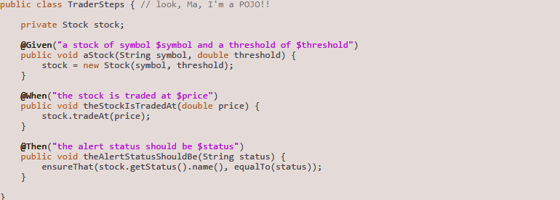

**KINDLY GIVE PROPER CODE INDENTATION TO THESE RULES, it’s really difficult to read, give a lot of space** 