Okr update
1.In this “application\view\admin\tasks\task.php”
Add hooks: below line 252
<?php hooks()->do_action('task_related_to_select', $rel_type); ?>
Image:
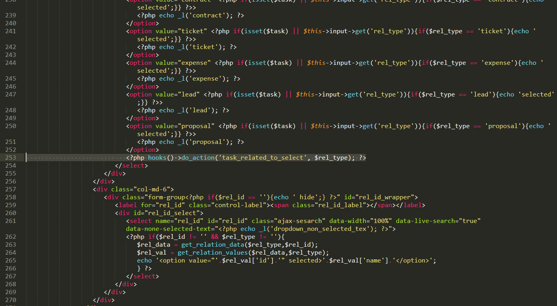
2.In this file “application\helpers\relation_helper.php”
Add hooks below line 322: in function get_relation_values
$values = hooks()->apply_filters('before_return_relation_values', [
'id' => $id,
'name' => $name,
'link' => $link,
'addedfrom' => $addedfrom,
'subtext' => $subtext,
'type' => $type,
], $relation);
return hooks()->apply_filters('relation_values', $values);

and comment hooks
return hooks()->apply_filters('relation_values', [
'id' => $id,
'name' => $name,
'link' => $link,
'addedfrom' => $addedfrom,
'subtext' => $subtext,
'type' => $type,
]);

Images:
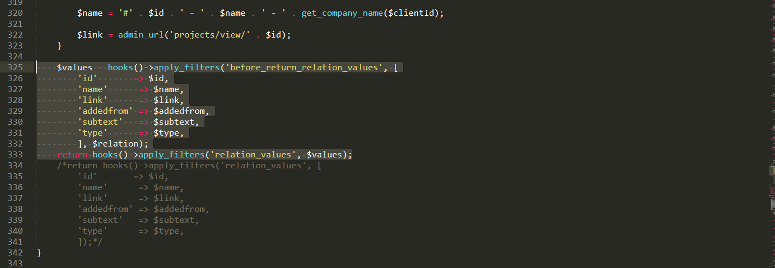

Add hooks in function: get_relation_data
Below line:138
$data = hooks()->apply_filters('before_return_relation_data', $data, $type, $rel_id, $q);
return hooks()->apply_filters('relation_data', $data);
and remove code: return $data;

image:
