mensaje 1 : You appointment in the school was confirmed
month - day number th ( day letter )
The place is in tsuruoka station :

12: 50 ~ 13:00 in Tsuruoka station , the bus come to pick up you. do not be late, otherwise the course will be cancelled please🙏

Bring :

If you Use Glasses
Zairyu card
Menkyo center document
Juminjio ( address certificate )
Name stamp ( hanko )
Hokenshou
Money ( karimenkyo 2950 yen , food )

Lunch includ
Room share ( you can cook)
Note
Pencil
Japanese sandals

Remember you final station is Tsuruoka .
In Tsuruoka the instructor will awaiting you until 13 Pm .

Mensaje 2 :
https://goo.gl/maps/bPBSunXGEFucK91s7

mensaje 3 :

When you reach to tsuruoka station, wait in this place
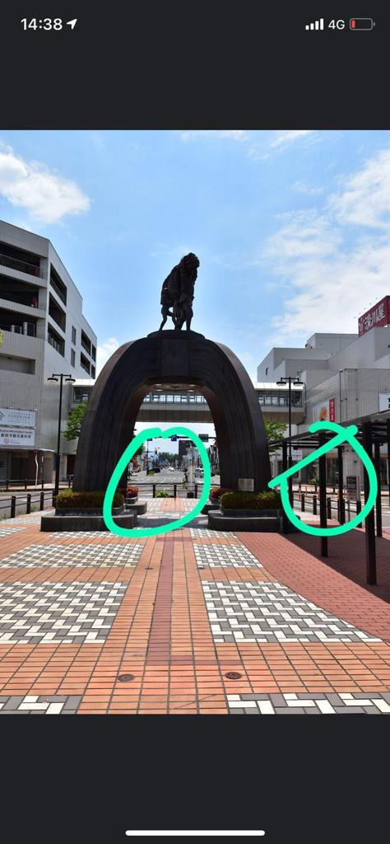

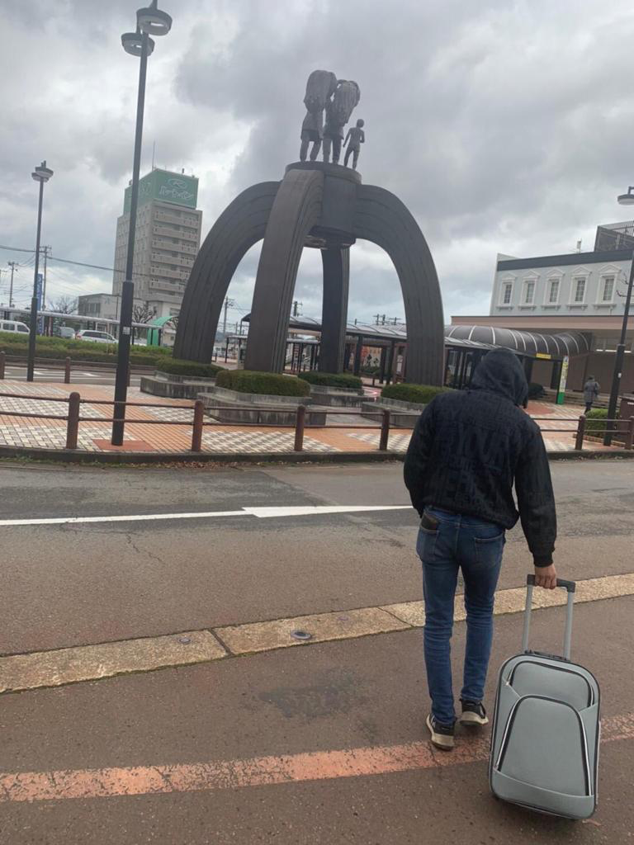

Mensaje 5:
At 13 pm ( exactly time ) this bus pickup you .
Can’t late the time . Is very important please

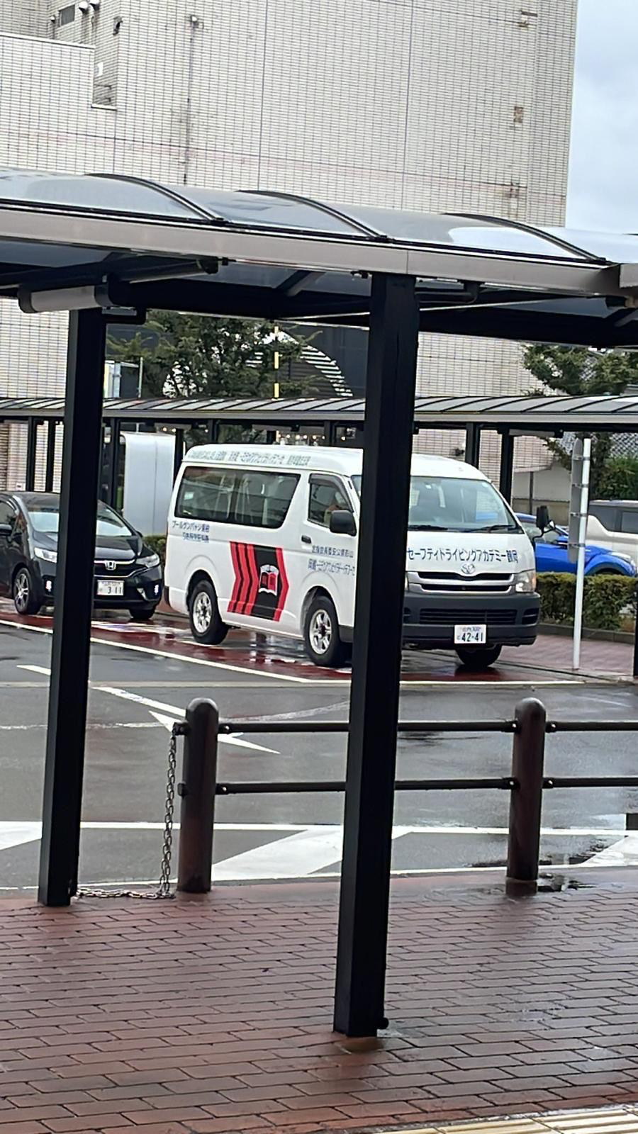

Mensaje 6 :

Please in the school should follow the rules .
1.- Can’t late the time for the driving lessons and theoric lessons
2.- can’t drink alcohol
3.- can’t smoke in prohibited places
4.- is prohibited to leave the school without permission and after 10 pm.
5.- It is prohibited to write on the walls or damage the school infrastructure.
If not follow these instructions ; can’t continue and your Course will be cancelled . Pay attention .

