The aim of this project is to make a system that would assign the customers to each employee and then sort them according to the priority for delivery.
On running the program -
You are greeted by a Main Menu asking the following options -
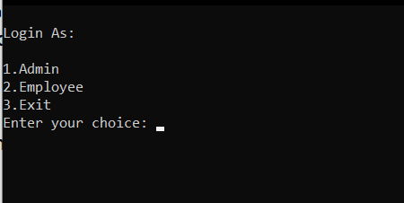

1. Admin- He is allowed to access the data of Employees and Customers.
The access includes- 1.1-Create a new entry of the employees.
1.2-View existing entry of the employees.
1.3-Create a new entry of the customer.
1.4-View existing entry of the employees.

Therefore , on choosing admin- you can select any of the four options and use their desired function.

2. Employee- He is allowed the access of-
2.1 The list of customers assigned to him.(the people he/she has to deliver the package to )
2.2 The details of customer;
like - Name , Phone Number , Address,
If the item is fragile or not.
NOTE-(In 2.1)The the customers are preassigned to a designated employee. The priority algorithm sorts the customers according to their priority(Priority Crieteria listed below) and then prints them on the screen.
The sequence of customers printed , is to be followed by the employee while delivering the products.
Priority crieteria- 1.Prime Membership.
2.Fragility of Product to be delivered.

3.Exit the program.

