Main method :

import Q_01.Window;

import Q_02.NamedWindow;

import Q_03.DisplayName;

import Q_04.DisplayDate;

import Q_05.ShowDate;

import Q_06.UserDefinedWindow;

import Q_07.TimeTitle;

import Q_08.StringSeparate;

import Q_09.CharacterCounter;

import Q_10.OddText;

import Q_11.NameReformat;

import Q_12.PositionedWindow;

public class Main {

public static void main(String[] args) {

// Window window = new Window();

// window.simpleWindow();

// NamedWindow newWindow = new NamedWindow();

// newWindow.getName();

// DisplayName name = new DisplayName();

// name.nameOutput();

// DisplayDate date1 = new DisplayDate();

// date1.showDate();

// ShowDate date2 = new ShowDate();

// date2.showDate();

// UserDefinedWindow display = new UserDefinedWindow();

// display.displayAttrib();

// TimeTitle titledWindow = new TimeTitle();

// titledWindow.timeDisplay();

// StringSeparate subText = new StringSeparate();

// subText.separateString();

// CharacterCounter text3 = new CharacterCounter();

// text3.textProcess();

// OddText text4 = new OddText();

// text4.showMiddleLetter();

// NameReformat name = new NameReformat();

// name.nameReformat();

// PositionedWindow newFrame = new PositionedWindow();

// newFrame.setframe();

}

}

Q1.

Code :

package Q_01;

import javax.swing.*;

public class Window {

JFrame sampleWindow = new JFrame("Welcome to Java");

public void simpleWindow() {

sampleWindow.setSize(800,600);

sampleWindow.setVisible(true);

}

}

Output :

Q2.

Code :

package Q_02;

import javax.swing.*;

import java.util.*;

public class NamedWindow {

Scanner cursor = new Scanner(System.*in*);

String fName,lName;

public void displayWindow(){

JFrame newWindow = new JFrame(fName+" "+lName);

newWindow.setVisible(true);

newWindow.setSize(800,600);

}

public void getName(){

System.*out*.print("Enter your first name : ");

fName = cursor.next();

System.*out*.print("Enter your last name : ");

lName = cursor.next();

displayWindow();

}

}

Output :

Q3.

Code :

package Q_03;

import java.util.*;

public class DisplayName {

Scanner cursor = new Scanner(System.*in*);

String fName, mName, lName;

public void nameOutput(){

System.*out*.print("Enter your first name : ");

fName = cursor.next();

System.*out*.print("Enter your middle name : ");

mName = cursor.next();

System.*out*.print("Enter your last name : ");

lName = cursor.next();

System.*out*.println(fName+" "+mName.charAt(0)+". "+lName);

}

}

Output :

Q4.

Code :

package Q_04;

import java.util.*;

import java.text.*;

public class DisplayDate {

Date today = new Date();

SimpleDateFormat sdf = new SimpleDateFormat("dd MMMM yyyy");

public void showDate(){

System.*out*.println(sdf.format(today));

}

}

Output :

Q5.

Code :

package Q_05;

import java.text.*;

import java.util.*;

public class ShowDate {

Date today = new Date();

SimpleDateFormat sdf = new SimpleDateFormat("EEEE, MMMM dd, yyyy");

public void showDate() {

System.*out*.println(sdf.format(today));

}

}

Output :

Q6.

Code :

package Q_06;

import javax.swing.*;

import java.util.*;

public class UserDefinedWindow {

JFrame display = new JFrame();

Scanner cursor = new Scanner(System.*in*);

String title;

Integer width, height;

private void createDisplay(){

display.setTitle(title);

display.setSize(width,height);

display.setVisible(true);

}

public void displayAttrib(){

System.*out*.print("Enter the Window title : ");

title = cursor.nextLine();

System.*out*.print("Enter W (width) : ");

width = cursor.nextInt();

System.*out*.print("Enter H (height) : ");

height = cursor.nextInt();

createDisplay();

}

}

Output :

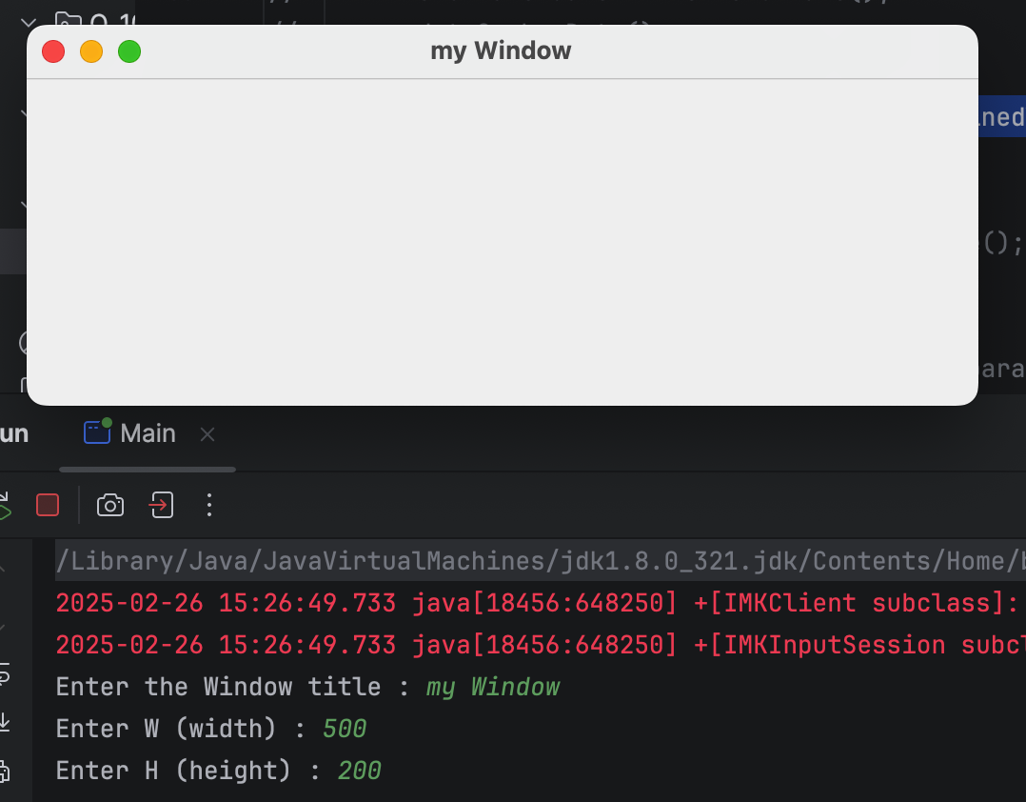

Q7.

Code :

package Q_07;

import java.text.*;

import java.util.*;

import javax.swing.*;

public class TimeTitle {

Date newDate = new Date();

SimpleDateFormat sdf = new SimpleDateFormat("h:m:ss a");

JFrame display = new JFrame(sdf.format(newDate));

public void timeDisplay() {

display.setVisible(true);

display.setSize(500,300);

}

}

Output :

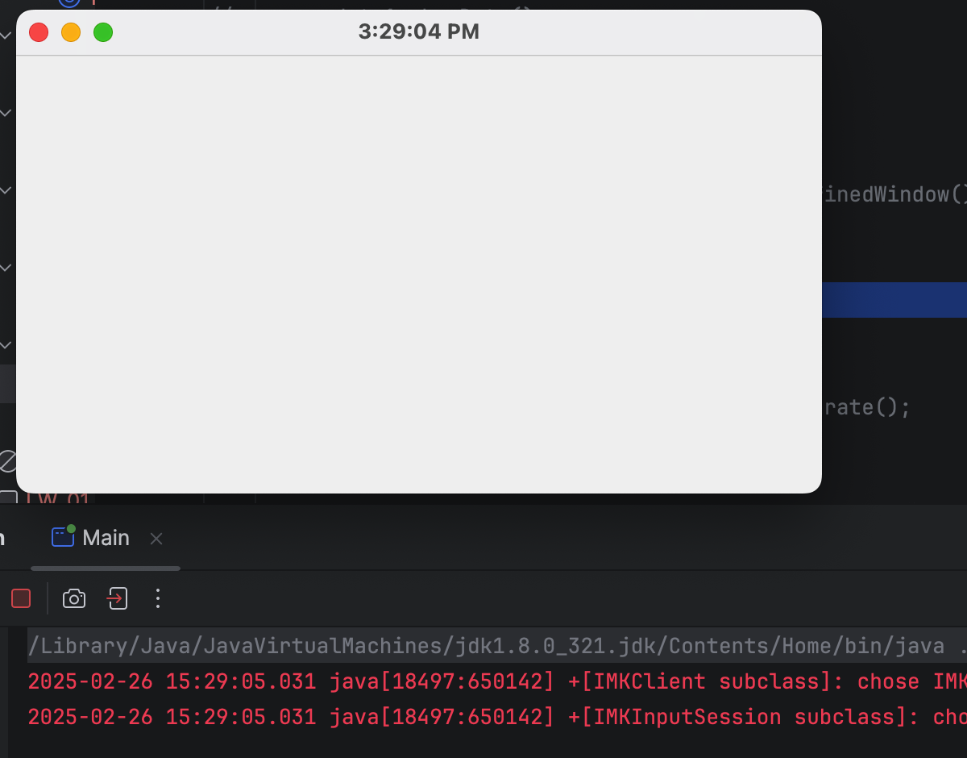

Q8.

Code :

package Q_08;

import java.util.*;

public class StringSeparate {

Scanner cursor = new Scanner(System.*in*);

String text;

Integer breakingPoint;

public void separateString(){

System.*out*.print("Enter the String with a single exclamation mark : ");

text = cursor.nextLine();

breakingPoint = text.indexOf("!");

System.*out*.println(text.substring(0,breakingPoint));

System.*out*.println(text.substring(breakingPoint+1));

}

}

Output :

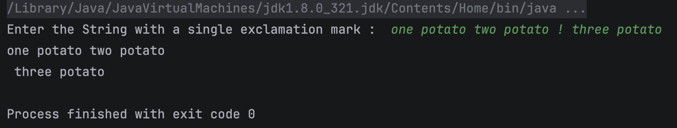

Q9.

Code :

package Q_09;

import java.util.*;

public class CharacterCounter {

Scanner cursor = new Scanner(System.*in*);

String text;

public void textProcess(){

System.*out*.print("Enter a String here : ");

text = cursor.nextLine();

System.*out*.println(text.length());

System.*out*.println(text.charAt(0));

System.*out*.println(text.charAt(text.length()-1));

}

}

Output :

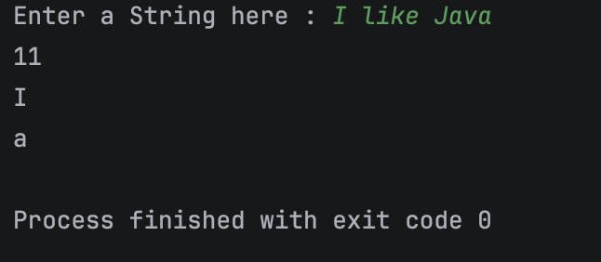

Q10.

Code :

package Q_10;

import java.util.*;

public class OddText {

Scanner cursor = new Scanner(System.*in*);

String text;

public void showMiddleLetter(){

System.*out*.print("Enter a String with odd number of characters : ");

text = cursor.nextLine();

System.*out*.println(text.charAt(text.length()/2));

}

}

Output :

Q11.

Code :

package Q_11;

import java.util.*;

public class NameReformat {

Scanner cursor = new Scanner(System.*in*);

String fName,mName,lName;

public void nameReformat(){

System.*out*.print("Enter your first name : ");

fName = cursor.next();

System.*out*.print("Enter your middle name : ");

mName = cursor.next();

System.*out*.print("Enter your last name : ");

lName = cursor.next();

System.*out*.println(lName+","+" "+fName+" "+mName.charAt(0)+".");

}

}

Output :

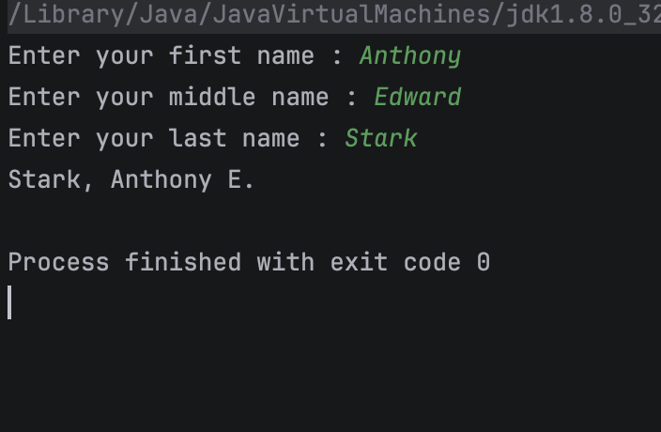

Q12.

Code :

package Q_12;

import javax.swing.*;

public class PositionedWindow {

JFrame window = new JFrame("My First Frame");

public void setframe() {

window.setVisible(true);

window.setSize(300,200);

window.setLocation(100,50);

}

}

Output :

