Part A: AI Tools in Day-to-Day TAM Work
  - Concrete workflows, outputs, and improvements

1. Improving the quality of customer replies
Workflow
Before sending a reply in Zendesk or Outlook, I paste my rough draft into ChatGPT or Microsoft Copilot and ask it to improve the tone and professionalism and fix the grammar, while keeping the technical meaning unchanged.
Example: a blunt draft like "delivery is failing because your sender id is not registered, register it before sending again" becomes a courteous reply that explains the cause, the fix, and the next step. I review and personalise it, then send.
Output
- A polished reply with correct grammar, a professional tone, and a clear cause, fix, and next step.
Improvement
- More professional, empathetic replies with fewer errors.
- A send-ready reply in a minute or two instead of several minutes of re-wording.
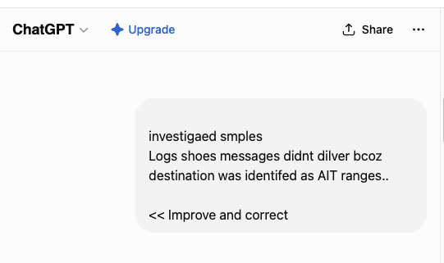
Input: my rough draft passed to ChatGPT
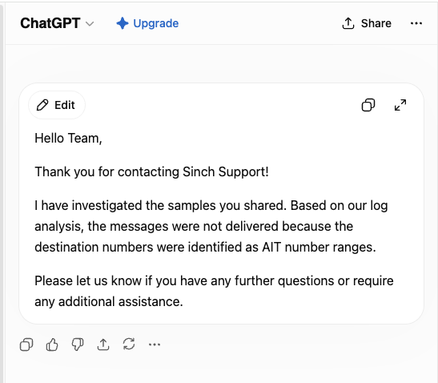
Output: the polished, professional reply

2. Detailed explanations with related Sinch KB articles
Workflow
When a customer needs a detailed explanation or a set of answers backed by documentation, I use ChatGPT or Claude to draft a clear response and to point me to the most relevant Sinch knowledge base, Trust Center, and developer articles. I verify every link against the live Sinch sources before sending.
Example: a customer sent a list of data privacy and security questions. I drafted a clear answer to each and matched them to the relevant Sinch Trust Center, legal, and KB pages, then reviewed and verified every link before sending the final reply.
Output
- A clear explanation tailored to the question, with relevant Sinch documentation links for self-service.
Improvement
- A thorough, well-sourced answer in minutes instead of manual searching.
- Consistent explanations that reduce follow-up questions.
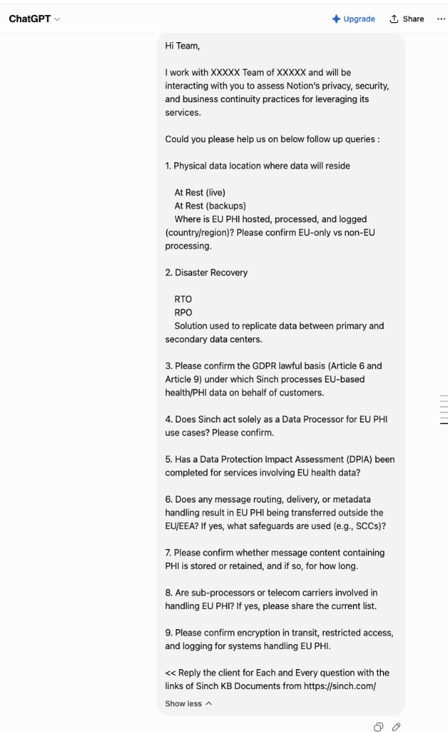
Input: the client query
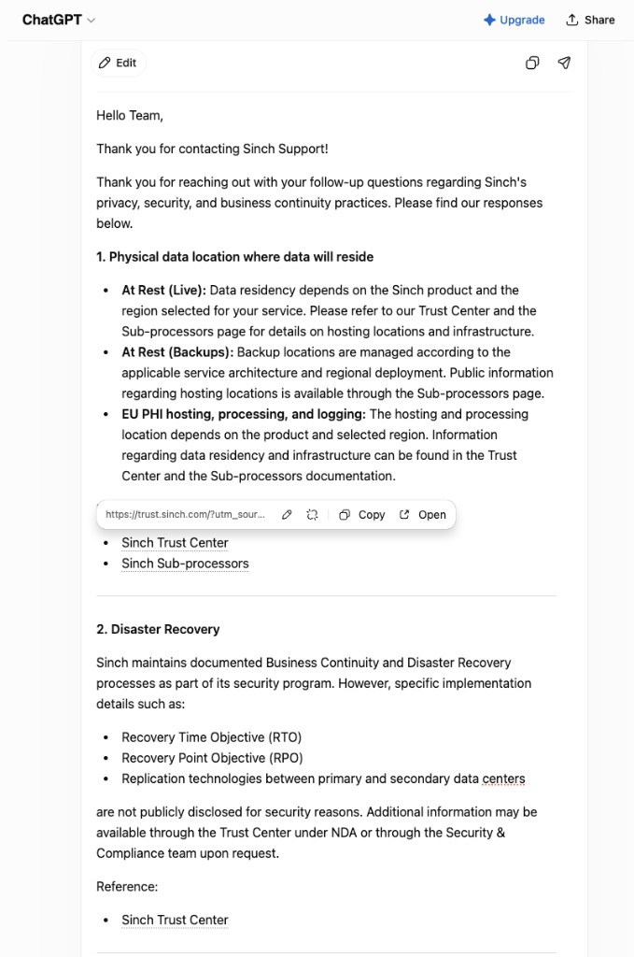
Output: the ChatGPT draft answer
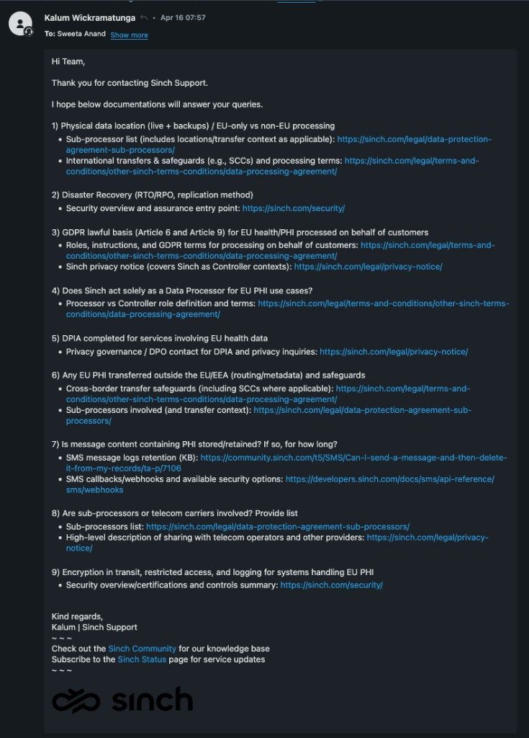
Final: the revised reply I sent, with verified Sinch links

3. Building reporting tools
Workflow
When the reporting I need does not exist in Zendesk, I use ChatGPT to scope it and Claude to build and iterate the code, then deploy it to a live URL. I built the TAM Support Intelligence dashboard this way (full detail in Part B).
Output
- A live, filterable dashboard with KPI cards, at-risk alerts, account health scores, and one-click CSV, Markdown, and PDF exports.
Improvement
- A working multi-view tool in days instead of weeks, with no formal development queue.
- Data-backed QBRs from exportable evidence.

Summary
Use case | AI tool(s) | Main gain
Improving customer replies | ChatGPT, Microsoft Copilot | Clearer, more professional replies, fewer errors, faster
Detailed explanations and KB articles | ChatGPT, Claude | Faster, well-sourced answers with Sinch documentation links
Building reporting tools | ChatGPT, Claude | Automated portfolio reporting, days not weeks (see Part B)

In each case the AI tool drafts and accelerates the work. I stay accountable for technical accuracy, customer tone, and the documentation links.

