Exercise 1: nslookup

1.1

Which is the IP address of the website [www.koala.com.au](http://www.koala.com.au)? In your opinion, what is the reason of having several IP addresses as an output?

The IPv4 addresses of [www.koala.com.au](http://www.koala.com.au) are 104.18.60.21 and 104.18.61.21, the IPv6 addresses are 2606:4700:30::6812:3c15 and 2606:4700:30::6812:3d15

The reason of having several IP addresses as an output is to increase website performance by receiving it from IP that is the closest based on location.

1.2

Find out the name of the IP address 127.0.0.1. What is special about this IP address?

The name is localhost. It can run network services on host/local machine without physical network interface by using a local loopback mechanism.

Exercise 2: Use ping to test host reachability

|  |  |  |  |
| --- | --- | --- | --- |
| Host | Reachable | | Reason |
| ping | website |
| [www.unsw.edu.au](http://www.unsw.edu.au) | T | T | - |
| [www.getfittest.com.au](http://www.getfittest.com.au) | F | F | NXDOMAIN, Non-Existent Domain |
| [www.mit.edu](http://www.mit.edu) | T | T | - |
| [www.intel.com.au](http://www.intel.com.au) | T | T | - |
| [www.tpg.com.au](http://www.tpg.com.au) | T | T | - |
| [www.hola.hp](http://www.hola.hp) | F | F | NXDOMAIN, Non-Existent Domain |
| [www.amazon.com](http://www.amazon.com) | T | T | - |
| [www.tsinghua.edu.cn](http://www.tsinghua.edu.cn) | T | T | - |
| [www.kremlin.ru](http://www.kremlin.ru) | F | T | Firewall blocking ICMP traffic |
| 8.8.8.8 | T | F | Domain name server |

*If you observe that some hosts are not reachable, then can you explain why? Check if the addresses unreachable by the ping command are reachable from the web browser.*

Exercise 3: Use traceroute to understand network topology

*\*Include all traceroute outputs in your report.*

3.1

Run traceroute on your machine to [www.columbia.edu](http://www.columbia.edu). How many routers are there between your workstation and [www.columbia.edu](http://www.columbia.edu)? How many routers along the path are part of the UNSW network? Between which two routers do packets cross the pacific ocean? *Hint: compare the round trip times from your machine to the routers using ping.*

There are 23 routers, there are 4 routers part of UNSW, between the 9th and 10th router the packets cross the pacific ocean.

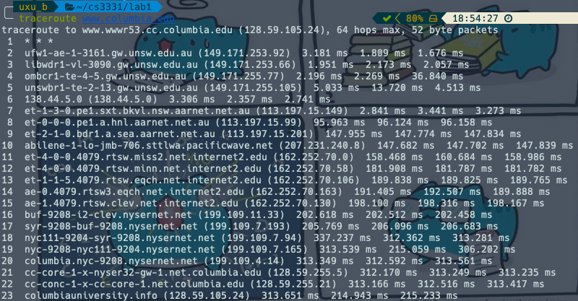

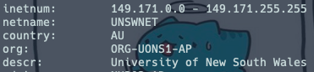

3.2

Run traceroute from your machine to the following destinations:

* [www.ucla.edu](http://www.ucla.edu) 🡪 14 hops

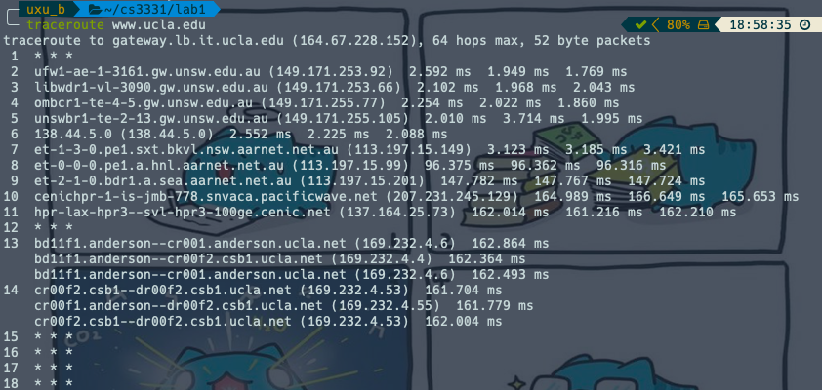

* [www.u-tokyo.ac.jp](http://www.u-tokyo.ac.jp) 🡪 15 hops

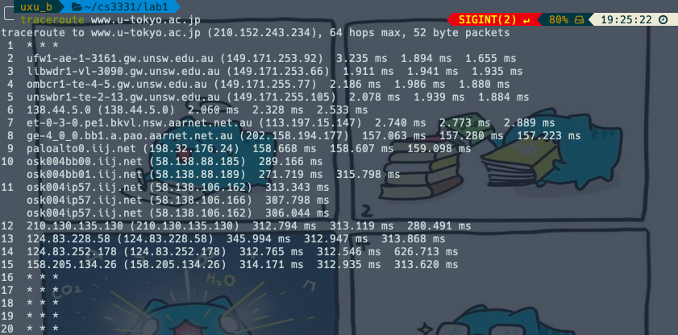

* [www.lancaster.ac.uk](http://www.lancaster.ac.uk) 🡪 18 hops

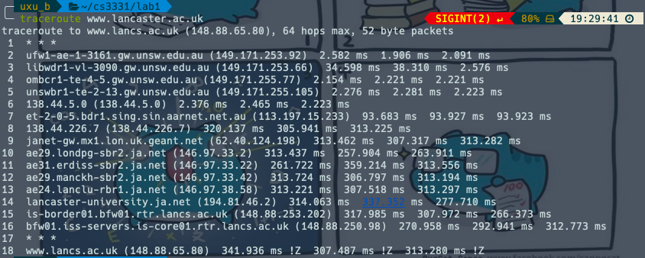

At which router do the paths from your machine to these three destinations diverge? Find out further details about this router. *Hint: you can find out more about a router by running the whois command (whois router-IP-address).* Is the number of hops on each path proportional the physical distance? *Hint: you can find out geographical location of a server using the following tool* [*http://www.yougetsignal.com/tools/network-location/*](http://www.yougetsignal.com/tools/network-location/)

At the 7th router, the path to these 3 destinations diverge. Japan has a shorter geographical compared to US but US(14 hops) took one less hop compared to Japan(15 hops) thus the number of hops on each path is not proportional to the physical distance.

3.3

Several servers distributed around the world provide a web interface from which you can perform a traceroute to any other host in the Internet. Here are two examples:

* <http://www.speedtest.com.sg/tr.php>

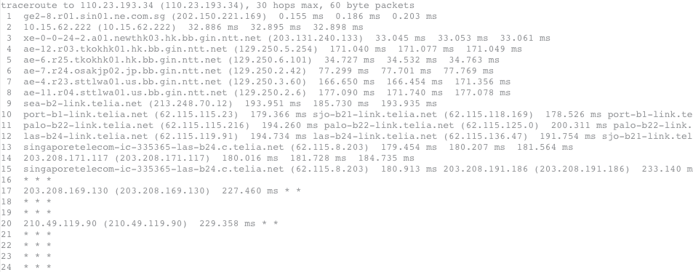

*\*reverse(to speedtest.com.sg)*

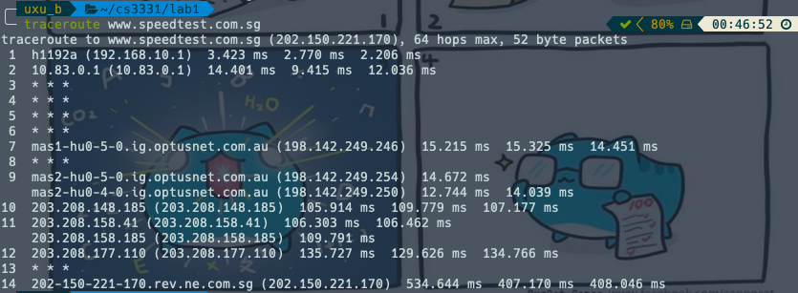

* <https://www.telstra.net/cgi-bin/trace>

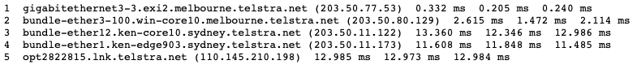

*\*reverse(to telstra.net)*

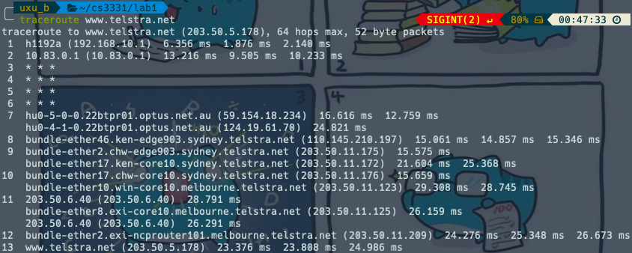

Run traceroute from both these servers towards your machine and in the reverse direction (i.e. from your machine to these servers). You may also try other traceroute servers from the list at [www.traceroute.org](http://www.traceroute.org) . What are the IP addresses of the two servers that you have chosen. Does the reverse path go through the same routers as the forward path? If you observe common routers between the forward and the reverse path, do you also observe the same IP addresses? Why or why not?

* <https://network-tools.com>

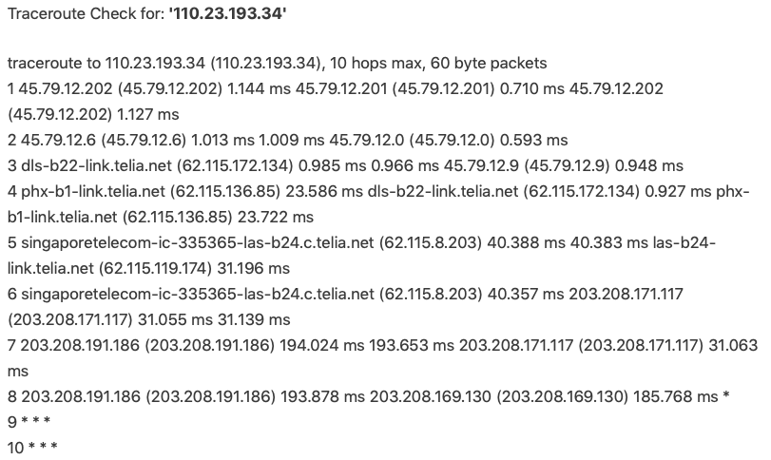

*\*reverse(to network-tools.com)*

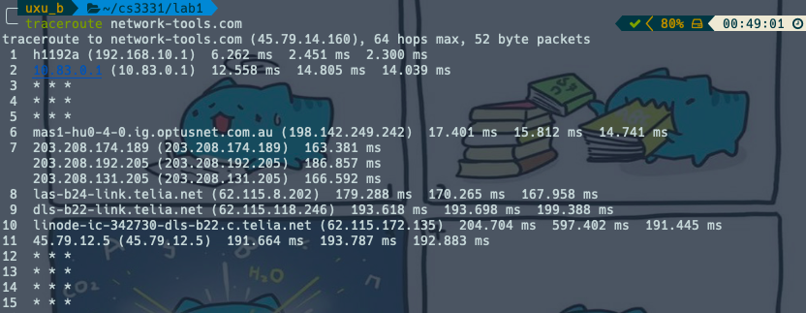

* [www.harenet.ad.jp](http://www.harenet.ad.jp)

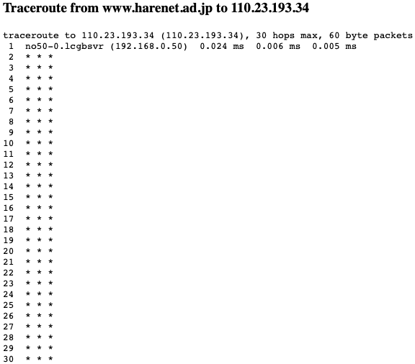

*\*reverse(to harenet.ad.jp)*

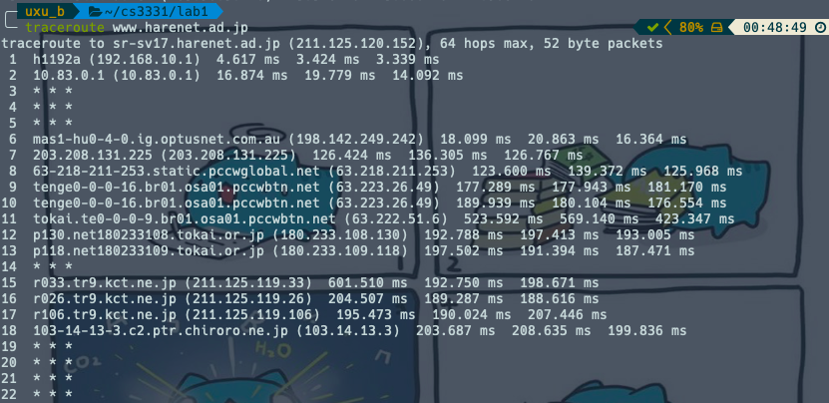

The IP address of the chosen 2 are network-tools.com(45.79.14.160) and harenet.ad.jp(211.125.120.152). Both didn’t go to and from on the same path/ routers but there are common routers with different IP as routing selects the optimal path.

Exercise 4: use ping to gain insights into network performance

*\*Include all graphs in your report*

We now use the ping utility to investigate network delay and its implications on network performance. In particular, we will analyze the dependency of packet size and delay.

There is a shell script, [runping.sh](https://webcms3.cse.unsw.edu.au/COMP3331/19T3/resources/32088), provided that you can use instead of running many pings with different packet sizes by hand. After downloading this script on your machine make sure you can execute it. If not, you will have to execute the following command in the command line: *chmod u+x runping.sh*. To run the ping traces you may use the runping.sh script as follows: ./runping.sh [www.abc.net](http://www.abc.net)(or whatever other destination you want to ping). It will automatically run ping for different packet sizes and with 50 ping packets per size. Note, since a ping is sent once per second, this script will take a few minutes to finish. Basically, this script only executes the commands:

$ ./runping.sh www.uq.edu.au

$ ./runping.sh www.dlsu.edu.ph

$ ./runping.sh www.tu-berlin.de

**Note that all delay values reported are in milliseconds (ms) and reflect the round trip time (RTT) between your host and the destinations.**

When the runping.sh script is finished for all destinations, you can plot the results using another provided script, [plot.sh](https://webcms3.cse.unsw.edu.au/COMP3331/19T3/resources/32082),as follows:

The graph *destination_delay.pdf*shows how delay varies over time (different colours correspond to different packet sizes), and *destination_scatter.pdf*shows delay vs. packet size as a scatter plot. *destination_avg.txt* contains the average (2nd column) and minimum (3rd column) delay values corresponding to each packet size (1st column).

$ ./plot.sh www.uq.edu.au-p*

$ ./plot.sh www.dlsu.edu.ph-p*

$ ./plot.sh www.tu-berlin.de-p*

Use this script for the following destinations:

* [www.unsw.edu.au/](http://www.unsw.edu.au/)

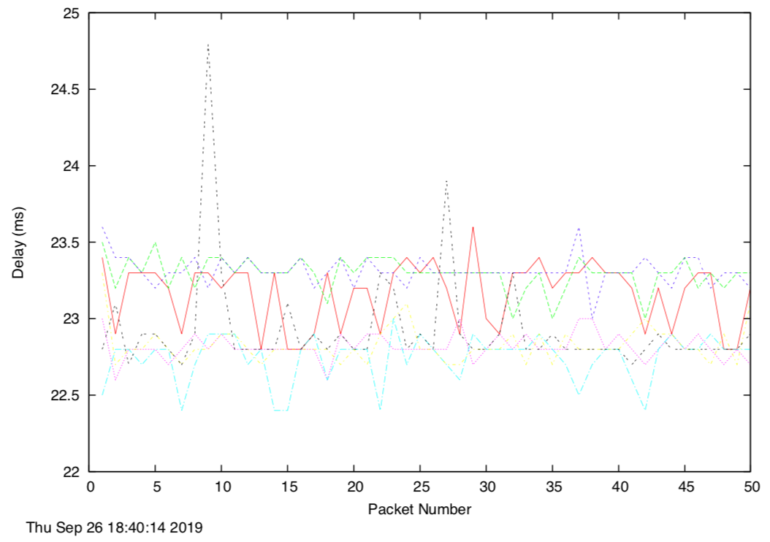

*delay

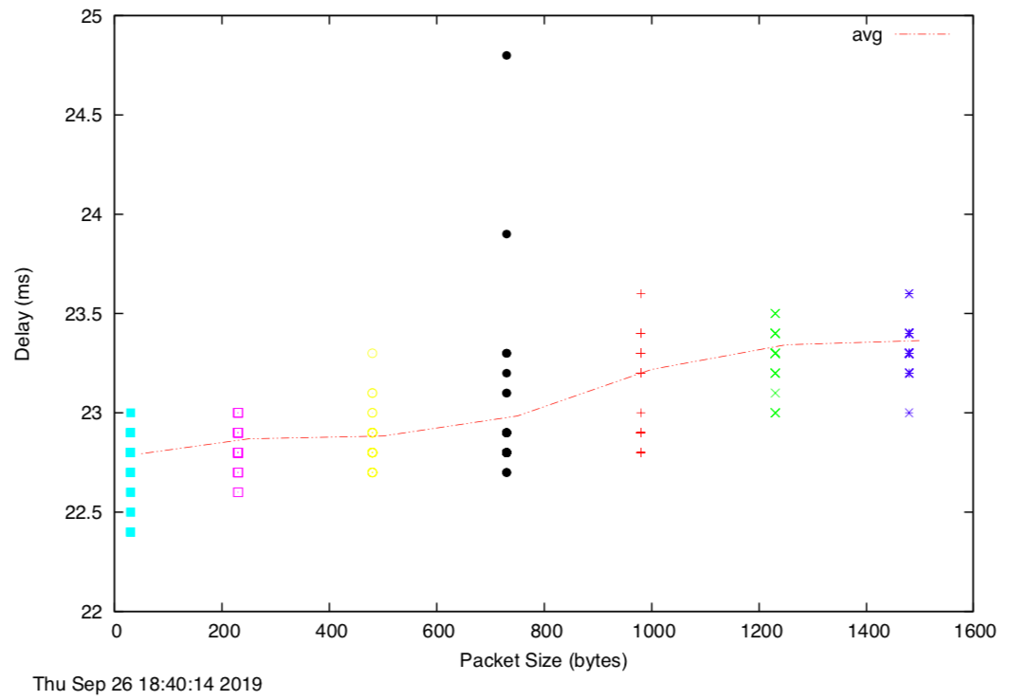

*scatter

* [www.upm.edu.my/](http://www.upm.edu.my/)

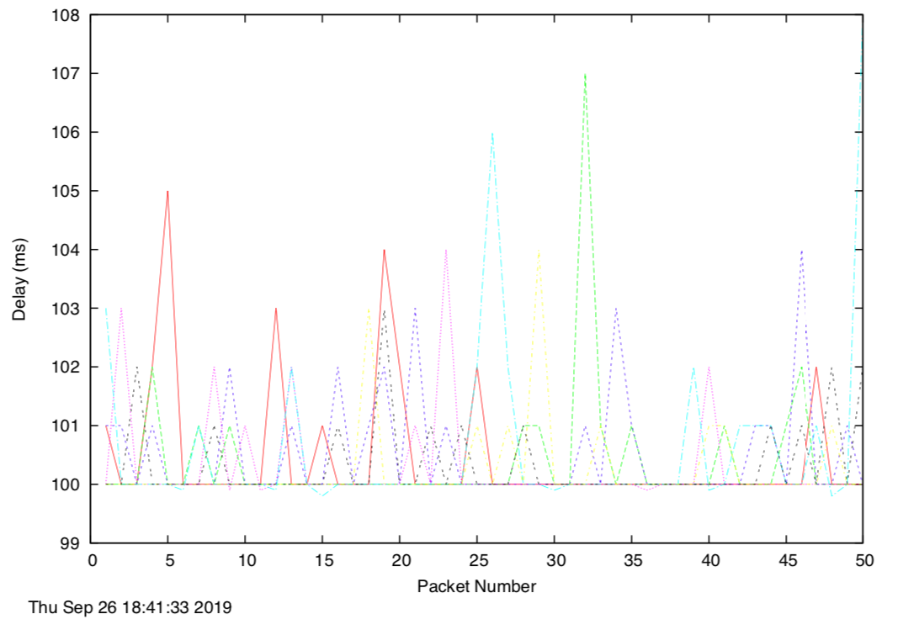

*delay

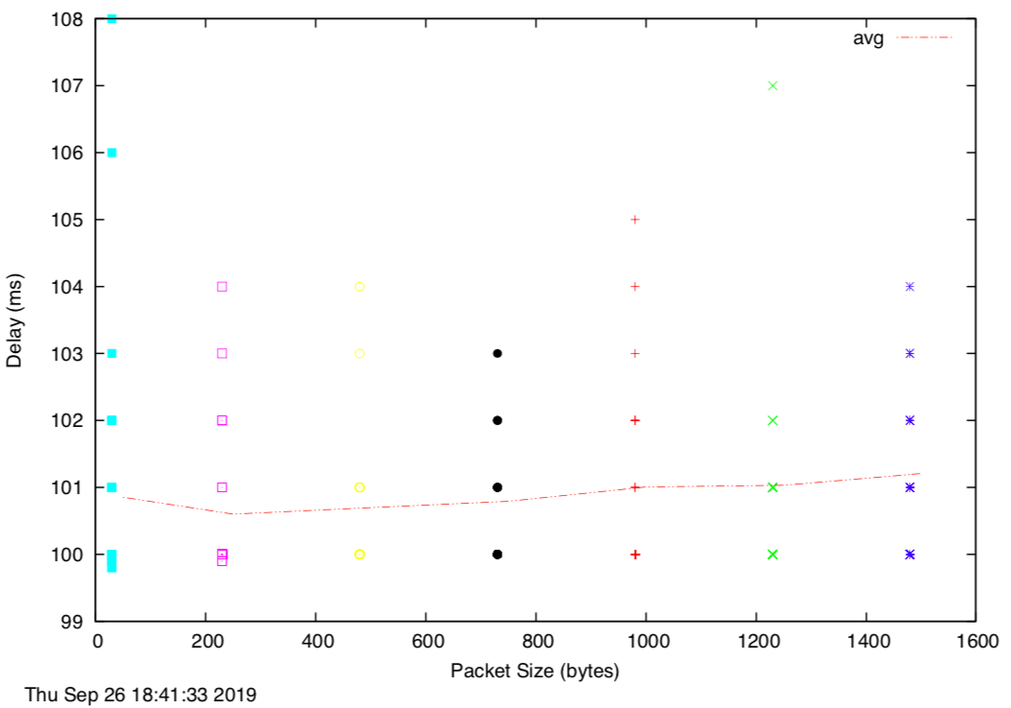

*scatter

* [www.tu-berlin.de](http://www.tu-berlin.de)

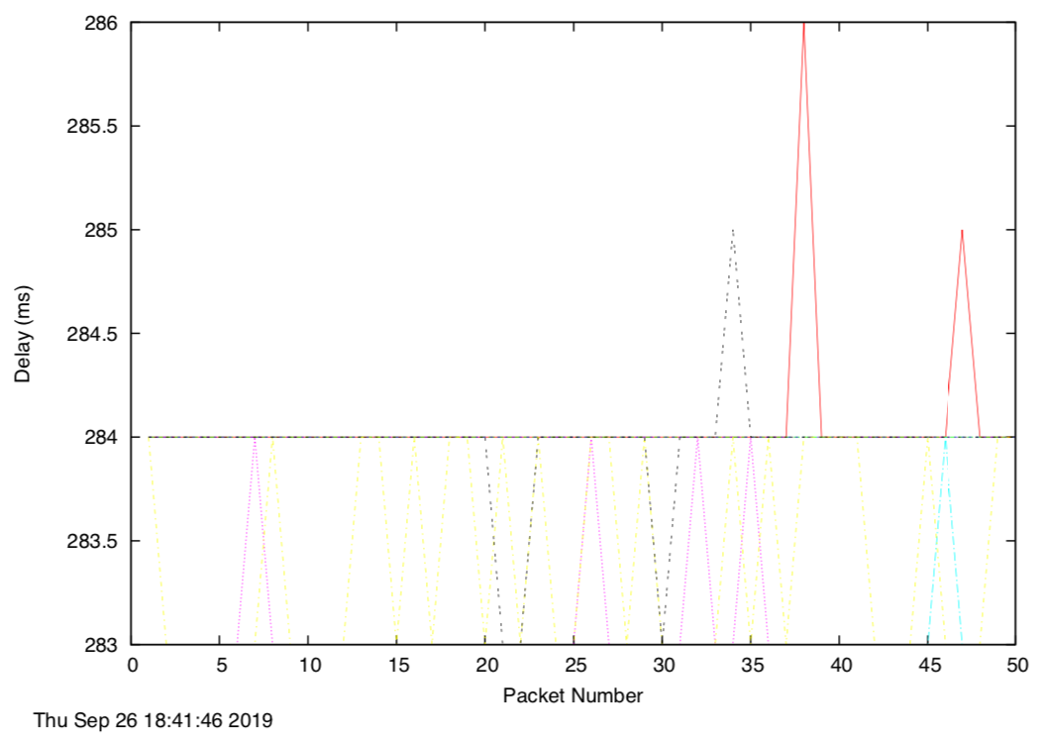

*delay

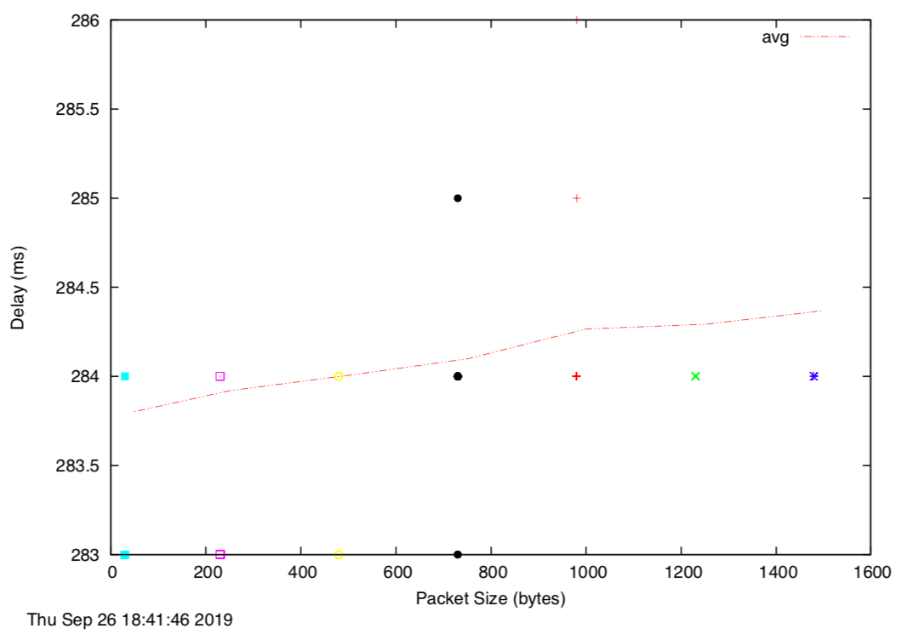

*scatter

4.1

For each of these locations ﬁnd the (approximate) physical distance from UNSW using Google Maps and compute the shortest possible time T for a packet to reach that location from UNSW. You should assume that the packet moves (i.e. propagates) at the speed of light, 3 x 10 8m/s. Note that the shortest possible time will simply be the distance divided by the propagation speed. Plot a graph where the x-axis represents the distance to each city (i.e. Brisbane, Manila and Berlin), and the y-axis represents the ratio between the minimum delay (i.e. RTT) as measured by the ping program (select the values for 50 byte packets) and the shortest possible time T to reach that city from UNSW. (Note that the y-values are no smaller than 2 since it takes at least 2*T time for any packet to reach the destination from UNSW and get back). Can you think of at least two reasons why the y-axis values that you plot are greater than 2?

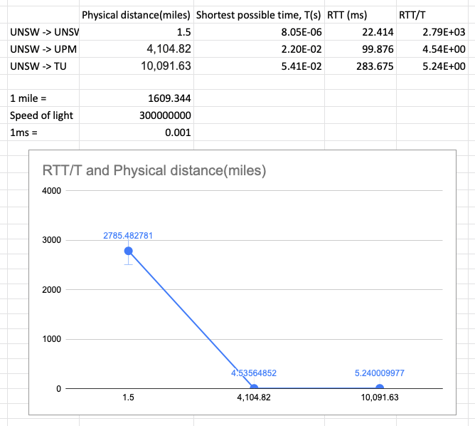

The round trip time, RTT is the time taken to travel to and from source to destination. The shortest possible time, T taken thus, RTT will be more or at least 2*T, also it can’t be faster than the speed of light.

4.2

Is the delay to the destinations constant or does it vary over time? Explain why.

It seems pretty constant expect for UNSW -> UNSW. I am assuming that since UNSW -> UNSW have shortest length of physical link, the propagation delay might have effect and queueing delay might have also have effected it as it depends on congestion level of the routers and the time waiting(output link) for transmission

4.3

Explore where the website for [www.epfl.ch](http://www.epfl.ch/)is hosted. Is it in Switzerland?

Yes it is in Switzerland.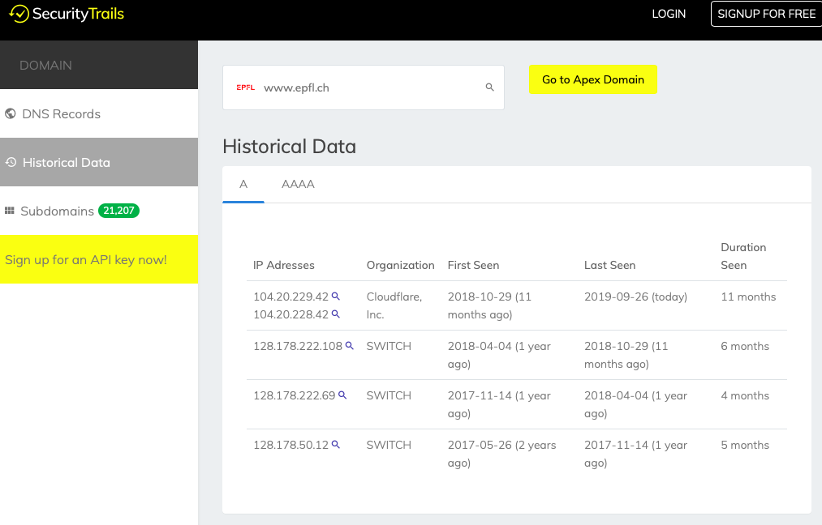

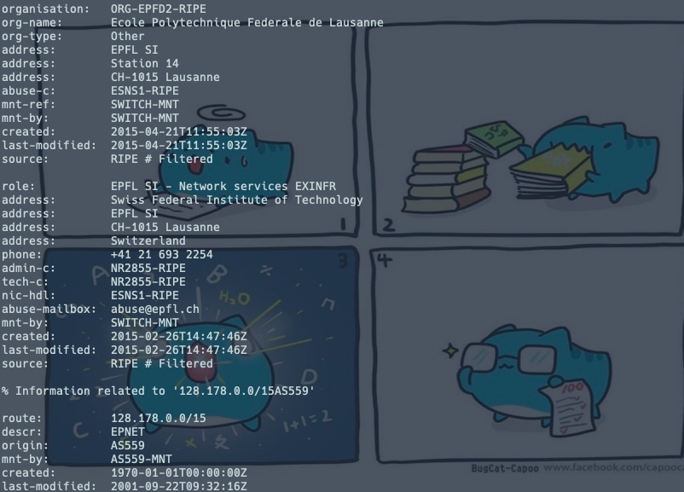

4.4

The measured delay (i.e., the delay you can see in the graphs) is composed of propagation delay, transmission delay, processing delay and queuing delay. Which of these delays depend on the packet size and which do not?

|  |  |  |
| --- | --- | --- |
| Dependant on packet size. | | |
|  | Yes | No |
| Propagation delay |  | √ |
| Transmission delay | √ |  |
| Processing delay |  | √ |
| Queueing delay |  | √ |