HW1

311512064鄧書桓

Part 1.ROS (I only use ROS)

Publisher:

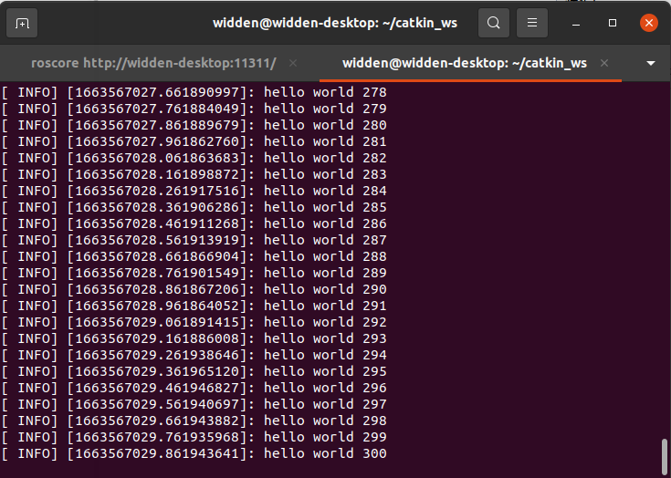

Subscriber:

