2.A

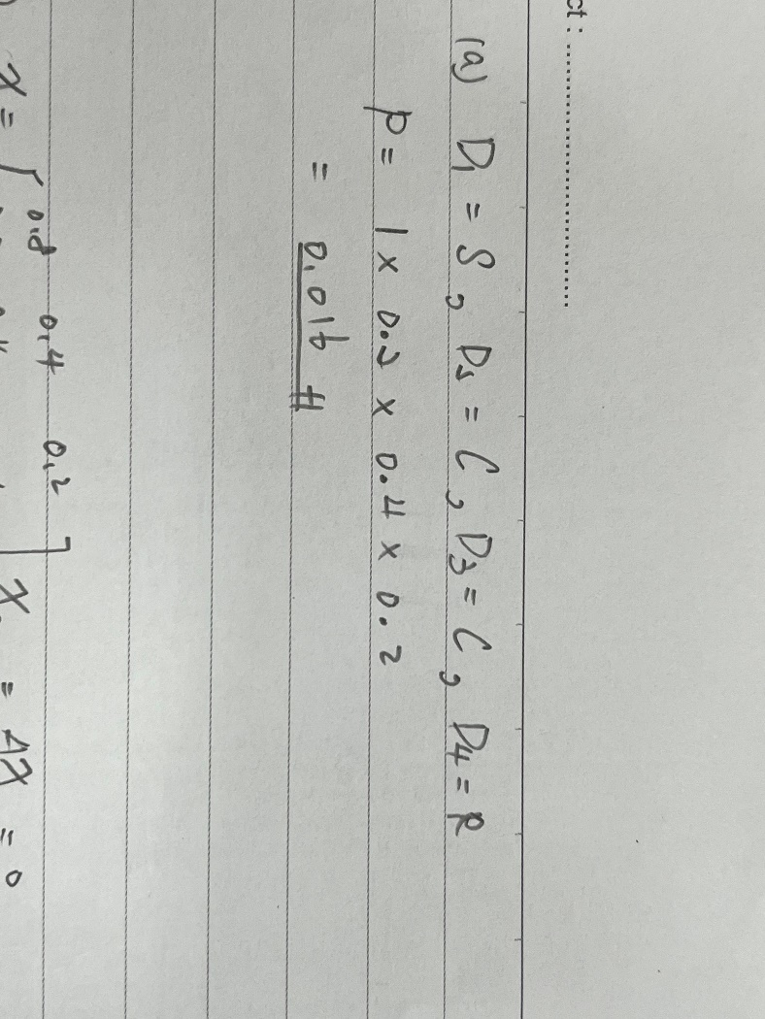

2.B

Code:

import numpy as np

trans = [

    [0.8, 0.4, 0.2],

    [0.2, 0.4, 0.6],

    [0, 0.2, 0.2]

]

today = [[0], [0], [1]]

states = [["s"], ["c"], ["r"]]

num = int(input("How many days: "))

if today[0][0] == 1:

    print("day 1 is sunny")

elif today[1][0] == 1:

    print("day 1 is cloud")

else:

    print("day 1 is rainy")

for i in range(2, num+1):

    tormorrow_p = np.dot(trans, today)

    tomorrow_d = np.random.choice(np.reshape(

        states, 3), replace=True, p=np.reshape(tormorrow_p, 3))

    if tomorrow_d == "s":

        print("day {} probable is sunny".format(i))

        today = [[1], [0], [0]]

    elif tomorrow_d == "c":

        print("day {} probable is cloudy".format(i))

        today = [[0], [1], [0]]

    else:

        print("day {} probable is rainy".format(i))

        today = [[0], [0], [1]]

輸出

第一天是sunny:

第一天是cloudy:

第一天是rainy:

2.C

Code:

import numpy as np

trans = [

    [0.8, 0.4, 0.2],

    [0.2, 0.4, 0.6],

    [0, 0.2, 0.2]

]

states = [["s"], ["c"], ["r"]]

s_count, c_count, r_count = (0, 0, 0)

def sim(days):

    today = [[1], [0], [0]]

    num = days

    for i in range(2, num+1):

        tomorrow_p = np.dot(trans, today)

        tomorrow_d = np.random.choice(np.reshape(

            states, 3), replace=True, p=np.reshape(tomorrow_p, 3))

        if tomorrow_d == "s":

            today = np.array([[1], [0], [0]])

        elif tomorrow_d == "c":

            today = np.array([[0], [1], [0]])

        else:

            today = np.array([[0], [0], [1]])

    return tomorrow_d

for i in range(10000):

    wheather = sim(49)

    if wheather == "s":

        s_count = s_count+1

    elif wheather == "c":

        c_count = c_count+1

    else:

        r_count = r_count+1

stationary_distrubution = [s_count/10000, c_count/10000, r_count/10000]

print("Stationary Distriburion is" + str(stationary_distrubution))

輸出:



2.DE

2.FG

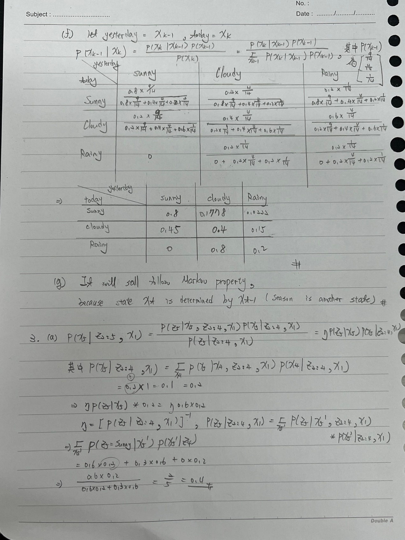

3.A

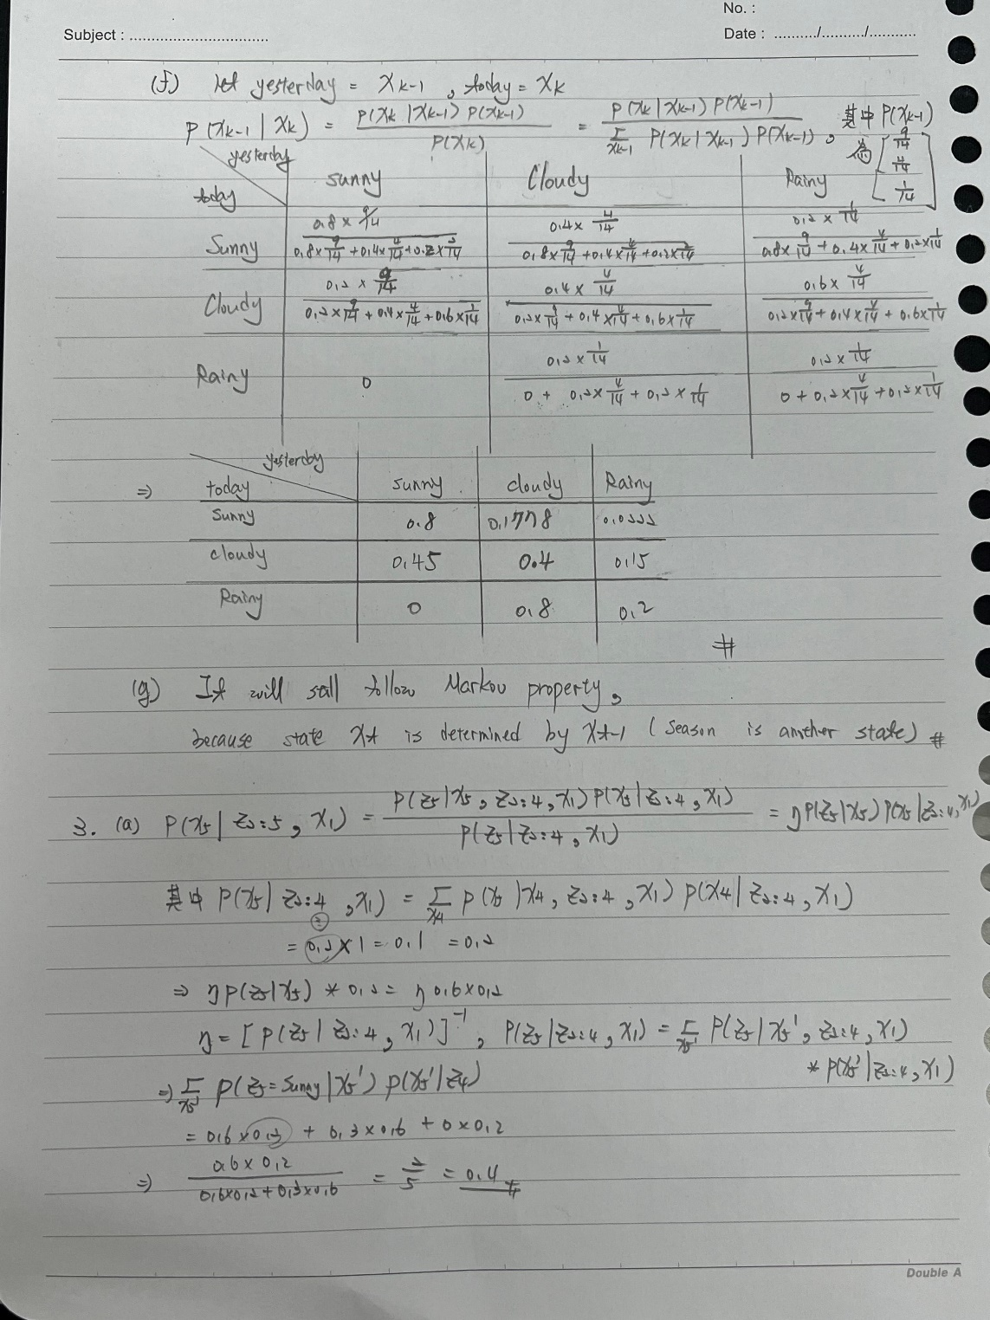

3.B

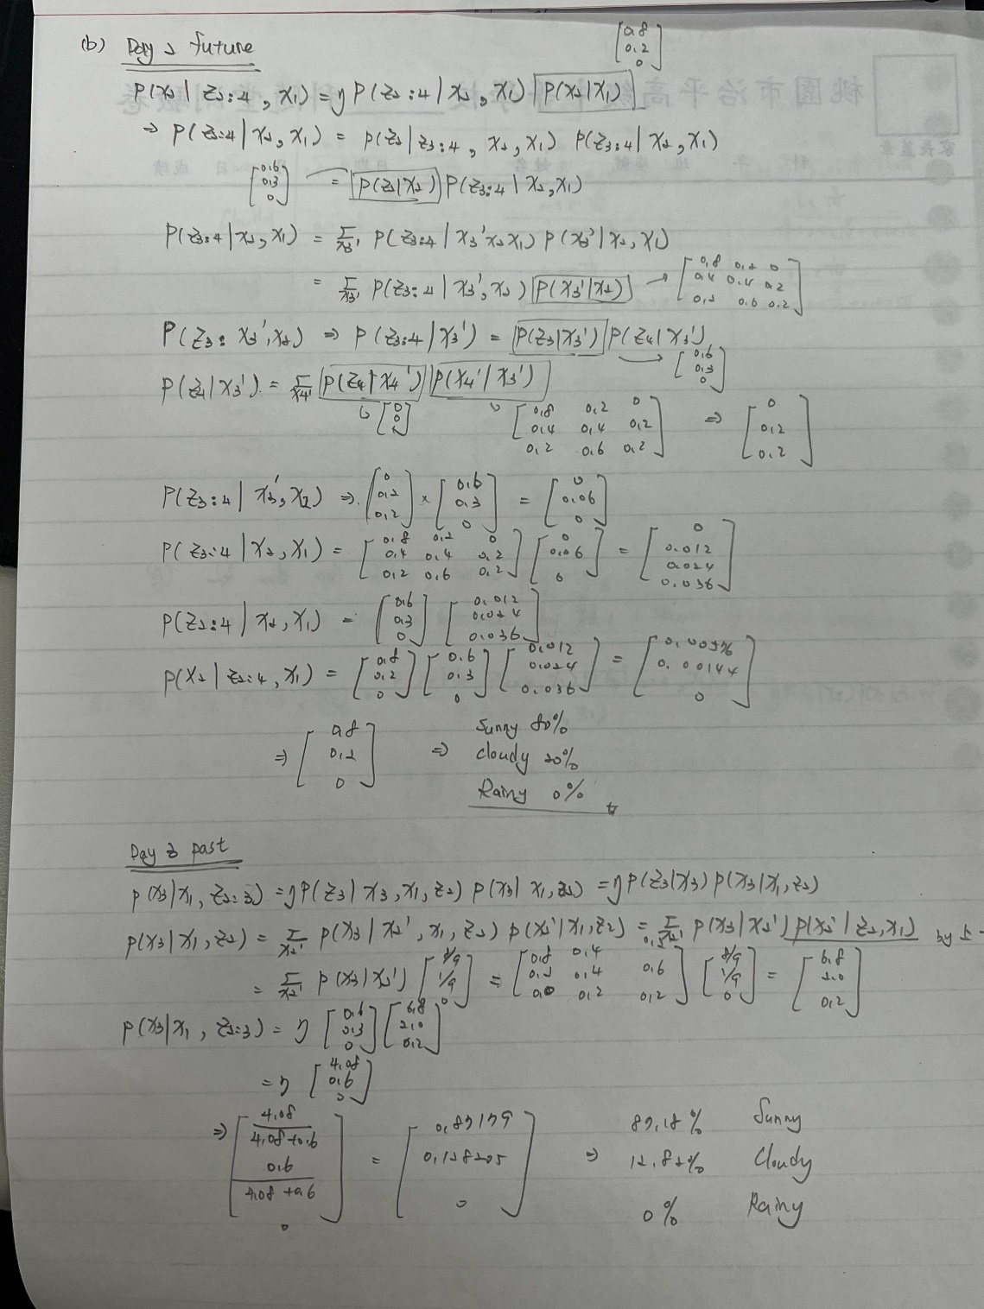

3.C

