Self Driving Car

311512064鄧書桓

1. **video link:**

<https://www.youtube.com/watch?v=2hC9IG6MFD0&feature=share&si=ELPmzJkDCLju2KnD5oyZMQ>

1. **Screenshot from video**

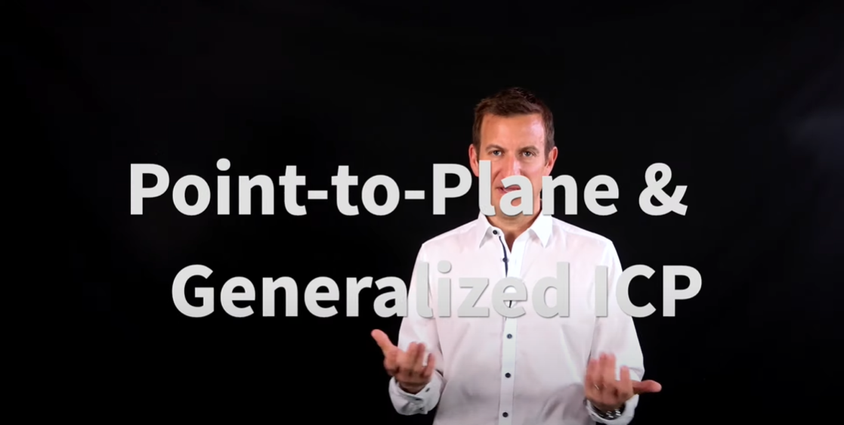

1. **Bref introduction**

Tradition Point to point ICP minimize two point’s distance to find the nearest point. The formula is below. However, it takes lost of time to iterate.

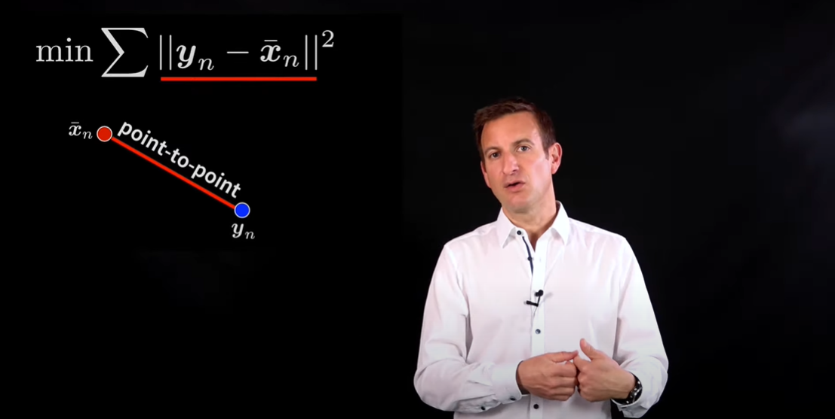

As a result, Point to plain ICP had born. It takes normal information into account and leads to better convergence with a smaller number of iterations with regard to the point to point ICP. The following two picture show how it works.

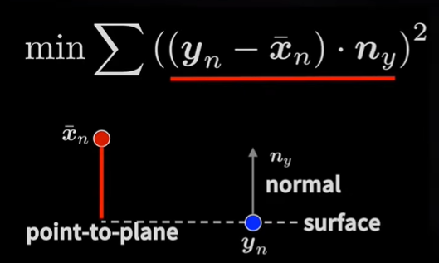

The last is General ICP. It combines point and plane matrix and represents point on surfaces locally by covariance matrices.What’s more, it also take normal information into account and align pointers with each other. As a result, the author in this video recommends the beginner to study GICP first.