VP Process Inc.
Sept. 2020

WL-MIO Web Design

Main Landing Page: wlmio.com and wlmio.ca are currently re-directed to widgetlords.com

Main Landing Page:

- Title
- Picture of WLMIO complete with DIN Rail
- Description
- Block Diagram
- Scalability Description
- Scale Block Diagram
- Software Description (UAVCAN and LIBMIO Widgetlords library)
- Links to Various Modules
- Model 6000 Backplane
- Model 6010 Power Supply 9 to 32 VDC Input, 5 VDC @ 4 Amp Output
- Model 6020 Raspberry Pi Interface c/w RS485 and HART Interface
- Model 6030 Relay Output Module 4 Channel
- Model 6040 Analog Input Module SDAFE 4 Channel
- Model 6050 Analog Output 4-20 mA (Source or Sink) Module 4 Channel
- Model 6060 Digital Input / Pulse Counter / Frequency Input Module 4 Channel
- Model 6070 Voltage Output (0 to 10 VDC) Module 4 Channel
- Model 6080 Thermistor Input (Typical 10K 3380 Beta) Module 8 Channel

Each module and component will have a dedicated page:

- Title
- Module Picture
- Description
- Block Diagram
- Field Wiring (Backplane) Diagram
- Specifications

Basic Specifications for each module:

- Power Input (Backplane Side and Field Input Side
- No. of channels
- Input / Output Type
- Ratings
- Temperature / Environmental
- Physical Dimensions
- Certifications

WL-MIO Main Landing Page

WL-MIO

Industrial Automation Simplified

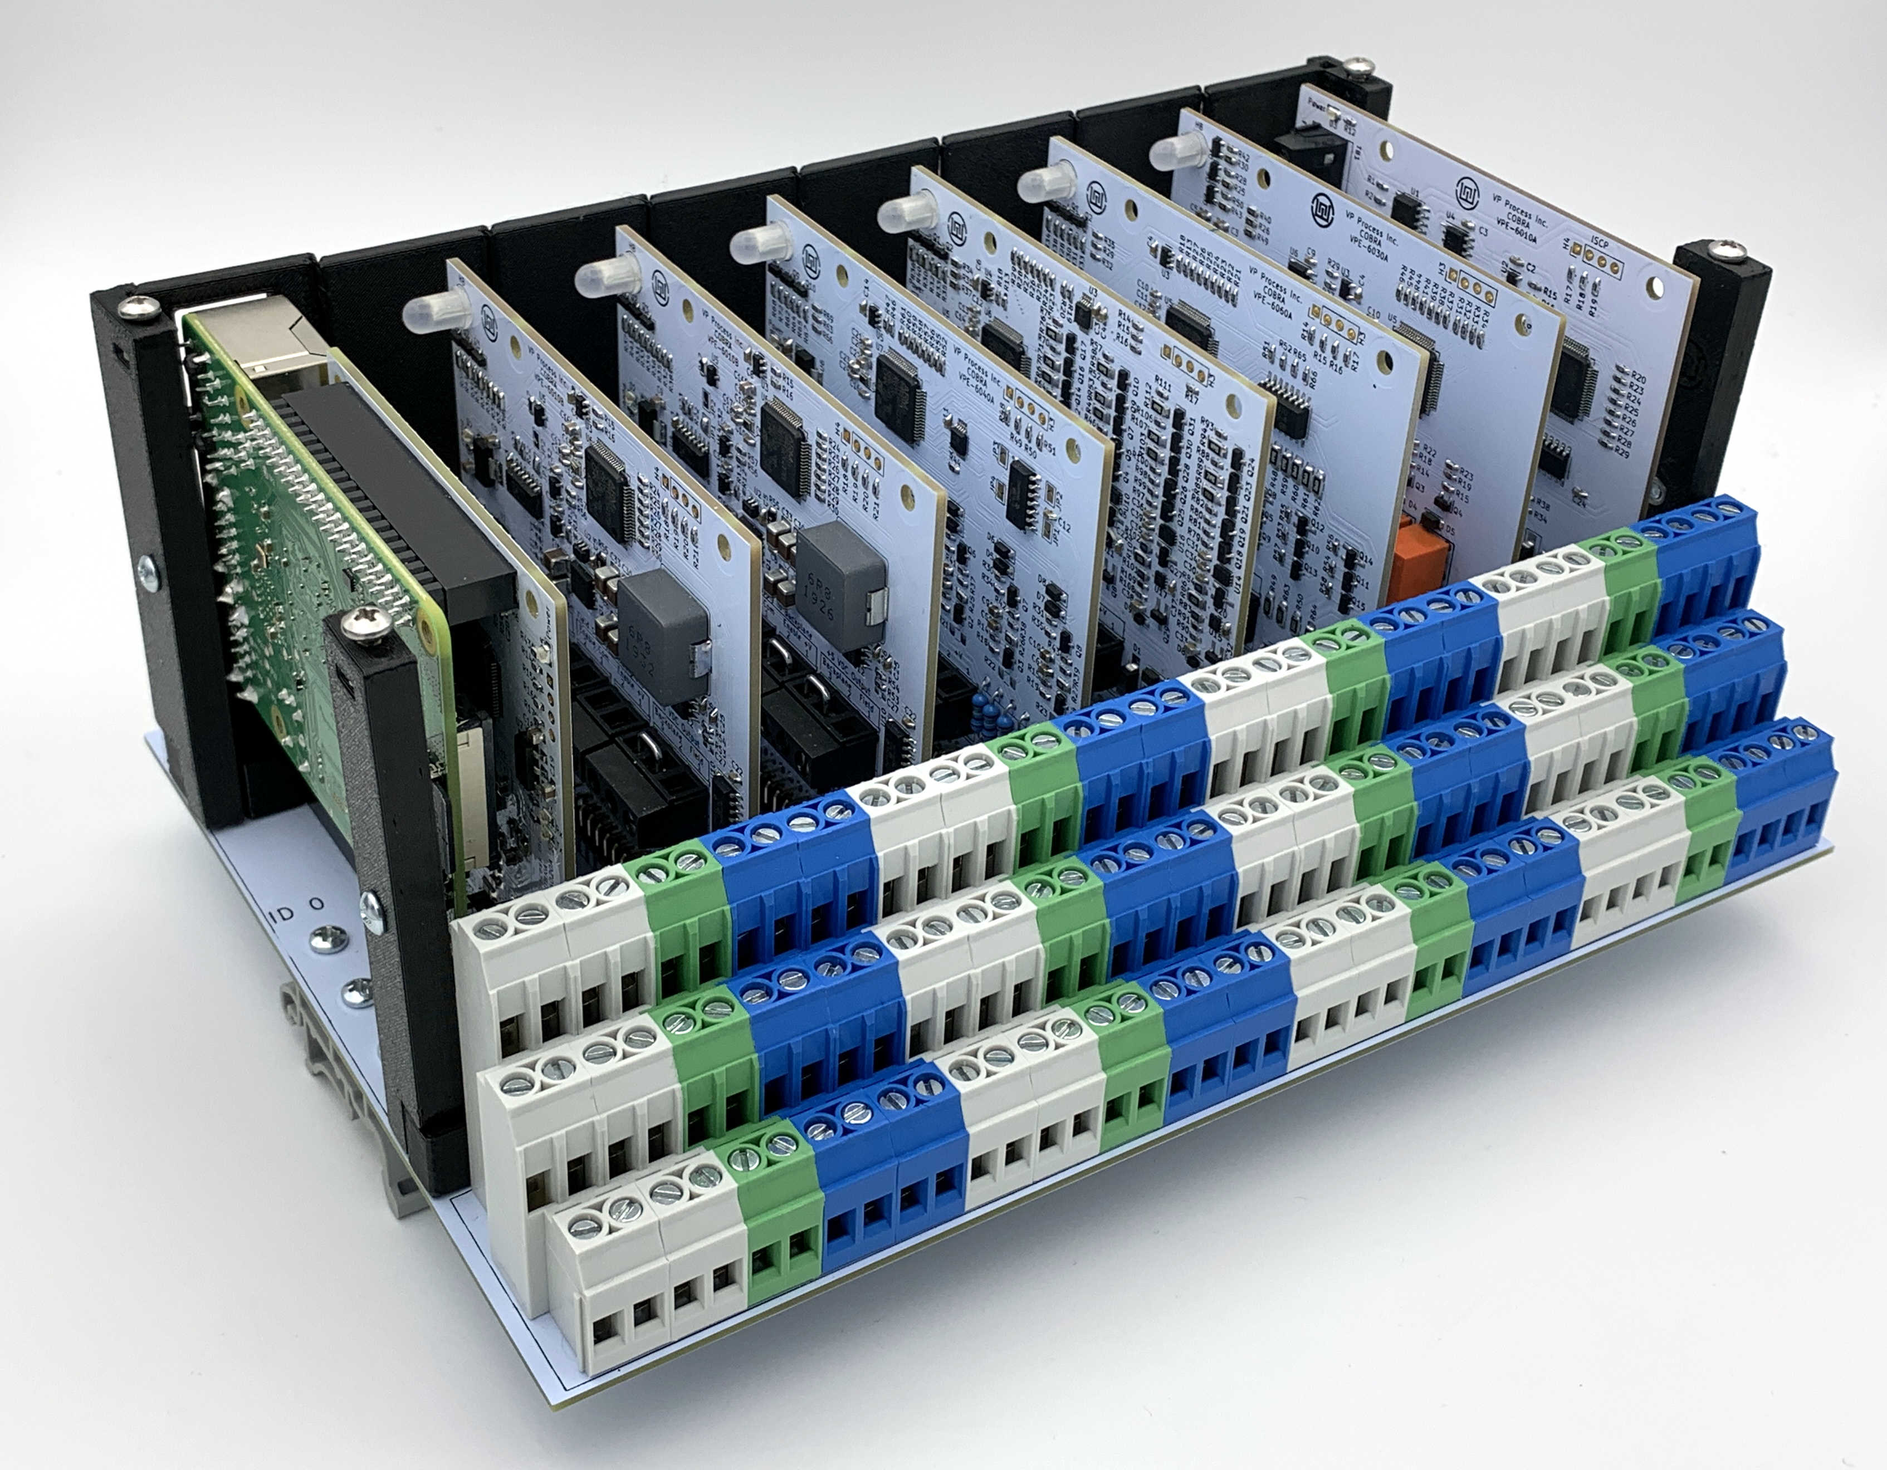

High Density Multi Input / Output Platform

“Land The Wires One Last Time”
DIN Rail Backplane for 8 WL-MIO I/O Modules
16 Platforms per System = up to 508 I/O Points per Raspberry Pi

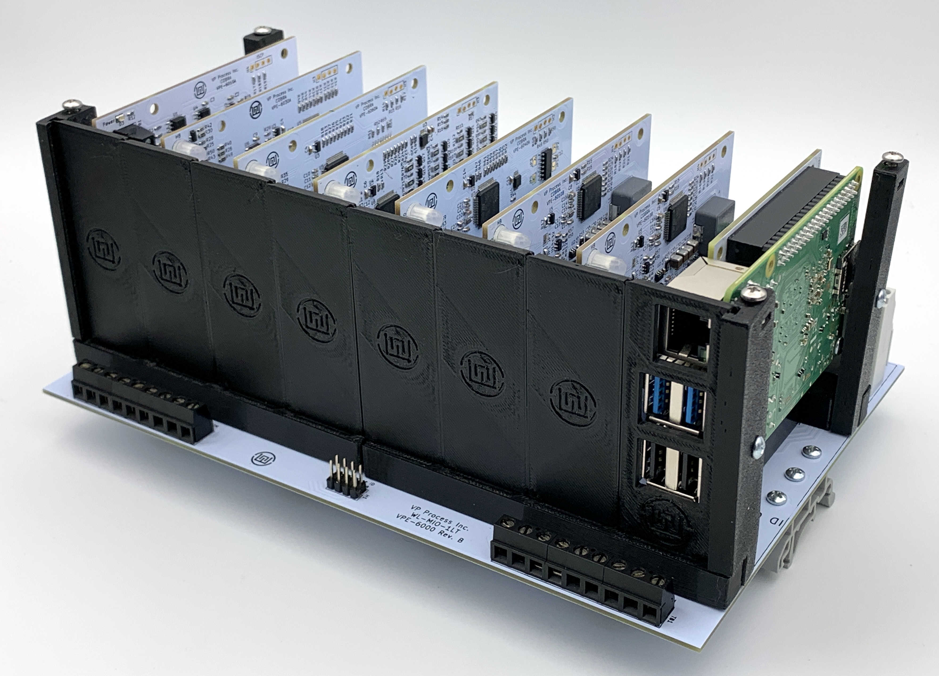

WL-MIO Backplane Block Diagram

WL-MIO 4 Pt. Module ID 7
WL-MIO 4 Pt. Module ID 6
WL-MIO 4 Pt. Module ID 5
WL-MIO 4 Pt. Module ID 4
WL-MIO 4 Pt. Module ID 3
WL-MIO 4 Pt. Module ID 2
WL-MIO Module ID 1
Typically Raspberry Pi Module
CAN Bus
9 Pt. Block

CAN Bus
9 Pt. Block

Power Input
24VDC (Typical)
Backplane Field Wiring
5 VDC Output Power to Backplane
Raspberry Pi Module ID
RS485 (Optional HART)
NOTE: Raspberry Pi
Controller Module can
Occupy ANY slot in the
Backplane
Multiple Raspberry Pi
Modules can be used in
One Backplane

Each Module has 3 SHIELD Connections

Each Module has 12
I/O Terminal Block
Connections

Module Address is
Determined by
Module Insertion
Location (0 thru 7)
Plus Backplane ID
Backplane ID
Is Set Via a 4Pt.
Jumper
Terminal Blocks
3 Level c/w Screw -
Rising Cage Clamp
WL-MIO Backplane Dimensions
8.25” DIN Rail length
5.8” Wide
3.5” Deep
WL-MIO Module ID 0
Typically 5 VDC Power Supply
Typical DIN Rail
NOTE: Power Supply Module
Can Occupy Any Slot In The
Backplane And Is Treated As
A 4 Pt. Analog Input Module
Multiple Power Supplies Can Be Used In A Single Backplane

Scale 16 WL-MIO Backplanes

1 Raspberry Pi Module
7 WL-MIO Modules
CAN ID = 0 - 7
8 WL-MIO Modules
CAN ID = 8 - 15
CAN Bus
8 WL-MIO Modules
CAN ID = 16 - 23
CAN Bus
8 WL-MIO Modules
CAN ID = 24 - 31
CAN Bus
8 WL-MIO Modules
CAN ID = 32 - 39
8 WL-MIO Modules
CAN ID = 40 - 47
CAN Bus
8 WL-MIO Modules
CAN ID = 48 - 55
CAN Bus
8 WL-MIO Modules
CAN ID = 56 - 63
CAN Bus
CAN Bus
8 WL-MIO Modules
CAN ID = 64- 71
8 WL-MIO Modules
CAN ID = 72 - 79
CAN Bus
8 WL-MIO Modules
CAN ID = 80 - 87
CAN Bus
8 WL-MIO Modules
CAN ID = 88 - 95
CAN Bus
CAN Bus
8 WL-MIO Modules
CAN ID = 96 - 103
8 WL-MIO Modules
CAN ID = 104 - 111
CAN Bus
8 WL-MIO Modules
CAN ID = 112 - 119
CAN Bus
7 WL-MIO Modules
CAN ID = 120 - 127
CAN Bus
CAN Bus
Software Overview

CAN
Hardware
Linux Kernal Driver
WL-MIO
Modules
(Request, Response, Message)
Proprietary to VP Process Inc.
UAVCAN
Open Source
MIT Licence
WLMIOD
Open Source
MIT Licence
UAVCAN
Open Source
MIT Licence
DBUS
Open Source
BSD Licence RPi4
NodeJS
libwlmio
C
Open Source
MIT Licence
NXT
OpenPLC
pywlmio
Python
Open Source
MIT Licence
Setup
dtoverlay + Commands
EEPROM storage
WL-MIO Hardware ID
Provided by
VP Process Inc.
Links to WL-MIO Modules

Model 6000 Backplane
Model 6010 Power Supply 9 to 32 VDC Input, 5 VDC @ 4 Amp Output
Model 6020 Raspberry Pi Interface c/w RS485 and HART Interface
Model 6030 Relay Output Module 4 Channel
Model 6040 Analog Input Module SDAFE 4 Channel
Model 6050 Analog Output 4-20 mA (Source or Sink) Module 4 Channel
Model 6060 Digital Input / Pulse Counter / Frequency Input Module 4 Channel
Model 6070 Voltage Output (0 to 10 VDC) Module 4 Channel
Model 6080 Thermistor Input (Typical 10K 3380 Beta) Module 8 Channel

Model 6000 Backplane

