William Diment

Oscar Gandara

Kathryn Gray

Eddie Stoian

CSCI 3308

Boese

We are presenting a project that we are calling “The Regex Memory Game”, and the purpose of this project is to create a game that will help students learn Regex in a fun and interactive manner. Our vision is to make learning Regex fun, and the specific motivation that drives this vision is to help incoming studies learn regex, and to give another form of studying for any regex expressions that may be on an exam. The specific pitfalls that we may have while working on this project are the facts that none of us have worked with each-other before, and it looks like our project will be somewhat database heavy, and none of us have any previous experiences with databases, along with only having a cursory knowledge of regex at this point. What we are planning on doing to mitigate these vulnerabilities is to learn Regex as well as possibly can, and also to learn as much as we can about databases so that we are able to efficiently and optimally use the database that we implement. We are using Github so as to easily control our software, and we are using Trello as a project tracker. Our requirements for this project are as follows.

User – 1: As a user, I want to be able to play the game so that I can learn Regex. Size: 8

Functional – 1: As a user, I want a timer to keep track of how much time I have left in the game. Size: 2

Functional - 2: As a user, I want a variety of questions and answers to test my Regex knowledge. Size: 3

Functional – 3: As a user, I want to be able to choose the difficulty level of the questions I have. Size: 3

Functional – 4: As a user, I want to be able to check the scoreboard to see my scoreboard. Size: 2

Non-Functional – 1: As a user, I want to see when I finish the game. Size: 1

Non-Functional – 2: As a user, I want to be able to see the cards when I click them. Size: 3

Non-Functional – 3: As a user, I want a quit button to be able to leave the game. Size: 3

The methodology that we are using is Agile, and the project plan is attached as a screenshot.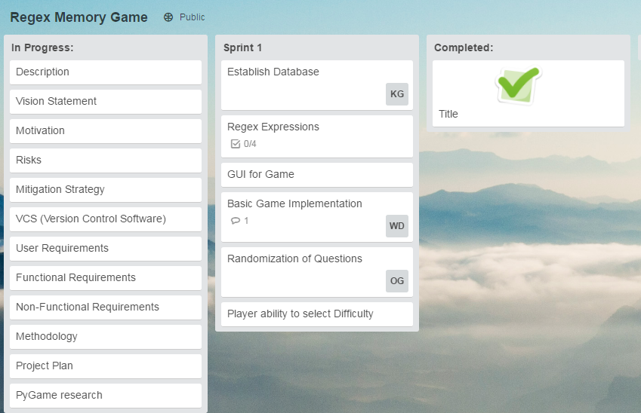

Link to Trello Project Page: <https://trello.com/b/5Yo9Y22B/regex-memory-game>

Link to github repository: https://github.com/widi9545/csci3308regexgame